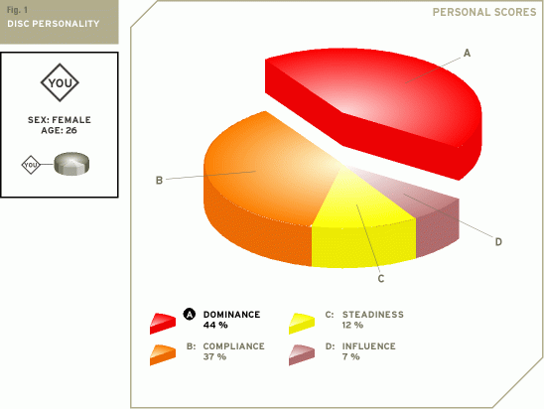

Your DISC personality type
Your unique sequence of scores characterizes you in a specific way. The positive impact you are likely to make on people is:

You have a strong inner motivation to assertively create and implement new ideas.
You handle pressure well - you strive for excellence and expect others to do the same.
You are innovative but tend to avoid risk taking.

DISC Patterns or Profiles
As you will appreciate, there are literally thousands of different combinations of scores. Therefore to help interpretation, communication and understanding, DISC Personality Model experts have defined - through statistical analysis of the score combinations - fifteen DISC 'Patterns' or 'Profiles'.

The 'Profiles' are often given names. The objective of these names is to give a single descriptive term that captures the essence of that Profile. Names often used are Achiever, Coach, Evaluator, Counselor, Creative, Individualist, Inspirational, Investigator, Objective Thinker, Perfectionist, Persuader, Practitioner, Enthusiast, Results-Oriented or Specialist

To understand the DISC theory even further descriptions are given for people who score comparatively high and comparatively low on each of the four DISC dimensions.

Dominance
Comparatively High
Here are some traits and behaviours that describe people who are comparatively high in Dominance:
enjoy competition and challenge.
are goal orientated and want to be recognised for their efforts.
aim high, want authority and are generally resourceful and adaptable.
are usually self-sufficient and individualistic.
may lose interest in projects once the challenge has gone and they tend to be impatient and dissatisfied with minor detail.
They are usually direct and positive with people, enjoying being the centre of attraction and may take it for granted that people will think highly of them.
They may have a tendency to be rather critical of others. Consequently, other people may tend to see them as being rather domineering and overpowering.

Comparatively Low
Here are some traits and behaviours that describe people who are comparatively low in Influence:
are usually socially passive.
quite frequently have an affinity for things, machinery and equipment.
are generally comfortable working alone.
frequently have a tendency to be analytical and once they have sorted the facts out they communicate them in a straightforward direct way.
tend to take little at face value.
They may well have learned and developed good social skills but they only bring these into play when logic dictates such tactics.

Comparatively Low
Here are some traits and behaviours that describe people who are comparatively low in Steadiness:
tend to enjoy change and variety in their work and non-work life.
are expansive by nature and tend not to like routine and repetitive work/activities.
They enjoy stretching themselves intellectually and physically.

Compliance
Comparatively High
Here are some traits and behaviours that describe people who are comparatively high in Compliance:
are usually peaceful and adaptable.
tend not to be aggressive.
tend to be cautious rather than impulsive.
avoid risk-taking.
act in a tactful, diplomatic way and strive for a stable, ordered life.
are comfortable following procedures in both their personal and business life.
They prefer sticking to methods that have proved successful in the past. They have a high acceptance of rules and regulations.

