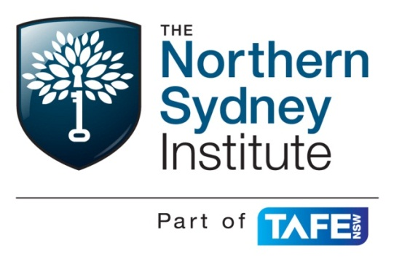
SITXHRM503 Monitor staff performance
Assessment Events
Due Dates:
Part 1 – Week 18; (before 6pm on the day of your scheduled class)
Part 2 – Performance counselling Scenario –Week 18 (before 6pm on the day of your scheduled class)
This assessment relates to the following elements in the unit SITXHRM503
- Monitor staff performance and provide feedback.
- Recognise and resolve performance problems.
- Implement performance management systems.

Required skills

- Communication skills to provide effective feedback, coaching and counseling to team members
- Critical thinking skills to evaluate the reasons contributing to poor staff performance
- Initiative and enterprise skills to proactively provide colleagues with appropriate guidance and support to enhance their work performance
- Literacy skills to:
  - Read and interpret staff records and performance management documents
  - Write potentially complex and sensitive information about staff performance
- Planning and organising skills to coordinate regular performance appraisals and coordinate and operate formal counseling sessions
- Problem-solving skills to identify and respond to staff performance issues
- Self-management skills to take responsibility for monitoring staff performance
- Teamwork skills to monitor the performance of individuals, their effect on the team and take corrective action to enhance the whole of team performance.

Required knowledge

- Role and importance of monitoring staff performance and providing feedback and coaching
- The key elements of performance standards and performance management systems
- Performance appraisal practices, including:
  - Reasons for performance appraisal
  - The format for and inclusions of performance appraisal documents
  - Methods of appraising performance

- For the specific organisation:
  - Procedures for performance appraisal interviews
  - Procedures for formal counseling sessions
  - Grievance procedures.
Critical aspects of assessment
Evidence of the ability to:
- monitor the day-to-day effectiveness of staff and provide supportive feedback and guidance for improvement
- conduct structured performance appraisals and formal counseling sessions for diverse staff members operating at different levels of effectiveness
- Integrate knowledge of procedures for formal performance management and counseling.

The unit is graded and therefore you will receive an AC, CC or CD in your transcript of results.

PART 1
Written report

Weighting 60% of total marks for this unit.

You are the owner/manager of your chosen hospitality/tourism business. (Use the same business you used in the assessment for the unit Recruit, Select & Induct Staff SITXHRM501) As a new business opening within the next three months one of your priorities is to develop a Performance Management Plan that will ensure your new staff are developed, trained and appraised continuously. You see this as essential in maintaining low staff turnover, rewarding employees with feedback and resulting ultimately in delivering a consistent standard of service to your customers. (You are to work with the same partner as you did when completing the unit Recruit, Select & Induct Staff SITXHRM501, where possible.)
Your Task:
As part of your performance Management plan, you must describe and explain the benefit to your business of each of the following;

- Your probationary period (if you choose to have one). (10 marks)
- Strategies you will use to communicate performance standards and your performance expectations to your employees. (Organisational and job related). (10 marks)
- Your approach to providing feedback (both informal and formal appraisal - include an appraisal form and a description of the strategies you will use to obtain information about, and measure, employee performance against the set KPI’s.) (28 marks)
- Your approach to providing training (including induction, job training, professional development opportunities). (10 marks)
- Your approach to recognising and rewarding employee/team achievements and performance.
(12 marks)
- Your approach to conducting performance counselling sessions to manage identified poor performance. (including your disciplinary procedure should the performance not improve) (20 marks)
- Your grievance procedure. (10 marks)
- Your termination procedure (including your exit interview procedure) (20 marks)

Total marks /120 ( /2 = /60)

PART 2
The Performance Counselling session - Scenario
Weighting - 20% of total marks for this unit.
Your new business has now been in operation for over 12 months. Your performance management plan has been implemented successfully and as a result you have developed a highly motivated team who have met and exceeded your expectations in all aspects of their performance.
However over the last two weeks you have identified, through observation, that one of your key full-time employees has been underperforming in almost all of their KPA’s, failing to achieve many of their KPI’s.
Their behaviour in the workplace has also changed, indicated by the following;
- They have been late to work on more than three occasions
- They avoid talking you and other employees
- They have caused conflict with other employees on two occasions that you know of
- You have received comments from some of your regular customers that they have been rude when serving them.
You have also found out through discussions with your employees that this employee is dealing with a major personal issue at home (not confirmed however)
Your task:
Using your documented approach to performance counselling (described in Part A)
- Describe and explain what action (the steps) you would take to resolve the situation. (10 marks)
- Describe the potential impact the situation is likely to have on the workplace if left unresolved.
(10 marks)

