Global Warming: A Growing Epidemic
Sydney Garrity
Monmouth University

Introduction: What is Global Warming?
Global warming is an increase in the world’s temperature that happens gradually over time because of pollution, toxic gases, and environmental deterrents. This sounds like a mild change that is happening globally but continuing to ignore detrimental effects that humans are causing the planet may result in a world that is unlivable in the near future. This is not a myth like some may think. It is very common for some to be in denial of the inevitable; that our world is changing around us and if we don’t make a change things will continue to worsen. Increased temperatures taking place on the planet are partially natural and partially the result of human activity. Global warming is an issue if it is not addressed properly, and timely, it will consume the place that we call home.
The Issue at Hand
My Position: Why do Some think Global Warming is A Myth? (GUO)
Understanding the Issue
Summary

(Last Name, Year)

References
Trenberth, K. E., Dai, A., Schrier, G. V., Jones, P. D., Barichivich, J., Briffa, K. R., & Sheffield, J. (2014, January). Global Warming and Changes in Drought [Scholarly project]. In ProQuest. Retrieved March 29, 2019, from https://search-proquest- com.ezproxy.monmouth.edu/docview/1651464571?pq-origsite=summon

Figures title:
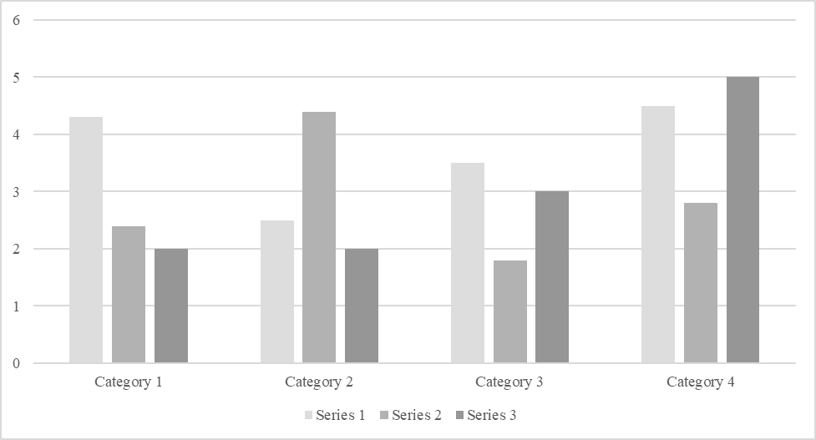
Figure 1. [Include all figures in their own section, following references (and footnotes and tables, if applicable). Include a numbered caption for each figure. Use the Table/Figure style for easy spacing between figure and caption.]
For more information about all elements of APA formatting, please consult the APA Style Manual, 6th Edition.

