Dimensions of Organizational Culture

Student’s Name:________________ Chosen Company/Organization Name:___________

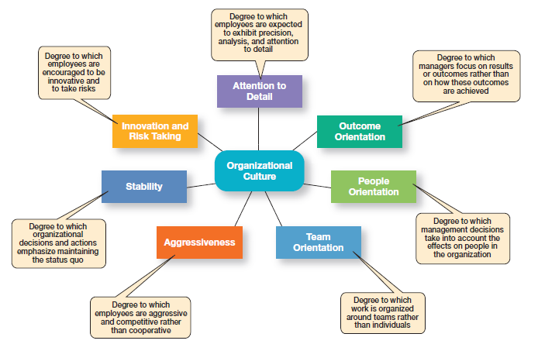

Select an organization that you might like to work for. Use online resources to learn about the company’s
culture to prepare for this activity. For this activity, students will dissect the company’s
- culture
- external environment

I. Corporate Culture Analysis
The purpose of this exercise is for you to obtain information pertaining to the organizational culture for your chosen company.

Questions
1. What are the organization’s espoused values and beliefs?
2. Using the diagram depicting the Dimensions of Organizational Culture as a guide, how would you classify the organization’s culture in each of these areas?
- Attention to Detail
- Outcome Orientation
- People Orientation
- Team Orientation
- Aggressiveness
- Stability
- Innovation & Risk Taking

II. External Environment Scan
The purpose of this exercise is for you to consider how the external environment effects organizational culture for your chosen company. Answer each question below.

Questions
- What impact does the current economy have on your company and its industry?
- What impact does the government and laws have on your company and its industry?
- Name a competitor of your company. What threat does the competitor most pose?
- Where and how does your company find future employees?
- How does your chosen company utilize technology? What threat might technology pose in the future?
- What is the effect of globalization on your company’s culture?
- In your opinion, what is the largest challenge facing your chosen company?

