Paper Proposal Assignment Name: Maoyi Wu
Art 304

1. Thematic exhibit: female deities
Pre-Colonial Thematic Proposal (Period exhibit) / Aztec art

2. IMAGES.
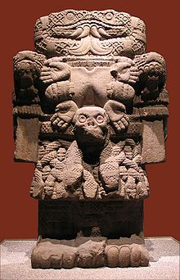

Image 1:

Coatlicue, 1300-1500, Tenochtitlan
I will include more information from https://www.ancient.eu/Coatlicue/ , and the article which named A New Interpretation of the Aztec Statue Called Coatlicue, “Snakes-Her-Skirt” for the final paper.

Image 2:
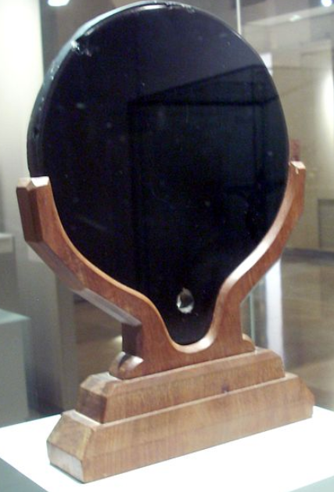
Carved Mirrors, c.1200–1521, Tenochtitlan
https://courses.lumenlearning.com/boundless-arthistory/chapter/the-aztecs/

Image 3:
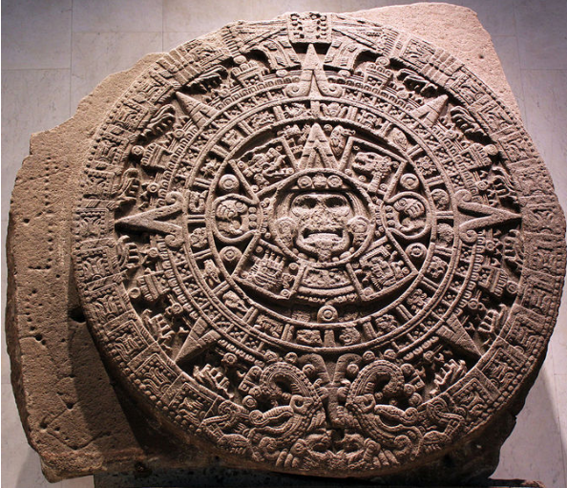
Calendar Stone: Engraving of the Sunstone, ca. 1792, Mexico
http://www.mexicolore.co.uk/aztecs/calendar/calendar-stone

3. Sources.

1. Dicesare, Catherine R. "Tlaloc Rites and the Huey Tozoztli Festival in the Mexican Codex Borbonicus." Ethnohistory 62, no. 4 (2015): 683-706. doi:10.1215/00141801-3135290.
2: Klein, C. F. “A New Interpretation of the Aztec Statue Called Coatlicue, ‘Snakes-Her-Skirt.’” Ethnohistory, vol. 55, no. 2, 2008, pp. 229–250., doi:10.1215/00141801-2007-062.
3: Boundless. "Boundless Art History." Lumen. Accessed October 23, 2018. https://courses.lumenlearning.com/boundless-arthistory/chapter/the-aztecs/.

