SAGINAW VALLEY STATE UNIVERSITY

THE CUZCO SCHOOL: 18th CENTURY SECULAR AND RELIGIOUS ARTS
THEMATIC EXHIBIT PROPOSAL

BY:
EMILY MARIE SOVEY
Art 304
December 11, 2012

To Whom It May Concern,
The art of the colonial period in Latin America can be separated into two differing branches of production: those done by artists of European descent and indigenous artists. European painters were trained in the traditional style of Renaissance; and as the years progressed, they were influenced by Baroque, Mannerism, and then Rococo. The eighteenth century saw the manifestation of the Rococo style in Colonial Latin America, albeit with some changes from local cultural influence. The other artists, however, were natives of the land and so brought forth in their works some of the styles and traditions that were a part of their cultures. The Cuzco School was perhaps the most famous guild of anonymous indigenous artists, located in Cuzco, Peru. During early colonization, this school was formed by monks who wanted to further the education of indigenous people through the production of art. As the school grew, and the indigenous converted to Christianity, art became a medium through which these artists could celebrate their religious beliefs. During the seventeenth century and onwards, the anonymity of artists furthered this idea that their pieces were meant to be created in reverence for God and not their own achievements. By the eighteenth century, the artists of the Cuzco School had developed a certain style that combined the aesthetics of European art in combination with their own cultural influence, yet maintaining a focus on the religious aspects of the pieces. I have chosen the following as a sampling of paintings done by the Cuzco School in the eighteenth century, so as to create an exhibit that will help to inform the general public as to why this group of artists was so important to the production of art in Colonial Latin America.
The Cuzco School was active in Peru from the 16th to the 19th century, and its main purpose was to be a guiding force for indigenous artists to create the ‘appropriate’ kinds of paintings. Monks would monitor the creation of pieces, making sure that natives were correctly portraying religious imagery. They were especially interested in keeping out the cultural aspects that the indigenous were prone to use. However, many of the indigenous artists added in small details that would help to remind them of their culture while still adhering to the rules of the church. Initially, the paintings portrayed religious themes of the Virgin and Child, and other simple biblical references; so as to reinforce the main doctrine of Christianity among the natives. With the coming of the eighteenth century, the imagery incorporated a variety of religious scenes along with some historical references of the conquest. In the proposed exhibit, it will be these themes which will be explored in the variety of images.
The first image that I have selected to be a part of the exhibit is, “The Virgin of Bethlehem,” created in 1770. (Figure 1) This piece is a strong representative of the style favored by natives, and shows how they not only deviated from the traditional Renaissance depiction of figures, but also included aspects of their own culture. The Virgin Mary is rendered in very flat, stylized clothing with floral, gold patterning; which was very typical of art produced by the indigenous people who were not trained in the Renaissance traditions. This style of decoration was known as brocateado, and was used as a means of appealing to indigenous viewers. She is shown standing upon a crescent moon, which was part of Francisco Pacheco’s concept on the depiction of the Virgin. In this portrayal of the virgin, such things as the crescent moon, flowers, and other symbols were incorporated to show both the divinity of Mary and her purity. At the same time, however, the moon is also symbolic of the Great Goddess Incan deity, who is closely associated with agriculture and life. By incorporating this aspect, the artist is reflecting the idea that although the indigenous people have converted to Christianity, they are still aware of their cultural heritage.
Another image which is closely related to the Virgin and Child is the depiction of the Christ child with Saint Joseph. (Figure 2) In this painting, a young Christ is standing hand in hand with his mortal father, Joseph. In his hand, Joseph is holding a branch of white lilies, which is symbolic of both his and Christ’s purity. Again, this saint follows the dictations of Francisco Pacheco ideology of the portrayal of religious figures. Joseph is depicted as being in his early thirties, mature yet still youthful, so as to convey to the natives the concept of an ideal father role. The figures are each clothed in heavily stylized cloth, with a gold leaf pattern of brocateado that portrays a sense of flattening in the painting common among works produced by the Cuzco School artists. There is a hint of a landscape background, but it is nondescript so as to not draw the viewer’s attention away from the central figures. Surrounding the scene is a border of various flowers, a direct reference to the indigenous culture. By including these flowers, the artist is reminding the viewer of the Incan deities, and the idea of agriculture as being an important part of their heritage.
The Last Judgment scene was one that very commonly used in Spain during the thirteenth century in the tympanum of Romanesque churches. This scene was one that cautioned the members of the church to remember that at death Christ would weigh their souls so as to decide whether or not they were worthy of heaven. Often this scene would be accompanied by a gruesome depiction of hell, which was seen as a reminder of the punishment for one’s sins. Such is the case with the piece done by the Cuzco School artists. The painting shows Michael the Archangel holding a balance scale, representing the judgment of the good and evil that a person has done. Below him are the souls who are not worthy of heaven and so must suffer in hell for their sins. This scene was used more commonly in the seventeenth and eighteenth century (once most of the indigenous had been converted); so as to reinforce the idea that sinful behavior would be condemning in the afterlife.
Another popular religious scene was that of the Last Super. Hence, it is no surprise that the artists of the Cuzco School used it as one of their themes. (Figure 4) In this traditional Christian scene, Jesus is shown in the middle with one hand in blessing and the other breaking bread. It is this imagery which alludes to the Christian idea of the Eucharist, that the bread and wine is symbolic or the body and blood of Christ. This scene would have been used to help correlate the biblical scene to the indigenous converts, showing the meaning behind the Eucharist and the importance of Christ’s death for the salvation of their sins.
The next image selected to be a part of the Cuzco School exhibit is “The Allegorical Flotilla of Salvation.” (Figure 5) This piece is significant because it represents the rebellion of colonial cities against that of Spain and other European nations. Many of the natives were not content with the Spanish governing body in Latin America, which caused a sense of unease in the colonies. Many of the indigenous, because they had converted to Christianity, believed that it Christ’s plan that they be saved. Hence, the image of the allegorical flotilla is seen as a representation of this belief. Christ is seen on the crucifix on the central ship and then again as he would appear in the heavens. To the right, the ship carries the Virgin and Child; and to the left, the ship carries Saint Rose of Lima. Each of these figures holds an important religious status, and is meant to show that God has agreed that the natives should be saved.
While many of the pieces done in the Cuzco School were of religious imagery, there were others that depicted the colonization of the Incan peoples. Specifically, these paintings were often created to show the inclusion of natives into the world of the Spaniards. In a painting done in the Jesuit Church, Iglesia de la Compania, the artist depicts the marriage of an Inca Princess and a Spanish Captain. (Figures 6.1 and 6.2) This scene shows how the original Spanish colonists wanted to incorporate the natives into their culture by marrying them. Thus, the indigenous peoples are shown in their native dress, whereas the Spanish are garbed in the European fashion. However, the Inca Princess is shown wearing the style favored by the Spaniards, conveying the idea that these people could be could be integrated into the Spanish culture. It was also a common practice to include both indigenous peoples and those of European descent in a painting to show that the two people could live in harmony with one another. Thus, making this piece a primary example of the interrelations between the Inca civilizations and the Spanish colonists, as portrayed through the Cuzco artists.
I hope that you deeply consider this exhibit proposal as part of a display on Colonial Latin American art focusing on that of the paintings of the Cuzco School during the eighteenth century. I believe that this assortment would aptly fulfill a section dedicated to the paintings done by these artists, encompassing a variety of examples in both style and context. Each piece was specially chosen to represent a different aspect of art produced in the Cuzco School, and would help any viewer of the exhibit to have a better understanding of the aesthetics used by natives to create religious pieces in Colonial Latin America.

Sincerely,
Emily Marie Sovey

IMAGE INDEX:
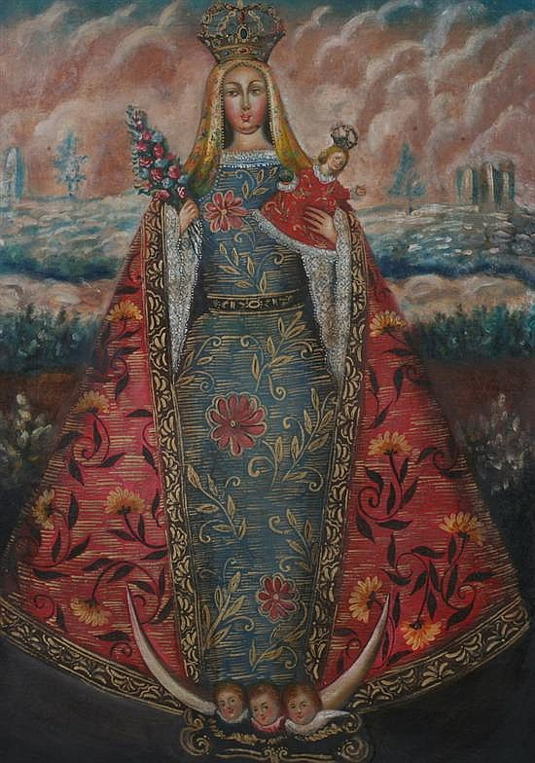
Figure 1: Virgin of Bethlehem, Cuzco School, Oil on Canvas, Lima Museum of Art, 1770.
http://www.artfact.com/auction-lot/cuzco-school-18th-century-.-our-lady-of-bethlehe-1-c-bb93a1847

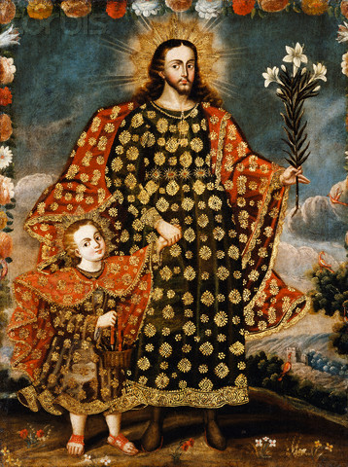
Figure 2: Saint Joseph and the Christ Child, Cuzco School, 1799. http://content.lib.washington.edu/cdm4/item_viewer.php?CISOROOT=/buildings&CISOPTR=13532&CISOBOX=1&REC=1
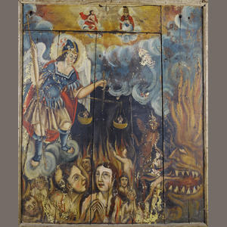

Figure 3: The Last Judgment, Oil on Panel, Cuzco School, 18th Century.
http://www.bonhams.com/auctions/17954/lot/113/

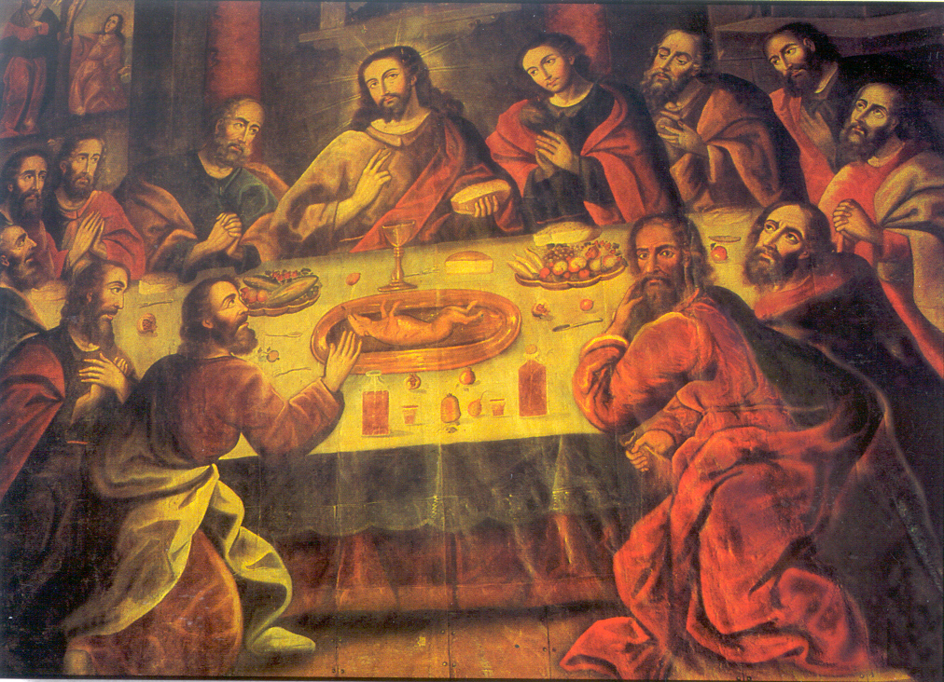
Figure 4: The Last Super, Marcos Zapata, Cuzco School, Cuzco Cathedral, 1764.
www.delange.org/CathedralCusco/Dsc00099.jpg

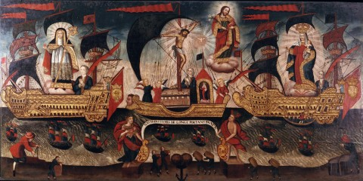
Figure 5: Allegorical Flotilla of Salvation, Oil on Canvas, Cuzco School, 18th Century.
http://www.pada.net/members/memPicFull.php/41/316

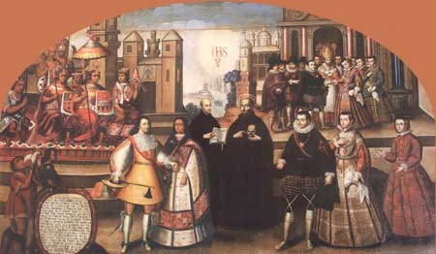
Figure 6.1: Martín García de Loyola y Beatriz Clara Coya, Cuzco School, Iglesia de la Compania, 1741.
http://www.perutourism.com/newsletter2/images/princesa2.jpg

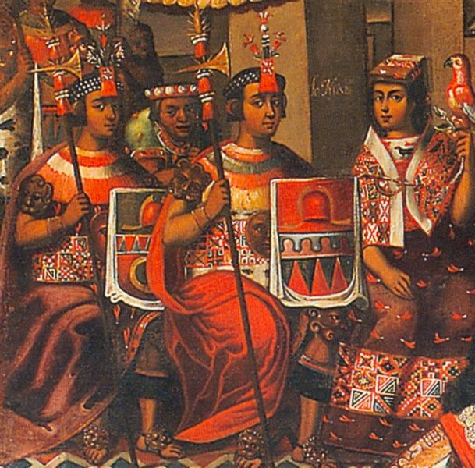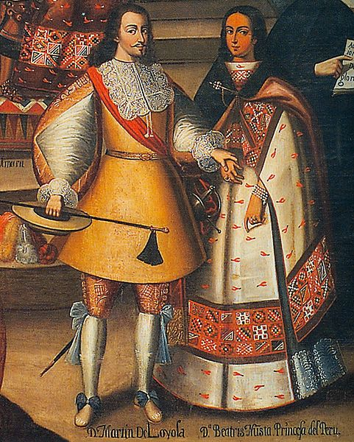
Figure 6.2: Details of Martín García de Loyola y Beatriz Clara Coya, Cuzco School, Iglesia de la Compania, 1741.
http://www.bienvenidaperu.com/English/Ediciones/Edicion47/capitan_princesa/body.htm

BIBLIOGRAPHY

- Bailey, Gauvin Alexander. “Indian Conquest of Catholic Art: The Mughals, the Jesuits, and Imperial Mural Painting.” Art Journal 57, no. 1 (1998): 24-30.

- Bireley, Robert. The Refashioning of Catholicism, 1450-1700: A Reassessment of the Counter Reformation. Catholic University of America Press, 1999.

- Cahill, David. “Colour by Numbers: Racial and Ethnic Categories in the Viceroyalty of Peru, 1532-1824.” Journal of Latin American Studies 26, no. 2 (1994): 325-346.

- “Cuzco School.” Oxford Art Online. www.oxfordartonline.com.library.svsu.edu. December 6, 2012.

- Degregori, Luis Nieto. “The Captain and the Inca Princess in the Jesuit Church.” Bienvenida Editors. http://www.bienvenidaperu.com. December 6, 2012.

- Donahue-Wallace, Kelley. Art and Architecture of Viceregal Latin America, 1521-1821. NM: University of New Mexico Press, 2008.

- Dubois, Laurent. “The Price of Liberty: Victor Hugues and the Administration of Freedom in Guadeloupe, 1794-1798.” The William and Mary Quarterly 56, no. 2 (1999): 363-392.

- Emily Kelly. Course 304 Lectures. Saginaw Valley State University, 2012.

- Gade, Daniel W. “Landscape, System, and Identity in the Post-Conquest Andes.” Annals of the Association of American Geographers 82, no. 3 (1992): 460-477.

- Kleiner, Fred. Gardner’s Art Through the Ages: A Global History. CA: Wadsworth Publishing, 2010.

- Martin, Regis. The Last Things: Death, Judgment, Hell, Heaven. (Ignatius Press, 1998).

- Mills, Kenneth. “The Limits of Religious Coercion in Mid-Colonial Peru.” Past & Present, no. 145 (1994): 84-121.

- Petzold, Andreas. Romanesque Art. (Prentice Hall, 2003).

- Pouncey, Lorene. “Tumulos of Colonial Peru.” The Art Bulletin 67, no. 1 (1985): 18-32.

- Tradigo, Alfredo. Icons and Saints of the Eastern Orthodox Church. (J. Paul Getty Museum, 2006).

- “Zapatos, Marcos.” Oxford Art Online. www.oxfordartonline.com.library.svsu.edu. December 6, 2012.

Kelley Donahue-Wallace, Art and Architecture of Viceregal Latin America, 1521-1821 (NM: University of New Mexico Press, 2008) 133.
Ibid.
“Cuzco School,” Oxford Art Online. www.oxfordartonline.com.library.svsu.edu,. December 6, 2012.
Emily Kelly, Course 304 Lectures, Saginaw Valley State University, 2012.
Gauvin Alexander Bailey, “Indian Conquest of Catholic Art: The Mughals, the Jesuits, and Imperial Mural Painting,” Art Journal 57, no. 1 (1998): 24-30.
Gauvin Alexander Bailey, 24-30.
Kelley Donahue-Wallace, 140.
Kelley Donahue-Wallace, 148.
Ibid.
Kenneth Mills, “The Limits of Religious Coercion in Mid-Colonial Peru,” Past & Present, no. 145 (1994): 84-121.
Kelley Donahue-Wallace, 154.
Ibid.
Gauvin Alexander Bailey, 24-30.
Fred Kleiner, Gardner’s Art Through the Ages: A Global History, CA: Wadsworth Publishing, 2010.
Regis Martin, The Last Things: Death, Judgement, Hell, Heaven (Ignatius Press, 1998); Andrea Petzold, Romanesque Art (Prentice Hall, 2003).
Alfredo Tradigo, Icons and Saints of the Eastern Orthodox Church, (J. Paul Getty Museum, 2006) 188.
Alfredo Tradigo, 188.
Laurent Dubois, “The Price of Liberty: Victor Hugues and the Administration of Freedom in Guadeloupe, 1794-1798,” The William and Mary Quarterly 56, no. 2 (1999): 363-392.
Ibid.
Kenneth Mills, 84-121.
Luis Nieto Degregori, “The Captain and the Inca Princess in the Jesuit Church,” Bienvenida Editors, http://www.bienvenidaperu.com. December 6, 2012.
David Cahill, “Colour by Numbers: Racial and Ethnic Categories in the Viceroyalty of Peru, 1532-1824,” Journal of Latin American Studies 26, no. 2 (1994): 325-346.

