The Minnesota/Midwest Identity Project Semester__________
Name: Age: Gender (M/F):
Hometown: Ethnicity/Nationality:
Place of Birth: Number of Years in MN:

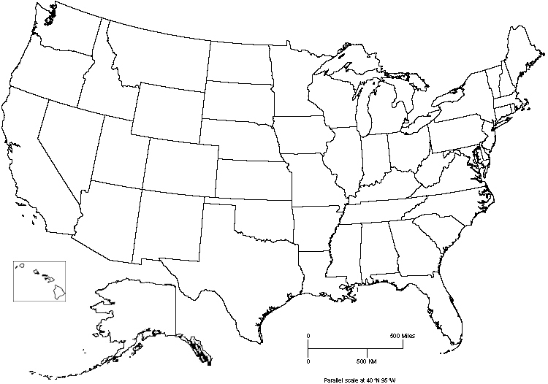
Midwest as Vernacular Culture Region. Or, what states do you consider part of the Midwest?
  - On the map overleaf, fill in your information. Then, write the letters MW in the states you consider part of the Midwest. You may bisect states but draw lines to show which parts of the states you include as part of the Midwest
  - Write down reasons for why you chose the states you did, as well as the reasons for bisecting any states.

