Comments for this paper:
The way I read this paper, it has the following elements: Thesis: I believe design should be relevant, organized, innovative and functional" Object: Beethoven poster Methodology: Unclear? There are a few issues with these. First, the thesis should be the whole point of the paper, not its one line conclusion. Remember, this was to be a POSITION paper that expresses your position, in terms of value. The beginning of your paper defines design but then does nothing with this definition. The idea in this class is to evaluate some part of the design process or practice and then to offer some argument that is followed by generalizations into the meaning of design. Your paper unfortunately lacks these elements. It has a thesis that is hidden in the last line and provides no arguments. Further, regarding meaning, you should remember what we said about Papanek. What we care about in our class is meaning, not purely formal descriptions in themselves. Your paragraph which claims to 'analyze' the poster says "Brockmann uses black shapes on white background to illustrate the piano keyboard which I find really smart and relevant which reflects the harmony in Beethoven’s music. The uses of black and white shapes, along with the careful placement of the arcs created a letter b which correspond to “Beethoven” even more. The angles and the precise placement of the arcs in this design are placed by doubling the diameter of each arc6. This makes the design clean and organized while at the same time keep the random look." But this is precisely what we DONT want to do in this class. We are interested in how this object has meaning, not in the formal description of it. Whether the design is 'clean' or not is irrelevant. If however you wish to talk about cleanliness and relevance as a necessary link between a representation design and its object, then you should provide an ARGUMENT explaining WHY this is necessary. This, i think is the best place for development in order to turn this into a research paper. Further, once you think about what your argument and thesis will be, then picking an appropriate methodology will be easier. Now that you will think about the research paper, I would suggest the following: Begin with your thesis, "I believe that design should be..." And ask WHY Once you have your reason why, you can then provide an argument, supported by object analyses which illustrate your point. You can for instance examine an object that has no such 'relevance' and show that it is an example of bad design, or another object like the poster here and further explain WHY it is an example of good design. What's so much better about the Beethoven poster than another poster whose formal elements don't match its content? Giving these elements some thought will make for a great research paper.

Design is a crucial process in a wide range of innovation. Design is also useful in adding value to product and services, stimulating the growth of sales through the creation of more attractive products that will, in turn, facilitate and boost sales of products. In an organization, design is needed in the transformation of new ideas into real and complete products. The whole process of designing goes beyond just creating a drawing and plan of the final product. It extends to offering new and crucial insights that move innovation to new levels. It involves extensive research in the market to find out what customers want, brainstorming to collect variety of ideas and pick the best and finally prototype to establish the viability of ideas. Therefore, in this context, the discussion below focuses on analyzing the Beethoven poster designed by Josef Muller-Brockmann.
What does Design entail
It is good to note that the full process of design includes several steps. The first step is the definition of the problem or the need that enables the designer to focus on the solution. Second, a background check is done to collect as much information as possible. The information may be in form of photographs, sketches, word description or any other way of capturing information. The third step entails sharing the ideas with the team and analyzes the ideas and coming up with the best of all. After picking the best idea, it is then used to find the solution. At this stage, several small-scale design solutions are developed. The next stage involves collecting feedback from multiple sources including friends, professionals or experts and other trusted parties. The feedback can then be used to make corrections that have emerged as inevitable.
Design should be viewed as a crucial tool not only for the development of new products and services from ideas but also for improving the already existing one. From a wider perspective, design is not even limited to an academic degree or profession. A designer is always present where there is a transformation of ideas into products or services even when there is no official position for a designer in the organization. The individual who dictates the appearance of the product does the role of the designer.
Beethoven poster Analysis
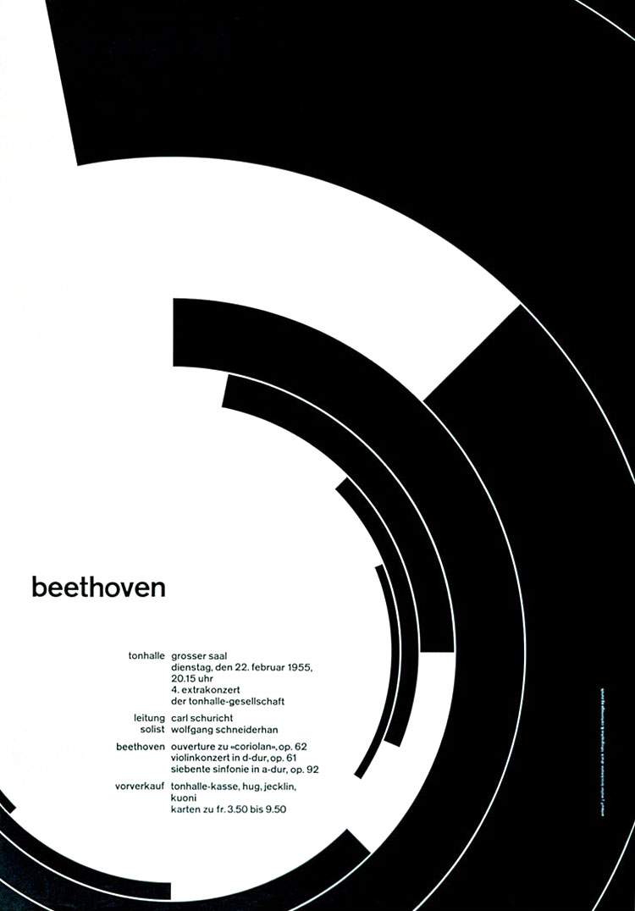

The Beethoven poster is designed by Swiss graphic designer Josef Müller-Brockmann. With a background of architecture design, Brockmann introduced the grid systems into Graphic Design. He’s work is best known for its simplicity and clean use of typography. He and his design style has become the characteristic of Swiss style design.
The Beethoven poster was designed in 1955 is one of his most famous designs that incorporates grids, typography and shapes. Beethoven is a famous pianist and composer, thus Brockmann uses black shapes on white background to illustrate the piano keyboard which I find really smart and relevant which reflects the harmony in Beethoven’s music. The uses of black and white shapes, along with the careful placement of the arcs created a letter b which correspond to “Beethoven” even more. The angles and the precise placement of the arcs in this design are placed by doubling the diameter of each arc. This makes the design clean and organized while at the same time keep the random look.
The typography follows a very strict grid too. There is a two-column grid that all the titles and subtitles are on the left and contents are on the right. This conveys the messages very straightforward. With the san-serif typeface, the poster has a modern feeling in contrast with the content which is about classical music.
Josef Müller-Brockmann once said “In my poster, advertising, brochure and exhibition creations, subjectivity is removed in favor of a geometric grid that determines the arrangement of words and images. The grid is an organizational system that makes the message easier to read, this allows you to get an effective result at a minimum cost.”
In my opinion, the grid system Broockmann introduced is the most basic and fundamental element in graphic design. Also, being relevant and finding inspiration through the content is one of the most effective way of design. He’s works inspired me in most of my designs. I believe that design should be relevant, organized, innovative and functional. Without these, it’s just called art.

Bibliography

Micheli, Pietro, Helen Perks, and Michael B. Beverland. "Elevating design in the organization." Journal of Product Innovation Management 35, no. 4 (2018): 629-651.

Thornton, Sarah M., Francis E. Lewis, Vivian Zhang, Mykel J. Kochenderfer, and J. Christian Gerdes. "Value sensitive design for autonomous vehicle motion planning." In 2018 IEEE Intelligent Vehicles Symposium (IV), pp. 1157-1162. IEEE, 2018.

Purecell, Kerry William,. “Josef Müller Brockmann.” Eye Magazine. http://www.designishistory.com/1940/joseph-mueller-brockmann/

Whitehead, Jennifer. “Beethoven poster by Josef Muller-Brockmann.” Oct 19, 2017. https://medium.com/fgd1-the-archive/beethoven-poster-by-josef-muller-brockmann-ce06940edf74

“Josef Müller-Brockmann ‘swiss style’”, grapheine. https://www.grapheine.com/en/history-of-graphic-design/graphic-designer-muller-brockmann-swiss-style

Thornton, Sarah M., Francis E. Lewis, Vivian Zhang, Mykel J. Kochenderfer, and J. Christian Gerdes. "Value sensitive design for autonomous vehicle motion planning." In 2018 IEEE Intelligent Vehicles Symposium (IV), pp. 1157-1162. IEEE, 2018.
Micheli, Pietro, Helen Perks, and Michael B. Beverland. "Elevating design in the organization." Journal of Product Innovation Management 35, no. 4 (2018): 629-651.
Ibid.
Kerry William Purecell. “Josef Müller Brockmann.” Eye Magazine.
Jennifer Whitehead. “Beethoven poster by Josef Muller-Brockmann.” Medium. Oct 19, 2017.
Ibid.
“Josef Müller-Brockmann ‘swiss style’.” Grapheine.

