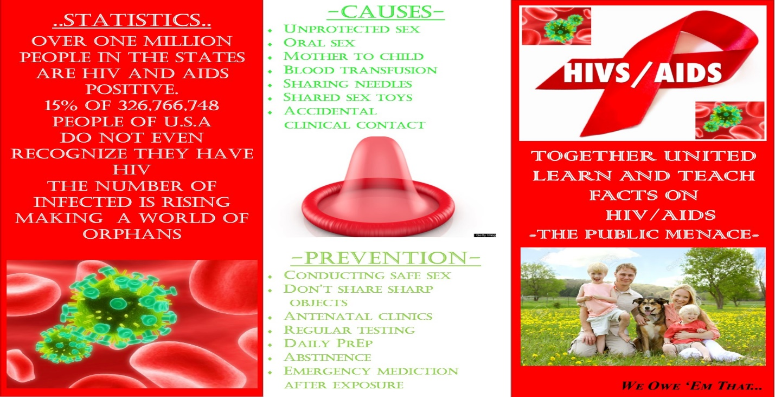
The concept of HIV and AIDS is still a subject ignored by many not only in the developing world but also in the developed world. Therefore, relaying the information is relevant especially for the teenage in the developed world who have the tendency to binge everything they come across. With the escalated HIV infections in the United States of America, there comes the need to make a reminder to all the binge everything teenagers out there.
The media on the anatomy of HIV and AIDS has been done via the means of a trifold brochure after the contemplation stage of change. To ensure a high degree of efficacy, the brochure should focus on the target audience which is set as college and high school students who worship the novel emerging trends in the methodology of going about in life.
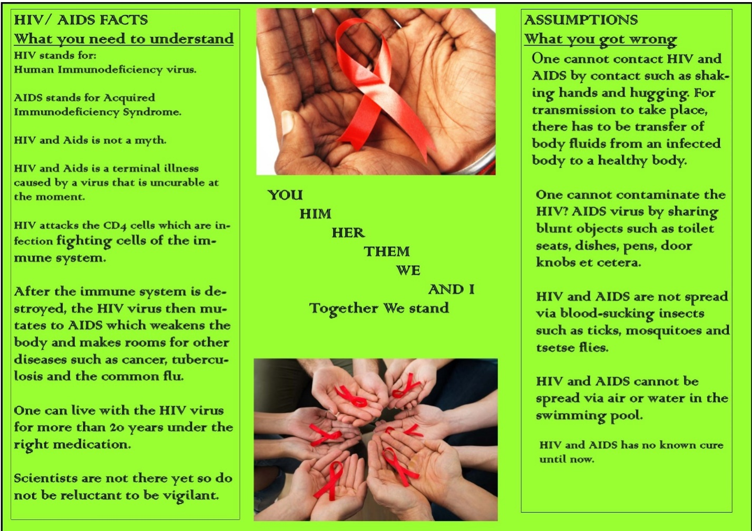
This brochure analyzes to a certain depth the anatomy of HIV and AIDS, causes, prevention, assumptions made, statistics and facts. The cover page has causes, statistics,and prevention. The dominant color on the cover page is red, the color of danger which acts as a cautioning symbolism in the paper. The red color also helps to set in the gravity of the aura that surrounds this social and biological issue of life.
The inner phase of the brochure with the facts, assumptions and the catchphrase has a green background. The green color is always used symbolically to denote life. Yes. Life after first adhering to the reality of HIV and AIDS in the community and the only way to counter it is by remaining vigilant and cautious of our own behaviors and actions to care for the ones, we love for…. We owe them that.

