Supply Chain Strategies

Airbus SE is getting its own lesson in the impact of supply chains on earnings.Buoyant demand boosted profit at the aircraft manufacturer in the third quarter, but the WSJ’s Robert Wall reports supplier delays led Airbus to cut its estimate for aircraft deliveries this year by roughly 20 planes. The backlogs at suppliers are putting a cap on the jet maker’s ability to capitalize on a global surge in air travel that has powered rising demand for new planes. Rival Boeing has also faced supply chain setbacks, particularly with its engines, but it told analysts last week that those issues had been mostly resolved. Both plane-makers have dealt with shortages of components including toilets parts, seats and engines. Boeing and Airbus are targeting around 800 plane deliveries each by the end of the year, but it looks like Airbus’s path to get there could be steeper.

Airbus’s Big Problem: It Can’t Make Jets Fast Enough for Airlines

Net income rose in the third quarter amid strong jet demand from global airlines
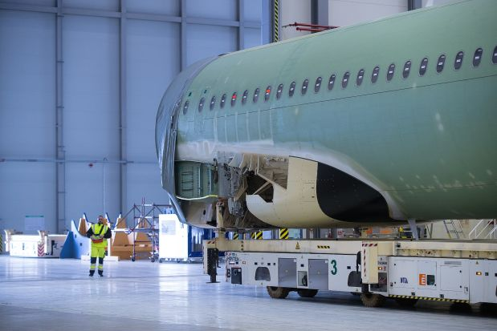
An assembled aircraft fuselage in transit at an Airbus factory in Hamburg, Germany. PHOTO: KRISZTIAN BOCSI/BLOOMBERG NEWS
By Robert Wall
Updated Oct. 31, 2018 6:19 a.m. ET
Airbus SE EADSY -0.05% said its deliveries and free cash flow this year would fall short of targets because of supplier problems, which have buffeted the European plane maker and U.S. rival Boeing Co. BA 2.31% as they race to build all the aircraft they have promised.
Still, Airbus’s profit rose in the third quarter, reflecting buoyant demand for new jets from airlines. Passenger numbers are soaring globally, boosted by a surge in budget carriers. Airlines are snapping up aircraft to meet that demand but also to modernize fleets to save fuel amid elevated oil prices.
Airbus on Wednesday reported adjusted earnings that exceeded analysts’ expectations, and its shares, which had retreated in recent weeks on concerns about its outlook, climbed 4.1% in Paris.
Net profit totaled €957 million ($1.09 billion), compared with €307 million in last year’s third quarter, and sales advanced 20% to €15.5 billion.
The company is on track to deliver about 20 fewer planes than originally planned, Chief Financial Officer Harald Wilhelm said. Airbus’s goal was 800 deliveries and it still aims to hit that number but only because the total now includes about 18 new A220 single-aisle aircraft after Airbus took a controlling stake in that airliner program midyear from Canada’s Bombardier Inc. Airbus produced 718 planes in 2017.
Airbus revised its outlook for free cash flow before mergers and acquisitions and customer financing to below last year’s level of €2.95 billion, from on par with 2017. Mr. Wilhelm said the new figure, which includes a €300 million cash headwind from the A220 program, should now come in closer to €2 billion.
Airbus left its full-year outlook for earnings before interest and taxes unchanged at €5 billion.
“Even though we delivered more aircraft than a year earlier, we still have a lot to do to meet our commitments,” Chief Executive Tom Enders said in the earnings statement, itself delayed for more than an hour by technical problems.
Cash DashAirbus again faces pressure to deliver large amounts of cash in the fourth quarter to meet full-year targetsSource: AirbusNote: cash flow before mergers and acquisitions
.billion2013’14’15’16’17’18-5-4-3-2-101234567€8
The delivery delays come as Airbus is boosting production for some of its most popular models. Surging demand for air travel has led to several years of bumper plane orders for Airbus and Boeing, but building those planes has been a struggle. Shortages of engines, seats and toilets parts are among the problems plane makers have had to confront.
Airbus delivered only 503 planes in the first nine months of this year. Delays have primarily been linked to the flow of engines from CFM International, a joint venture of General ElectricCo. and Safran SA, as well as United Technologies Corp. Both engine makers have pledged to meet 2018 delivery commitments.
Boeing also has suffered supplier problems that set back its plane deliveries, leaving some engine-less aircraft parked at its production facility. But Boeing Chief Executive Dennis Muilenburg last week said the issues had been largely resolved, and the company confirmed its goal of producing 810 to 815 jetliners, up from 763 jetliner deliveries last year.

NEWSLETTER SIGN-UP
In past years Airbus struggled to keep deliveries on track, but managed to boost output in the final weeks to hit financial goals. But this time around is different, and Airbus’s predicament worsened when British aircraft-engine makerRolls-Royce Holdings PLC last week said it would deliver 9% fewer engines this year. Rolls-Royce said it was struggling to build an engineused on the Airbus A330neo wide-body plane; as a result, Airbus said it would deliver about 10 fewer A330s this year.
For airlines, the delays have been a repeated source of frustration. Willie Walsh, chief executive of British Airways parent International Consolidated Airlines Group SA, last week blasted aircraft and engine makers for failing to meet their commitments. “These issues have gone on far too long already,” he said.
Scandinavian budget carrier Primera Air blamed late Airbus plane deliveries for disruptions to its business. The carrier went bust this month.
Mr. Walsh said IAG unit Aer Lingus is expecting a long-range version of the Airbus A321neo due next year to arrive late. Plane lessor AerCap Holdings PLC also expects plane deliveries to continue with some deliveries sliding into next year, its chief executive, Aengus Kelly, said Tuesday.
Mr. Wilhelm said Airbus had the engines and planes parts in hand to meet its updated production target. Getting them all assembled would still require hard work, he said.
Airbus is still in talks with some customers for its A380 superjumbos and A330 wide-bodies to take planes they had previously ordered. The aircraft are already built, and the inventory is weighing on cash.
The plane maker warned that talks with government customers to renegotiate the contract for its unprofitable A400M military transport plane were advancing but more slowly than planned. Airbus had hoped to agree new contractual terms this year.

