REFERANCE: Nahavandi, A. (2015). The Art of Leadership (7th ed.). Upper Saddle River, NJ: Upper Saddle River
After studying this chapter, you will be able to:
- Define leadership and leadership effectiveness.
- Discuss the major obstacles to effective leadership.
- Compare and contrast leadership and management.
- List the roles and functions of leaders and managers.
- Explain the changes in organizations and how they affect leaders.
- Summarize the debate over the role and impact of leadership in organizations.

The Leadership Question
Some leaders are focused on getting things done while others put taking care of their followers first. Some look at the big picture, and others hone in on the details. Is one approach better than the other? Which one do you prefer?
Who is a leader? When are leaders effective? These age-old questions appear simple, but their answers have kept philosophers, social scientists, scholars from many disciplines, and business practitioners busy for many years. We recognize bad leadership. Bad leaders are dishonest, self-centered, arrogant, disorganized, and uncommunicative. However, being honest, selfless, organized and communicative are necessary, but not sufficient to be a good leader. This chapter defines leadership and its many aspects, roles, and functions.

Effective Leadership
We recognize effective leaders when we work with them or observe them. However, leadership is a complex process, and there are many different definitions of leadership and leadership effectiveness.

Who Is a Leader?
Dictionaries define leading as “guiding and directing on a course” and as “serving as a channel.” A leader is someone with commanding authority or influence. Researchers have developed many working definitions of leadership. Although these definitions share several elements, they each consider different aspects of leadership. Some define leadership as an integral part of the group process (Green, 2002; Krech and Crutchfield, 1948). Others define it primarily as an influence process (Bass, 1960; Cartwright, 1965; Katz and Kahn, 1966). Still others see leadership as the initiation of structure (Homans, 1950) and the instrument of goal achievement. Several even consider leaders to be servants of their followers (Greenleaf, 1998). Despite the differences, the various definitions of leadership share four common elements:
- First, leadership is a group and social phenomenon; there can be no leaders without followers. Leadership is about others.
- Second, leadership necessarily involves interpersonal influence or persuasion. Leaders move others toward goals and actions.
- Third, leadership is goal directed and action oriented; leaders play an active role in groups and organizations. They use influence to guide others through a certain course of action or toward the achievement of certain goals.
- Fourth, the presence of leaders assumes some form of hierarchy within a group. In some cases, the hierarchy is formal and well defined, with the leader at the top; in other cases, it is informal and flexible.
Combining these four elements, we can define a leader as any person who influences individuals and groups within an organization, helps them establish goals, and guides them toward achievement of those goals, thereby allowing them to be effective. Being a leader is about getting things done for, through, and with others. Notice that the definition does not include a formal title and does not define leadership in terms of certain traits or personal characteristics. Neither is necessary to leadership.
This broad and general definition includes those who have formal leadership titles and many who do not. For Jonas Falk, CEO of OrganicLife, a start-up company that provide nutritious school lunches, leadership is taking “an average team of individuals and transform(ing) them into superstars” (Mielach, 2012). For consultant Kendra Coleman, leadership is about taking a stand (Mielach, 2012). Bill Gates, founder of Microsoft, considers empowerment to be an essential part of leadership (Kruse, 2013). For the CEO of the Container Store, “leadership and communication are the same thing. Communication is leadership” (Bryant, 2010). In all these examples, the leader moves followers to action and helps them achieve goals, but each focuses on a different element that constitutes leadership.

When Is a Leader Effective?
What does it mean to be an effective leader? As is the case with the definition of leadership, effectiveness can be defined in various ways. Some researchers, such as Fred Fiedler, whose Contingency Model is discussed in Chapter 3, define leadership effectiveness in terms of group performance. According to this view, leaders are effective when their group performs well. Other models—for example, Robert House’s Path-Goal Theory presented in Chapter 3 —consider follower satisfaction as a primary factor in determining leadership effectiveness; leaders are effective when their followers are satisfied. Still others, namely researchers working on the transformational and visionary leadership models described in Chapters 6 and 9, define effectiveness as the successful implementation of change in an organization.
The definitions of leadership effectiveness are as diverse as the definitions of organizational effectiveness. The choice of a certain definition depends mostly on the point of view of the person trying to determine effectiveness and on the constituents who are being considered. For cardiologist Stephen Oesterle, senior vice president for medicine and technology at Medtronic, one of the world’s biggest manufacturers of medical devices and pacemakers, restoring lives is both a personal and an organizational goal (Tuggle, 2007). Barbara Waugh, a 1960s civil rights and antidiscrimination activist and once personnel director and worldwide change manager of Hewlett-Packard Laboratories (often known as the “World’s Best Industrial Research Laboratory”—WBIRL), defines effectiveness as finding a story that is worth living: “You decide what you want your life to be about and go after it” (Marshall, 2009: 3). John Hickenlooper, Colorado governor and former mayor of Denver, focuses on an inclusive style, cooperation, aligning people’s self-interest, and getting buy-in from the people who are affected by his decisions (Goldsmith, 2008).

Effectiveness versus Success
Clearly, no one way best defines what it means to be an effective leader. Fred Luthans (1989) proposes an interesting twist on the concept of leadership effectiveness by distinguishing between effective and successful managers. According to Luthans, effective managers are those with satisfied and productive employees, whereas successful managers are those who are promoted quickly. After studying a group of managers, Luthans suggests that successful managers and effective managers engage in different types of activities. Whereas effective managers spend their time communicating with subordinates, managing conflict, and training, developing, and motivating employees, the primary focus of successful managers is not on employees. Instead, they concentrate on networking activities such as interacting with outsiders, socializing, and politicking.
The internal and external activities that effective and successful managers undertake are important to allowing leaders to achieve their goals. Luthans, however, finds that only 10 percent of the managers in his study are effective and successful. The results of his study present some grave implications for how we might measure our leaders’ effectiveness and reward them. To encourage and reward performance, organizations need to reward the leadership activities that will lead to effectiveness rather than those that lead to quick promotion. If an organization cannot achieve balance, it quickly might find itself with flashy but incompetent leaders who reached the top primarily through networking rather than through taking care of their employees and achieving goals. Barbara Waugh, mentioned earlier, considers the focus on what she calls the “vocal visionary” at the expense of the “quiet implementer” one of the reasons many organizations do not achieve their full potential (Marshall, 2009). Joe Torre, the famed Los Angeles Dodgers baseball coach, believes that solid, quiet, and steady managers who do not brag are the ones who get things done (Hollon, 2009).
Ideally, any definition of leadership effectiveness should consider all the different roles and functions that a leader performs. Few organizations, however, perform such a thorough analysis, and they often fall back on simplistic measures. For example, stockholders and financial analysts consider the CEO of a company to be effective if company stock prices keep increasing, regardless of how satisfied the company’s employees are. Politicians are effective if the polls indicate their popularity is high and if they are reelected. A football coach is effective when his team is winning. Students’ scores on standardized tests determine a school principal’s effectiveness. In all cases, the factors that make the leader effective are highly complex and multifaceted.
Consider the challenge faced by the executives of the New York Times, one of the world’s most respected newspapers. In 2002, the paper won a record seven Pulitzer prizes, a clear measure of success. A year later, however, the same executive editor team that had led the company in that success was forced to step down because of plagiarism scandals (Bennis, 2003). The executive team’s hierarchical structure, autocratic leadership style, and an organizational culture that focused on winning and hustling were partly blamed for the scandals (McGregor, 2005). By one measure, the Times was highly effective; by another, it failed a basic tenet of the journalistic profession. Politics further provide examples of the complexity of defining leadership effectiveness. Consider former U.S. president Clinton, who, despite being impeached in the U.S. Senate, maintained his popularity at the polls in 1998 and 1999; many voters continued to consider him effective. Hugo Chavez, the late president of Venezuela, was adored by his supporters for his advocacy for the poor and despised by his opponents for his dictatorial style. Whether any of these leaders is considered effective or not depends on one’s perspective. General Motors’ recent troubles further illustrate the need for a broad definition of effectiveness.

An Integrative Definition
The common thread in all these examples of effectiveness is the focus on outcome. To judge their effectiveness, we look at the results of what leaders accomplish. Process issues, such as employee satisfaction, are important but are rarely the primary indicator of effectiveness. Nancy McKintry, CEO of Wolters Kluwer, an information services company, states, “At the end of the day, no matter how much somebody respects your intellect or your capabilities or how much they like you, in the end it is all about results in the business context” (Bryant, 2009a). The executive editorial team at the New York Times delivered the awards despite creating a difficult and sometimes hostile culture. Voters in the United States liked President Clinton because the economy flourished under his administration. Hugo Chavez survived many challenges because he pointed to specific accomplishments.
One way to take a broad view of effectiveness is to consider leaders effective when their group is successful in maintaining internal stability and external adaptability while achieving goals. Overall, leaders are effective when their followers achieve their goals, can function well together, and can adapt to changing demands from external forces. The definition of leadership effectiveness, therefore, contains three elements:
- Goal achievement, which includes meeting financial goals, producing quality products or services, addressing the needs of customers, and so forth
- Smooth internal processes, including group cohesion, follower satisfaction, and efficient operations
- External adaptability, which refers to a group’s ability to change and evolve successfully

The Leadership Question—Revisited
So focusing on the task, on people, on the big picture, on the details, and so forth can all be part of leadership. What works depends on the leader, the followers, and the situation. While some things generally don’t work, for example using fear and threats in all situations, there are many different styles and approaches to leading that can be effective. Understanding the situation is key.

Why Do We Need Leaders?
Leadership is a universal phenomenon across cultures. Why is leadership necessary? What needs does it fulfill? Do we really need leaders? In the business world, new leaders can influence a firm’s credit rating by affecting the confidence of the financial community. For example, while Xerox weathered considerable financial and leadership problems in 2000 and 2001, the selection of Anne Mulcahy, a company veteran, as CEO helped ease stakeholders’ concerns. In other sectors, a city or nation might feel a sense of revival and optimism or considerable concern when a new leader comes to power, as was the case in the 2008 U.S. presidential elections with the win of Barack Obama. We believe that leadership matters. The reasons why we need leaders closely fall in line with the functions and roles that leaders play and are related to the need or desire to be in collectives. Overall, we need leaders for following reasons:
- To keep groups orderly and focused. Human beings have formed groups and societies for close to 50,000 years. Whether the formation of groups itself is an instinct or whether it is based on the need to accomplish complex tasks too difficult for individuals to undertake, the existence of groups requires some form of organization and hierarchy. Whereas individual group members may have common goals, they also have individual needs and aspirations. Leaders are needed to pull the individuals together, organize, and coordinate their efforts.
- To accomplish tasks. Groups allow us to accomplish tasks that individuals alone could not undertake or complete. Leaders are needed to facilitate that accomplishment, and to provide goals and directions and coordinate activities.
- To make sense of the world. Groups and their leaders provide individuals with a perceptual check. Leaders help us make sense of the world, establish social reality, and assign meaning to events and situations that may be ambiguous.
- To be romantic ideals. Finally, as some researchers have suggested (e.g., Meindl and Ehrlick, 1987), leadership is needed to fulfill our desire for mythical or romantic figures who represent us and symbolize our own and our culture’s ideals and accomplishments.

Research on Significance of Leadership
Despite the common belief that leaders matter, considerable debate among leadership scholars addresses whether leadership actually affects organizations. Some researchers suggest that environmental, social, industrial, and economic conditions determine organizational direction and performance to a much higher degree than does leadership (Brown, 1982; Cyert and March, 1963; Hannan and Freeman, 1977; Salancik and Pfeffer, 1977a). External factors, along with organizational elements such as structure and strategy, are assumed to limit the leader’s decision-making options, reducing the leader’s discretion. For example, Salancik and Pfeffer (1977a), in a study of the performance of mayors, found that leadership accounted for only 7 to 15 percent of changes in city budgets. Similarly, Lieberson and O’Connor (1972) found that whereas leadership has minimal effects on the performance of large corporations (accounting for only 7 to 14 percent of the performance), company size and economic factors show considerable links to firm performance. Additionally research about managerial discretion indicates that managers have less influence on organizations than environmental and internal organizational factors (Finkelstein and Hambrick, 1996; Hambrick and Finkelstein, 1987).
Other research findings suggest that leadership does indeed have an impact. For example, in reevaluating Lieberson and O’Connor’s 1972 study, Weiner and Mahoney (1981) find that a change in leadership accounts for 44 percent of the profitability of the firms studied. Other researchers (Day and Lord, 1988; Thomas, 1988) indicate that the early results were not as strong as originally believed, and recent studies suggest that leadership can have an impact by looking at the disruption that can come from changes in leadership (Ballinger and Schoorman, 2007) and find a strong effect of CEOs on company performance (Mackey, 2008). Additionally, research continues to indicate that leadership has a positive impact on a variety of organizational effectiveness factors including climate and work group performance (McMurray et al., 2012) in both business and public organizations (e.g., Vashdi, Vigoda-Gadot, and Shlomi, 2013).

Leading Change The Container Store
“You can build a much more wonderful company on love than you can on fear,” says Kip Tindell, the CEO of the highly successful Container Store chain (Klein, 2013). He has put that principle to work in all aspects of his business. Chances are that if you have engaged in a home or office organization project, you have heard of the Container Store. The privately held company offers creative, practical, and innovative solutions to a multitude of storage problems and has established an enviable track record of success and growth of 26 percent growth per year (Container Store’s secret growth story, 2013). The company has been consistently ranked as one of the best places to work in, and it considers its employees its greatest asset. Its unique culture and treating its employees well are other areas in which it claims leadership (Container Store Web site, 2013). One of the principles that the company espouses is that “one great person equals three good people” (Bliss, 2011).
Kip Tindell says, “We talk about getting the customer to dance . . . every time she goes into the closet . . . because the product has been designed and sold to her so carefully” (Birchall, 2006). Achieving this level of service takes a dedicated and, the company believes, happy employees that the company carefully recruits (often mostly through its existing employees) and trains. Whereas in comparable companies, the average salesperson gets about eight hours of training during the first year on the job, it is not unusual for Container Store salespeople to get over 200 hours of training before a new store opens (Birchall, 2006). In addition to a family-friendly work environment, the company covers close to 70 percent of its employees’ health-care insurance costs, pays 50 to 100 percent higher wages than its competitors’ pay, and provides flexible shifts to accommodate its employees’ work–life balance.
The investment in employees has paid off. The Container Store has an annual turnover of about 10 percent, compared with 90 percent for most retail stores. Its founders, Kip Tindell and Garrett Boone, believe that the unique culture and the success of the company are inseparable.
Sources: Birchall, J. 2006. “Training improves shelf life,” Financial Times, March 8. http://search.ft.com/ftArticle?queryText=Kip+Tindell&y=0&aje=true&x=0&id=060307009431 (accessed July 8, 2007); Bliss, J. 2011. “Container store—Flames of trust,” SatMetrix. http://www.netpromoter.com/netpromoter_community/blogs/jeanne_bliss/2011/10/24/the-container-store-flames-of-trust (accessed May 30, 2013); Container Store’s secret growth story, 2013. http://www.youtube.com/watch?v=uDmfbrcGxSk (accessed May 30, 2013); Container store website, 2013. http://standfor.containerstore.com/putting-our-employees-first/ (accessed October 6, 2013); Containing Culture, 2007. Chain Store Age (April): 23–24; Klein, J. 2013. “Put people first,” Under 30 CEOs. http://under30ceo.com/put-people-first-reflections-from-kip-tindell-ceo-the-container-store/ (accessed May 30, 2013).
In trying to reconcile the different arguments regarding the need for and impact of leadership, it is important to recognize that leadership is one of many factors that influence the performance of a group or an organization (see Table 1-1 for a summary). Additionally, the leader’s contribution, although not always tangible, is significant in providing a vision and direction for followers and in integrating their activities. The key is to identify situations in which the leader’s power and discretion over the group and the organization are limited. These situations are discussed as part of the concept of leadership substitutes in Chapter 3 and in presentations of the role of upper-echelon leaders in Chapter 7. Finally, the potential lack of impact of leaders in some situations further emphasizes the importance of followers in the success of leadership and the need to understand organizations as broad systems.

Table 1-1 Significance of Leadership
- Leadership is one of many factors that affect the performance of organizations.
- Leadership can indirectly impact other performance factors.
- Leadership is essential in providing vision and direction.
- Identifying the situations in which leadership matters is essential.
- The combination of leaders with followers and other organizational factors makes an impact.

Obstacles to Effective Leadership
In any setting, being an effective leader is a challenging task. Even with a clear definition of leadership and what makes a leader effective, being effective is not easy. Meanwhile, organizations pay a heavy price for ineffective, incompetent, or unethical leadership (Bedeian and Armenakis, 1998; Kellerman, 2004). The keys to becoming an effective leader are knowledge, experience, practice, and learning from one’s mistakes. Unfortunately, many organizations do not provide an environment in which leaders can practice new skills, try out new behaviors, and observe their impact. In most cases, the price for making mistakes is so high that new leaders and managers opt for routine actions.
Without such practice and without failure, it is difficult for leaders to learn how to be effective. The experience of failure, in some cases, may be a defining moment in the development of a leader (George, 2009). The question is, therefore, what are the obstacles to becoming an effective leader? Aside from different levels of skills and aptitudes that might prevent a leader from being effective, several other obstacles to effective leadership exist:
- First, organizations face considerable uncertainty that creates pressure for quick responses and solutions. External forces, such as voters and investors, demand immediate attention. In an atmosphere of crisis, there is no time or patience for learning. Ironically, implementing new methods of leadership, if they are allowed, would make dealing with complexity and uncertainty easier in the long run. Therefore, a vicious cycle that allows no time for the learning that would help current crises continues. The lack of learning and experimentation in turn causes the continuation of the crises, which makes the time needed to learn and practice innovative behaviors unavailable.
- Second, organizations are often rigid and unforgiving. In their push for short-term and immediate performance, they do not allow any room for mistakes and experimentation. A few organizations, such as Virgin Group Ltd., 3M, and Apple Computers that encourage taking risks and making mistakes, are the exception. The rigidity and rewards systems of many institutions discourage such endeavors.
- Third, organizations fall back on old ideas about what effective leadership is and, therefore, rely on simplistic solutions that do not fit new and complex problems. The use of simple ideas, such as those proposed in many popular books, provides only temporary solutions.
- Fourth, over time, all organizations develop a particular culture that strongly influences how things are done and what is considered acceptable behavior. As leaders try to implement new ideas and experiment with new methods, they may face resistance generated by the established culture.
- Finally, another factor that can pose an obstacle to effective leadership is the difficulty involved in understanding and applying the findings of academic research. In the laudable search for precision and scientific rigor, academic researchers sometimes do not clarify the application of their research, making the research inaccessible to practitioners.
The complex and never-ending learning process of becoming an effective leader requires experimentation and organizational support. The inaccessibility of academic research to many practitioners and the short-term orientation of the organizations in which most managers operate provide challenging obstacles to effective leadership. Except for the few individuals who are talented and learn quickly and easily or those rare leaders who have the luxury of time, these obstacles are not easily surmounted. Organizations that allow their leaders at all levels to make mistakes, learn, and develop new skills are training effective leaders.

Leadership and Management
What is the difference between a leader and a manager? Are the two basically the same, or are there sharp distinctions between them? These questions have been at the forefront of the discussion of leadership for many years. Kevin Kruse, bestselling author and entrepreneur, believes that organizations need good management to plan, measure, hire, fire, coordinate activities, and so forth. However, he states that leadership is about people (Kruse, 2013). Table 1-2 presents the major distinctions between managers and leaders. Whereas leaders have long-term and future-oriented perspectives and provide a vision for their followers to look beyond their immediate surroundings, managers take short-term perspectives and focus on routine issues within their own immediate departments or groups. Zaleznik (1990) further suggests that leaders, but not managers, are charismatic and can create a sense of excitement and purpose in their followers. Kotter (1990; 1996) takes a historical perspective in the debate and proposes that leadership is an age-old concept, but the concept of management developed in the past 100 years as a result of the complex organizations created after the Industrial Revolution. A manager’s role is to bring order and consistency through planning, budgeting, and controlling. Leadership, on the other hand, is aimed at producing movement and change.

Table 1-2 Managers and Leaders
Managers | Leaders
Focus on the present | Focus on the future
Maintain status quo and stability | Create change
Implement policies and procedures | Initiate goals and strategies
Maintain existing structure | Create a culture based on shared values
Remain aloof to maintain objectivity | Establish an emotional link with followers
Use position power | Use personal power
The debates suggest that for those who draw a distinction between leaders and managers, leaders demonstrate attributes that allow them to energize their followers, whereas managers simply take care of the mundane and routine details. Both are necessary for organizations to function, and one cannot replace the other. By considering the issue of effectiveness, many of the arguments regarding the differences between leadership and management can be clarified. For example are managers who motivate their followers and whose departments achieve all their goals simply effective managers, or are they leaders as well? Being an effective manager often involves performing many of the functions that are attributed to leaders with or without some degree of charisma. The distinctions drawn between leadership and management may be more related to effectiveness than to the difference between the two concepts. An effective manager of people provides a mission and sense of purpose with future-oriented goals, initiates goals and actions, and builds a sense of shared values that allows followers to be focused and motivated, all actions that are attributed to leaders. Therefore, effective managers can often be considered leaders. Management professor Henry Mintzberg further suggests that good leaders must manage their team and organizations as well. By focusing too much on leadership, at the expense of management, much of the hard work needed to make organizations effective may be left unattended. He states: “Being an engaged leader means you must be reflective while staying in the fray-the hectic, fragmented, never-ending world of managing” (Mintzberg, 2009).
Thus, any manager who guides a group toward goal accomplishment can be considered a leader, and any good leader must perform many management functions. Much of the distinction between management and leadership comes from the fact that the title leader assumes competence. Consequently, an effective and successful manager can be considered a leader, but a less-competent manager is not a leader. Overall, the debate over the difference between the two concepts does not add much to our understanding of what constitutes good leadership or good management and how to achieve these goals. It does, however, point to the need felt by many people and organizations for effective, competent, and visionary leadership/management. This book does not dwell on the distinction between the two concepts and uses the terms interchangeably.

Roles and Functions of Leaders
Although leaders in different organizations and different cultures perform dissimilar functions and play unique roles, researchers have identified a number of managerial roles and functions that cut across most settings.

Managerial Roles
To be effective, leaders perform a number of roles. The roles are sets of expected behaviors ascribed to them by virtue of their leadership position. Along with the basic managerial functions of planning, organizing, staffing, directing, and controlling, leaders are ascribed a number of strategic and external roles, as well, which are discussed in detail in Chapter 7. Furthermore, one of the major functions of leaders is to provide their group or organization with a sense of vision and mission. For example, department managers need to plan and organize their department’s activities and assign various people to perform tasks. They also monitor their employees’ performance and correct employees’ actions when needed. Aside from these internal functions, managers negotiate with their boss and other department managers for resources and coordinate decisions and activities with them. Additionally, many department managers must participate in strategic planning and the development of their organization’s mission beyond the immediate focus on their own department or team.
One of the most cited taxonomies of managerial activities is proposed by Henry Mintzberg (1973), who added the 10 executive roles of figurehead, leader, liaison, monitor, disseminator, spokesperson, entrepreneur, disturbance handler, resource allocator, and negotiator to an already long list of what leaders do. Mintzberg’s research further suggests that few, if any, managers perform these roles in an organized, compartmentalized, and coherent fashion. Instead, a typical manager’s days are characterized by a wide variety of tasks, frequent interruptions, and little time to think or to connect with their subordinates. Mintzberg’s findings are an integral part of many definitions of leadership and management. The roles he defines are typically considered the major roles and functions of leaders.
Interestingly, research suggests that male and female managers may perform their roles differently. In her book, The Female Advantage: Women’s Way of Leadership, Sally Helgesen (1995) questions many myths about the universality of management behaviors. Through case studies of five female executives, Helgesen faithfully replicated the methodology used 20 years earlier by Mintzberg in his study of seven male managers. Mintzberg had found that his managers often worked at an unrelenting pace, with many interruptions and few nonwork-related activities. The men felt that their identity was tied directly to their job and often reported feeling isolated, with no time to reflect, plan, and share information with others. They also reported having a complex network of colleagues outside work and preferring face-to-face interaction to all other means of communication.
Helgesen’s findings of female managers matched Mintzberg’s only in the last two categories. Her female managers also were part of a complex network and preferred face-to-face communication. The other findings, however, were surprisingly different. The women reported working at a calm, steady pace with frequent breaks. They did not consider unscheduled events to be interruptions; they instead viewed them as a normal part of their work. All of them reported working at a number of nonwork-related activities. They each cultivated multifaceted identities and, therefore, did not feel isolated. They found themselves with time to read and reflect on the big picture. Additionally, the female executives scheduled time to share information with their colleagues and subordinates.
The gender differences found between the two studies can be attributed partly to the 20-year time difference. However, Helgesen’s suggestions about a different female leadership style, which she calls “the web,” are supported by a number of other research and anecdotal studies. Helgesen’s web is compared to a circle with the manager in the center and interconnected to all other parts of the department or organization. This view differs sharply from the traditional pyramid structure common in many organizations. Chapter 2 further explores the gender differences in leadership.

Functions of the Leader: Creation and Maintenance of an Organizational Culture
One of the major functions of leaders is the creation and development of a culture and climate for their group or organization (Nahavandi and Malekzadeh, 1993a; Schein, 2010). Leaders, particularly founders, leave an almost-indelible mark on the assumptions that are passed down from one generation to the next. In fact, organizations often come to mirror their founders’ personalities. Consider, for example, how Starbucks, the worldwide provider of gourmet coffee, reflects the dreams and fears of its founder, Howard Schultz (see Leading Change case in Chapter 10). The company is known for its generous benefit package and its focus on taking care of its employees. Schultz often repeats the story of his father losing his job after breaking his leg and the devastating and long-lasting effect this event had on him and his family (George, 2007). As is the case in many other organizations, the founder’s style, or in the case of Starbucks, the founder’s family history, has an impact on the culture of an organization.
If the founder is workaholic and control oriented, the organization is likely to push for fast-paced decision making and be centralized. If the founder is participative and team oriented, the organization will be decentralized and open. Norm Brodsky, a veteran entrepreneur who created several businesses, realized how much his hard-driving personality affected the culture of his company. He also realized that his wife and partner’s more caring style was having a positive impact on employees, so he worked on softening his own style and supporting her initiatives (Brodsky, 2006). The leader’s passion often translates into the mission or one of the primary goals of the organization, as is the case of Howard Schultz for Starbucks. Similarly, David Neeleman’s passion for customers and high-quality service (see Section “Leadership in Action” at the end of this chapter) has shaped the management of all the companies Neeleman has founded. The leaders set the vision and direction and make most, if not all, of the decisions regarding the various factors that will shape the culture (Figure 1-1).
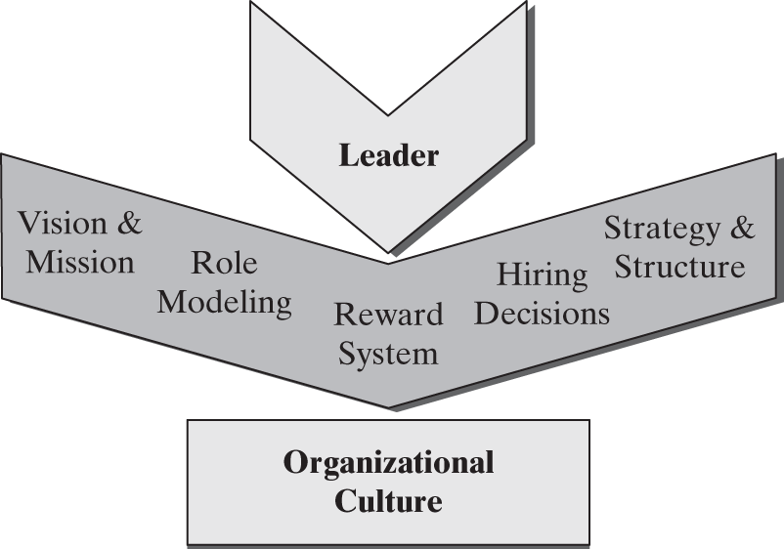

Figure 1-1 Leader’s Functions in Shaping Organizational Culture
Leaders are role models for other organizational members. They establish and grant the status symbols that are the main artifacts of organizational culture. Followers take their cues from the leaders on what behaviors are and are not acceptable. For example, Stephen Oesterle, senior vice president at Medtronics leads by example in two ways. As the leader in charge of medicine, one of his key roles is to look for new technology that can advance the company’s mission. He is considered an international technology scout who scours the globe in search of technological innovation to assure his company’s future success (Walsh, 2012). As a marathon runner, he promotes a healthy lifestyle and its role in restoring lives, which is the mission of his company (Tuggle, 2007). Another example is Tyler Winkler, the senior vice president of sales and business development for Secure Works, who is obsessed with improving sales numbers. One of his first statements to his employees was, “Make your numbers in three months or you’re out” (Cummings, 2004). He measures everything, observes employees closely, and provides detailed feedback and training, all to improve sales. His methods became the norm in the organization and created a legion of loyal employees.
Research about the importance of empathy in leadership suggests another function for leaders, related to cultural factors. Researchers argue that a key function of leaders is to manage the emotions of group members (Humphrey, 2002). Even though attention to internal process issues, such as the emotional state of followers, has always been considered a factor in leadership, it is increasingly seen not as a peripheral task, but rather as one of the main functions. This function is particularly critical to maintaining followers’ positive outlook in uncertain and ambiguous situations. Followers observe their leaders’ emotional reactions and take their cue from them to determine appropriate reactions (Pescosolido, 2002). An unlikely example of the emotion management role of leaders is Bob Ladouceur, the legendary La Salle, California, high school football coach and the man behind a great dynasty of 20 undefeated seasons and 399 wins (Sankin, 2013). Ladouceur, who retired as head coach after 34 years in 2013, focuses on shaping the lives of his students, rather than simply winning. His players are not generally considered to be the most talented or the strongest. Ladouceur, however, gets extraordinary performance from them through hard training and character building. He states, “If a team has no soul, you’re just wasting your time” (Wallace, 2003: 100–104). He wants his players to get in touch with their emotions and develop “love” for their teammates. For Ladouceur, managing these emotions is the key to his teams’ winning streaks. He considers his relationships with his followers and coworkers, rather than his winning record, to be the highlight of his career (Hammon, 2013).
Other means through which the leader shapes culture are by decisions regarding the reward system (Kerr and Slocum, 1987) and by controlling decision standards. In one organization, rewards (financial and nonfinancial) go to only the highest contributors to the bottom line. In another, accomplishments such as contribution to cultural diversity or the degree of social responsibility are also valued and rewarded. Additionally, leaders are in charge of selecting other leaders and managers for the organization. Those selected are likely to fit the existing leader’s ideal model and, therefore, fit the culture. Other influential members of the organization provide leaders with yet another opportunity to shape the culture. Many firms, for example, establish a nominating committee of the board of directors. In such committees, top managers nominate and select their successors. Therefore, they not only control the current culture but also exert a strong influence on the future of their organization. To select his successor before he left in 2001, General Electric’s (GE) Jack Welch carefully observed, interacted with, and interviewed many of the company’s executives. He sought feedback from top company leaders, and after selecting Jeff Immelt, Welch orchestrated the transition of power. This carefully orchestrated succession ensured that the new leader, although bringing about some new ideas, fit the existing culture of the organization (Useem, 2001). A similar careful process took place at Procter & Gamble in 2009 and again in 2013 (see Section “Leadership in Action” case in Chapter 7).
The power of the leader to make decisions for the organization about its structure and strategy is another effective means of shaping culture. By determining the hierarchy, span of control, reporting relationship, and degree of formalization and specialization, the leader molds culture. A highly decentralized and organic structure is likely to be the result of an open and participative culture, whereas a highly centralized structure will go hand in hand with a mechanistic/bureaucratic culture. The structure of an organization limits or encourages interaction and by doing so affects, as well as is affected by, the assumptions shared by members of the organization. Similarly, the strategy selected by the leader or the top management team will be determined by, as well as help shape, the culture of the organization. Therefore, a leader who adopts a proactive growth strategy that requires innovation and risk taking will have to create a culture different from a leader who selects a strategy of retrenchment.

Applying What You Learn
Leadership Basics
Leadership is a complex process that is a journey rather than a destination. All effective leaders continue to grow and improve, learning from each situation they face and from their mistakes. Here are some basic points that we will revisit throughout the book:
- Find your passion: We can be at our best when we lead others into something for which we have passion.
- Learn about yourself: Self-awareness of your values, strengths, and weaknesses is an essential starting point for leaders.
- Experiment with new behaviors and situations: Learning and growth occur when we are exposed to new situations that challenge us; seek them out.
- Get comfortable with failure: All leaders fail; good leaders learn from their mistakes and consider them learning opportunities. Mistakes are more likely to happen when you are placed in new challenging situations that provide you with opportunities to learn.
- Pay attention to your environment: Understanding all the elements of a leadership situation, and particularly followers, is essential to effectiveness. Ask questions, listen carefully, and observe intently so that you can understand the people and the situations around you.
- Remember that it’s about others: Leadership is not about you and your personal agenda. It’s about getting things done for, through and with others.
- Don’t take yourself too seriously: A good sense of humor and keeping a perspective on priorities will help you. You are not as good as your most fervent supporters believe and not as flawed as your reticent detractors think, so lighten up!

Changes in Organizations and in Expectations of Leaders
To some, a leader is someone who takes charge and jumps in to make decisions whenever the situation requires. This view is particularly dominant in traditional organizations with a clear hierarchy in which employees and managers carry out narrowly defined responsibilities. To others, a leader is a facilitator who simply channels the group’s desires. The extent to which a leader is attributed power and knowledge varies by culture and will be discussed in Chapter 2. Even though the U.S. mainstream culture is not as authority oriented as some other cultures, a large number of our leadership theories are implicitly or explicitly based on the assumptions that leaders have to take charge and provide others with instructions. For example, the initiation-of-structure concept provides that effective leadership involves giving direction, assigning tasks to followers, and setting deadlines. These activities are considered an inherent part of an effective leader’s behaviors. Similarly, the widely used concept of motivation to manage (Miner and Smith, 1982) includes desire for power and control over others as an essential component.

What Do You Do?
You have started on a new job, and based on the interview and discussion with people prior to accepting the job you were led to believe that the company strongly believes in employee participation, engagement, and flexibility. A couple of months of working with your new boss, however, all you see is command and control, with little opportunity for you to provide any input. What do you do?

New Roles for Leaders
With the constant need for innovation, intense global competition, economic pressures, and changing demographics, organizations are changing drastically. As a result, many of the traditional leadership functions and roles are changing as well. Figure 1-2 presents the traditional control-oriented model and the new result-oriented model for leaders in organizations. The changing environment for organizations has forced us to reconsider our expectations and requirements for leadership. Effective leaders of diverse and global teams are not necessarily in control of the group. They might need facilitation and participation skills much more than initiation-of-structure skills. For example, employees in traditional organizations are responsible only for production; the planning, leading, and controlling functions, as well as the responsibility for results, fall on the manager (see Figure 1-2). An increasing number of organizations, however, are shifting the activities and responsibilities typically associated with managers to employees. Managers are expected to provide the vision, get the needed resources to employees, act as support persons, and get out of employees’ way. The employees, in turn, learn about the strategic and financial issues related to their job, plan their own activities, set production goals, and take responsibility for their results.
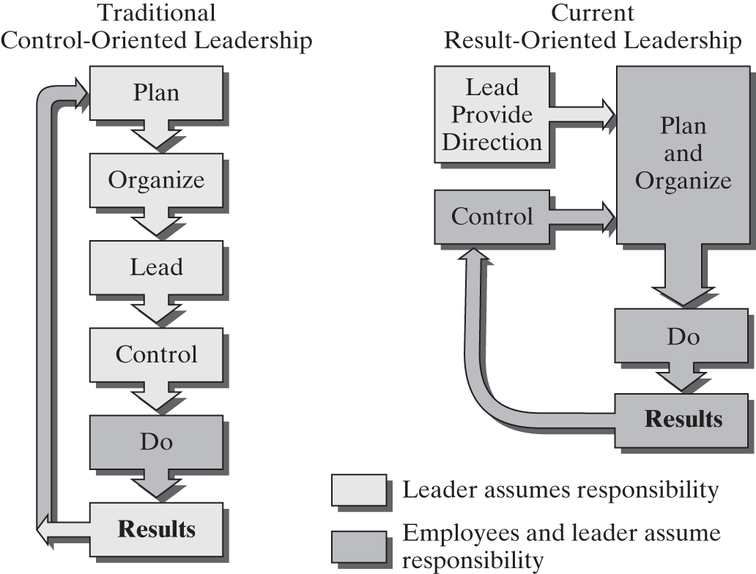

Figure 1-2 Control Versus Results-Oriented Leadership
Many executives have adopted new management techniques to help them with the challenges inherent in the new roles for leaders. A recent article in Entrepreneur featured several business leaders and their ideas about how leadership is changing. When thinking about what defines leadership, Ted Devine, CEO of a specialized online business insurance company, states: “No walls, no barriers, no hierarchy. Everybody can talk to everybody. Everybody can participate in a decision. We work together” (5 influential CEOs, 2013). Similarly, Scott Abel, CEO of Spice Works, a network management company, believes that the role of leader is to capture the energy of his employees. The idea of cooperation and ownership of the organization are also something that Sheila Johnson, cofounder of BET network embraces. Curtis Symond, who works at BET, says: “Above all else, Sheila leads by example through her passion. It’s difficult to work with her, be around all of her excitement and energy, and not want to join in and get involved” (5 influential CEOs, 2013).
Harnessing employees’ ideas and engaging them in the goals of the organization is increasingly a key role for leaders. When Rick Sapio was the CEO of the 37-employee New York City Mutual.com, a mutual fund advisory company, he knew that his business was high pressure with little time to stay in touch with his employees (Buchanan, 2001). Recognizing the importance of involving employees, however, Sapio created “Hassles,” an electronic mailbox through which employees could express their concerns and ideas with a guarantee from the CEO that they will be addressed within a week. For those who preferred to see the boss in person, Sapio scheduled one hour each week in a conference room (rather than his office, which seemed inaccessible) where anyone could drop in to give him input. Jeffrey Immelt, CEO of General Electric, has made learning and getting to hear everybody’s ideas one of his priorities. His predecessor, Jack Welch, notes that a great leader needs to “get under the skin of every person who works for the company” (Hammonds, 2004: 32). Leaders at large companies such as Procter & Gamble, Whole Foods, and Toyota, as well as small start-ups such as Evernote, practice being egalitarian and cooperative. Their priorities are fast decision making, training, and innovation.
The new leadership styles are not limited to business organizations; they can also be seen in government and other not-for-profit organizations. Harry Baxter, chairman and CEO of Baxter Healthcare in Deerfield, Illinois, likes to focus on doing the right thing instead of being right. He suggests, “I have very few definitive answers, but I have a lot of opinions” (Kraemer, 2003: 16). Philip Diehl, former director of the U.S. Mint, and his leadership team transformed the stodgy government bureaucracy into an efficient and customer-centered organization by asking questions, listening to stakeholders, creating a sense of urgency in employees, and involving them in the change (Muio, 1999). These changes also occur in local, state, and federal government agencies. For example, Ron Sims, who was recognized in 2006 as one of the most innovative public officials, is known for always looking for common ground while operating from a clear set of principles (Walters, 2006). Ron Sims is also known for leading by example. When he talked about county employees adopting a healthier lifestyle, he started eating better and biking and lost 40 pounds (Walters, 2006).
These leaders leave their top-floor offices to keep in touch with the members of their organizations. Given the rapid pace of change and complexity of the environment in which many organizations operate, cultivating extensive sources of information and involving many people in the decision-making process are essential.

Factors Fueling Changes
A number of external and internal organizational factors are driving the changes in our organizations and in the role of leaders and managers (Figure 1-3). First, political changes worldwide are leading to more openness and democracy. These political changes shape and are shaped by images of what is considered to be appropriate leadership. With the fall of the Soviet Union at the end of the twentieth century, the world has seen a spread in democratic principles aimed at power sharing. Uprising in North Africa and the Middle East and the Arab Spring movement demonstrated the desire of many for more openness and democracy. In the United States, the public continues to expect transparency in both the private and the public sectors. Politicians are forced to share details of their past and their personal life and justify to the public many, if not all, of their decisions. Communities increasingly demand participation in the decisions regarding their schools, health-care systems, and environment.
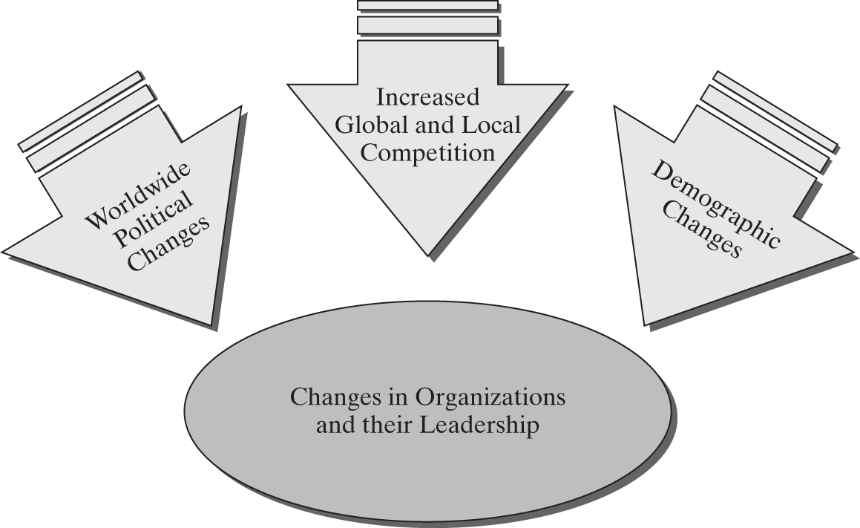

Figure 1-3 Factors Fueling Changes in Organizations and Their Leadership
Second, with the worldwide economic downturn, increasing global and local competition, and complex and fast-changing technologies, numerous organizations struggle for survival and to justify their existence. Many are forced to reconsider how they provide goods and services to their customers and to the public and to reevaluate the assumptions they held as basic truths. For example, while Unions in the United States are struggling for both membership and a new identity, in some cases, their leadership has succeeded by focusing on cooperation with management, something that would have been unimaginable a few years back. Monty Newcomb, a shop steward at a chemical plant in Calvert City Kentucky, worked with his union and with management to integrate trust and team building between union and management with the traditional collective bargaining process (Davidson, 2013). This new collaboration took a while to take hold but eventually resulted in both groups accomplishing their goals, increasing efficiency and quality, and preventing the company from shipping jobs overseas.
Another key factor fueling changes in leadership is the diversity in the United States and many other countries (Figure 1-4). Demographic changes that lead to increased diversity in the various groups and organizations push leaders to consider this diversity when making decisions. Many countries include similar or even greater cultural diversity. For example, Malaysia’s population is highly diverse and consists of Malays, Chinese, Indians, Arabs, Sinhalese, Eurasians, and Europeans, with the Muslim, Buddhist, Daoist, Hindu, Christian, Sikh, and Shamanistic religions all practiced (World Fact Book: Malaysia, 2013). Although the majority of Singapore’s population of more than 4 million is Chinese, it also includes Malays, Indians, and Eurasians. As a result, the country has four official languages: English, Malay, Mandarin, and Tamil (World Fact Book: Singapore, 2013). Table 1-3 highlights some of the ethnic and demographic changes and trends in the United States.
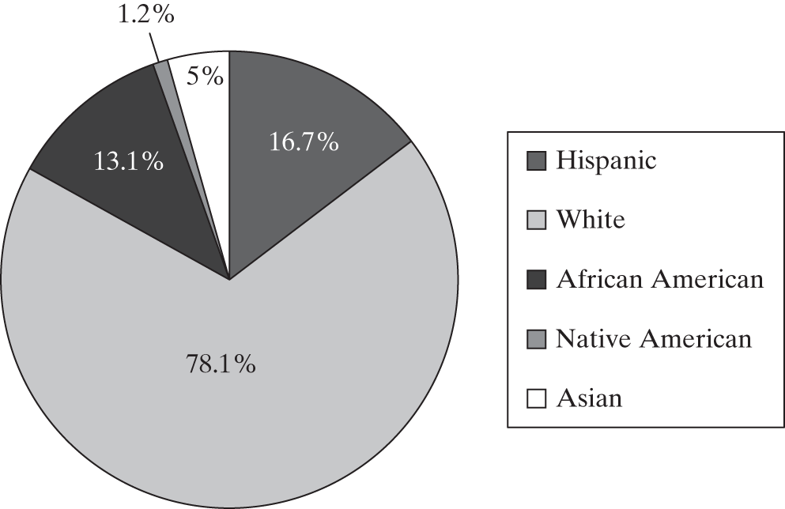

Figure 1-4 Diversity in the U.S. Population
Source: United States Census Bureau, 2013.http://quickfacts.census.gov/qfd/states/00000.html (accessed May 30, 2013).

Table 1-3 U.S. Demographic Highlights and Trends
- In 2007, 20.3 percent of the U.S population spoke a language other than English at home compared to 13 percent in 2000.
- More than half of the U.S. workforce consists of women and minorities.
- By 2016, minorities will make up one-third of the U.S. population.
- By 2025, the percentage of European Americans in the population will drop from 72 percent in 2000 to 62 percent.
- By 2025, Hispanics are estimated to be 21 percent of the population, outnumbering African Americans, who will make up 13 percent of the population.
- By 2050, the Hispanic population of the United States will grow to 30.25 percent.
- By 2025, the average age will be close to 40, as opposed to under 35 in 2000.
- By 2025, more than 50 percent of the population of Hawaii, California, New Mexico, and Texas will be from a minority group.
- By 2050, the average U.S. resident will be from a non-European background.
- By 2050, only about 62 percent of the entrants into the labor force will be white, with half that number being women.
Source: http://www.census.gov/population; and Bureau of Labor Statistics, 2013. http://www.bls.gov/emp/ep_table_303.htm.
Some of the diversity that leaders must manage is related to age. Roxann Hewertson, CEO of the Highland Consulting Group, an organization that focuses on leadership issues and a faculty at Cornell University, says the younger workers do not respond to traditional hierarchies easily. As a result she believes,“There’s a real hunger out there for finding a better way. The old way is broken. It doesn’t serve us” (5 influential CEOs, 2013). Nick Petrie, senior faculty member of the Center for Creative Leadership, an influential leadership organization, strongly believes, “There is a transition occurring from the old paradigm in which leadership resided in a person or role, to a new one in which leadership is a collective process that is spread throughout networks of people” (5 influential CEOs, 2013). Other demographic trends in the United States include the largest percentage of the population being older baby boomers (born between the late 1940s and the 1960s) at the top, and the millennial generation (born after the mid-1980s) at the bottom, with the generation Xers (born between the 1970s and 1980s) pinched in the middle. This suggests that many organizational leaders are managing employees from generations other than their own and therefore must take cultural and generational factors into account. We will discuss the impact of generational differences on individuals in Chapters 2 and 4.
The increasing number of women in the workforce is another factor that has an impact on leadership. Although women currently hold only 10 percent of the executive positions in the United States, they make up over 47 percent of the general workforce with a clear majority of women being part of the labor force (Women in the Labor Force, 2010). Similar trends exist all over the world. For example, women make up almost 47 percent of the labor force in Canada, close to 45 percent in China, over 50 percent in Russia (Labor force, 2009). Scandinavian countries are leading the way with the number of women in top management and leadership positions in the executive offices and boardrooms. In Sweden, women hold 23 percent of the board seats (Amble, 2006). As a result, the old ways that were designed for a gender and ethnically homogeneous population do not always work with employees and customers from varied backgrounds and cultures. Much of the burden for devising and implementing the needed changes falls on the leadership of our organizations. The demand to listen to and address the needs of nonhomogeneous groups requires skills that go beyond controlling and monitoring.
Because of the pressures for change, many organizations find themselves rewriting their policies to address the needs of a diverse community and consumer base. Consultant Ted Childs, who used to be IBM’s president of global workforce diversity states, “Business is at its core about relationships. I think diversity work takes away barriers that interfere with relationship building” (Child, 2013). He adds: “You’re going to have to sell to people who are different from you, and buy from people who are different from you, and manage people who are different from you…. This is how we do business. If it’s not your destination, you should get off the plane now” (Swan, 2000: 260). He views getting people to respect those who are different from them as the biggest challenge in managing diversity.

Barriers to Change
Despite the factors that fuel the need for change, few organizations and individuals have adopted new models for leadership painlessly. In part because of perceived financial pressures and attempts to find a quick way out of them, organizations turn to tough autocratic leaders whose goals are clearly not employee motivation and loyalty. For example, John Grundhofer, nicknamed “Jack the Ripper,” specialized in implementing massive layoffs and found his skills in high demand. Similarly, Al Dunlap, with nicknames such as “Ming the Merciless” and “Chainsaw Al,” for a long time moved successfully from the top position of one organization to another before being fired from Sunbeam Corporation in 1998. For many years, the financial community applauded him for his drastic cost-cutting strategies that involved widespread layoffs. Bill George, the highly respected former CEO of Medtronic, states that this focus on short-term and quick results cannot create the motivation necessary for the innovation and superior service that are essential to leadership and organizational effectiveness (George, 2003).
Another obstacle to implementing new models of leadership is that even though teams are fairly common in lower and middle levels of organizations, top management still remains a one-person show. The hierarchical structure of many organizations makes change difficult. Old cultures resist change. Few organizations truly reward enterprising employees and managers for crossing the traditional hierarchical barriers. Instead, most organizations continue to reward their leaders for tried-and-true approaches or sometimes for nonperformance- and nonproductivity-related behaviors, despite the lack of success (Luthans, 1989). Marcus Buckingham, a researcher at the Gallup Organization, has studied global leadership practice for 15 years. According to Buckingham, “The corporate world is appallingly bad at capitalizing on the strengths of its people” (LaBarre, 2001: 90). Gallup’s extensive surveys show that employee engagement can have a considerable positive impact on an organization’s performance. Recent surveys of employees in the United States by the Conference Board indicate the low level of overall satisfaction with jobs, at 47 percent (Conference Board, 2012). Other research indicates that job satisfaction is lower in larger companies with more bureaucracy, lower autonomy, and low responsibility (Wall Street Journal, 2006). Few organizations take full advantage of their employees’ input. Tom Peters, the well-known management consultant, suggests that while business leaders focus on strategy, they often “skip over the incredibly boring part called people,” thereby failing to take advantage of one of the most important aspects of their organization (Reingold, 2003: 94). In addition, changing the established behaviors of managers is very difficult. John Kotter, Harvard Business School professor and noted authority on change, suggests, “The central issue is never strategy, structure, culture, or systems. The core of the matter is always about changing the behavior of people” (Deutschman, 2005).
In addition, although they might spend a great deal of time working in teams, employees are still rewarded for individual performance. In other words, our reward structures fail to keep up with our attempts to increase cooperation among employees and managers. Furthermore, many employees are not willing or able to accept their new roles as partners and decision makers, even when such roles are offered to them. Their training and previous experiences make them balk at taking on what they might consider to be their leader’s job. Even when organizations encourage change, many leaders find giving up control difficult. Many receive training in the benefits of empowerment, teams, and softer images of leadership, but they simply continue to repeat what seemingly worked in the past, engaging in what researcher Pfeffer calls substituting memory for thinking (1998). With all that training on how to be in charge and in control, allowing employees to do more might appear to be a personal failure. Either because of years of traditional training or because of personality characteristics that make them more comfortable with control and hierarchy, managers’ styles often create an obstacle to implementing necessary changes. Research about children’s images of leadership indicates that the belief that leaders need to be in control develops early in life. Children, particularly boys, continue to perceive a sex-typed schema of leaders: Leaders are supposed to have male characteristics, including dominance and aggression (Ayman-Nolley, Ayman, and Becker, 1993).

Summary and Conclusions
A leader is any person who influences individuals and groups within an organization, helps them in the establishment of goals, and guides them toward achievement of those goals, thereby allowing them to be effective. Leaders are needed because they create order and organization in groups, allowing them to achieve their goals; they help people make sense of the world and can serve as ideal and romantic symbols for their followers. To be effective, leaders must help the organization maintain internal health and external adaptability. Despite the apparent simplicity of the definitions of leadership and effectiveness, both are difficult concepts to implement.
Various studies propose separate definitions for leadership and management. The activities performed by leaders, however, are similar to those typically considered the domain of effective managers. Although some view the roles of leaders and managers as being different, effective, and competent, managers are often also leaders within their groups and organizations. In addition to performing the traditional managerial roles and duties, leaders also play a special role in the creation of a culture for their organizations. They can affect culture by setting the vision and direction, making direct decisions regarding reward systems, hiring other managers and employees, and being role models for others in the organization. The role of leaders is changing with our shifting expectations and global and organizational pressures. Leaders find themselves providing more vision and direction and focusing on results rather than command and control. While new roles take hold slowly, political, economic, demographic, and social changes drive the need for change. However, leaders find use of traditional models, lack of involvement of followers, and falling back on old practices hard obstacles to overcome.

