Greetings! For this week’s assignment, you are going to practice assessing a piece of student writing using the 6 traits model. We’re going to do this in two steps. First, you’re going to read the student’s writing as you score it for five of the traits: Ideas and Content; Organization, Word Choice, Voice, and Sentence Fluency. You will not be scoring it for Conventions and Presentation.
As a side note and as a reminder – writing does not need to be assessed on all traits all the time. It is more common to select a focus for a writing piece. For example, you might have students write an expository piece with the objective of scoring for just ideas/content, organization and perhaps sentence fluency. You choose your focus based on the needs and intent of both the students and the assignment.
Keeping in mind this was a second-grade writing sample addressing the poetry standard around the assigned topic of weather – use your rubric and reviewing the descriptors – score accordingly. When you are done scoring, jot down 1-2 paragraphs providing your rationale and reflection for your scores, then repeat this process for writing 2.
The writing sample I’m about to share with you is from a former student of mine. Steven was a beautifully inquisitive, tender-hearted second grader with more passion and gumption than most children… or adults. All second graders were tasked with writing a poem about weather as part of their January benchmark test. I will now read Steven’s poem to you as you evaluate it for the five targeted traits:
WRITING 1
Rain is your friend.
It sings to you when you’re gloom.
It says, “Cheer up and watch the dancers”
They put on a show
You get out a blanket and a glass of hot chocolate.
You sit and watch the magical rain.
As the rain falls to the ground it looks like ballerinas twirling around and around.
You hear the patter of the rain on the roof top.
You see Mother Earth smiling at you.
Rain is the tool to all life.
Without rain the trees and grass and other plans would die and the plants would die.
So cheer when the world takes a shower and enjoy the trees, grass, and other plants and the singing and dancing rain.
So say hi to the sun and hello to the beautiful rain!

Ready to evaluate Steven’s writing again?
This time, you are going to still evaluate the original five areas, but now we’re also going to throw in Conventions. So that you can assess the mechanics of the poem, I will display the poem while reading it to you.
WRITING 2
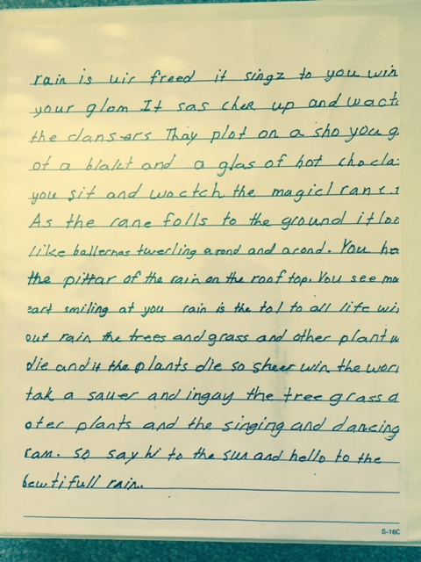

Before you begin, your rationale and reflection, stop and think about the impact of grading students’ writing using the 6 traits versus if you scored it holistically. Being completely honest with yourself, if you were to sit down with your red pen and grade Steven’s paper “old school” – what grade would he have? Likely not a passing grade, right? But when we splinter off the individual domains, I think we can all agree that Steven used outstanding voice and word choice. He exceeded in many areas. Clearly, conventions was not one of those areas…but conventions is only one area. Using this model to assess student writing allows us a better diagnostic of specific areas where students exceed and where we need to fill the gaps.
Now, look back at both of your scored rubrics and review the lesson materials regarding the 6+1 traits model. Write a 1-2 paragraph reflection titled "Part 2 Scoring Reflection" that includes your scoring rationale, your thoughts on the experience of assessing, and the connections to the course materials. Include references and resources in your post.

