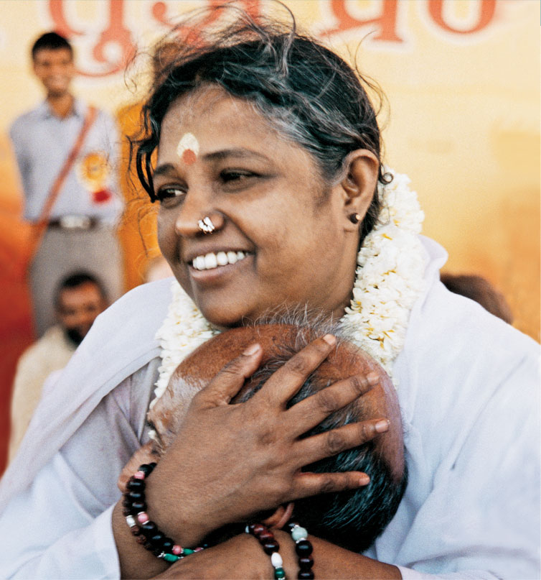

Here is an example of a modern-day Hindu saint, through whom people receive the "darshan" described in this chapter:
"Ammachi's appearances are no small event. Her devotees arrive hours early (many from out of state) to "take a number" to receive personal darshan (blessing) from her. If you get there at starting time, the number is already up into the 500s.
In anticipation of her arrival, an aisle is formed from the entrance of the hotel to the lecture hall, lined with chanting, barefoot devotees. (Shoes are deposited on shelves in an adjacent room.) As her car pulls up to the door, the mantra picks up. Indian music begins blaring from a portable cassette player from inside the hotel. Two rows of young women in saris precede Ammachi, carrying silver platters of flower petals. Ammachi floats behind them, smiling and touching hands (Oprah-style) with admirers. Entering the door to the lecture hall, Ammachi pauses as another devotee washes her feet with sandalwood paste. A puja (a ritual where water, milk and flowers are offered to God) is performed. As Ammachi mounts the stage, those who have been waiting outside scramble to get a good spot on the floor in front of the stage, near her.
Her full name is Mata Amritanandamayi, but most call her "Mother," "Amma" or "Ammachi." Ama means love. She is considered by many to be an avatar, a fully realized master, an incarnation of God. Based in Kerala, India, she travels throughout the world, giving darshan to thousands of people, tirelessly, sometimes for 18 hours at a time.
Every year in early July Amma visits the Chicago area, this time at the Naperville Sheraton. After a short introduction, Amma speaks through an interpreter. She talks about love and unity. "When we experience physical problems," says Amma, "learn love and compassion and have concern for all beings. Then we can heal. Love is the best medicine. ... Just as our bodies need food to grow, our souls need love. ...Let love grow within us and unite all of us and let the supreme grace guide each and every one of us."
When we experience challenges, Amma says, "Sometimes we are faced with small obstacles which help us avoid larger obstacles in the future. We need spirituality to survive in the ocean of samsara (the physical world). The biggest trials and tribulations are actually lessons to teach us to be more careful in the future or to exhaust some of our karma."
After Amma's message, Indian music is performed by 8 to 10 musicians sitting on the stage behind Amma. Mantras are chanted, and darshan begins, lasting until 3 or 4 a.m., until the line ends. After two more days and evenings, Amma is off to another city where hundreds more devotees are waiting.
Amma was born with an intense longing for God. At the age of five, she began composing songs with deep, mystical meaning, which she sang throughout the village. She worked long hours in the service of her family, and at night she meditated instead of sleeping. She showed great compassion for the sick, the poor and the elderly. Often she brought them food and clothing from her family's home (for which she was severely punished). Although she underwent many hardships as a child, she sought solace only in God, in the form of Krishna, repeating his name incessantly.
As Amma reached her teens, her love for God grew even stronger. She sang and danced in ecstasy, intoxicated with God. Eventually she experienced a profound mystical union with God in which she no longer could distinguish between Krishna and herself. Her family considered her eccentric and eventually drove her out of the house. She slept outdoors, and animals fed her: a cow from her udder and a dog carried packets of food to her in his mouth.
One day Amma had a vision of the Divine Mother and became overwhelmed with yearning for union with her. She practiced rigorous spiritual discipline for several months, which culminated in the total dissolution of her personal self into the Divine Mother. She describes this experience as follows: "Smiling, The Divine Mother became a mass of effulgence and merged in me. My mind blossomed and was bathed in the many-hued light of Divinity. Thenceforth, I saw nothing as apart from my own Self."
After experiencing God-consciousness, Amma withdrew from the world and remained immersed in bliss. One day she heard a voice from within her say, "I am in all as the One Essence and do not have any particular abode. It is to give solace to suffering humanity that you have come into this world, and not merely for enjoying Divine Bliss. Therefore, worship Me by showing mankind the way back to Me."
Amma began teaching her philosophy of love, compassion and union with the divine to anyone who was interested. When the villagers asked for proof in the form of a miracle that she was indeed one with God, she told him that the greatest miracle is for one to realize their True Self. But out of compassion for them and to inspire faith, she asked one man to bring a small pitcher of milk. When he dipped his finger into it, it had changed into sweet jam which was distributed to hundreds of people there. After that, large crowds began to gather around her and her home became an ashram.
On another occasion, a devotee brought her an oil lamp which her older brother, one of her greatest antagonists, broke. Amma asked her devotees to bring shells into which water was poured and a wick was placed. She asked the people to light the wicks, and the light from the shells lasted the entire night.
Now, Amma sees up to 10,000 people each day in India. Her work has expanded into a worldwide organization, the Mata Amritanandamayi Mission Trust, which sponsors orphanages, hospitals, shelters and schools. All of Amma's appearances are free and paid for by donations or from the sale of her books, photos, and other items that are sold at the events."
Respond (with open-mindedness & respect) to this practice, taking into consideration the Eck reading.

