System Integration Project Plan for Keiser Permanente Medical Care

Student’s Name:
Instructor’s Name:
Course Name and Number:
Date:

Table of Contents
Project Information (Week 1) 3
Introduction 3
Enterprise Description 3
Overall Objectives of the Project 4
Major Components of the Project 4
Boundaries of the Project 4
Project Plan (Week 1) 5
Work Breakdown Structure (WBS) 5
System Integration Best Practices (Week 1) 6
Requirements Specifications (Week 2) 8
Enterprise System Integration Analysis (Week 3) 9
Systems Integration Approach Evaluation and Selection (Week 3) 10
Proposed System Integration Components Architecture (Week 4) 11
Implementation Framework (Week 4) 12
System Integration Implementation Plan (Week 5) 13
Conclusion 14
References 15

Project Information (Week 1)

Introduction
In the recent past, there has been a rise in the rate of technological growth and as a result, enterprise environments have evolved via the adoption of the new technology. Most enterprises across major industries are in business, health, agriculture and even information technology among others have adopted various systems which help them make their work easier, efficient and at the same time convenient for all their employees and clients to do business together effectively. When it comes to communication, for example, most enterprises have adopted the use of bring your own device (BYOD) technology which helps the employees access the company’s information with ease (Sabooniha, 2012). Apart from communication, some of the other sectors include transportation, information sharing, storage techniques as well as emergency and payment services. All these are just but examples of how various enterprises across major industries have adopted various technology for efficient and effective operations.
Due to this, it has, therefore, become essential to connect these systems together so that they can be more effective and make work easier. This is the reason why systems integration is necessary for any enterprise. Systems integration is basically a phase or a process of engineering affiliated with the joining of various different components and subsystems into one large system so as to ensure that each one of them is functioning as required. Research has it that more than 65% of enterprises with integrated subsystems in the United States are expected to be more productive as compared to those which have not embraced the technology (Khorramshahgol, 2017). This is the reason why this project is done, so as to solve the problem of unproductivity and to enlighten Americans into integrating their systems and eventually increase their productivity.

Enterprise Description
Kaiser Permanente Medical Care is a healthcare facility located in Charlotte, North Carolina. The facility was established more than three decades ago in 1985 by George McGregor. It initially served as a medical supplies facility but later became a hospital which served only outpatients. It then grew to become one of the largest healthcare facility in Charlotte and at the moment it is an all-rounded healthcare facility offering both inpatient and outpatient facilities. It also provides emergency services to anyone within North Carolina via vehicle and flying ambulances and at the same time, it has a pharmaceutical unit which sells drugs to its patients and also sells in wholesale. All these activities have a lot of services that need to be covered including information on medical records, billing, ordering, and clinical time observation as well as delivery services among others. All these activities need therefore to be integrated or put together to ensure easy communication.

Overall Objectives of the Project
The two major objectives of this project are;
- To achieve a fully integrated system at Kaiser Permanente Medical Care
- To be able to practically observe the advantages of an integrated system upon implementation

Major Components of the Project
Major components needed for integration include;
- 323 RMD-Y6 Arduino
- 1 Domain Server, 2 Communication Servers, and 2 Database Servers
- Support services databases and records including those from labs, inpatient, outpatient, emergency services, pharmacy, and imaging
- Lighting systems
- Bank office including human resources management and store/inventory management among others.

Boundaries of the Project
Some of the things that the project will not address include;
- Energy management
- Intrusion detection
- Elevator services
- Biometrics services across the health facility
- White space management
- Payroll management

Project Plan (Week 1)
The project will take a period of five weeks. The following table shows the work breakdown structure demonstrating the starting date and the finishing date as well as the processes involved during the project and the resource needed for its success.

Work Breakdown Structure (WBS)
Task | Start Date | End Date | Duration
Kaiser Permanente Medical Care Systems Integration Project Plan | 1st June 2018 | 6th July 2018 | 35 days
Project Definition | 1st June | 2nd June | 1
Problem Definition | 1st June | 2nd June | 1
Feasibility Study | 1st June | 5th June | 4
Define the stakeholders | 2nd June | 3rd June | 1
Project’s Scope Definition and Getting the Involved Stakeholders | 5th June | 6th June | 1
Requirement Specification | 6th June | 7th June | 1
Make meetings With Stakeholders, Management and IT Administrators | 8th June | 10th June | 2
Enterprise System Integration Analysis | 8th June | 18th June | 10
Systems Integration Approach Evaluation and Selection | 12th June | 15th June | 3
Proposed System Integration Components Architecture | 14th June | 27th June | 13
Implementation Framework | 10th June | 31st July | 20
Project Implementation | 10th June | 31st July | 20
Determining the influence of the Project on the Society | 1st July | 3rd July | 2
System Integration Implementation Plan | 4th July | 5th July | 1
Close the project | 5th July | 6th July | 1
Prepare project close document | 1st July | 6th July | 5
Table 1: WBS

System Integration Best Practices (Week 1)
For successful implementation of this project, there are some of the measures that need to be considered and adopted. These measures are what we call the system’s best practices. The following are some of the best practices to be considered in this project;
- Define user permissions, roles, and needs:
- Enable non-repudiation
- Document edge case protocols
- Build-in security from the ground up
- System’s architecture skeleton development
- Configuration control
- Subsystems and components specifications
- Integration entry checkout for every component
- Integrating the components to form subsystems
- Tracking the process of integration via continuous regression testing
- Determining the performance of the system and testing of the same
The following diagrams show the process flow that is intended to be used for designing the systems integration architecture in this project.
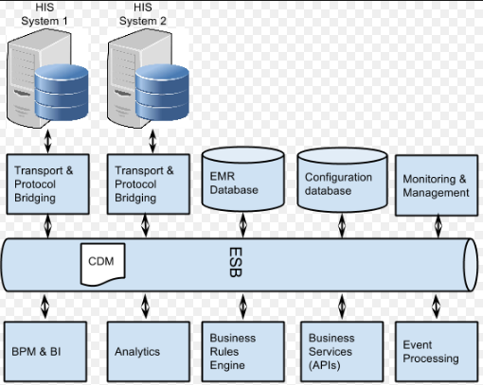
Diagram 1: Major database integration systems
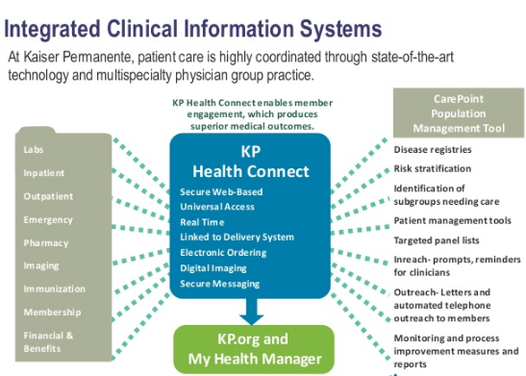
Diagram 2: Major systems to be integrated at Kaiser Medical Center
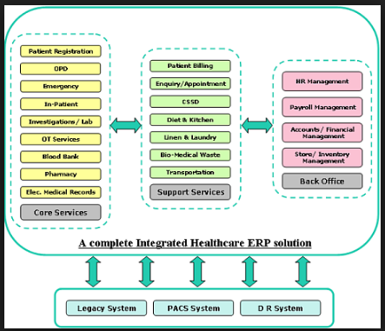
Diagram 3: Process flow diagram of systems to be integrated

Requirements Specifications (Week 2)
Just as mentioned earlier, the major requirements specifications include;
- 323 RMD-Y6 Arduino
- 1 Domain Server, 2 Communication Servers, and 2 Database Servers
- Support services databases and records including those from labs, inpatient, outpatient, emergency services, pharmacy, and imaging
- Lighting systems integral model(1S-TY Scooper)
- A systems integration software
- 2 defined coding programs for Arduino programming procedures
- Mat-Lab software for simulation of the systems before implementation.

Enterprise System Integration Analysis (Week 3)
All the components, first of all, will be confirmed whether they are all available or not. All the components must be available for the project to be a success otherwise the project will not be even simulated, leave alone implementation. All the systems will be tested to prove their functionality. The software interfaces will be tested to prove their compatibility. All of them needs to be compatible, otherwise, the system cannot be integrated. If however, they are not, a new software is introduced with the help of a code that will help make the systems compatible. The same components available at Kaiser Permanente Healthcare Facility will be duplicated in a Mat-Lab Simulink and then coded using an Arduino to make sure whether the system will really work or not (Hobday, 2006). Here is where everything including corrections and perfections are made as well as imperfections corrected. This is where the system integration for the healthcare facility is done the analysis.

Systems Integration Approach Evaluation and Selection (Week 3)
Compelling venture assessment requires consolidating the numerous clashing goals of choice maker(s) into choice models. Among the numerous proposed techniques of multi-criteria basic leadership, objective writing computer programs are maybe the most prevalent and broadly utilized. In spite of the fact that it joins various destinations and touches base at an ideal arrangement, its significant disadvantage is that the choice maker(s) must determine the objectives and needs from the earlier. To defeat this issue the Delphi strategy is recommended to be connected before objective programming plan with the goal that the targets and their comparing goal levels can be recognized (Kitsiou, 2006). Another disadvantage of objective writing computer programs is that it doesn't give an efficient way to deal with set needs and exchange offs among targets. For this reason, a logical progressive system process is utilized.

Proposed System Integration Components Architecture (Week 4)
Upon testing and analysis of the major component to be integrated via Ma-Lab as explained earlier, the project team will come up with a perfect architecture which will incorporate all the components and come up with an integrated system which allows communication among all of them. The architecture should be simple and easy to implement provided all the necessary implementation procedures are used. Research also has it that all the disadvantages of the architecture have also to be pointed out including some of the most sensitive parts so that it makes implementation easy (Houser, 2011).

Implementation Framework (Week 4)
The implementation framework will involve four main things including the context, phases, roles, and components. Components are basically the conceptual and physical tools that will be used to implement the project. It will be made up of five things which are monitoring, measuring, coaching and training as well as innovation and the desired outcomes of the project. Roles will be defining the persons responsible for certain tasks. All the tasks will be given to specific people within a certain period of time so as to facilitate the ease in the implementation process. Rather than starting with a linear progression procedure, a multi-phased technique will be followed during the implementation process. Key stages to be followed in the implementation process will include maintaining, improving, executing, preparing and deciding. Context is all about where a process is going to take place (Olsen, 2010). All the activities will be assigned to each responsible individual of the team and the places of implementation will also be stated.

System Integration Implementation Plan (Week 5)
Upon the development of an implementation framework, an implementation plan will be developed based on the activities devised in the implementation framework. The implementation process will take a period of 20days upon analysis and virtual simulation and implementation of the project in a computer software. This will involve the real simulation of the entire project via coming up with various program codes and software that will enable the implementation process a success. The project team will set up the servers and come up with an internal communication network which will link all the databases in the servers and they will be able to communicate with each other. The codes and software with the help of an Arduino will integrate fully and link-up with the rest of the databases in the systems and this way the hardware will be able to communicate wirelessly.

Conclusion
Systems integration is very essential in every enterprise and in our case, in healthcare institutions. Kaiser Permanente Medical Care will benefit a lot from the implementation of the Systems Integration (SI) procedures. Apart from its advantages ranging from the ease in communication processes, transportation, emergency services improvement and easy access into the health records by the various users, the technology provides an overall efficient and effective working environment where coordination is at the highest level and therefore it becomes very hard for something to go wrong without anyone noticing. Therefore, generally, SI is a vital technology that needs to be adopted by every enterprise.

References
Houser, P. (2011). Best Practices for Systems Integration. Engineering & Product Excellence,
Northrop Grumman Corporation. Retrieved on July 10, 2018, from; https://ndiastorage.blob.core.usgovcloudapi.net/ndia/2011/system/13007_HouserThursday.pdf
Hobday, M., Davies, A., & Prencipe, A. (2015). Systems integration: a core capability of the
Modern corporation. Industrial and corporate change, 14(6), 1109-1143.
Kitsiou, S., Manthou, V., & Vlachopoulou, M. (2006). A framework for the evaluation of
Integration technology approaches in healthcare. Proceedings of the IEEE in Information and Communication Technologies in Bioinformatics, 28-30. Retrieved on July 10, 2018, from; https://www.researchgate.net/publication/259297683_A_Framework_for_the_evaluationof_integration_technology_approaches_in_healthcare
Khorramshahgol, R., Azani, H., & Gousty, Y. (2017). An integrated approach to project
Evaluation and selection. IEEE Transactions on Engineering Management, 35(4), 265-270. Retrieved on July 10, 2018, from; https://ieeexplore.ieee.org/document/7449/
Olsen, L., Saunders, R. S., & Yong, P. L. (Eds.). (2010). The healthcare imperative: lowering
Costs and improving outcomes: workshop series summary. Chapter 17. National Academies Press. Retrieved on July 10, 2018, from; https://www.ncbi.nlm.nih.gov/books/NBK53926/
Sabiha, N., Toohey, D., & Lee, K. (2012, August). An evaluation of hospital information
Systems integration approaches. In Proceedings of the International Conference on Advances in Computing, Communications and Informatics (pp. 498-504). ACM. Retrieved on July 10, 2018, from; http://citeseerx.ist.psu.edu/viewdoc/download?doi=10.1.1.712.42&rep=rep1&type=pdf

