Question a:

One of Edmonia Lewis' most famous sculptures is Forever Free from 1867. Feel free to discuss this sculpture OR add other examples of her art.
In what ways can we analyze the depiction of race and/or gender in the art of Edmonia Lewis?
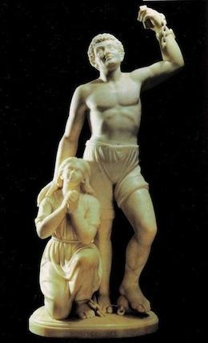

Other questions to consider:
Where does the title of the sculpture come from?
What aspects of the sculpture express the theme of Forever Free?

Can you think of other works of art with a similar theme?

Question b:

In the 19th century, the United States expanded rapidly in population - through large families, immigration, and (initially) importation of African slaves. It also expanded rapidly in territory - through purchases, annexations, wars, and treaties. These changes led to a country with one of the most diverse populations in the world, but with government policies such as Jim Crow laws, Indian boarding schools, Exclusion acts, etc. that functioned to maintain a culture with a widespread belief in the necessity of conforming to the dominant white, Anglo-Saxon culture.

That tension between assimilation and identification with diverse cultural roots continues today in the U.S. and elsewhere. A few years ago, Absolut Vodka ran an ad in Mexican media that caused an uproar with some people in the United States.
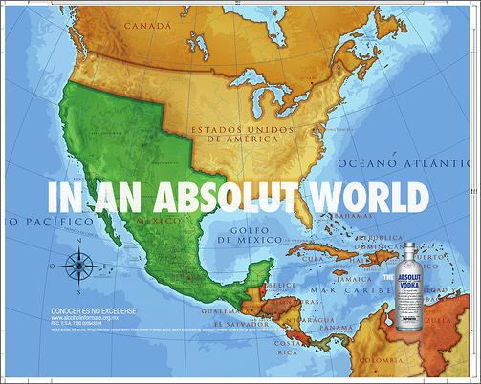

It depicted a map of North America with Mexico's boundaries restored to those prior to the Mexican-American War. There are some opponents of increased immigration that believe that there is a deliberate strategy for Mexican immigrants to take over the Southwest. In 2010, Arizona's controversial AB 1070 law was in part a reaction to the stresses of a large unassimilated immigrant population. In the years that followed, some other states passed similar laws. Now the Trump administration is planning the building of a wall to separate Mexico from the U.S.
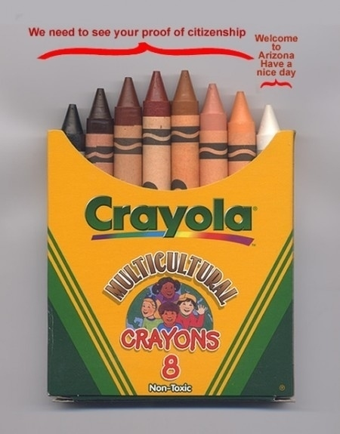

What are the relative merits of assimilation and diversity?

