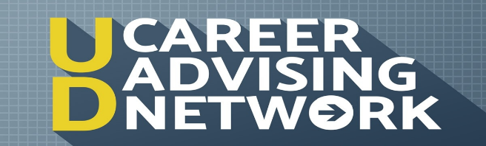
PART TWO: Advising Session
BUAD309
Total possible points: 67.5 (see rubric)
Two Parts: Session reflection & Self-Assessment

NAME:

STEP ONE: ADVISING SESSION REFLECTION
What are three things that you learned or gained insight about from your advising session. Be clear and thoughtful in your responses. I’m looking for connection to the value of this exercise.
--Response should be concise but show insight. Do not exceed this page --

STEP TWO: Self-Assessment: UDCAN Advising Session

- Was I on time? Yes___ No___

- Did I introduce myself? Yes___ No___

- Did I know the interviewer's name and use it correctly? Yes___ No___

- Was I in a quiet, private location for my session? Yes___ No___

- Did I give positive signals about my interest in speaking with this contact?
**Complete A or B depending on session type**

- Skype: Did I show interest, eagerness, and enthusiasm in my body language by sitting up and leaning forward? Yes___ No___

(b) Phone: Did my tone of voice show interest, eagerness, and enthusiasm?
Yes___ No___

- Did I sound nervous? Yes___ No___

- Did I show that I was prepared/listening by answering questions with appropriate depth? Yes___ No___

- Did I demonstrate my preparation in the areas of:

(1) Alum’s Educational Background............ Yes___ No___ N/A___
(2) Alum’s Work Experience........................ Yes___ No___ N/A___

(3) Alum’s Accomplishments....................... Yes___ No___ N/A___

(4) Knowledge of the Company................... Yes___ No___ N/A___

(5) My Career plans and goals.................... Yes___ No___ N/A___

- Did I answer all the questions honestly?........... Yes___ No___

- Which questions did I have most trouble answering adequately?

- Did I ask relevant questions when given the opportunity to do so? Yes No___
- What were my greatest strengths in the interview?

- What were my greatest areas of weakness?

- How could I have improved this interview?

How would I assess my overall performance?

Poor Adequate Good Excellent

