THE PENGUIN

The Penguin
October 24, 2010 marked a culinary crossroads for Charlotte. Penguingate, as it had been dubbed on Twitter, was coming to an end and regulars of the Penguin Drive-In restaurant gathered to say farewell to their local hang-out as they knew it. The next day, the doors would be closed and a new chapter would begin for the historic restaurant as well as its proprietors.
How, though, did a property that started out as an ice cream shop become the center of a media firestorm and lead to the splintering of friendships, partnerships, and a local community?

It All Started With an Ice Cream Shop
In 1954, Jim Ballentine bought an ice cream shop that had been known as the Penguin since the late forties. He bought the Penguin building, lot, and existing equipment and embarked on a dream that he had shared with his wife on their first date – to own a restaurant (Markovich, 2011).
Jim and his wife, Jean, took the ice cream shop and turned it into a classic drive-in, complete with traditional diner fare and a beer selection. The Penguin grew and so did the Ballentine family with the addition of five daughters. Popularity of the Penguin forced Jean to quit her job as a nurse to become a full-time partner with Jim. As the restaurant became a home away from home, it was only natural for the daughters to be involved with the family business.
The Penguin never had to advertise; word of mouth about the drive-in spread all over Charlotte. Patrons kept coming back to the restaurant for the food and cheap beer. Ballentine opened the Penguin seven days a week, 365 days a year. He told his family, “There are people depending on me to be there” (Suchetka, 1995).
After 50 years of being in business, the classic drive-in was starting to show its age. Eventually, crime increased and break-ins became routine. The Penguin became known as a shabby neighborhood joint where drug addicts hung out.
In 1999, Jim Ballentine fell ill and retired, leaving ownership in the name of his wife, Jean. With no one to continue running the restaurant, the Ballentine family knew it was time to close the Penguin.

Then Came the Fried Pickles
Around the same time the Penguin closed, two locals, Brian Rowe and Jimmy King, had been playing with the idea of opening a bar. Friends encouraged them to approach the Ballentine family about reopening the Penguin. Rowe and King signed a five-year lease agreement for the property and use of the Penguin name with Jean Ballentine in 2000. The lease and name was renewable for a second five-year term. Their promise to Jean was to maintain the spirit of the Penguin that the family had worked so hard to establish (WSOCTV.com, 2010).

King and Rowe set out to fulfill their dream of opening the Penguin as a bar. However, due to North Carolina laws, the business also had to serve food in order to obtain a liquor license. So Rowe invited the caterer from his wedding, Greg Auten, to develop the menu and manage the kitchen.
King and Rowe invested their own resources into reviving the Penguin by renovating the building, buying new kitchen equipment, and adding a jukebox. King also re-vamped the logo to create a sleeker, more modern penguin logo. In an interview, King said, “We wanted to make it authentic. We didn’t want to make it like Happy Days. We didn’t want the Marilyn Monroe and the Elvis Presley vibe. ‘Cause in the fifties they were current” (Markovich, 2011). The Penguin reopened in May 2001.
King was the daytime front office guy while Rowe, a former Marine, covered the night shift. Auten developed a unique menu that would prove to be a key to the Penguin’s future popularity. All three sported heavy tattoos and a biker-bar swagger that helped to create the business they wanted: “a dive bar that wasn’t threatening,” a cool, safe place for people to hang out (Markovich, 2011).
It took three years of working seven days a week, but the Penguin began to see lines stretching into the parking lot on a daily basis as socialites, businessmen, students, and bikers all converged on the place now nicknamed “The Bird.” It was known for its food, friendly welcoming staff, and laid-back attitude. Lisa Ballentine, one of Jim Ballentine’s five daughters, said, “They [Auten, King, and Rowe] breathed new life into the Penguin” (Schwab, 2010).
Customers’ favorites included grilled pimento cheese sandwiches, the Hemi and Small Block burgers, and black bean hummus. By far, the most popular menu item was the fried pickles. Auten estimated that 90% of the orders were accompanied by a basket of fried pickles (Suchman, 2007).

“The Bird” Goes Nuts
The Penguin family lost its patriarch when Jim Ballentine passed away on January 11, 2007 (Obituaries, 2007). His wife, Jean, became owner of all their assets, including the Penguin. In Jim Ballentine’s obituary, Auten, King, and Rowe were listed as “extended family.” Meanwhile, his beloved Penguin was about to step into the spotlight.
Brian Rowe said, “The first year it was slow, the second year it was slow. Around the fourth year, things started to pick up and the sixth and seventh year we were very busy. Then that Food Network thing aired and we went nuts” (Hodges, 2010).
In March 2007, Guy Fieri, star of the Food Network’s Diners, Drive-Ins, and Dives, filmed a segment at the Penguin. Auten, King, and Rowe were all featured in the segment, though most of the attention was on Auten’s menu creations.
On May 7, the same day the Penguin made its national television debut, Ballentine Family Investments, LLC was formed. Ownership of the Penguin was transferred from Jean Ballentine to the limited liability company, which would later be managed by Lisa Ballentine, one of Jim and Jean’s daughters.
After the segment aired on May 7, the Penguin was no longer Charlotte’s hidden gem. We “took the spot from relative obscurity to a thriving hotspot,” King said (King, 2010). Now, not only were patrons lining up outside the door, so were businessmen who were looking to capitalize on the Penguin’s success. Franchising seemed like an obvious next step.

Franchising Facts
The International Franchise Association defines a franchise as “a license that describes the relationship between the franchisor and franchisee, including the use of trademarks, fees, support, and control” (International Franchise Association, 2011). Franchisors [sellers] are entrepreneurs that have an established business they are looking to expand by licensing their brand including, but not limited to, trademarks and trade dress. Franchisees [buyers] are also entrepreneurs who are looking to reduce the risk and expense of starting their own business through use of an established brand and business model.
“Franchisees have the legal right to operate a franchised business and use the business’s trademarks...” (Melvin, 2011). Trademarks are a form of intellectual property that can consist of distinctive marks such as business name, logo, package design, décor, and any other aspects that tend to promote the respective product or service (Stim, 2010). An individual or business can apply to the United States Patent and Trademark Office [USPTO] to protect ideas, designs, and written words. Trademarks are most commonly recognized as a specific name (e.g., McDonalds) or logo (e.g., the Nike “swoosh”).
Trade dress is a type of trademark that is not easily defined and is a continually evolving form of intellectual property. It is best described as the elements used to identify a product or service. Trade dress protection covers all sensory impressions that consumers associate with a brand or business. These elements can include décor, uniforms, layout, and menus. A famous example of trade dress protection would be the Hard Rock Café brand (Stim, 2010).
Trademarks are an important business asset, especially for franchises. Trademarks, including logos and trade dress, communicate the brand to all the stakeholders associated with that franchise. Registration of trademarks is a way for franchisors to protect their brand and is an absolute requirement when establishing a franchising business model. Franchisees are buying the right to use an established brand. It would be a foolish investment for a franchisee to invest in a brand with unregistered trademarks.
In summary, trademarks help to ensure brand recognition. Successful franchises (e.g., McDonalds) provide a consistent delivery of the brand, and consumers demand consistency. Through the collaboration of the franchisor and franchisee, trademarks are leveraged to build consumer awareness in new markets and gain loyalty through consistent brand execution.

Penguin Proprietorship?
The trio initially declined franchising offers, contending that the secret of the Penguin was the mix of food, environment, and people, which could not be replicated. That sentiment changed after the premiere on Diners, Drive-Ins, and Dives.
Martin Sprock, the successful franchisor of brands such as the Flying Biscuit and Moe’s Southwest Grill, approached Auten, King, and Rowe about franchising the Penguin. Negotiations between Sprock and the three Penguin partners lasted about six months, but a deal was never signed. Sprock said, “I didn’t try to buy this particular little restaurant right here. I was buying the name and the marks and the rights to expand the Penguin, all over into fifty states if possible” (Markovich, 2011).
In 2008, to protect the Penguin brand from knock-offs, King and Rowe worked with Jean Ballentine to trademark the Penguin logo and name. When the trademark was filed, King and Rowe’s names were absent from the registration, even though King had redesigned the logo that graced bumper stickers and t-shirts advertising the restaurant and bar. The trademarks for the Penguin logo and name were filed, respectively, on July 29 and 30, 2008. (see exhibits C and D)
Rowe recalls Jean Ballentine saying, “… as long as you’re running the Penguin, you can use the name” (Markovich, 2011). Documents exist that prove this, but they are not part of the public record.
Rowe felt the relationship he had with the Ballentine family was simple: the family owned the building and the name; the three partners [Auten, King, and Rowe] were tenants and owned the actual business model that occupied the building.

Ruffled Feathers
2010 marked the ten-year anniversary of the Auten, King, and Rowe era of the Penguin. Early that year, Auten left the Penguin to start his own restaurant, Pinky’s, on the west side of town because he “wanted more of his own thing” (Schwab, 2010). In May, King and Rowe signed a lease to own and operate another landmark Charlotte restaurant, the Diamond, in a joint venture with fellow restaurateur, Andy Kastanas. King and Rowe “thought it would be cool to run two historic restaurants not just in the same neighborhood, but on the same block” (Markovich, 2011). The new venture was intended to complement the existing setup at the Penguin.
After King and Rowe signed the lease on the Diamond, Lisa Ballentine approached the two about ownership in the Penguin. She wanted to keep 51% ownership in the Penguin, with the remaining 49% to be split between King and Rowe. She was authentic about her partnership offer, but she also had concerns about “napkins . . . flying out the back door ‘cause the Diamond’s out of napkins” (Markovich, 2011).
King and Rowe declined the offer. They felt the Ballentine family only owned the building, name, and logo, not the business. The business belonged to King and Rowe, and they were not going to sell out their business for minority ownership, especially when they rebuilt the Penguin from the rotting building they leased in 2000. The ownership negotiations ceased. Lisa Ballentine reflected, “Yeah, the lease was coming to an end, but you were going out with another girl anyway . . . We’re all doing what’s best for the Penguin” (Schwab, 2010).
In July 2010, the Ballentine family approached Martin Sprock about franchising the Penguin. Little is known about the content of the discussion, but in September 2010, Martin Sprock’s representative announced that Ballentine Family Investments would not be renewing the lease with King and Rowe and that the Penguin would be under new management. King and Rowe’s lease on the Penguin would end November 1, 2010. The announcement said, “The Ballentine family has decided to give their restaurant a new lease on life while staying true to the dreams their family has always kept for the Penguin” (Hodges, 2010).
King and Rowe also issued their own press release affirming their stance on ownership, stating “The Penguin Drive-In [would] cease to operate under the current ownership effective October 24th” (see exhibit E). Although King and Rowe threatened legal action against Ballentine Family Investments, no official paperwork was filed.

#Penguingate
With the announcement about the Penguin’s new management and potential franchising, websites, Facebook, and Twitter lit up with Charlotteans’ reactions. #Penguingate became a trending topic as Charlotte’s active social media community vocalized its outrage and disappointment with the announced changes.
An event page was started by Mark Cline titled Boycott the Penguin as of Oct. 24. Cline, a supporter of the Penguin under King and Rowe’s management, wrote that he “started this event to show support for Brian and Jimmy, that’s it.” Cline only sent the event invite to about 50 Facebook friends and by the next day, he had received 300 confirmations. The event page eventually grew to include over 15,000 people planning to boycott the Penguin as of October 24. Cline went on to comment, “I, in no way, intended this to be aimed at current, past, or future owners in a negative way” (Boycott the Penguin, 2010).
A comment written in response to the boycott on The Charlotte Observer blog said, “I won’t eat in that building after October 24, and I won’t respect anybody that does. I won’t eat in a Penguin franchise. I won’t eat in a restaurant owned by anybody involved in the travesty of a “new” Penguin. I will boycott” (Opinion, 2010).
News of the boycott spread beyond the Charlotte city limits. Andrew Mark Veety, resident of St. Louis, Missouri, wrote on his blog, “I think it’s time to retire my Penguin tee-shirt after wearing it with pride around St. Louis for almost three years. It’s a sad day for Charlotte…Fight the good fight -- boycott the New Penguin Drive-in!” (Veety, 2010).
Charlotte Magazine summed up the situation: “Rowe was stunned by the online push to boycott the New Penguin. Lisa [was] bewildered by the new reality of social media, where sarcastic insults and conspiracy theories can become fact when they’re repeated and re-tweeted often enough” (Markovich, 2011).

It’s Not All Black and White
As the last embers of the social media firestorm burned out, it left the city torn between two restaurants, the Penguin and the Diamond. However, in this situation, there was no clear victor. “No one wins a fight over sliced dills and seasoned flour,” said restaurant critic Helen Schwab. “The genius of the Penguin, the reason for the passion and the poison, is that folks come to feel it’s their own, to hold it dear and not to take it for granted” (Schwab, 2010).

Bibliography

Best New Restaurant (Opened in Last 12 Months): The Diamond Restaurant. (2011, August 16). Creative Loafing. Retrieved from http://clclt.com/charlotte/best-new-restaurant-opened-in-last-12-months/BestOf?oid=2441187
Boycott the Penguin as of Oct. 24. [ca. 2010]. In Facebook [Event page]. Retrieved
August 13, 2011, from www.facebook.com/event.php?eid=149194901785607
Hodges, C. (2010, September 27). The Penguin Drive-In changes ownership. [Web log comment]. Retrieved from http://blogs.creativeloafing.com/theclog/2010/09/27/the-penguin-drive-in-changes-ownership/
International Franchise Association. (2011). Retrieved from www.franchise.org
King, J. (2010, September 20). Penguin Drive-in changes ownership [Press release]. Retrieved from http://uptownclt.com/2010/09/the-saga-at-the-penguin-continues/
Markovich, J. (2011, March 29). Frayed Pride and Fried Pickles. Charlotte Magazine. Retrieved from http://charlottemagazine.com/Charlotte-Magazine/April-2011/Frayed-Pride-and-Friend-Pickles/
Melvin, S. P. (2011). The Legal Environment of Business: A Managerial Approach. New York, NY: McGraw-Hill Irwin.
Obituaries in the news. (2007, January 12). The Charlotte Observer. Retrieved from http://www.legacy.com/obituaries/charlotte/obituary.aspx?n=james-william-ballentine&pid=85940149
Opinion: Losing a unique 'Penguin' hurts the hearts of its fans. (2010, October 6). The Charlotte Observer. Retrieved from www.charlotteobserver.com/2010/10/06/1741504/losing-a-unique-penguin-hurts.html
Schwab, H. (2010, September 21). “Everybody’s cool”: Penguin update. [Web log comment]. Retrieved from http://helendining.blogspot.com/2010/09/penguin-update.html
Schwab, H. (2010, October 3). Why we care about the Penguin's fate. The Charlotte Observer. Retrieved from http://www.charlotteobserver.com/2010/10/04/1737743/the-polarizingplight-of-the-penguin.html
Spanberg, E. (2011, April 22). Growth on Martin Sprock's Menu. The Charlotte Business Journal. Retrieved from http://www.bizjournals.com/charlotte/print-edition/2011/04/22/growth-on-sprocks-menu.html
Stim, R. (2010). Patent, Copyright, and Trademark: An Intellectual Property Desk Reference. Berkeley, CA: NOLO.
Suchetka, D. (1995, December 23). Camaraderies on Tap at the Penguin. The Charlotte Observer. Retrieved from http://ttomlinson.blogspot.com/2010/09/penguin-version-10.html
Suchman, P. (Producer). (2007, May 7). Diners, Drive-Ins, and Dives [Television broadcast]. New York, NY; Scripts Networks Interactive.
Veety, A. M. (2010, September 23). Penguin Drive-In - Say It Ain't So. [Web log comment]. Retrieved from www.andrewmarkveety.com/2010/09/penguin-drive-in-say-it-aint-so.html
WSOCTV.com. (2010, September 21). The Penguin Drive-In to Change Management, Concept. Retrieved from http://www.wsoctv.com/news/25097714/detail.html

Exhibit A: Timeline of the Penguin Drive-In

Year | Major Developments
1942 | - The Penguin was originally built to serve as a roadside soda and ice cream shop.
1954 | - Jim Ballentine bought the Penguin building, lot, and equipment inside.
1999 | - Jim retired and transferred ownership of the Penguin to his wife Jean Ballentine.  - The Penguin closed its doors. The building was put up for rent.
2000 | - Jimmy King and Brian Rowe signed the lease on the building and the Penguin  name.
2001 | - The Penguin re-opened as a bar and restaurant.
2007 | - January 11: Jim Ballentine died.  - March: The Food Network filmed a segment at the Penguin.  - May 7: The segment aired on the Food Network.  - May 7: The Ballentine family formed Ballentine Family Investments, LLC.  - May 8: Jean Ballentine transferred ownership of the Penguin to Ballentine Family  Investments, LLC.
2008 | - Franchisor Martin Sprock approached Auten, King, & Rowe about franchising  the Penguin.  - July 29: Jean Ballentine filed trademark for the Penguin name.  - July 30: Jean Ballentine filed trademark for the Penguin logo.
2010 | - January: Greg Auten left the Penguin to open Pinky’s.  - May 7: King & Rowe and Andy Kastanas signed a joint venture to run the  Diamond.  - September 20: Ballentine Family Investments, LLC and Jimmy King issued press  release announcing decision not to renew lease with King & Rowe.  - October 24: Rowe & King’s last night operating the Penguin.

Exhibit B: “The Bird” Bios
(Listed in order of introduction in the case)
Jim Ballentine: Owned and operated the Penguin with his family from 1954 until his retirement in 1999. He died January 11, 2007.
Jean Ballentine: Wife of Jim Ballentine. After Jim retired in 1999, Jean became owner of the Penguin until 2007 when she transferred ownership of the Penguin to Ballentine Family Investments, LLC. Both of the trademarks for the Penguin name and logo were registered under Jean’s individual name.
Jimmy King: Air Force veteran and Rowe’s partner; they leased the Penguin from Jean Ballentine in 2000. King redesigned the Penguin logo and was more of the front office guy until October 24, 2010.
Brian Rowe: Former Marine and King’s partner; they leased the Penguin from Jean Ballentine in 2000. Rowe helped to manage and operate the Penguin from 2001 until October 24, 2010.
Greg Auten: Became chef at the Penguin in 2001 and created many of the menu items that made the Penguin famous, most notably the fried pickles. He left the Penguin in 2010 to start his own restaurant, Pinky’s.
Guy Fieri: Celebrity chef and host of the Food Network’s Diners, Drive-Ins, and Dives.
Lisa Ballentine: Daughter of Jim and Jean Ballentine. Lisa is credited with making the decision not to renew the lease with King and Rowe in 2010. Lisa took over management of the Penguin on November 1, 2010.
Martin Sprock: Successful franchisor of brands such as Moe’s Southwest Grill and the Flying Biscuit. Sprock’s franchising company, Big Game Brands, finalized franchising agreements with Ballentine Family Investments in November 2010 (Spanberg, 2011).
Andy Kastanas: Charlotte restaurateur who entered into a joint venture with King and Rowe to operate the Diamond, another landmark restaurant around the corner from the Penguin.

Exhibit C: Trademark Registration for Penguin Drive-In Name
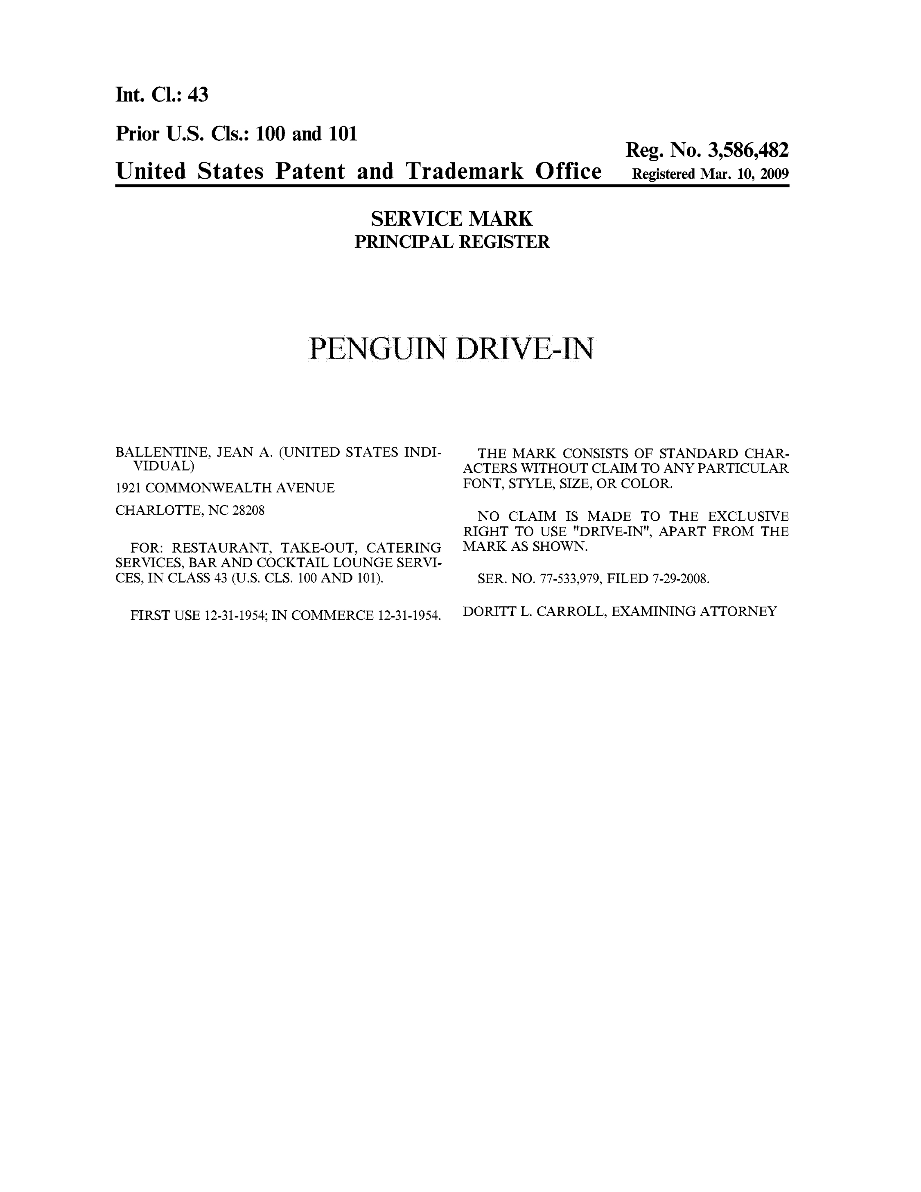

Exhibit D: Trademark Registration of Penguin Drive-In Logo
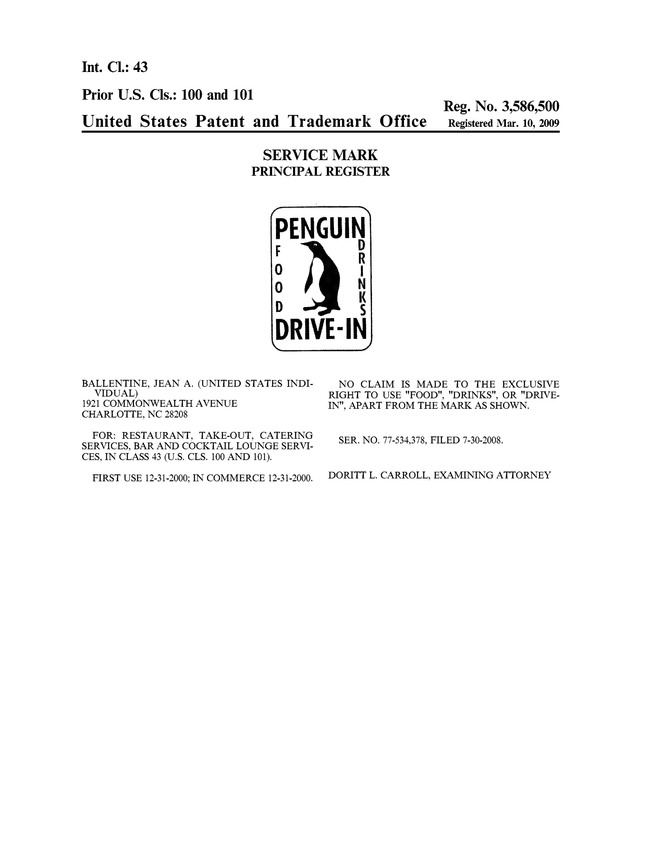

Exhibit E: Press Release Announcing Management Change at Penguin

Press Release
Contact: Jimmy King
Phone: (704) 491-8012
FOR IMMEDIATE RELEASE
September 20, 2010
Penguin Drive-in changes ownership
Charlotte, NC, September 20, 2010: The Penguin Drive-In is changing ownership after 10 years of business in the Plaza Midwood neighborhood. The popular restaurant was leased to current partners Jimmy King and Brian Rowe in 2000, who took the spot from relative obscurity to a thriving hotspot known for their handmade burgers and fried pickles. The Penguin has won numerous awards and received national recognition, including a feature on the Food Network’s series Diners, Drive-ins and Dives. The building’s original owners, the Ballentine family, will not renew the current lease and will retain ownership in the building and the Penguin Drive-In name.
Partners King and Rowe have announced plans to provide many signature items in their new venture, The Diamond Restaurant. The Diamond is a joint venture that includes Andy Kastanas of Soul Gastrolounge. Located at 1901 Commonwealth, The Diamond is currently undergoing extensive renovations with plans to open as a 24-hour diner in late October.
Partner Jimmy King states, “We wish the Ballentine family the best in their endeavors and thank all of our patrons for 10 years of incredible loyalty. We remain firmly committed to this neighborhood. Regardless of The Penguin’s future, we will remain in Plaza Midwood and continue to provide the quality of food and service that we have since re-opening The Penguin in 2000.”
The Penguin Drive-In will cease to operate under the current ownership effective October 24th.

