Searching Basics

Six simple strategies for creating effective database searches.

1. Start with a basic search.
Start by thinking about the main ideas in your research question. For example, in the question,"How can nonverbal communication be used to solve conflict management issues within organizations?"
These keywords can be used in your search statement:
"nonverbal communication" AND "conflict management" AND organizations
If you cannot think of any keywords, try a simple search in a database related to your topic. You can find keywords that you can use to improve your search in the abstracts and subject terms given for useful articles in your results.

2. Use AND and quotation marks to improve your results.
To be sure that a database includes all of your keywords in a search, use AND between them:
"nonverbal communication" AND "conflict management" AND organizations
If you place multi-word phrases (for example, "nonverbal communication") in quotation marks, most databases will search only for articles where the words appear exactly as they do within the quotes.
Using quotation marks will often increase the number of useful articles a search finds.

3. Expand your search using OR.
If you do not find enough useful articles, expand your search by using OR to include additional, related keywords:
"nonverbal communication" AND ("conflict management" OR "conflict resolution" OR mediation OR negotiation) AND organizations
Look through the subject terms, title, and abstract of useful articles you find for keywords related to those that you have used - then try connecting them using OR as shown above. This will often locate useful articles missed in your first search.

4. Expand your search using truncation.
Many databases allow you to use "*" (an asterisk) to truncate a term. Truncating allows you to search for all variations of a word using a single search. For example, a search for ...
negotiat*
... will find articles containing "negotiate," "negotiation," "negotiates," and related words with one search. Broadening a search like this can help you find more useful articles.

5. Exclude words with NOT.
NOT lets you exclude a word from your search - this is helpful when searching with keywords that have multiple or closely related meanings, for example:
"nonverbal communication" NOT "electronic communication"

6. Use subject terms.
Subject Terms, sometimes called descriptors, are words that reflect the main focus of an article in a database. Using subject terms will help you to create searches that are more precise than ones created by just using keyword. This type of search will help you to find articles that address a particular subject. Subject terms are included as part of the article record usually labeled as subjects or descriptors. In the UMUC OneSearch database, for example, all articles on conflict resolution are assigned the subject term "conflict resolution".
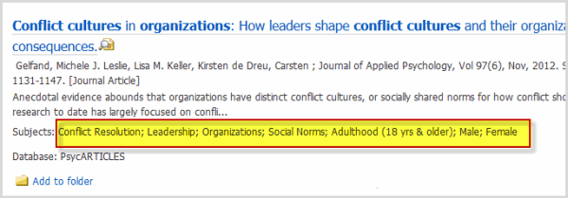
Because these terms are assigned to all articles on a specific topic, using a subject heading as a search term will retrieve only articles on that particular topic. Databases that use subject terms allow you to use their advanced search page to search only the subject terms field of the articles they contain:
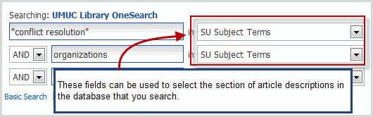
How can I use a database's thesaurus to find subject terms?
Some databases also include an online thesaurus, which you can search to find subject terms related to your research topic.

