Central Park Five Documentary
40-point assignment
Due:
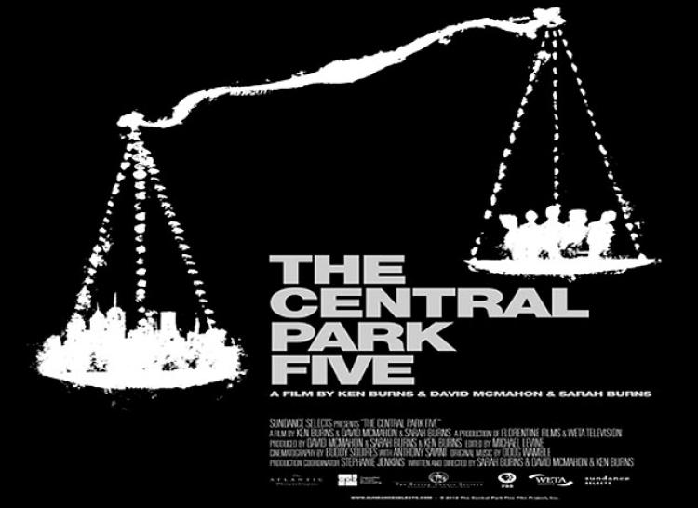
Your next assignment is to watch Ken Burn’s 2012 documentary “Central Park Five.” You have access to this film on Avila’s library page, under the link “Films on Demand.” Watch the entire (almost) 2-hour film, as you are responsible for a summary, a response, and an in-class quiz which will be given (ONLY) on Thursday 11/15.
The definition of RHETORIC is: “The art of effective or persuasive speaking or writing, especially the exploitation of figures of speech and other compositional techniques. Language designed to have a persuasive or impressive effect, but often regarded as lacking in sincerity or meaningful content.” As we discussed during the “product blog” unit, rhetoric can subtly influence what we see and believe, even when we don’t recognize that we are being manipulated by outside forces.
While you’re watching, take careful notes on how RHETORIC is used to manipulate and coerce the five boys’ fates. For example, note how the newspaper headlines impact the public’s opinion during their 1989 trial. Discuss how racial stereotypes influenced the rhetoric used by reporters, attorneys, and more. Pay attention to how/if the media impacts the public’s perception of the case.
Your write-up:
- While you are watching, make a list of 5 ways that RHETORIC (persuasive speech/writing) was used to influence the case against the boys who were accused and convicted of the rape of the Central Park jogger.

- What is your emotional response to this film? After watching it, were you inspired? Discouraged? Angry? Confused? Explain in 1 fully developed paragraph that provides examples from the film.

- Finally, write a 1-paragraph to this question: “Is this 6-year old film still relevant today? If so, what lessons can we learn from it?” Include examples of current events that you see are relevant to the lessons of this film, or examples of ways that the film is no longer relevant. As always, be specific.

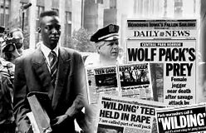
- On Thursday, November 15, you’ll have an in-class quiz that will include one more question about this film. You’ll turn that in with this write-up.

