Learning Objectives
- Be able to engage in effective internal recruitment planning activities
- Apply concepts of closed, open, and hybrid recruitment to the internal recruitment process
- Recognize which recruitment sources are available for internal candidates
- Evaluate internal recruitment based on established metrics
- Be able to evaluate communication messages for internal selection
- Recognize how applicant reactions influence the effectiveness of a recruitment plan
- Understand how affirmative action plans are implemented for internal recruitment

Introduction
Internal recruitment is the process of identifying and attracting current employees for open jobs. Internal recruits have numerous advantages: they already know the organization’s culture, they have already developed relationships with coworkers, and they may require less training than external hires. The nearly ubiquitous presence of internal labor markets underscores the importance of effective internal recruitment. One survey of 725 human resource (HR) professionals found that as a result of recruitment, selection, training, and development costs, organizations are increasingly looking internally to staff positions.1 A majority of those surveyed reported that managing their internal talent pool was either a high (45.6%) or a very high (27.7%) strategic priority in their organization. The development of internal talent was seen as one of the top talent management tasks (63% of respondents), even more so than the acquisition of talent (49.4% of respondents).
Unfortunately, despite the imperative placed on improving talent management, this survey also showed that only 25.7% of organizations have a formal talent management strategy, and only 13.8% of small businesses have a formal talent management system. This relatively limited implementation of effective formal talent management systems means there is much room for improvement. At the same time, a poorly managed internal talent management system can lead to accusations of favoritism, bias, or discrimination. Great care must be taken to ensure that any internal recruitment system is seen as fair.
The first step in the internal recruitment process is recruitment planning. The second step is developing a strategy for where, how, and when to look for recruits. Knowing where to look requires an understanding of open, closed, and hybrid internal recruitment systems. Knowing how to look requires an understanding of job postings, intranets, intra-placement, talent management systems, nominations, page 271in-house temporary pools, replacement and succession plans, and career development centers. Knowing when to look requires an understanding of lead time and time sequencing concerns. The third step consists of the communication message and medium for notification of the job vacancy. The fourth step in the process is developing a job posting system and providing applicants with an understanding of the selection process and how to best prepare for it. The fifth step in the process is the consideration of legal issues. Specific issues to be addressed include Affirmative Action Program regulations, bona fide seniority systems, and the glass ceiling.

STRATEGIC RECRUITMENT PLANNING
Like the external recruitment process, the internal recruitment process involves matching employee KSAOs (knowledge, skill, ability, and other characteristics) to organizational needs. Unlike external recruitment, the management of an internal recruitment process is directed toward channeling and enhancing existing capabilities rather than bringing in new capabilities from the external market. Internal recruitment must be integrated with employee training and development programs. Before identifying and attracting internal applicants to vacant jobs, attention must be directed to organizational and administrative issues that facilitate the effective matching of those applicants with available positions.

Defining Strategic Internal Recruitment Goals
The goals of an internal recruitment system will flow from the organization’s overall strategic goals. Much like external recruitment, an internal perspective on recruitment entails defining goals for attraction, goals for speed, and a time frame, but the operative issues for each of these topics will change.

Mobility Paths and Policies
The internal recruitment system will be crucially dependent on the mobility paths and policies that have been established in the organization. Just as the external labor market can be divided into segments or strata of workers believed to be desirable job applicants, so, too, can the internal labor market of an organization be divided into segments. This division is often done informally inside organizations. For example, managers might talk about the talented pool of managerial trainees this year and refer to some of them as “high-potential employees.” As another example, people in the organization talk about their “techies,” an internal collection of employees with the technical skills needed to run the business.
At a more formal level, organizations must create a structured set of jobs for their employees and paths of mobility for them to follow as they advance in their careers.
page 272

Mobility Paths
A mobility path consists of possible employee movements within the internal labor market structure. Mobility paths are determined by many factors, including KSAO requirements, workforce characteristics, organizational culture, and labor market characteristics. Mobility paths are of two types: hierarchical and alternative. Both types determine who is eligible for a new job in the organization.

Hierarchical Mobility Paths. Examples of hierarchical mobility paths are shown in Exhibit 6.1. As can be seen, the emphasis is primarily on upward mobility in the organization. Due to their upward nature, hierarchical mobility paths are often labeled “promotion ladders.” This label implies that each job is a step toward the top of the organization. Employees often see upward promotions as prizes because of the promotions’ desirable characteristics. Employees receive these prizes as they compete against one another for job vacancies. For example, a promotion might lead to a higher rate of pay, and a transfer may result in a move to a better work location. A great deal of research has been conducted on these types of “tournaments” for higher pay and promotions, with evidence clearly suggesting that individuals increase their effort when faced with the prospect of a large payoff.2 However, this same research suggests that competition can lead to counterproductive behavior, like sabotaging other employees or turnover among those who do not receive promotions.
An exception to the primarily upward mobility in the promotion ladders in Exhibit 6.1 shows the lateral moves that sometimes occur for the staff member who has both generalist and specialist experience as well as corporate and division experience. This staff member is considered more well-rounded and better able to work within the total organization. Experience as a specialist gives the person familiarity with technical issues that arise. Experience as a generalist gives the employee a breadth of knowledge about many matters in the staffing function. Corporate experience provides a policy and planning perspective, whereas division experience provides greater insight into day-to-day operational matters.
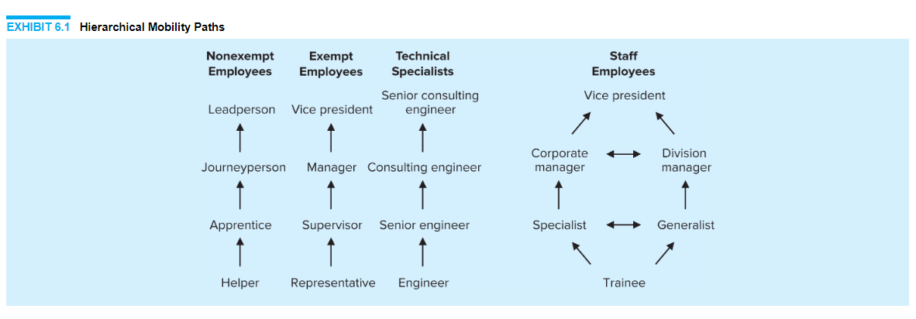
Hierarchical mobility paths make it very easy, from an administrative vantage point, to identify where to look for applicants in the organization. For promotion, one looks at the next level down in the organizational hierarchy, and for transfer, one looks over. Although such a system is straightforward to administer, it is not very flexible and may inhibit matching the best person to the job. For example, the best person for the job may be two levels down and in another division from the vacant job. It is very difficult to locate such a person under a hierarchical mobility path.

Alternative Mobility Paths. Examples of alternative mobility paths are shown in Exhibit 6.2. The emphasis here is on movement in the organization in any direction—up, down, and side to side. Employee movement is emphasized to ensure that each employee is continuously learning and that he or she can make the greatest contribution to the organization. This is in direct contrast to the hierarchical promotion ladder, where the goal is for each person to achieve a position with ever-higher status. Many organizations have shifted to alternative mobility paths for two reasons: (1) there is a need to be flexible given global and technological changes, and (2) slower organizational growth has made it necessary to find alternative ways to utilize employees’ talents.

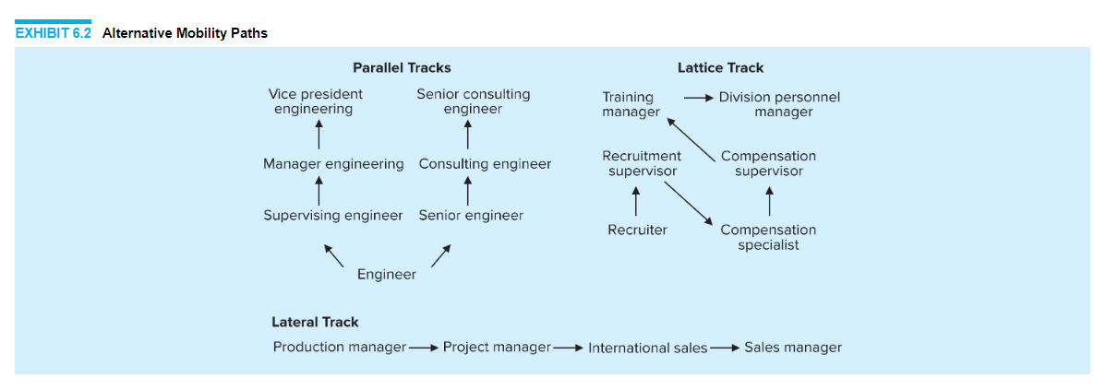
Parallel tracks allow for employees to specialize in technical work or management work and advance within either. Historically, technical specialists had to shift away from technical work to managerial work if they wanted to receive higher-status job titles and pay. In other words, a technical specialist was a dead-end job. Under a parallel track system, however, job titles and salaries of technical specialists are elevated to be commensurate with their managerial counterparts.
With a lateral track system, there may be no upward mobility at all. The individual’s greatest contribution to the organization may be to stay at a certain level for an extended period of time while serving in a variety of capacities, as shown in Exhibit 6.2.
A lattice mobility path has upward, lateral, and even downward movement. For example, a recruiter may be promoted to a recruitment supervisor position, but to continue to contribute to the organization, the person may need to take a downward step to become knowledgeable about all the technical details in compensation. After mastering these details, the person may then become a supervisor again, this time in the compensation area rather than in recruitment. The person may have experience in training from a previous organization and be ready to move to training manager without training experience internal to the organization. Finally, the person may make a lateral move to manage all the HR functions in a division (recruitment, compensation, and training) as a division personnel manager.
Some organizations have adopted a team-based structure, hoping to maximize the information flow, increase flexibility, and minimize boundaries among employees.3 These organizations may do away with formal job titles and ranks altogether, with workers being reassigned to different roles in various project teams as needed. Such a structure is generally found mainly in research and development environments. The role of internal recruitment in such organizations changes completely, as talent management is focused on pairing employee KSAOs with unique project demands that are constantly in flux. This means there is a dramatic increase in the need for assessment of employee KSAOs and collaboration with team leaders to reconfigure groups quickly and efficiently. Such team-focused arrangements can be highly motivational for highly skilled individuals who are self-directed and engaged in their profession.
The downside to alternative mobility paths is that they are very difficult to administer. Neat categories of where to look do not exist to the same degree as with hierarchical mobility paths. On the positive side, however, talented inside candidates who may not have been identified within a hierarchical system are identified because of the flexibility of the system.
When upward mobility is limited in an organization, as in those using alternative mobility paths, special steps need to be taken to ensure that work remains page 275meaningful to employees. If steps are not taken, the organization with limited promotional opportunities risks turnover of good employees. Examples of steps to make work more meaningful include the following:
- Alternative reward systems. Rather than basing pay increases on promotions, pay increases can be based on an individual’s knowledge, skill acquisition, and contribution to the organization as a team member. Research has shown that these programs are successful at encouraging employees to develop job-relevant skills.4
- Team building. Greater challenge and autonomy in the workplace can be created by having employees work in teams where they are responsible for all aspects of work involved in providing a service or product, including self-management.
- Counseling. Workshops, self-directed workbooks, and individual advising can be used to ensure that employees have a well-reasoned plan for movement in the organization.
- Alternative employment. Arrangements can be made for employee leaves of absence, sabbaticals, and consulting assignments to ensure that workers remain challenged and acquire new knowledge and skills.

Mobility Policies
Mobility paths show the relationships among jobs, but they do not show the rules by which people move between jobs. These rules are specified in written policies, which must be developed and should specify eligibility criteria.

Policy Development. It is important to ensure that mobility policies meet organizational goals, are seen as fair by employees, and can be administered easily.5 Fortunately, many of the same principles that enhance policy fit with strategy enhance perceived justice and also make the system easy to apply. These principles include clarity, objectivity, consistency, and transparency. The following are a few key characteristics of an effective mobility policy development process:
- Ensure that leaders of the organization who will be affected by the policy have an opportunity to participate in policy creation.
- Provide clear rationales for overall policy frameworks, linking them to organizational strategy and goals. Link specific mobility path policies to performance-relevant qualifications based on a job analysis (either job requirements or competency based).
- Clearly state rules for how employees will be notified of openings, deadlines, and data to be supplied; how requirements and qualifications are relevant; how the selection process will work; and how job offers will be made.
- page 276Outline employee and supervisor responsibilities and opportunities for development. Develop clear criteria for who is eligible to be considered for a vacancy in a mobility path.
- Communicate procedures and policies to all affected parties.

Policy Implementation. After the organization has developed its mobility policies, a strong set of supporting practices should ensure they are implemented as planned. To facilitate effective implementation of the policies and practices, the organization should match implementation plans to the components of policy creation:
- Continually collect data from leaders regarding the fit of mobility policies with organizational goals. If implementing the policies as written is difficult or interferes with organizational effectiveness, they should be revised.
- Track compliance with preestablished criteria and reinforce why these criteria are important for managers.
- Use tracking systems that ensure communication and selection procedures are followed and that favoritism and bias are minimized.
- Document employee development progress. Methods for tracking should be automated (such as through automatic e-mails or posting to a central career management system) and accessible for users.
- Supervisors and employees should receive regular updates regarding the status of any internal mobility decisions. This can be automated in a manner similar to the development progress system.

Closed, Open, and Hybrid Recruitment
The decision of how to communicate a job announcement to employees is a key component of an internal recruitment system. The choice among closed, open, and hybrid systems can affect employee motivation and perceptions of fairness, so each possibility should be carefully considered.

Closed Internal Recruitment System
Under a closed internal recruitment system, employees are not made aware of job vacancies. The only people made aware of promotion or transfer opportunities are those who oversee placement in the HR department, line managers with vacancies, and contacted employees. Exhibit 6.3 shows how a vacancy is typically filled under a closed system.
A closed system is very efficient. There are only a few steps to follow, and the time and cost involved are minimal. However, a closed system is only as good as the files showing candidates’ KSAOs. If the files are inaccurate or out of date, qualified candidates may be overlooked. Thus, maintaining accurate human resource information systems (HRISs) that track KSAOs regularly is vital.

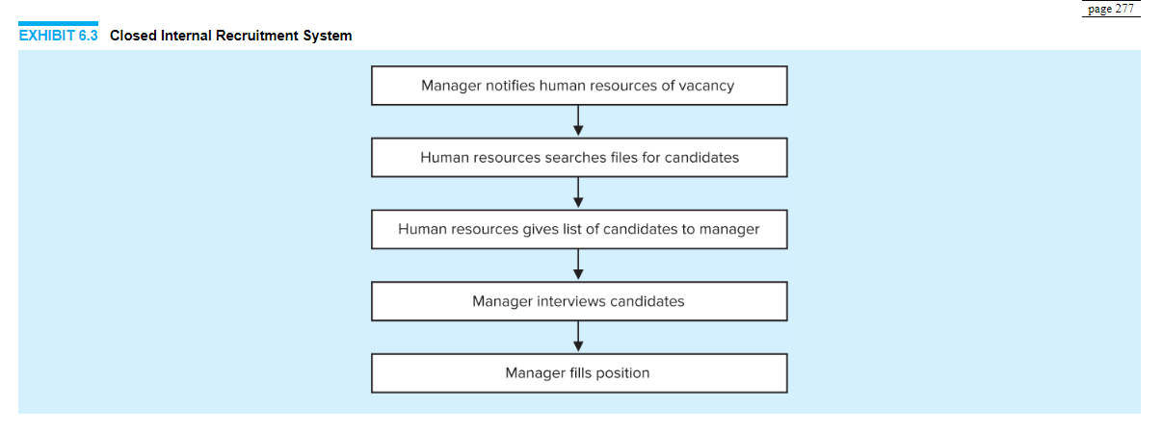

Open Internal Recruitment System
Under an open internal recruitment system, employees are made aware of job vacancies. Usually this is accomplished by a job posting and bidding system. Exhibit 6.4 shows the typical steps followed in filling a vacancy under an open internal recruitment system.
An open system gives employees a chance to measure their qualifications against those required for advancement. It helps minimize the possibility that supervisors will select favorite employees for promotion or transfer, and it often uncovers hidden talent.
An open system may, however, create unwanted competition among employees for limited advancement opportunities. It is a very lengthy and time-consuming process to screen all candidates and provide them with feedback. Employee morale may decrease among those who do not advance.

Hybrid System of Internal Recruitment
Under a hybrid system, both open and closed steps are followed at the same time. Job vacancies are posted and the HR department conducts a search outside the job posting system. Both systems are used in order to cast as wide a net as possible. The large applicant pool is then narrowed down by KSAOs, seniority eligibility, demographics, and availability of applicants.

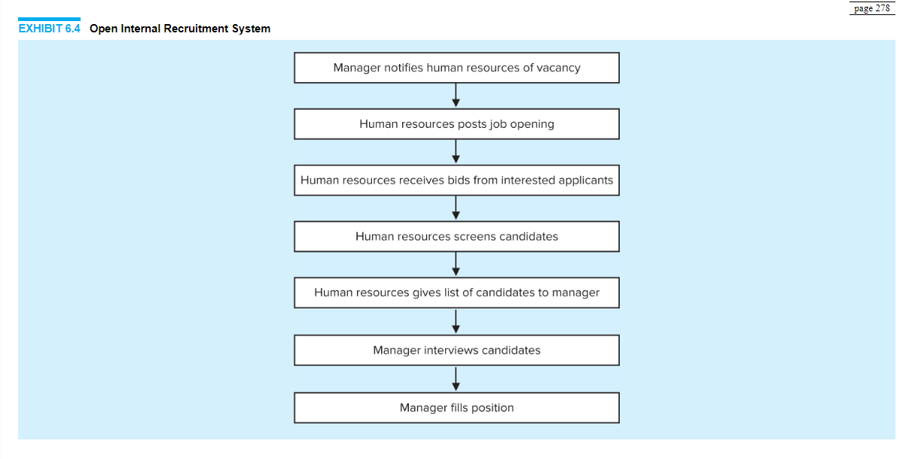
Merico Hotels uses a hybrid system that includes both the training and development of promising employees for specific higher-level positions along with job posting methods.6 The organization’s performance management system encourages employees to specify their potential internal career tracks and indicate which developmental opportunities will help them progress. Those who are identified as high-potential employees receive special training within a formal succession planning system. When jobs open, they are posted via an internal job vacancy software program developed specifically by Merico. Employees who are especially qualified for these openings are alerted by the organization and encouraged to apply.
A hybrid system has four advantages: qualified candidates are identified in advance, a thorough search is conducted, people have equal opportunity to apply for postings, and hidden talent is uncovered. The major disadvantage of a hybrid system is that it entails a time-consuming and costly process.

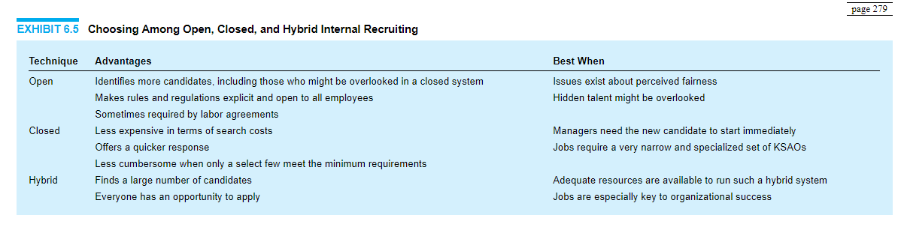

Criteria for Choice of System
In an ideal world with unlimited resources, one would choose a hybrid system of internal recruitment. However, due to resource constraints, most organizations must choose between open and closed systems. Several criteria need to be thoroughly considered before selecting an internal recruitment system. Exhibit 6.5 reviews these criteria.
Although the choice of system is important, the use of staffing software (see Chapter 13) allows bridges to be built between these systems in order to take advantage of the best features of each.

Organization and Administration
Not only must mobility paths and mobility policies be established as part of the planning process, but so too must administrative matters. Administrative matters include coordination, the budget, and the recruitment guide.

Coordination
Internal and external recruitment efforts need to be coordinated and synchronized via the organization’s staffing philosophy. If this is not done, disastrous results can page 280occur. For example, if independent searches are conducted internally and externally, two people may be hired for one vacancy. If only an external recruitment search is conducted, the morale of current employees may suffer if they feel they have been passed over for a promotion. If only an internal recruitment search is conducted, the person hired may not be as qualified as someone from the external market. Because of these possibilities, internal and external professionals must work together with the line manager to coordinate efforts before the search for candidates begins.
To coordinate activities, policies need to be created that specify the number and types of candidates sought both internally and externally. External recruiters should stay in frequent contact with internal placement professionals.

Budget
An organization’s budgeting process for internal recruitment should closely mirror that of external recruitment. The cost per hire may, however, differ between internal and external recruitment. The fact that internal recruitment targets candidates already working for the organization does not mean that the cost per hire is necessarily less than the cost per hire for external recruitment. Sometimes internal recruitment can be costlier than external recruitment because the methods involved in internal recruitment can be quite expensive. For example, internal candidates who are considered for the job but are not hired may need to be counseled on what to do in order to further develop their careers so that they can better compete for the position the next time it is vacant. When an external candidate is rejected, a simple and less costly rejection letter usually suffices.

Recruitment Guide
As with external recruitment, internal recruitment activities involve the development of a recruitment guide, a formal document that details the process to be followed to attract applicants to a vacant job. Included in the plan are details such as the time, money, and staff activities required to fill the job, as well as the steps to be taken to fill the vacancy created by the internal candidate leaving to take on the new job. An example of an internal recruitment guide is shown in Exhibit 6.6.

Timing
A final strategic consideration is for the organization to determine when to look for internal candidates. As with external recruitment, consideration involves the calculation of lead time and time sequencing concerns.

Lead Time Concerns
A major difference between internal and external recruitment is that internal recruitment not only fills vacancies but also creates them. Each time a vacancy is filled with an internal candidate, a new vacancy is created in the spot vacated by the internal candidate.

EXHIBIT 6.6 Internal Recruitment Guide

Position Reassignments Into New Claims Processing Center
Goal: Transfer all qualified medical claims processors and examiners from one company subsidiary to the newly developed claims processing center. Terminate those who are not well qualified for the new positions and whose existing positions are being eliminated.
Assumptions: That all employees have been notified that their existing positions in company subsidiary ABC are being eliminated and that they will be eligible to apply for positions in the new claims processing center.
Hiring responsibility: Manager of Claims Processing and Manager of Claims Examining.
Other resources: Entire human resource department staff.
Time frames:
Positions posted internally on April 2, 2016
Employees may apply until April 16, 2016
Interviews will be scheduled/coordinated during week of April 19, 2016
Interviews will occur during the week of April 26, 2016
Selections made and communicated by last week in May
Positions available and corresponding qualification summaries:
Total number of available positions: 60
6 claims supervisors—4-year degree with 3 years of claims experience, including 1 year of supervisory experience.
14 claims data entry operators—6 months of data entry experience. Knowledge of medical terminology helpful.
8 hospital claims examiners—12 months of claims data entry/processing experience. Knowledge of medical terminology necessary.
8 physician claims examiners—12 months of claims data entry/processing experience. Knowledge of medical terminology necessary.
8 dental claims examiners—12 months of claims data entry/processing experience and 6 months of dental claims examining experience. Knowledge of dental terminology necessary.
8 mental health claims examiners—12 months of claims data entry/processing experience and 6 months of mental health claims experience. Knowledge of medical and mental health terminology necessary.
8 substance abuse claims examiners—12 months of claims data entry/processing experience and 6 months of substance abuse experience. Knowledge of medical terminology necessary.
page 282Transfer request guidelines: Internal candidates must submit internal transfer request and an accompanying cover page listing all positions for which they are applying, in order of preference.
Internal candidates may apply for no more than five positions.
Transfer requests must be complete and be signed by the employee and the employee’s supervisor.
Candidate qualification review process: Transfer requests from internal candidates will be reviewed on a daily basis. Those not qualified for positions for which they have applied will be notified by phone that day, due to the large volume of requests.
All transfer requests and accompanying cover pages will be filed by the position to which they refer. If internal candidates apply for more than one position, their transfer packet will be copied so that one copy is in each position folder.
Once all candidate qualifications have been received and reviewed, each candidate’s transfer packet will be copied and transmitted to the managers for review and interview selection. Due to the large number of candidates, managers will be required to interview only those candidates with the best qualifications for the available positions. Managers will notify human resources with the candidates with whom they would like interviews scheduled. Whenever possible, the manager will interview the candidate during one meeting for all of the positions applied and qualified for.
Selection guidelines: Whenever possible, the best-qualified candidates will be selected for the available positions.
The corporation has committed to attempting to place all employees whose positions are being eliminated.
Managers reserve the right to not select employees currently on disciplinary probation.
Employees should be slotted into a position with a salary grade comparable to their current salary grade. Employees’ salaries shall not be reduced due to the involuntary nature of the job reassignment.
Notification of nonselection: Candidates not selected for a particular position will be notified by electronic message.
Selection notifications: Candidates selected for a position will be notified in person by the human resource staff and will be given a confirmation letter specifying starting date, position, reporting relationship, and salary.

Because of this difference, it is incumbent on the organization to do HR planning along with internal recruitment. This planning involves elements of succession planning (see Chapter 3) and is essential for effective internal recruitment.
Internal and external lead time considerations also differ because in an internal market, the employer can actively participate in identifying and developing the knowledge and skills of the pool of eligible internal employees. Strategic talent management means that the organization identifies crucial skills that will be needed for future positions and begins cultivating these skills in the workforce well in advance.7 By proactively developing needed skills in advance, the organization will be able to significantly reduce the lead time to fill positions with very specific KSAO requirements.

Time Sequence Concerns
As previously noted, it is essential that internal and external recruitment activities be properly coordinated. This is especially true with the timing and sequencing of events that must be carefully laid out for both recruitment and placement personnel. When filling a vacancy, many organizations start with internal recruitment, followed by external recruitment. Issues to be addressed include the time period for the internal search, whether external recruitment can be done concurrently with internal recruitment, and who will be selected if an internal candidate and an external candidate with relatively equal KSAOs are identified.

APPLICANT REACTIONS
Internal applicants will have different considerations than external applicants regarding recruitment methods. Their familiarity with the organization’s structure, reward practices, and decision-making procedures will allow them to better consider the long-term consequences of pursuing an internal position. Because they are already embedded within the organization, they will probably have a longer time horizon and can consider not just the immediate features of the job but also the future benefits of taking on a new position. From the organization’s perspective, it is much easier to evaluate the preferences of internal employees than those of external candidates. Supervisors and other organizational leaders will be able to discuss these preferences at length, and then customize messages to fit individual needs and preferences.
Perceived fairness of an internal recruitment process is extremely important. A potential applicant who feels that a company’s external recruitment policy is unfair is unlikely to pursue a job opportunity, and that generally will mark the end of the interaction. An employee who feels that his or her company’s internal recruitment policy is unfair will remain an employee, and the negative perceptions may spill page 284over to reduce motivation, engagement, and performance and might even lead to turnover. As noted earlier in the “Policy Development” and “Policy Implementation” sections, issues of fairness should be resolved through transparency, objectivity, consistency, and clarity. Reviews of the evidence suggest that procedures may be nearly as great a source of dissatisfaction to employees as decisions.8 In some organizations, dissatisfaction arises because there is no formal policy regarding promotion and transfer opportunities. Ensure that employees are aware of opportunities for which they are qualified, and clearly state the underlying logic for encouraging candidates to take different internal mobility paths.

COMMUNICATION
Once the planning and strategy development phases have been conducted, it is time to conduct the search. As with external recruitment, informing potential applicants about the opening and the characteristics of the position will have a strong influence on the types of individuals who apply. However, the content of the message and the media through which it will be transmitted are quite different.

Communication Message
Like the external recruitment message, the internal recruitment message can be realistic, targeted, or branded. A realistic message portrays the job as it really is, including positive and negative aspects. A targeted message points out how the job matches the needs of the applicant. A branded message emphasizes the value, culture, and identity of the unit to attract applicants who fit the brand label. For internal recruitment, information will be presented regarding the culture of the work unit or division and how it differs from other areas of the organization. The internal applicant will have more information about the organization and its practices than would most external applicants, but any additional information about the job itself might not be accurate and might arrive via rumors or other unreliable internal communication methods. Therefore, any recruitment message should take the internal image of the job into account.
Branded messages can emphasize how a specific area of the organization offers unique opportunities to internal applicants. This information can be communicated in a way that takes advantage of what employees already know about the job and organization. For example, a company expanding into a new regional market can describe how taking on a position in this new region will be a unique opportunity for personal and professional growth, with detailed information regarding specific products and initiatives that are active in that area, and even mention of key individuals whose reputations might be known in the organization who are also active in that area.
Targeted messages along with inducements are likely to attract experienced internal employees. Because internal applicants will be personally known by page 285coworkers and supervisors, messages can be specifically targeted around each person’s identified needs and desires. Targeted messages about the desirability of a position and the actual rewards should come directly from the job rewards matrix. The hiring manager needs to clearly communicate factual information in the job rewards matrix, rather than offers of potential rewards that the manager may not be able to provide.
Realistic messages can be communicated using a technique known as a realistic job preview (RJP). This technique needs to be carefully applied for internal recruitment because applicants may already have a picture of the job since they are already a member of the organization. It should not be automatically assumed that all internal candidates have accurate information about the job and organization. In fact, word-of-mouth information, such as rumors, within the organization can lead internal recruits to have inaccurate perceptions about a job that need to be corrected. RJPs are particularly appropriate for internal applicants when they move to an unknown job, a newly created job, or a new geographic area, including an international assignment. Alternatively, it is often possible to give internal recruits informational interviews with future coworkers, site visits, or even hands-on experience in the new work environment, which is less feasible with external recruits.

Communication Media
The actual methods or media used to communicate job openings internally include formal job postings, direct contact with potential supervisors and peers, and word of mouth. In most cases, all three media should be considered as potential parts of the process, although only the first two are encouraged.
A job posting should clearly define the duties and requirements of the job as well as the eligibility requirements. To ensure consistency and fair treatment, job postings are usually coordinated by the HR department. Other documents used to communicate a vacancy may include a description of the work unit and its location as well as a description of the job. A brochure or video can also be created to show and describe what the job and its location are like. Such a message would be important to applicants asked to relocate to a new geographic area or to accept an international assignment.
Potential supervisors and peers can describe to the internal applicant how the position he or she is considering fits into the larger organizational picture. Supervisors are knowledgeable about how the position fits with the strategic direction of the organization. Hence, they can communicate information regarding the expansion or contraction of the business unit within which the job resides. Moreover, supervisors can convey the mobility paths and requirements for future movement by applicants within the business unit, should they be hired. Peers can supplement these supervisory observations by giving candidates a realistic look at what actually happens by way of career development.
Word of mouth is difficult for the organization to control when it comes to external applicant searches, but it can be much more problematic for internal searches. This can be a highly selective, inaccurate, and haphazard method of communicating information. It is selective because, by accident or design, not all employees hear about vacant jobs. Talented personnel, including underrepresented groups, may thus be overlooked. It is inaccurate because it relies on second- or thirdhand information; important details, such as actual job requirements and rewards, are omitted or distorted as they are passed from person to person. Informal methods are also haphazard in that there is no regular communication channel specifying set times for communicating job information. As a result of these problems, the organization should be aware of word-of-mouth influences and attempt to minimize their effect on the applicant identification and attraction process.

STRATEGY IMPLEMENTATION
After the focus of the strategic recruitment search has been established and communication messages and media have been evaluated, the organization must develop a strategy to access viable internal job applicants.

Recruitment Sources
The choice of recruitment sources in an internal search is closely related to whether a closed, open, or hybrid system is employed. Some of the techniques described below are clearly more appropriate for a closed search, while others are more suited to an open search. One unique feature of the internal recruitment effort is that various sources overlap with one another and will likely be used simultaneously.

Job Postings
A job posting system is similar to the use of organizational websites in external recruitment. A posting spells out the duties and requirements of available jobs and provides a portal through which internal applicants can submit their materials. Organizations do not have to build these internal systems from the ground up; many HRIS developers integrate internal job posting systems into their programs. This means that when a job that has been designated as part of the internal market comes open, full posting information based on job analysis records can easily be put on the company intranet in one integrated process. Smaller organizations with less robust internal labor markets may post jobs through e-mails rather than through establishing a dedicated internal recruitment site. E-mail contact with selected individuals can also be part of a closed recruitment system as well.
An example of the type of information found in an internal job posting is shown in Exhibit 6.7. Such information includes the job title, category, compensation, and work schedule. A brief overview of desired qualifications and a job description can page 287be pulled directly into the system from job analysis files. Work unit descriptions can also be developed and standardized to make the process of uploading a new position more efficient. Finally, application instructions link the user to three different portals. The submission portal leads to a series of pages where applicants can submit their qualifications and statement of interest. The appraisal information portal allows applicants to link their individual application to previous performance appraisal information in the HRIS. Finally, the recommendation portal allows the applicant to request recommendations from other individuals within the organization; these requests generate e-mail messages to the relevant parties with information on how to submit a recommendation to the system. This example shows a very basic, utilitarian format for the posting, but many organizations supplement their postings with images of or personal messages from individuals working in similar roles.

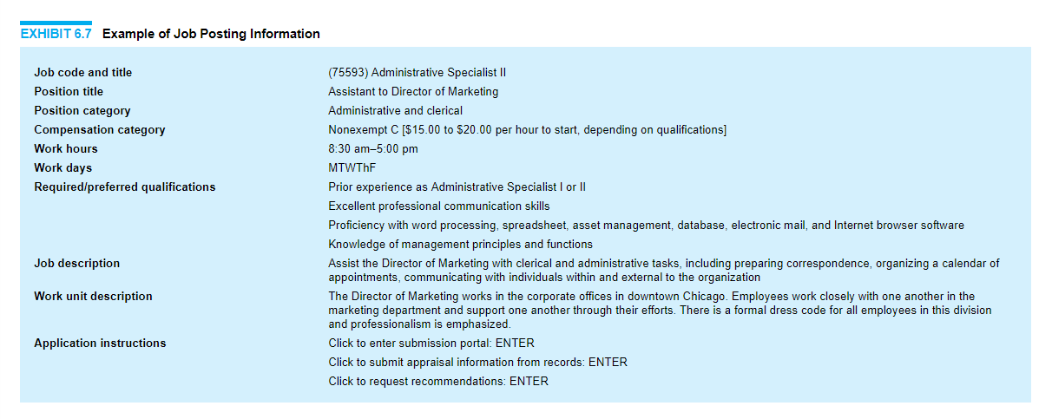
Despite their advantages, internal job posting systems have some drawbacks. Examples of such difficulties include situations where employees believe that someone was selected before the job was posted (a “bagged” job), cumbersome systems where managers and HR personnel are overwhelmed with résumés of unqualified candidates, and criticisms that the HR department is not doing an effective job of screening candidates for positions.
Another important issue with posting systems is in providing feedback. Not only do employees need to know whether they have received the job, but those who did not receive the job need to be made aware of why they did not. Providing this feedback serves two purposes. First, it makes job posting part of the career development system of the organization. Second, it invites candidates to bid on future postings. If employees are not given feedback, they may be less likely to bid for another job because they feel that their attempts are futile.

Talent Management System
A talent management system is a comprehensive method for monitoring and tracking the utilization of employee skills and abilities throughout the organization.9 The process of talent management is closely aligned with replacement and succession planning—talent management systems track the KSAOs of the workforce, and then replacement and succession planning translates this information into concrete action plans for specific job roles. Although talent management involves performance management and training processes in addition to managing the internal recruitment process, tracking employees’ KSAOs and their use in the organization is the key component of talent management systems.
Although a number of different models for implementing talent management systems exist, there are a few key processes common to most. The first stage of the process is identifying the KSAOs required for all jobs in the organization. This information can be obtained from job descriptions and job specifications. The complete set of KSAOs required across the organization will then be compiled into a master list. The current workforce will need to be assessed for its competence in this set of KSAOs, usually as an adjunct to routine performance evaluations. When positions come open, managers make a query to the talent management system to determine which employees are eligible. A process should be in place to make regular comprehensive examinations of the changing nature of KSAO requirements throughout the organization. Information from these analyses can then be used as page 289a springboard for developing comprehensive plans for training and development experiences.
There has been such a strong integration of database software for talent management systems that when staffing managers refer to them, they are often talking about the specific HRIS that is used to facilitate tracking KSAOs in the workforce. While these database applications offer great promise for coordinating information, many managers find operating talent management systems challenging. Most of the problems in implementing the systems in practice do not come from a lack of technology but from an excess of technology that cannot be understood by line managers. A few principles should be borne in mind when developing or evaluating a user-friendly talent management system:
- Keep the format for entering data as simple as possible.
- Have an easy method for updating basic information with each performance evaluation cycle.
- Make it easy to perform database queries.
- Provide varied formats for obtaining reports.
- Ensure that information is confidential.
- Make it possible to perform statistical analyses using relational databases.
- Integrate data with other HR files.

Nominations
Nominations for internal candidates to apply for open positions can be solicited from potential supervisors and peers. These individuals are an excellent source of names of internal candidates, as they are familiar with what is required to be successful in the position. They can help establish the criteria for eligibility and then, through their contacts in the organization, search for eligible candidates. Self-nominations are also useful in that they ensure that qualified candidates are not inadvertently overlooked using other applicant searching methods. Self-nomination is an especially important consideration in the internal recruitment of minorities and women.

In-House Temporary Pools
In-house temporary pools are important to the temporary staffing of organizations, and they are also an excellent source of permanent internal employment. Unlike employees hired through external staffing agencies, those employed through in-house temporary pools are legally treated as employees. Therefore, the full legal liability for these employees falls exclusively on the employer. Using in-house temporary employees has a number of advantages.10 Internal temporary employees require less orientation to the organization than external hires. Staffing agencies typically charge an employer an hourly fee for each temporary employee. But with an internal system, because the employer does not have to pay an hourly fee to an page 290external agency, the cost savings can be applied to higher levels of compensation and benefits. It is also easier for an organization to ensure the quality and person/organization fit for employees from an in-house pool relative to a pool of external hires. Temporary employment can also serve as an “audition” for full-time employment, allowing the temporary employee to try out a number of positions until the employee and the organization agree on a good person/job match. In health care, it is common to have “float” staff who are assigned to different units regularly, depending on the organization’s needs. These pools are especially valuable in this highly specialized field because quality control and knowledge of organizational policies and procedures are crucial for performance. Surveys of health care organizations show that these pools are seen as an important and effective tool for enhancing performance and minimizing costs.11 Substitute teachers are staffed in a similar manner. Such employees must be adaptable to different situations, and the organization must ensure that the employees have sufficient work. In addition, extra training may be needed for these employees since they are expected to have a broad range of skills in their repertoire.

Replacement and Succession Plans
A critical source of internal recruitment is provided by the results of replacement and succession planning. Most succession plans include replacement charts (see Chapter 3), which indicate positions and who is scheduled to fill those slots when they become vacant. Replacement charts usually also indicate when the individual will be ready for the assignment. Succession plans are organized by position and list the skills needed for the prospective position (i.e., “for the employee to be promoted into this position from her current position, she needs to develop the following skills”).
It is critical that succession planning be future oriented, lest the organization plan be based on historical competencies that fail to meet new challenges. Software exists to assist organizations with succession planning. Companies like Saba Succession, HRsmart, Silk Road Technology, and PilatHR Solutions offer succession planning packages used by many Fortune 500 companies that interface with an organization’s HRIS. These packages provide replacement charts and competency libraries that allow an organization to identify developmental activities and assignments for individuals in the replacement charts.
CEO succession has always been an important issue for organizations, but never more so than today. The need for employee development has heightened as an increasing proportion of the workforce is approaching retirement. There is great concern among career development specialists that the mass retirement of baby boomers will lead to a loss of organizational memory and knowledge built up with experience. Having strong succession planning techniques that will enable the more recently hired workforce to acquire knowledge from its experienced coworkers before moving into managerial positions is one way to minimize the impact of mass retirements. Interviews with executive recruiters and CEOs have found that industry- and organization-specific competencies are highly desirable.12 This underscores the need to develop these attributes in-house, since they will be hard to find on the open labor market.
The key to avoiding potential fiascoes is to have a succession plan for CEOs. A major retrospective study of CEO transition failures conducted by the Conference Board found that about half of organizations have neither an emergency succession plan nor a long-term succession plan.13 Key shortfalls identified in CEO succession plans include misalignment of hiring criteria with strategic organization needs, a fear of antagonizing the current CEO by trying to identify potential replacements, and a lack of investment in developing the entire workforce from the bottom up.
A succession plan should begin with a thorough job analysis and a listing of the characteristics and behaviors of a successful CEO.14 The organization should not leave it to the CEO to identify a successor. CEOs are typically not trained or experienced in staffing, and they may have selfish motives in appointing a successor. Alternatively, they may avoid appointing a successor altogether, thus keeping themselves in the job. Therefore, the board must be deeply involved in the selection process. Boards also need to realize that the succession process should begin well before the CEO departs; in fact, it should be a continuous process. Appropriate succession plans should also examine the pipeline for individuals to replace the top management team members (e.g., chief financial officer, chief operating officer, senior vice presidents) who might replace the CEO. As we saw in the planning chapter, each time an internal promotion occurs, it creates a need to staff the position of the individual who was promoted.

Career Development Centers
To facilitate internal transfers, many organizations have an internal office of career development that helps employees explore career options available within the organization.15 Career development centers provide employees with opportunities to take interest inventories, assess their personal career goals, and interview with representatives across the organization. The goal of career development centers is twofold. First, employees learn about themselves and have a chance to think about what they really want to achieve in their careers. Second, employers have a chance to explain the career options within the organization and develop methods to structure internal career paths that match the interests of their employees. Surveys conducted in numerous organizations consistently demonstrate that employees are more satisfied when their employers provide them with ample communication and opportunities for internal advancement—an interactive career development center can do both.16
The interest inventories provided in career development centers often take the form of multiple-choice questionnaires that ask employees to indicate their preferred work activities. For example, respondents might be asked whether they prefer tasks page 292that involve analytical processes like analyzing financial data or more social tasks like motivating a group of workers. After completing these surveys, employees compare their work preferences with the profiles of activities in a variety of jobs. Career development counselors can help talk employees through their thoughts and concerns about job options. Ideally, these career development inventories, coupled with careful analysis of KSAOs, will be paired with job analysis information to improve the person/job match. If employees lack the required KSAOs, career development counselors can suggest developmental work experiences or training opportunities.
Any assessment of career development centers needs to take the organization’s bottom line into account.17 Having full-time career development staff is a significant cost for any organization, and it is unlikely that small or medium-sized organizations will find it cost-effective to develop a comprehensive career development center. For smaller organizations, it is more advisable to develop smaller-scale informal initiatives based on personal interactions. Smaller organizations can make use of some career development tools by bringing in external career coaches or consultants to work with individuals who are especially interested in career development within the organization. To reduce costs, employees could take their career development profiles and receive initial feedback through web-based surveys. These electronic survey options save money by reducing staff needs, and employees will not need to go to the career development offices to receive initial counseling.
Although career development centers are complicated to develop and expensive to maintain, they offer organizations an opportunity to help employees learn about a large spectrum of careers. By providing employees with a clear sense of how they can direct their own careers, it is hoped that job satisfaction will increase and thus lead to increased retention. Because of the cost of career development services, it is especially important to keep track of the return on investment for these services.

Recruitment Metrics
Like external recruitment sources, each internal recruitment source has strengths and weaknesses. Exhibit 6.8 provides an overview of the metrics that might be expected for the categories of recruitment activities, along with issues considered relevant to each source. There is far less research on the costs and benefits of internal recruitment techniques, so our comments here are necessarily somewhat speculative; it is likely that each organization will need to consider its unique needs even more thoroughly than it would when selecting external recruitment methods.

Sufficient Quantity
Because the organization’s pool of employees will necessarily be smaller than the general labor market, most internal recruitment methods will have far lower quantity yields. Techniques that permit job postings and use of the organization’s intranet will likely produce far more candidates for promotion and advancement than will succession plans.

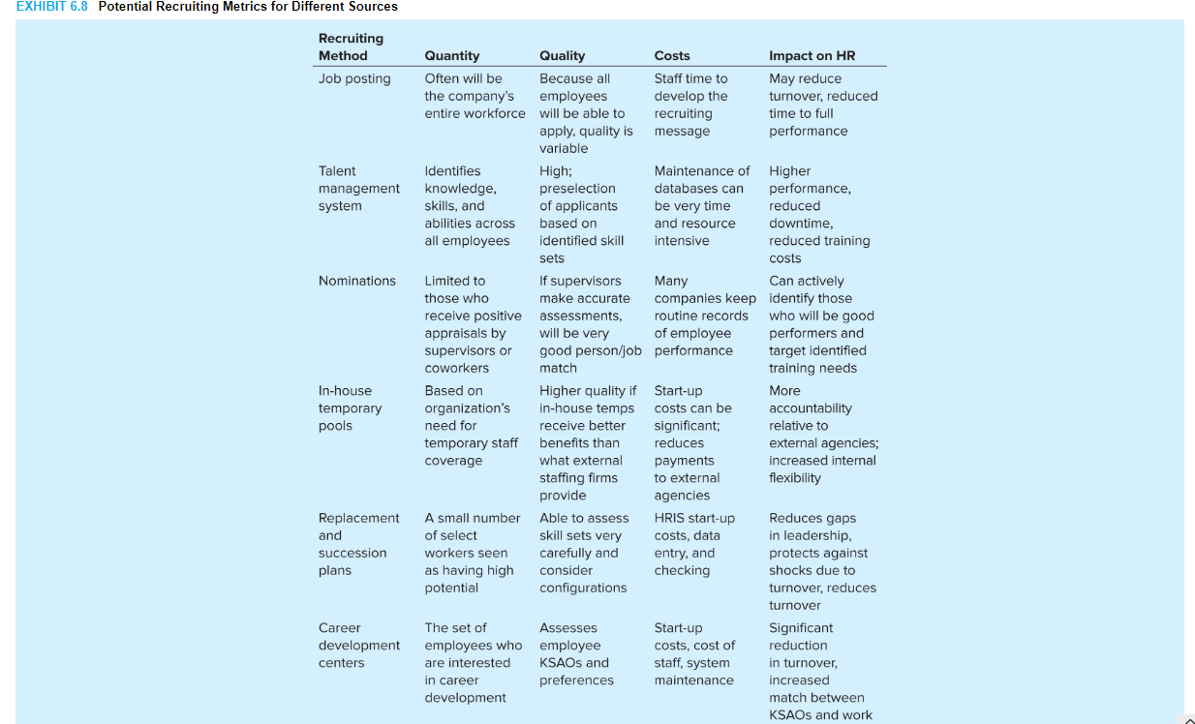

Sufficient Quality
The degree to which the organization utilizes its own internal information on candidate qualifications and job performance to narrow the pool will determine how qualified the applicants will be. In assessing applicant characteristics, organizations that have internal recruitment systems have a huge advantage over those that use external recruitment systems, so the ability of each source to draw in qualified internal candidates should capitalize on the additional capacity to carefully observe them. Regular performance appraisals of all employees, coupled with talent management systems to track KSAOs, are a vital part of an effective internal recruitment system.

Cost
Internal recruitment methods have a completely different set of costs than external recruitment methods. In some ways, internal recruitment can be far less expensive than external recruitment because the organization’s own internal communication systems can usually be utilized. It costs very little to send an e-mail to all qualified staff informing them of job opportunities or to post job advertisements on a physical or an electronic bulletin board. However, more sophisticated systems, such as a corporate intranet or comprehensive talent management system, take more personnel resources to set up and maintain. Career development centers are very costly propositions, and only organizations with considerable internal placement needs will find them cost-effective.

Impact on HR Outcomes
Very little research has been done on the effectiveness of various internal recruitment sources. Thus, it is imperative that organizational leaders consider how their internal recruitment systems affect turnover rates, job performance, and diversity. Despite the lack of research, it should be easier to monitor these outcomes directly, because it is easier to directly measure the applicant pool contacted through internal methods. From anecdotal observations, some preliminary conclusions can be drawn regarding the advantages of internal placement. There is some evidence that internal career opportunities can reduce turnover intentions.18 Internal recruitment methods may reduce the time it takes for employees to reach full performance once placed, because they will already be familiar with the organization and may know more about the job in question than an external hire would. Any costs of internal recruitment should be compared against the costs of external recruitment, and the replacement of the employee who takes an internal position should also be taken into account.
page 295

TRANSITION TO SELECTION
As with external recruitment, once a job seeker has been identified and attracted to a new job, the organization needs to prepare the person for the selection process. It should not be assumed that just because job seekers come from inside the organization they automatically know and understand the selection procedures. With the rapid advances being made in selection methods, the applicant might encounter methods that are different from those he or she previously experienced. Even if the same selection methods are used, the applicant may need to be refreshed on the process since much time may have elapsed between the current and previous selection decisions.
In many organizations, the most significant internal mobility decisions involve moving an individual from a role as an individual contributor to the management ranks. In this case, the process of “recruitment” incorporates sharing information about what the organization is looking for in a leader and then helping the employee develop these appropriate skills.19 In other words, recruitment, selection, and development come together in a succession management effort. When an employee has been identified as having some potential for leadership, there should be a gradual process of preparing him or her for the new role with self-development exercises. The employee’s interest in the position should be assessed to ensure that she or he is interested in mobility. The employee’s capacity to develop these skills should also be evaluated on an ongoing basis without committing to the mobility decision prematurely. Frequent communication regarding needed skills, job expectations, and responsibilities will help facilitate a smooth transition once the organization decides to offer the employee a higher-level position.

LEGAL ISSUES
The mobility of people within the organization, particularly upward, has long been a matter of equal employment opportunity/affirmative action (EEO/AA) concern. The workings of the internal labor market rely heavily on internal recruitment activities. Like external recruitment activities, internal recruitment activities can operate in exclusionary ways, resulting in unequal promotion opportunities, rates, and results for certain groups of employees—particularly women, minorities, people with disabilities, and veterans. Both the Equal Employment Opportunity Commission (EEOC) and the Office of Federal Contract Compliance Programs (OFCCP) have strong positions on improving advancement for these targeted groups. Seniority systems are likewise subject to legal scrutiny, particularly regarding what constitutes a bona fide system under the law. More recently, promotion systems have been studied as they relate to the glass ceiling effect and the kinds of barriers that have been found to stifle the upward rise of minorities and women in organizations.
page 296

Affirmative Action Programs
As is the case with external recruitment, the EEOC and OFCCP require strong actions by the organization to improve promotion opportunities and results for protected groups. The EEOC provides a set of employer best-practice ideas for such actions. The list is shown in Exhibit 6.9.

Bona Fide Seniority Systems
Title VII (see Chapter 2) explicitly permits the use of bona fide seniority systems as long as they are not the result of an intention to discriminate. This position presents the organization with a serious dilemma. Past discrimination in external staffing may have resulted in a predominantly white male workforce. A change to a nondiscriminatory external staffing system may increase the presence of women and minorities within an organization, but they will still have less seniority than the white males. If eligibility for promotion is based on seniority and/or if seniority is an actual factor considered in promotion decisions, those with less seniority are less likely to be promoted. Thus, the seniority system will have an adverse impact on women and minorities, even though there is no current intention to discriminate. Is such a seniority system bona fide?
Two points are relevant here. First, the law does not define “seniority system.” Generally, however, any established system that uses length of employment as a basis for making decisions (such as promotion decisions) is interpreted as a seniority system. Promotions based on ad hoc judgments about which candidates are “more experienced,” however, would not likely be considered a bona fide seniority system.20 Seniority systems can and do occur outside the context of a collective bargaining agreement.
Second, current interpretation is that, in the absence of discriminatory intent, virtually any seniority system is likely to be bona fide, even if it causes adverse impact.21 This interpretation incentivizes the organization not to change its current seniority-based practices or systems. Other pressures, such as the Affirmative Action Program Regulations or a voluntary affirmative action plan (AAP), create an incentive to change in order to eliminate the occurrence of adverse impact in promotion. The organization thus must carefully consider exactly what its posture will be toward seniority practices and systems within the context of its overall AAP.
Under the Americans With Disabilities Act (ADA), there is potential conflict between needing to provide reasonable accommodation to an employee (such as job reassignment) and provisions of the organization’s seniority system (such as bidding for jobs based on seniority). According to the Supreme Court, it will ordinarily be unreasonable (undue hardship) for a reassignment request to prevail over the seniority system unless the employee can show some special circumstances that warrant an exception.

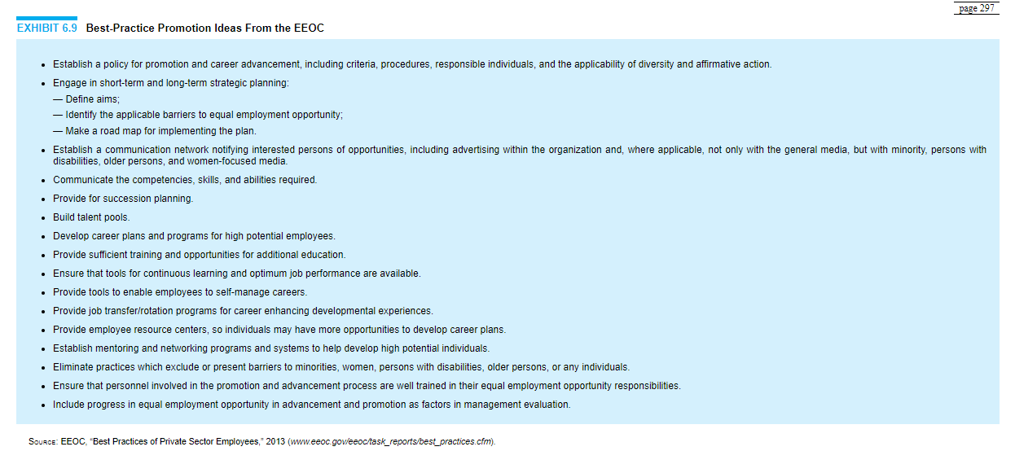

The Glass Ceiling
The “glass ceiling” is a term used to characterize strong but invisible barriers to promotion in the organization, particularly to the highest levels, for women and minorities. Evidence demonstrating the existence of a glass ceiling is substantial. The overall labor force is 74% white and 54% male. At the very top in large corporations, senior-level managers are overwhelmingly white males. As one goes down the hierarchy and across industries, a more mixed pattern of data emerges. EEOC data show that nationwide the percentage of women who are officials and managers has increased to over 36.4%. In some industries, particularly health care, retail, legal services, and banking, the percentage of women managers is substantially higher. Women account for over 51% of employees in management, professional, and related occupations. In other industries, such as manufacturing, trucking, and architectural/engineering services, the percentage of women managers is much lower (13%–18%).22 An important study of women’s representation in the corporate pipeline across 118 diverse companies found that their representation decreased as follows: entry-level professional (43%), manager (37%), senior manager/director (32%), vice president (27%), senior vice president (23%), C-suite (17%). Moreover, women’s expected representation at each level was 15% lower than that of men, suggesting broad promotion barriers.23
Unfortunately, similar kinds of data for minorities are not available, though few doubt a general underrepresentation of minorities in managerial roles as well. Thus, the closer to the top of the hierarchy, the thicker the glass in the ceiling. At lower levels, the glass becomes much thinner. Across industries, there are substantial variations in this pattern.
Where glass ceilings exist, two important questions should be asked: What are the reasons for a lack of upward mobility and representation for minorities and women at higher levels of the organization? What changes need to be made, especially staffing-related ones, to help shatter the glass ceiling?

Barriers to Mobility
An obvious conclusion from such data is that there are barriers to mobility, many of which originate from within the organization. The Federal Glass Ceiling Commission conducted a four-year study of glass ceilings and barriers to mobility. It identified many barriers: lack of outreach recruitment practices, lack of mentoring training in revenue-generating areas, lack of access to critical developmental assignments, initial selection for jobs in staff areas outside the upward pipeline to top jobs, biased performance ratings, little access to informal networks, and harassment by colleagues.24 Added to this list should be another important barrier, namely, child rearing and domestic responsibilities that create difficult work/life balance choices.
The study mentioned above of women in corporate pipelines in 118 companies looked at representation in line roles (positions focused on core operations page 299and with profit and loss responsibility) and staff roles (support positions for line management, such as legal, accounting, human resources, and IT). Going up the hierarchy, women increasingly held staff roles, while men did not. Since promotion to senior-level line positions usually requires line experience, women’s chances of advancement to senior line roles lessened. This finding is consistent with the findings of the Federal Glass Ceiling Commission, and it highlights the critical importance of line role experience for advancement to top leadership positions.25
Other causal factors for advancement disparities also were found. These included somewhat less desire by women for a top job (especially due to stress/pressure of the role, and lack of interest in the role); women’s perceptions that they have fewer opportunities than men and that their gender has inhibited their advancement success so far; a belief that gender diversity is not a priority for their CEO or direct manager; low participation in work flexibility (e.g., part-time schedule, family leave), professional development (e.g., coaching sessions, executive training), and family-oriented flexibility programs (e.g., maternity leave) due partly to fear of being penalized for using the program; uneven distribution of household/child care chores; and fewer men in women’s professional networks.

Overcoming Barriers
It is generally recognized that multiple actions, many of them beyond just staffing-system changes, will be needed to overcome barriers to mobility. Exhibit 6.10 shows a suggested listing of such actions. They include both recruitment and other actions.

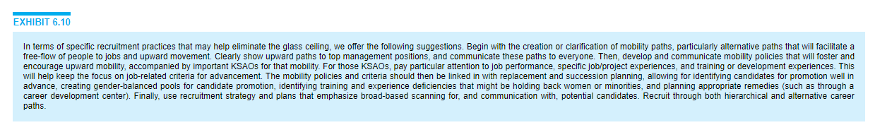
An example of a far-reaching diversity initiative to expand the internal diversity pipeline is the Championing Change for Women: An Integrated Strategy program at Safeway, a retail grocery giant. A focal point is the Retail Leadership Development (RLD) program, a formal full-time career development program for entry-level grocery store employees to prepare them for moving up into the management ranks (90% of store managers and above come through the program). The program has a particular focus on women and people of color. Employees apply for the program by taking a retail knowledge and skill exam. Those who complete the program are immediately assigned to a store as an assistant manager—the stepping stone to further advancement. To support the advancement program, all managers attend a managing diversity workshop, receive additional on-the-job education, and have access to a toolkit to help them incorporate diversity discussions into their staff meetings. Managers are evaluated in part on their success in meeting diversity goals, and bonus money is riding on that success. Every manager is also expected to serve as a mentor, helping his or her protégés acquire the KSAOs necessary for continued advancement. Other elements of the program include strong support and participation from the CFO and from women’s leadership network groups (for black, Asian, Hispanic, and LGBT [lesbian, gay, bisexual, and transgender] employees), modification of a requirement to relocate in order to gain experience, and work/life balance initiatives for employees with and without children. Since the program was initiated, the number of women who qualified for and completed the RLD program has risen 37%, and the number of women store managers has increased by 42% (31% for white women and 92% for women of color).26
In summary, solutions to the glass ceiling problem require myriad points of attack. First, women and minorities must have visibility and support at top levels—from the board of directors, the CEO, and senior management. That support must include actions to eliminate prejudice and stereotypes. Second, women and minorities must be provided with job opportunities and assignments that will allow them to develop the depth and breadth of KSAOs needed for ascension to, and success in, top management positions. These developmental experiences include assignments in multiple functions, management of diverse businesses, line management experience with direct profit-loss and bottom-line accountability, diverse geographic assignments, and international experience. Naturally, the relative importance of these experiences will vary according to the type and size of the organization. Third, the organization must provide continual support for women and minorities to help ensure positive person/job matches. Included here are mentoring, training, and flexible work-hour systems. Fourth, the organization must gear up its internal recruitment to aggressively and openly track and recruit women and minority candidates for advancement. Finally, the organization must develop and use valid methods of assessing the qualifications of women and minority candidates (see Chapters 8 and 9).27
page 301

SUMMARY
The steps involved in the internal recruitment process—planning, strategy development, and communication—closely parallel those in the external recruitment process. With internal recruitment, the search is conducted inside rather than outside the organization. In situations where both internal and external searches are conducted, they need to be coordinated with each other.
The planning stage requires that the applicant population be identified. The process begins by understanding strategic recruitment goals. Next, an understanding of mobility paths in the organization and mobility path policies is a vital part of deciding how to implement internal recruitment. To access the internal applicant population, attention must be devoted in advance of the search to the number and types of contacts, the budget, development of a recruitment guide, and timing. Understanding applicant reactions to internal recruitment policies is also crucial for developing effective systems.
When searching for candidates, the message to be communicated can be realistic, targeted, or branded. Which approach is best depends on the applicants, job, and organization. The message is usually communicated with a job posting. It should, however, be supplemented with other media, including input from potential peers and supervisors. Informal communication methods with information that cannot be verified or that is incomplete are to be discouraged.
There are a variety of internal methods for taking applications in the strategy implementation phase. These include posting information about jobs on the company intranet and career development centers with interest inventories and counseling staff. Just as with external recruitment, multiple criteria must be considered in choosing internal sources.
The organization needs to provide the applicant with assistance for the transition to selection. This assistance requires that the applicant be made fully aware of the selection process and how to best prepare for it. Taking this step, along with providing well-developed job postings and clearly articulated mobility paths and policies in the organization, should help applicants see the internal recruitment system as fair.
Internal recruitment activities have long been the object of close legal scrutiny. Past and current regulations make several suggestions regarding desirable promotion system features. The relevant laws permit bona fide seniority systems, as long as they are not intentionally used to discriminate. Seniority systems may have the effect of impeding promotions for women and minorities because these groups have not had the opportunity to accumulate an equivalent amount of seniority as compared with that of white males. The glass ceiling refers to invisible barriers to upward advancement, especially to the top levels, for minorities and women. Studies of promotion systems indicate that internal recruitment practices contribute to page 302this barrier. As part of an overall strategy to shatter the glass ceiling, changes are now being experimented with for opening up internal recruitment. These include actions to eliminate stereotypes and prejudices, training and developmental experiences, mentoring, aggressive recruitment, and use of valid selection techniques.

