Executive summary
The medical billing services exist to manage medical services. These services help to relieve the medical professionals of tedious work and offer better means for maximizing the medical practices. MedEase LLC will not only maximize returns from insurance carriers but will also free medical staff for critical duties. In addition, MedEase LLC is contributing the hardarew to the business. However, we are expecting to borrow another $16,000.
Objectives:
The objectives and goals of our business is to:
- To process 2,000 claims a month-by-month 20.
- To acquire one account by the end month two
- To be recognized as local industry expert in the fields of medical reimbursement
- To adding various services to our offerings of electronic claims submissions, which include:
- Managed care contract analysis
- Code optimization
- Full practice management
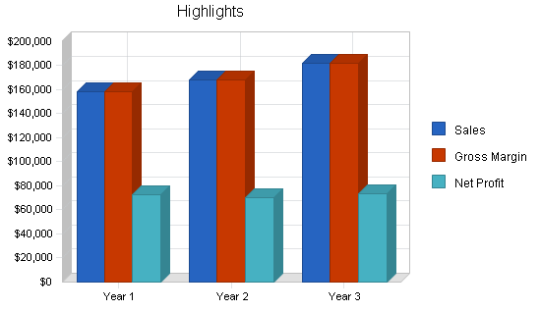
Mission:
MedEase LLC, is a medical reimbursement business that is fully dedicated to helping medical practice to being more effective and thus, save money by enhancing and allow them to outsource their insurance processes. Our mission is to have a shopping for all the medical practices. We intend to make enough profits to repaying our business-start-up finance and loans and hence, ensure continued success and growth.
Company business summary:
Our business company will be organized as a partnership. Our logo will be a trademarked through Trade Mark Office and Department of Commerce Patent. Our trademark will cover Reimbursement Consulting and Medical Practice Management.
Company business ownership:
Clarissa Zamora and Jocelyn Quintana will form the MedEase LLC. Jocelyn has an associates degree in Business Fundamentals, three years of teaching experiences, five years of managerial experience in financing industry. Jocelyn Quintana has gained experience in back-office operations, marketing, and sales and in management. Jocelyn Quintana has eight years filing and filling out medical insurance claims, filing apeals, checking claim status, receiving reimbursement from insurance payors and posting payments. She will use this experience in management of MedEase LLC.
On the other hand, Clarissa Zamora has 11 years extensive experience of filing and filling out medical insurance claims, filing apeals, checking claim status, receiving reimbursement from insurance payors and posting payments. This widespread experience has given valuable insights into the working nature of the Health Insurance Industry.
Start-up summary:
MedEase LLC will generally focus on Clarissa and Jocelyn working on full-time basis. The duties of Jocelyn will center on sales/marketing, data entry and purchasing and back office operations. Clarissa’s duties will mainly center on clerical administration, data entry, Medical billing and training. However, both will take the role of accounting responsibilities.

Start-up requirements:
Expenses
Legal | $300
Business opportunity | $600
Office Suppliers Stationary | $6,060
Insurance | $300
Furniture | $800
Software | $7870

Company facilities and locations:
MedEase LLC will have its main offices and business operations in New Mexico. The company’s offices will be used for accounting and marketing operations. Other offices will be used for clerical operations and data entry.
Services:
Our business position in the market will be full medical reimbursement services with individual pricing. When it comes to administrative functions, our goal is to have a one-stop shop for medical practices. Our business polices are geared toward customizing our charges basing on the service rendering of our business which is approximiately 5% of reimbursement of the providers claims.

