INFORMATION
Expansion of Voting
Have you ever heard someone say, "One vote doesn't make a difference" or "I don't care about politics" or "There aren't any real choices and politicians are corrupt anyway"? Sure you have. But those statements spur questions like these: If you're not involved, how can you change things? And what can one person do?
The primary way most Americans participate in government is by voting. The questions of who gets to vote, and how, and when, have been important to American government from the very beginning.
The right to vote is called suffrage. In the colonial period and in the early American republic, suffrage was usually limited to white men who owned property. That changed as political understanding grew and as women and minority groups learned how to fight for their rights.
In this activity, you'll look at the history of suffrage and see how the thinking about voting rights has changed in the United States.

Voting Before the Constitution
In colonial times, in order to vote, you had to own property and pay taxes. In most places, this also meant that you had to be male, white, and over a certain age. In some colonies, voting was also restricted by religion.
Voting was part of the reason why the colonists fought the American Revolution—do you agree with Parliament or the Americans?
The understanding in colonial times was that those responsible for the economic well-being of a colony should decide how the colonies were run. Therefore, women (who were viewed as part of their husbands' or fathers' households), children, enslaved people, and indentured servants had no vote.
Parliament in Great Britain took a different view. It believed that the mother country was the primary stakeholder of the colonies. This disagreement led to the Revolution and to a new understanding of voting rights. Once the door had been opened, there was no going bac

Voting Under the Constitution
In 1787, representatives from 12 of the 13 original colonies met in Philadelphia and drafted the Constitution of the new United States. It was ratified in 1789. Among the many powers the Constitution reserved for the individual states was deciding on suffrage.
Typically, the states adopted the old colonial model—voting was limited to white men over 21 who owned property and paid taxes; sometimes there were religious requirements, too.
One by one, the states abolished the property, tax, and religious requirements. By 1830, all white male adults in the United States could vote.
Click New Jersey to learn how New Jersey accidentally gave women the vote.

Constitutional Amendments Expand Suffrage
Over the years, a number of amendments have been made to the Constitution to expand the franchise to more Americans. The amendments below pertain to voting.
- The Fifteenth Amendment (1870) prohibited the states from denying voting rights because of race or previous condition of servitude.
- The Nineteenth Amendment (1920) gave women the right to vote.
- The Twenty-third Amendment (1961) gave citizens of Washington, D.C., the right to vote in national elections.
- The Twenty-fourth Amendment (1964) prohibited a poll tax.
- The Twenty-sixth Amendment (1971) lowered the voting age from 21 to 18.
The Constitution is a living document. Several of the amendments concern voting rights.

Constitutional Amendments Expand Suffrage
The Fifteenth Amendment was adopted after the Civil War because it was felt that an amendment was needed to ensure voting rights for freed male slaves.
The Twenty-third Amendment gave the people of Washington, D.C., the right to vote for the president. Before that, because the capital was not a state, people who lived in the seat of the federal government had no say in electing their leader.
The struggle to expand voting rights for many groups of Americans was long and difficult.
Click Experience to read about the experience of voting.

Suffrage for African American Men
At the end of the Civil War, three amendments were added to the Constitution. The Thirteenth Amendment banned slavery, the Fourteenth Amendment made the former slaves citizens of the United States, and the Fifteenth Amendment gave male citizens of any race or color the right to vote.
In the defeated South, particularly, many people resented the new rights of the former slaves. The U.S. government had placed the former Confederacy under martial law until it proved it was ready for republican government. This program was known as Congressional Reconstruction.
Northerners who supported giving African Americans the right to vote feared that others would work to deny former slaves voting rights, so the Fifteenth Amendment was passed to expressly grant them voting rights.
The right of citizens of the United States to vote shall not be denied or abridged by the United States or by any State on account of race, color, or previous condition of servitude.
—U.S. Constitution, Fifteenth Amendment, Section 1

Suffrage for African American Men
The first African American vote in the South was an important moment. Harper's Weeklymagazine devoted its cover to the four groups who formed the new political alliance. Can you find four facts in this image?
Hover over the people in this illustration for more information.

Women's Struggle for Suffrage
When the Fifteenth Amendment, which would give African American men the right to vote, was being drafted, women petitioned to be included in the extension of voting rights but were turned down. Some western territories, such as Wyoming and Utah, granted women the right to vote as early as 1869, but most women in the United States had to wait until the Nineteenth Amendment was ratified in 1920 to cast their first ballot.

Progressive Reform
Between about 1890 and 1920, American politics was dominated by the Progressive movement, a loosely organized reform effort led by people who believed that society could be and must be improved.
Progressives came largely from the middle class and from both major political parties. They worked to increase the political power of the people and to clean up government.
The Progressive movement achieved many reforms in various areas of society. In politics, they generally supported the expansion of democracy through woman suffrage; the direct election of senators; and recall, referendum, and initiative. But some Progressives supported restrictions on voting among immigrants and the poor, and the movement failed to take up the cause of racial equality.
In the South, laws, voting restrictions, threats, and violence had disenfranchised most African Americans by the turn of the century. This was a step backward from Reconstruction.

Continuing Struggles in the Twentieth Century
Despite constitutional amendments guaranteeing the right to vote, limits on suffrage continued.
Throughout the twentieth century, many people worked to prevent "unreliable" citizens from voting. It was one thing to have the right on paper but another to find a way to get around the obstacles that politicians placed in the way of voters.
One such obstacle was the poll tax. Another was the literacy test given to prospective voters, who had to prove they could read. To allow "safe" white voters to avoid the poll tax or literacy test, there was sometimes a grandfather clause—if your grandfather was eligible to vote, so were you. So African Americans whose grandfathers had been enslaved weren't eligible to vote.
The Twenty-fourth Amendment to the Constitution (1964) made the poll tax illegal, but abuses of voter rights continued. It took a concerted effort by such organizations as the National Association for the Advancement of Colored People and the passage of the Voting Rights Act in 1965 to ensure safe passage to the polls for all. In the 1970s, the right to vote was extended to young people.
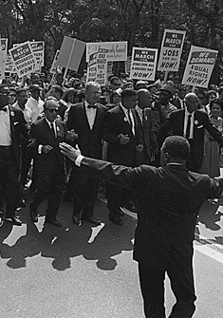
In the 1960s, the Southern Freedom Movement worked for voting rights for all Americans. Marches like this one in Washington, D.C., declared the Movement’s commitment.

Hanging Chads and Complicated Ballots
The 2000 presidential election made history when it took a month to count all the votes and required a Supreme Court decision to settle.
The main problem was with the Florida ballots. Different counties had different styles of ballots. In particular, the so-called butterfly ballot used in Palm Beach County seemed to favor President Bush.
For weeks, thousands of voting officials attempted to recount the ballots. One problem was how to count "hanging chads," pieces of paper that were punched out of some of the ballots.
The Supreme Court finally voted to end the Florida recount, and candidate Al Gore conceded the election victory to George W. Bush.
As a result of the election confusion, Congress passed the Help America Vote Act in 2002. The Act is designed to simplify the voting process and to help poorer counties get electronic voting machines.
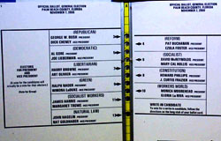
This butterfly ballot was used in Palm Beach County, Florida, in the 2000 presidential election. Thousands of voters punched the second hole on the card, thinking they had selected the second candidate on the left .

Let Youth Speak Out.
Before 1971, the minimum voting age was 21.
During the Vietnam War, young people began to agitate for the vote. After all, if an 18-year-old boy could be drafted and sent to kill and perhaps be killed, why couldn't he vote?
In 1971, the Twenty-sixth Amendment gave the voting franchise to all Americans 18 and older.
Nearly half of 18- to 24- year-olds voted in the 1972 presidential election. Believe it or not, that's a fairly high turnout in the United States. The percent of young people voting declined in the years after the passage of the Twenty-sixth amendment, and the percentage of young people who vote has remained consistently lower than the percentage of people over 65 who vote.

In 1971, the Twenty-sixth Amendment gave the vote to all Americans 18 and older. The youth vote changed American politics.

Ignored, Not Implored
Why don't young people exercise their right to vote? Voting requires effort—the effort to learn about the issues, listen to the candidates, register, and, above all, show up on election day.
After the 1970s, politicians began to ignore the youth vote. But in recent elections, politicians are once again paying attention to the needs of young people.
Candidates have begun using media and messaging targeted at young people. In 2004 and 2008, the youth vote increased to nearly 50 percent, but that still doesn't compare with older voters. Seventy-two percent of voters aged 65 to 74 voted in 2008.
Many young people maintain that they don't vote because it doesn't matter. They say politicians don't listen to them anyway. But voting is a fundamental responsibility of citizenship. It is also the best way to get politicians to pay attention. If they know you are likely to vote, they will listen and respond to what you have to say.

The suffragist Susan B. Anthony (1820–1906) is such an important figure in American history that she has been honored by having her image on $1 coins.
She was a civil rights leader who fought to gain women the right to vote. In her lifetime, she traveled thousands of miles and gave hundreds of speeches.
In 1872, Susan B. Anthony voted in the presidential election. She was arrested and put on trial for casting an illegal vote.
At the trial, Anthony made a strong defense of women's rights as citizens, but the jury didn't even get to decide—the judge directed them to vote guilty. Susan B. Anthony was ordered to pay a fine, but she never did—and the government never collected.
Women didn't get the vote until 1920, when the Nineteenth Amendment was passed.

A Letter from Jail
Use the information below to get some context for your reading. Then click Susan B. Anthony to read Anthony's letter.
The Fifteenth Amendment to the Constitution gave African Americans the right to vote. Susan B. Anthony and other women claimed that, because the Constitutional amendment didn't mention gender, they—as citizens—should have the right to vote, too.
Susan B. Anthony voted on November 7, 1872. The election officials, some of whom were on her side, permitted her to vote. But 11 days later, she was arrested.
On election day, Anthony wrote a letter to her friend and fellow suffragist Elizabeth Cady Stanton. As you read the letter, try to imagine the excitement of taking such a bold move.

Becoming a Party Animal
A political party is an organization of people with similar views and goals. They get together to try to get their candidates elected to office.
The major American parties—the Democrats and the Republicans—are well established and well organized. There are other political parties in the country, too, called third parties.
Americans don't have to be old enough to vote to become involved in party politics. Parties have organizations for teens—usually with the word young in the title—to help the young get started in the political process.

Giving Money, Time, and Talent
Raising money is important to political parties. So is getting the message out—letting the public know what the vital issues are. People who want to be involved can donate money to their favorite cause. They can also participate in events; for example, join a march or attend a rally or protest.
Or, they can become a volunteer and work to get other people to act—ring doorbells, pass out flyers, handle the phones, or any of a number of other activities. Volunteers are the people who make political organizations work, and volunteers can be any age.
Although canvassing can be hard work—people can be abrupt or even rude when they're interrupted—it can also be rewarding.

Taking Action in Your Community
In general, what concerns you most in the world? Economic problems? The environment? Immigration? Any or all of these issues might be reasons to back a political party.
But what about local issues? Is the city planning to knock down a historic building or build a highway through your favorite park? What about recreation in your neighborhood?
Chances are, somebody wants to do something about a local issue—and you can join in. Skateboarding in the city of brotherly love is an example. Once banned, citizens are trying to restore the privilege. Even Ed Bacon—actor Kevin Bacon's dad and a former city planner—supported skateboarding in famous LOVE Park.

Get People Together
Scott Kip, the president of the Skateboard Advocacy Network in Philadelphia, was one of the key organizers in the LOVE Park skateboarding petition. Through his efforts, the city paid for the design of a new skate park and secured $1 million to help maintain the existing LOVE park when skateboarding is allowed there again. Kip’s organization currently donates all proceeds to the current FDR park located on the outskirts of the city.
Read what Kip has to say about a key thing to remember when becoming politically active.

Expressing Your Views
Another way of getting involved politically is to communicate with people in public office. If you don’t know who they are, then find out
- Who they are.
- What they're doing.
- Where they can be reached.

Most political offices today, from the school board to the White House, have websites. You don't have to go farther than your computer to find their contact information.
Don't know what to think? Study the issues. Use your news sources—the Internet, TV, and radio. If you have a particular issue at heart, join a listserv. Listservs often provide information on how to contact leaders about specific proposals.
Don't know what to say? Just be polite, and be specific: Explain what your interest is and what you would like to see happen.
Don't be discouraged if you get a form letter back; elected officials are busy people. But remember that your opinion counts.

Making Yourself Heard
There are many ways in which Americans can express their views publicly. They can put bumper stickers on their cars, for example. They can also wear pins and T-shirts, and put decals on their bikes, offering free advertising for the causes of their choice.
Another way is by participating in public opinion polls and surveys. They can vote on websites, adding their voice to the voices of others. This kind of voting isn't binding like true voting is, but it helps give politicians a measure of public opinion.
One popular way to express an opinion on an issue is by writing to a local newspaper. A good letter to the editor should be short, thoughtfully reasoned, and to the point. A well-written letter on a subject that concerns most readers may end up published.

Making Yourself Heard
Attending rallies and peaceful demonstrations is yet another way people get the word out about an issue. Not all demonstrations are protests; a demonstration can be a show of support or a way to draw attention to a subject.

Participate!
Americans find many ways to become involved in politics, from national issues to the local scene. Every day, people write their Congressional representative, pop a check in the mail to their favorite advocacy organization, tack a bumper sticker on their car, or volunteer to go door to door.
Some of these activities might not be open to people who are not of voting age. For instance, they might not be permitted to go canvassing.
But they can be informed, and they can begin to express their opinions on matters important to them.

Your Political IQ
Test your political IQ by matching the names of political actions with their description.
Click circles on the left and drag to circles on the right to create matches. Correct matches stick and turn green.

Election campaigns—they create a lot of advertising on television and junk up the neighborhood with political signs everywhere, right?
Elections. Who needs them?
Can you imagine a democracy without them? What if somebody made all the decisions in the country without letting the public speak? America would be a different place.
In this lesson, you'll learn about the history of voting in the United States and how the right to vote was expanded from property owners who were white males to include minorities, women, and young people.
You'll also learn some of the ways in which young Americans can participate in the political process even before they're old enough to vote.

Levels of Political Participation
What's in It for Me?
Different factors affect people's willingness to participate in the political process. Age is one factor, and it’s why organizations such as Rock the Vote and the AARP exist to promote voting based on the shared interests of certain age groups.
Education is another factor, and so is how much money someone makes. What mainly determines people's willingness to get involved, however, is whether the issues affect their own interests. Put another way, political participation is based on self-interest.
Young voters and older voters have special interests in the political scene—and organizations exist to focus on their issues and to get out the vote to see that something gets done about those issues.

POLITICAL OPINIONS PART 1
In America, one of the most cherished freedoms is the freedom of speech—the freedom to express opinions openly.
But where do you get your opinions? Maybe you like a certain music group because your friends do, or maybe you don't like that music group just because everybody else seems to.
Political opinions are more important than what group you like, of course. The political decisions a community or a nation makes determine the solutions it hopes to find to the problems it faces.
The community you live in affects the way you look at political issues; you undergo political socialization. Many factors go into political socialization and help shape your political opinions. Some of the most important ones are family, religion, gender, marital status, race/ethnicity, and the region where you live.
In this lesson, you'll look at each of these factors in political socialization and examine their role in shaping political opinions and attitudes.

Demographic Factors
When you hear about categories of personal characteristics for a community or a nation, it's usually a discussion about demographic factors.
Before you look at how demographic factors affect political opinions, take a look at them from the point of view of those who measure political opinions—the pollsters.
Click the blue triangles to see how important demographic information is in measuring public opinion.

Family Ties
Are you like the other members of your family, or others close to you? Do you mostly think alike or disagree? Young people probably know how their parents feel about important issues. And, whether they agree or disagree with their parents' opinions on those issues, their parents’ opinions affect how young people view the issues themselves.
Hover over the image to see what members of this family are thinking. How are they shaping each other's opinions?

Family Ties
Family factors may influence more than just how someone views or votes on an issue. Family behavior influences level of involvement: If it's the custom in a family to join a party or to vote regularly, the young people are likely to do so as well. If a family is active in community affairs, then the young folks are likely to join in, too.
And if someone comes from a long line of politically aware people, chances are they'll know more about the issues.

Religion and Politics
Religious affiliation is an important factor in American politics—a greater percentage of Americans in the center of the country participate in organized religion than do those in the East or West. But keep in mind that far more people live in the East and West than in the middle of the country. Taken as a whole, about 70 percent of Americans identify with a religion and participate in organized religion at least sometimes.
Religious affiliation can be a strong factor in the way people see issues and in determining what issues people find most important.
Some of the political issues that have been affected by religious viewpoints in recent years are abortion, gay marriage, stem-cell research, environmental issues, welfare, and the death penalty.
The First Amendment guarantee of religious liberty has long been interpreted by the Supreme Court and others to have established separation of church and state, the idea that the government and religion shouldn't interfere with each other. The First Amendment states that the government can't establish a religion or prohibit the free exercise of religion. This means that organized government and organized religion cannot tell each other what to do.
Even so, the two are connected in that both deal in values. Political views are based on values, and since religion can help shape a person's values, religion plays a role in American politics.

Gender and the Issues
We have seen that, today, men and women are equally likely to vote.
When women first got the vote in 1920, suffragists argued that once women had the vote they could then quickly pass everything else on the women's rights agenda. Instead, it turned out that most of the time men and women voted alike; class, region, and culture were more important than gender.
Even though other issues were more important, a gender gap in voting still persists between men and women. The 2012 presidential election produced the biggest gender gap ever recorded: President Barack Obama won women's votes 54 percent to 46 percent, and Republican challenger Mitt Romney won men's votes 54 percent to 46 percent.
In the past, politicians worried about the gender gap in voting. With more women in the workplace, attitudes are changing.
Gender and the Issues
Why the gender gap? Some observers claim that the gap is real, that women vote and see the issues differently from men. Others say that other demographic factors, such as family and religion, are the real reasons for perceived differences in voting patterns.
Most women work outside the home today and both genders are concerned with employment issues. Although women may have a more direct concern about the issue of equal pay for equal work, men may worry about what paying women less does to worker morale and the family income. Dads have reason to be just as concerned as moms are about education.

Marital Status
Another important demographic factor that shapes political opinion is marital status.
This pie graph from the U.S. Census Bureau illustrates the breakdown in marital status for women 35 and over in 2000.
Marital status information is important to public officials—city planners, who need to know what kind of housing people need; tax officials, who can estimate likely incomes from the number of families there are; and school boards, among others.
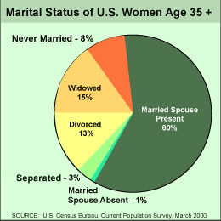

Activity ResourcesOpens in modal popup window
Page 10 of 15
Marital Status
Attitudes toward political questions—such as how public money should be spent, what tax breaks should be handed out, or how to fund public education—can be affected by the marital status of people in a given area.
Views on public policy can be affected by the needs of the groups people are associated with.
Young singles view their needs as being different than those of older married people with children about to go to college. Political leaders have to respond to these perceptions.
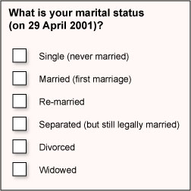
Marital status is not a yes/no question on the census form. The census collects demographic data every 10 years in the United States.
Race and Ethnicity as Factors
Race and ethnicity are other important demographic factors in shaping political opinions. The United States is an ethnically diverse country—and rapidly becoming more so.
Consider the data in this slide show about the growth rate of the U.S. population by ethnic group. Why do you think that the Asian and Hispanic populations have such high rates of growth?
Click the blue arrow to be

Race and Ethnicity as Factors
Although different ethnic groups have many of the same concerns—for example, everybody wants good schools for their children and safe neighborhoods to live in—each group may have particular issues that it considers especially important. Bilingual education, affirmative action, and minority hiring practices are examples, as are immigration quotas and civil rights for immigrants.
Click Ethnic Politics for information on immigrants and American

Regional Interests
Where you live has an impact on how you view the issues. Whether you live in the North, South, East Coast, West Coast, or Midwest, there are issues specifically important to your region. What region you live in has a lot to do with the kinds of occupations most people in your community have, and that helps shape political opinions.
Farmers from the Midwest have a strong lobby in Washington. In Northern California, Silicon Valley technology is a major interest. In Oregon, loggers are worried that environmentalists will take their jobs away, and environmentalists are worried that logging will endanger animals such as the spotted owl.
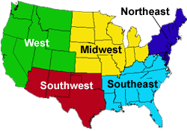

Activity ResourcesOpens in modal popup window
Page 14 of 15
Regional Interests
It's not just a region's economy that affects Americans' political opinions. A region's history, the makeup of its population, and even its climate can shape political opinions. Consider Florida, which has a large population of Cuban immigrants and an even larger population of elderly retirees.
Still, no matter what region you live in, you are not influenced by regional interests alone. You are also a member of a family, an ethnic group, and, perhaps, a religious community. You belong to many groups at once.
All of these influences work together to shape political socialization. Sometimes these factors support each other, and sometimes they conflict. Either way, they make up the diversity of interests that interact with the political system.

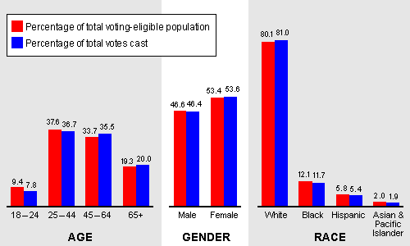

Activity ResourcesOpens in modal popup window
Page 6 of 12
Democracies and Voter Turnout
In some countries, voting is required by law. In the United States, and in most countries, it is voluntary.
On the bar graph, you will notice that most of the democracies listed have higher voter turnout than the United States does. Why do you think that is? Do you know anything about the issues facing voters in those countries? Probably not. But you may know that Lithuania is a new democracy formed after the breakup of the Soviet Union. Its voter turnout is slightly higher than that of the United States.
What makes people in new democracies so enthusiastic about elections, while people in older democracies take this right for granted?
Read on to look at some of the factors.
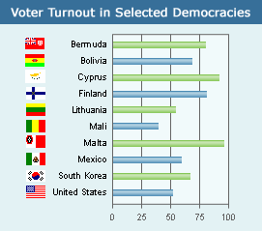

Political Efficacy
Look at this chart showing voter turnout in U.S. elections from 1968 to 2004.
You will notice two things: The percentage of eligible people who voted never reached more than 60 percent, and more votes were cast in presidential election years than in other years. In presidential election years, more people voted for legislators, too—probably because they turned out to vote for the president.
What makes people decide to vote or not to vote? Mainly, the feeling that their vote counts. This perception of the importance of voting is called political efficacy.
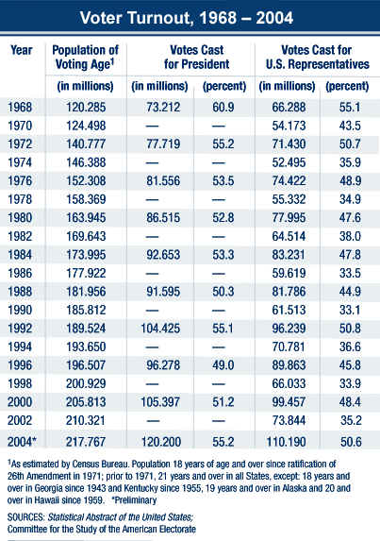

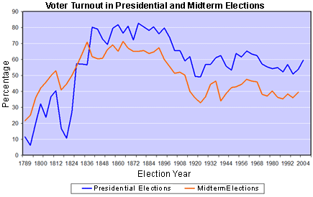

Voter Fraud
Voter fraud is the intentional act of casting false votes, falsifying legitimate votes, or denying a voter his or her right to vote. Election commissions exist to combat the problem of fraud, which has taken many forms over the years.
Some of the types of voter fraud to suppress votes include literacy tests and poll taxes. Here are some other types of voter fraud:
- Bribery
- Miscounting votes
- Disqualifying votes
Another possible source of voter fraud is misuse of the absentee ballot. That issue was a major concern in the presidential election of 2000

Voter Fraud
The process of electronic voting also raises concerns. There is concern that hackers could interfere with a computerized election. This issue was debated before the passage of the Help America Vote Act in 2002. After the 2006 election, the trend has been toward electronic voting machines that provide a voter-verified paper ballot suitable for recounts.
Another kind of voter fraud is stuffing the ballot box. Some lawmakers have expressed grave concern that get-out-the-vote organizations will enable ineligible people to vote in great numbers, but investigations by the Justice Department indicate that this fear is largely unfounded.

How Involved Are Americans?
What about other levels of political participation? How do Americans stack up?
From the graph, you can see that, from 1973 to 1994, the percentage of Americans who engaged in the political activities you've been learning about—helping a political party, writing a representative in Congress, running for office, writing letters—has declined.
However, the opportunities for involvement for young people have never been greater.
How Involved Are Americans?
What about other levels of political participation? How do Americans stack up?
From the graph, you can see that, from 1973 to 1994, the percentage of Americans who engaged in the political activities you've been learning about—helping a political party, writing a representative in Congress, running for office, writing letters—has declined.
However, the opportunities for involvement for young people have never been greater.

Vote Early and Often
It may not be legal to vote early and often in a real election, but you can at least check your knowledge of voting and political participation as often as you want.
View Voting Knowledge below. Drag and drop the tiles from the bottom to the blanks in the top. When you’re done, select Check Me.

