Homework #1: Becoming a Participant Observer (GeneTierney) – Using the guidelines in chapter one of “Doing Cultural Anthropology” (Angrosino 2007), attend a public gathering and do a miniature ethnography. Any public location will do. Follow the instructions in “Doing Cultural Anthropology.” Look for the following things:
- Examples of cultural symbols
- Examples of culture being learned
- Examples of culture being shared
- Examples of culture helping to adapt to the environment
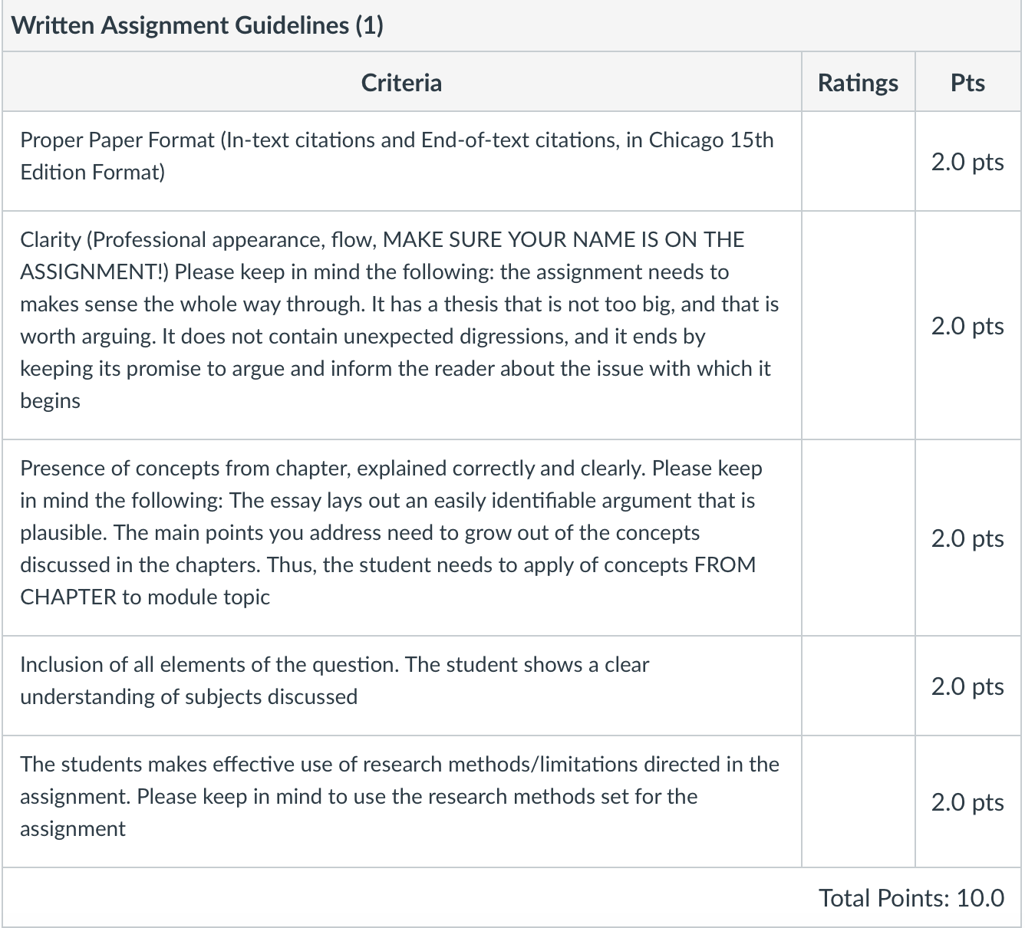
Once you have taken notes on your observation, submit them online in the appropriate location. Make sure you follow the Rubric! (400-600 words)

