Babin Bohara
Govt 2302
Sherry Sharifian
September 30th, 2017

Running for the office

I am currently residing in 2916 Harwood Road, Bedford, Texas and my Texas house district is 92 it is represented by Jonathan Stickland who is a Republican. According to information provided by house’s website, the total population of District 92 is 169,109 where a majority of the population are an age of 18 to 64 year about 112,118 and rest of the population are of different ages. Observing the educational information provided on the district website over 9.1% are less than high school graduate and 32.5% have bachelor’s degree or higher among the total population.
Among the total population, 92,187 people are employed and 84.2% are employed in private sector, 10.9% are in the Government sector and 4.8% are self-employed. And the Per capita income of district 92 is $31,032. And out of total population 20,236 which is 12.1% are in poverty. Looking at the election result of district 92 we know that most people are republican.
Acknowledging the facts, in my opinion, the issue arises based upon the district’s demographics should be the education because from the fact it shows that only the 32.5% of the population have bachelor’s degree or higher which is not very high. The reason behind it could be less intuition for getting a degree. Due to lesser qualified population, it ultimately affects the employment, as we can see that the government sector employment is not much compared to private sector.
Considering that I’ll be running for Texas house of representatives for district 92 there are various areas that need to be considered. As I have mentioned above good educational opportunities should be created. For instance, if I were a representative of this district I would focus more on school and colleges that will help the community to grow with a better educational environment. Encouraging people who completed their high school to go college and get a higher degree. So, they would be capable enough with their qualification to get a better job in a better place.
Though I reside in a district represented by a Republican party my thought align to the democratic party. From the survey, I took I identified that several of my thought meet democrat platform.
The first thing that I would be concerned about the district to develop would be its environmental safety. As a district representative, I would solely look after the ways that are possible to make the environment safer and cleaner. By every means, say it with the reduction of industrial waste or any substandard vehicle that pollutes the environment. Likewise, Democrats motive that government should make environment cleaner with any cost it takes I have a similar thought toward it.
Secondly, I would promote private businesses to people without the interference of governmental body. Which would be more liberal to the people to grow big and succeed. The businesses that people are having would even get better and other people will get influenced by it. On other hand, people would have opportunities to get jobs.
Lastly, the social security of the people in need, poor people who are living their life with the government’s fund. Those people are not getting enough and every people in need are not covered by the fund that government is providing. So, I would look forward helping those people who need help to live a better life.
Mostly my thoughts align with the democratic party but some things like social security to poor people does not align though I would try to fix it on my behalf. If I would get an opportunity to be a representative of my district I would try to consider these areas strongly.

Screenshots

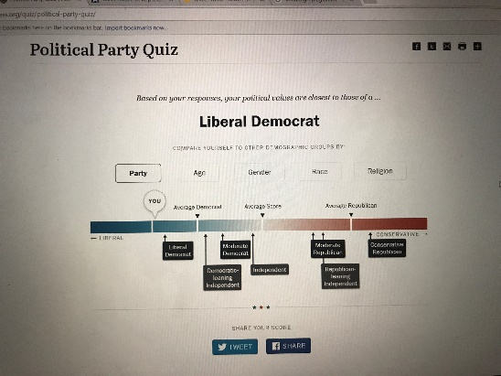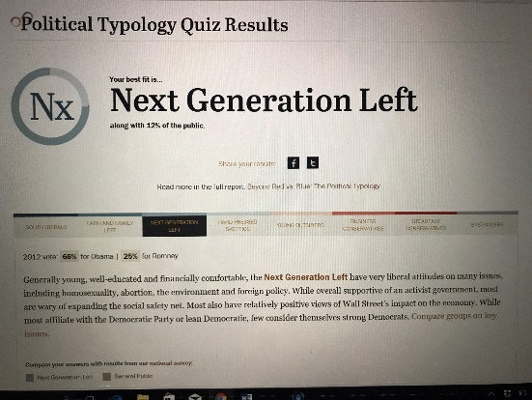

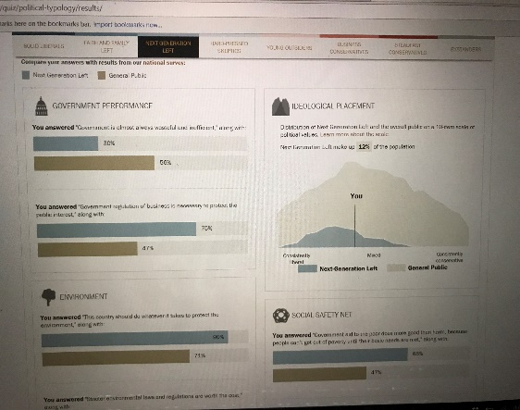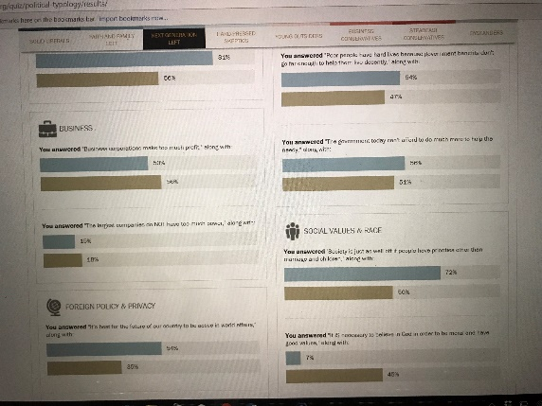

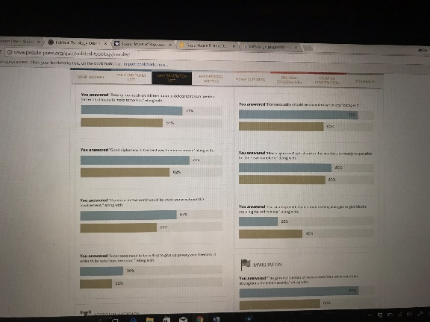

Work cited
- http://www.fyi.legis.state.tx.us/Home.aspx
- http://www.house.state.tx.us/members/member-page/?district=92
- http://www.people-press.org/quiz/political-party-quiz/
- http://www.people-press.org/quiz/political-typology/
- http://www.txdemocrats.org/our-party/texas-democratic-party-platform/

