The MU e-Concierge is university’s search engine for finding information on existing resources and services. This search is located on the MU portal, https://commons.marymount.edu/muservice/
Without a help manual, it is challenging for new students (freshmen & transfer) to find resources quickly and efficiently to meet mid-term academic demands in their first semester.
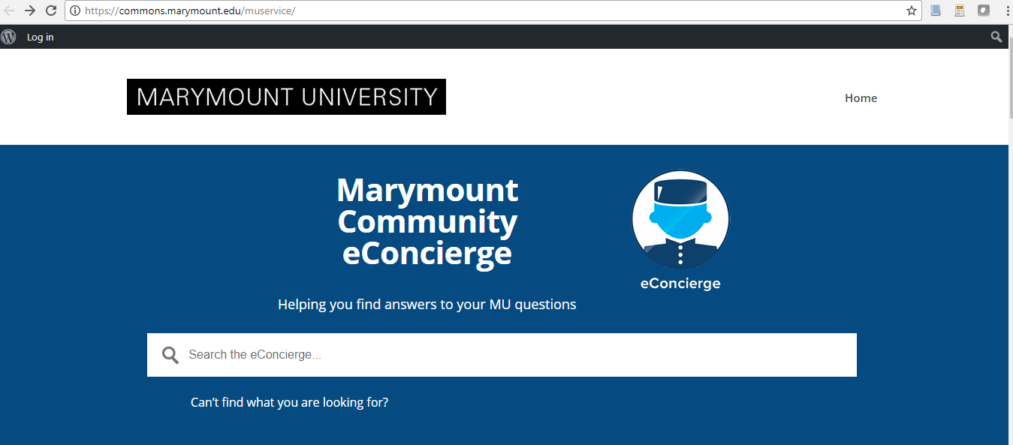
Required:
Prepare a user-manual on how new students can find and use library resources at MU. The manual should be at least 7 pages and include the following:
- A brief overview on how to use the manual and the topics that it will cover
- How to access library resources using the e-concierge
- Input and output for the system
- FAQ

Check the attachment please

