DDBA 8307 Week 6 Assignment Exemplar – Multiple Regression

John Doe

DDBA 8307-6

Dr. Jane Doe

Multiple Linear Regression

Type text here. Describe and defend using the multiple linear regression test for your analysis. Use at least two outside resources—that is, resources not provided in the course resources, readings, etc. These citations will be presented in the References section. This exercise will give you practice for addressing Rubric Item 2.13b, which states, “Describes and defends, in detail, the statistical analyses that the student will conduct….” This section should be no more than two paragraphs.

Research Question

Is there a statistically significant relationship between stress, engagement, intent to leave, and job satisfaction?

Hypotheses

H₀: There is not a statistically significant relationship between stress, engagement, intent to leave, and job satisfaction.
H₁: There is a statistically significant relationship between stress, engagement, intent to leave, and job satisfaction.

Results

In this subheading, I will present descriptive statistics, discuss testing of the assumptions, present inferential statistic results, and conclude with a concise summary.

Descriptive Statistics
A total of 426 employees participated in the study. The assumptions of outliers, multicollinearity, normality, linearity, homoscedasticity, and independence of residuals were evaluated with no significant violations noted. Table 1 depicts descriptive statistics for the study variables. Figure 1 depicts a scatter plot of the bivariate correlation, indicative of a negative linear relationship between job satisfaction and intent to leave.
Table 1
Means and Standard Deviations for Quantitative Study Variables
Variable | M | SD | Bootstrapped 95% CI (M)
Stress | 26.36 | 10.56 | [24.80, 27.94]
Engagement | 43.60 | 12.51 | [41.90, 45.28]
Intent to leave | 72.34 | 15.21 | [70.23, 74.51]
Job satisfaction | 169.12 | 10.00 | [167.68, 170.44]
Note: N = 204.

Descriptive Statistics for Study Variables
Variable | M | SD
Stress
Engagement
Intent to leave
Job satisfaction

Tests of Assumptions

The assumptions of multicollinearity, outliers, normality, linearity, homoscedasticity, and independence of residuals were evaluated. Bootstrapping, using 1,000 samples, enabled combating the influence of assumption violations.
Multicollinearity. Multicollinearity was evaluated by viewing the correlation coefficients among the predictor variables. All bivariate correlations were small to medium (Table 2); therefore, the violation of the assumption of multicollinearity was not evident. The following table contains the correlation coefficients.
Table 2

Correlation Coefficients Among Study Predictor Variables
Variable | Stress | Engagement | Intent to Leave
stress | 1.00 | .151 | -.010
Engagement | .151 | 1.00 | .562
Intent to leave | -.010 | .562 | 1.00
Note. N = 204.

Outliers, normality, linearity, homoscedasticity, and independence of residuals. Outliers, normality, linearity, homoscedasticity, and independence of residuals were evaluated by examining the Normal Probability Plot (P-P) of the Regression Standardized Residual (Figure 1) and the scatterplot of the standardized residuals (Figure 2). The examinations indicated there were no major violations of these assumptions. The tendency of the points to lie in a reasonably straight line (Figure 1), diagonal from the bottom left to the top right, provides supportive evidence the assumption of normality has not been grossly violated (Pallant, 2010). The lack of a clear or systematic pattern in the scatterplot of the standardized residuals (Figure 2) supports the tenability of the assumptions being met. However, 1,000 bootstrapping samples were computed to combat any possible influence of assumption violations and 95% confidence intervals based upon the bootstrap samples are reported where appropriate.
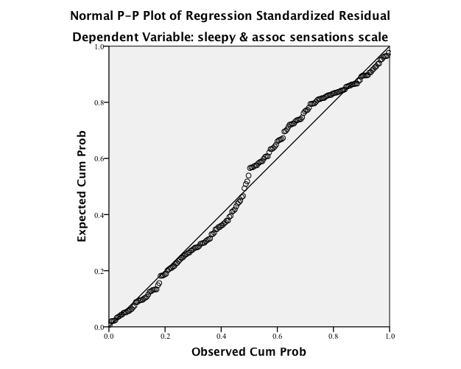

Figure 1. Normal probability plot (P-P) of the regression standardized residuals.

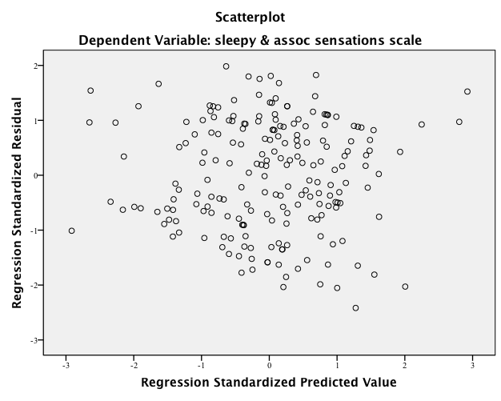

Figure 2. Scatterplot of the standardized residuals.

Inferential Results

Standard multiple linear regression, α = .05 (two-tailed), was used to examine the efficacy of stress, engagement, and intent to leave in predicting job satisfaction. The independent variables were stress, engagement, and intent to leave. The dependent variable was job satisfaction. The null hypothesis was that there is not a statistically significant relationship between stress, engagement, and intent to leave. The alternative hypothesis was that there is a statistically significant relationship between stress, engagement, and intent to leave. Preliminary analyses were conducted to assess whether the assumptions of multicollinearity, outliers, normality, linearity, homoscedasticity, and independence of residuals were met; no serious violations were noted (see Tests of Assumptions). The model as a whole was able to significantly predict job satisfaction: F(3, 200) = 4.778, p < .003, R² = .067. The R² (.067) value indicated that approximately 7% of variations in job satisfaction is accounted for by the linear combination of the predictor variables (stress, engagement, and intent to leave). In the final model, stress and intent to leave were statistically significant with stress (t = –3.892, p < .01, β = –.393) accounting for a higher contribution to the model than intent to leave (t = –2.595, p < .05, β = –.268). Engagement did not explain any significant variation in job satisfaction. The final predictive equation was:
Job satisfaction = 70.205 – .148(stress) + .109(engagement) – 2.303(intent to leave).
Stress. The negative slope for age (–.148) as a predictor of job satisfaction indicated there was about a .148 decrease in job satisfaction for each 1-point increase in stress. In other words, job satisfaction tends to decrease as stress increases. The squared semi-partial coefficient (sr²) that estimated how much variance in job satisfaction was uniquely predictable from stress was .03, indicating that 3% of the variance in job satisfaction is uniquely accounted for by stress, when organizational commitment and engagement are controlled.
Intent to leave. The negative slope for intent to leave (–2.303) as a predictor of job satisfaction indicated there was a 2.303 decrease in job satisfaction for each additional 1-unit increase in intent to leave, controlling for stress and engagement. In other words, job satisfaction tends to decrease as intent to leave increases. The squared semi-partial coefficient (sr²) that estimated how much variance in job satisfaction was uniquely predictable from intent to leave was .04, indicating that 4% of the variance in job satisfaction is uniquely accounted for by intent to leave, when stress and engagement are controlled. The following table depicts the regression summary.

Table 3

Regression Analysis Summary for Predictor Variables
Variable | Β | SE Β | β | t | p | B 95% Bootstrap CI
Stress | -.148 | 0.054 | -.393 | -3.892 | <. 01 | [-.262, -.025]
Engagement | .109 | 3.770 | -.038 | 0.371 | .712 | [-.008, .245]
Intent to leave | -2.303 | .888 | -.268 | -2.595 | .011 | [-.442, -.081]
Note. N= 204.

References

Type references here in proper APA format.

Appendix – Multiple Linear Regression SPSS Output

Insert the appropriate SPSS output here.

The 95% Bootstrap confidence intervals are produced when the bootstrapping procedure is selected in the SPSS regression process. See the Multiple Linear Regression videos in the Week 6 Learning Resources.
You will run these plots when running the regression procedure.
It is important to note the results of your assumption test will differ from this hypothetical example. Therefore, you must report the results appropriately for your analysis. Do not copy this example verbatim; ensure you understand “your” analysis output.
Identify the test and of purpose of the test.
Restate the independent variables as presented in the purpose statement and research question; there is to be no deviation.
Restate the dependent variables as presented in the purpose statement and research question; there is to be no deviation.
Identify the assumptions and state how they were assessed.
State whether the model (app predictors included) could predict (or not) the dependent variable. Report the appropriate statistics (e.g., F(3, 200) = 4.778, p < .003, R² = .067).
Derived from the SPSS output.
Β values are to be used in the regression equation. These are the unstandardized coefficients in the SPSS output.
The beta weights identify which variables contribute more to the model. These are the standardized coefficients in the SPSS output.
The test statistic for the hypothesis test for the slope (Β) is derived from the SPSS output and is used to evaluate the significance of the Β weights, where p ≤ .05 is significant.
The sig. (p) value for the hypothesis test for the slope (Β); derived from the SPSS output; used to evaluate the significance of the Β weights, where p ≤ .05 is significant.
The 95% Bootstrap confidence intervals are produced when the bootstrapping procedure is selected in the SPSS regression process. See the Multiple Linear Regression videos in the Week 6 Learning Resources.

