Updated Dec. 20, 2017 9:43 a.m. ET
Natalia Drozdiak

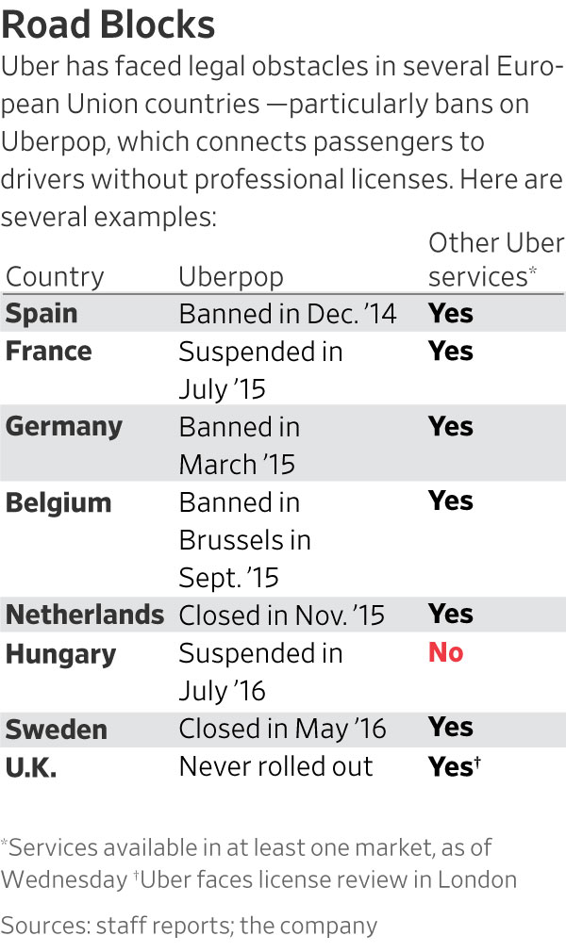
Transport Vs. Tech
BRUSSELS—Uber Technologies Inc. suffered a major defeat in its effort to overturn strict rules and licensing requirements in Europe, after the bloc’s highest court Wednesday ruled the ride-hailing company should be regulated as a transportation service, rather than a digital service.
The judgment by the European Court of Justice won’t force Uber to curtail most of its services in Europe, but the decision is a blow to the company’s efforts to use courts to lighten its regulatory load—and forces it to deal more directly with national and local governments that set rules governing car and transport services in Europe. Those authorities have sought to hold Uber to often-strict rules and licensing requirements that apply to taxi and traditional car-hire services.
“This ruling will not change things in most EU countries where we already operate under transportation law,” an Uber spokeswoman said. “As our new CEO has said, it is appropriate to regulate services such as Uber and so we will continue the dialogue with cities across Europe.”
Still, the decision could have wider ramifications for Uber, and other sharing-economy firms, in markets beyond Europe. Officials here over recent years have taken a more aggressive stance than other jurisdictions on a wide array of regulatory and enforcement issues affecting Silicon Valley firms—including taxes, privacy and alleged anti-competitive behavior. While the legal reach of such rulings extends only to Europe, other jurisdictions have started looking to the continent as an example when tackling regulatory and enforcement issues on their own turf.
Last year, for instance, Indonesia passed a law creating a “right to be forgotten,” similar to one the European Union’s top court established in 2014. That decision allowed EU citizens to request Alphabet Inc.’s Google and other search engines to remove results deemed to infringe privacy.
Any specific ramifications from the Uber case at the ECJ outside of Europe would depend on individual regulatory regimes related to transportation rules, which varies widely around the world. Indeed, Uber used Europe’s unique rules establishing lighter regulations for information-services firms to argue it shouldn’t be subject to the more burdensome rules EU countries can apply to transportation.
The court’s finding—ruling against Uber’s argument that it was simply a marketplace to connect people who want services—could also undermine similar arguments that many Silicon Valley firms make to keep regulators at arm’s length around the world. Airbnb Inc., for instance, has declined to proactively filter some types of listings in Paris in part because it says it is a technology platform, not a housing provider.
“Regulators abroad that have social systems similar to the EU may find inspiration in this decision with respect to how to craft their freelance economy rules,” said Dave Anderson, an EU law partner in the Brussels office of Berwin Leighton Paisner LLP.
Under EU law, national governments have more control over how they regulate transport companies, like taxis or traditional car-hire services. But online services are granted freedom from some kinds of regulatory intervention, such as strict licensing requirements.
The judgment dashes any hopes for Uber of regulatory rollback in Europe and could embolden regulators to impose more onerous restrictions on the company. It also creates a roadblock for Uber for any potential expansion or revival of its lower-cost UberPop service, which uses drivers without professional licenses. Uber only offers the service in Poland, Czech Republic, Slovakia and Romania after rolling back the service in most other EU countries. Uber says it currently has no intentions of bringing UberPop back to the countries where the company has previously suspended it, adding the company now operates under the regulatory framework in most of those countries.
Uber has tussled with taxi companies and regulators around the world for much of its eight-year history, but the scrutiny has been especially intense in Europe. There it has faced local or national bans on its UberPop service in Italy, Germany, Belgium, the Netherlands, Spain and Hungary and sometimes violent protests from entrenched taxi services. Uber has long tried to fight local transportation laws by arguing it isn’t a transportation company but rather an online platform, which is protected under EU law from disproportionate regulation.
In its judgment, the ECJ said Uber’s service “must be regarded as forming an integral part of an overall service whose main component is a transport service and, accordingly must be classified not as ‘an information society service,’” referring to the legal term for an online platform.
The ECJ argued Uber’s app is indispensable both to the drivers and the passengers and that the company “exercises decisive influence over the conditions under which the drivers provide their service.”

Europe's highest court ruled Uber is a transport company, not a tech company, with big implications for how it is regulated on the continent.
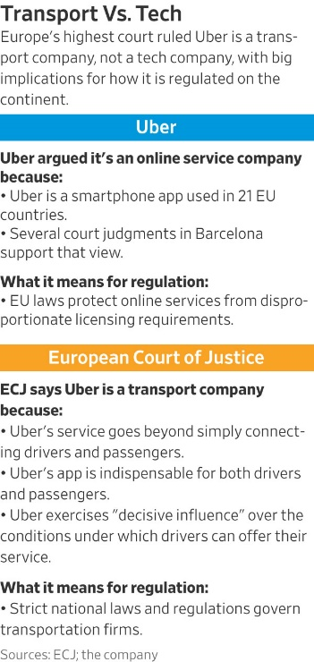
While this particular court case cannot be appealed, Uber can pursue other legal challenges in courts to defend its business.
The ruling is the latest setback for Uber’s new chief executive, Dara Khosrowshahi, who took the role in September after Travis Kalanick stepped down in June under investor pressure after months of scandal and legal setbacks. Mr. Khosrowshahi is appealing a ruling in London that would prevent Uber from operating there and is cleaning up multiple issues left behind under Mr. Kalanick’s watch, including a huge data hack that was covered up and a former security official’s claims of espionage and other tricks to gain an edge.
In September, London’s top transport authority stripped Uber of its private-car-hire license in the city, citing “a lack of corporate responsibility” that it said could undermine public safety and security. Uber said it would appeal the decision, during which it can still operate.
In November, Uber revealed it paid hackers $100,000 in an effort to conceal a data breach affecting 57 million accounts one year ago, when Mr. Kalanick was still CEO. And it was revealed in court, where Uber is fighting a lawsuit from Alphabet Inc. alleging stolen trade secrets, that Uber paid a security executive at least $4.5 million to keep concealed allegations he made that the company surveilled competitors and used devices that couldn’t be traced to Uber to avoid legal discovery, among a host of other claims.
The EU court case originates from legal action filed by Elite Taxi, a Barcelona-based association of independent taxi drivers, which is seeking penalties against Uber for operating its low-cost Uberpop service without the necessary taxi licenses and authorization from the city. Elite has argued Uber was competing unfairly by building a new model for transportation without the costs normally associated with it. A Spanish court banned UberPop there in December 2014.
The Barcelona-based law firm SBC Abogados, which represented Elite in the case, said on Twitter: “The Court of Justice of the European Union has just ruled in our favor that Uber is a transport company, therefore its activity must be regulated, the unfair competition that we denounce is over.”
—Greg Bensinger in San Francisco and Sam Schechner in Paris contributed to this article.
Write to Natalia Drozdiak at natalia.drozdiak@wsj.com
1. What decision did the European Court of Justice make about Uber?
2. How will the decision made by the European Court of Justice impact Uber's operations in Europe?
3. What are the broader implications of the decision by European Court of Justice for other sharing-economy businesses?
4. Do you support the ruling of the European Court of Justice that Uber is a transportation company rather than an online platform? Explain your position.

