Antigone Images

ANTIGONE IN ART
As you can imagine, a tale as powerful as Antigone with such a controversial heroine has inspired many works of art.

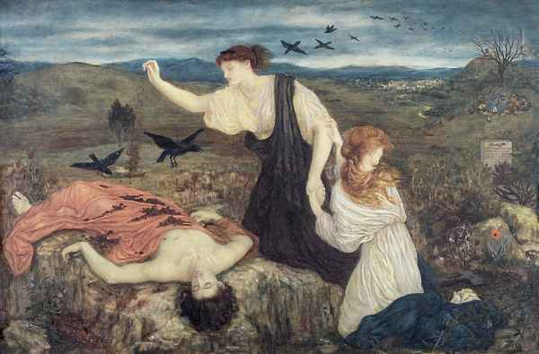
Consider this rendering of Antigone covering Polyneices' body. Is it how you imagined the scene? What strikes you as being expected or unexpected? Why do you suppose the artist chose to include Ismene? What does her posture suggest?

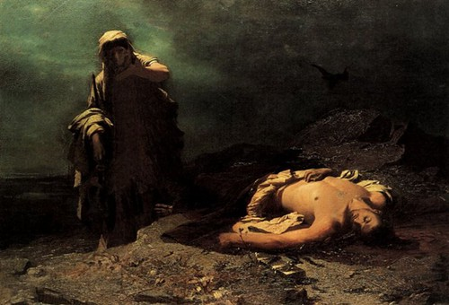
Now compare that with this rendering of the same scene. What differences do you see between the two paintings? which one better matches your mental image of the scene? How does the mood vary in the two paintings?

Assignment:
Write a 1-2 page comparison of these two paintings. Since this is a scene that happens off stage in the play, we don't have the author's description to set the scene. Use what you know from the play to help you determine which picture you believe best captures the scene. Explain your choice.

Image #1 found at: http://preraphaelitepaintings.blogspot.com/2010/10/marie-spartali-stillman-antigone-from.html
Image #2 found at:
http://slog.thestranger.com/slog/archives/2010/10/28/the-greek-tragedy-of-the-seattle-police-department

