Family Assessment
Robin Ward
NSG/482: Promoting Healthy Communities
Carol Vreeland Dallred
6/17/19

Introduction
Stanhope & Lancaster (2015) argued that periodical family assessments that nurses perform is the linchpin for family nursing interventions and more significantly is utilized systematically in identifying developmental stages and respective family risk factors. Several tools issue guidelines on ways of knowing families, conduct analysis on their situations with the aim of determining their strengths as well as weaknesses. The Friedman Family assessment tool is one such important tool. This paper entails an assessment of the psychological, emotional, and physical needs of a selected family. Assessment of family is a vital nurse exercise that assists in the establishment of healthcare needs as afore step in the provision of counseling (Kaakinen, 2018). In this report, structural and clear framework is utilized in the assessment of the family needs.
Family Overview
The family under consideration comprises an 86 year old man called Harry; a 93-year wife named Gladys together with four fully grown children. The family residence is located in an upscale community, evidence that they belong to a higher social class. The old man, Harry, is practiced as a criminal defense lawyer but is currently retired. He had a lengthy practice that lasted for 50 years in San Diego City. Currently, the old man battles Alzheimer's disease. Gladys, the wife, is a retired nurse whose length of practice lasted for more than thirty years. She remains to be of stable health condition and currently provides care to her sickling husband. Jim is the couple's firstborn and lives in the city of New York and practices law just like the father. Jim is currently divorced, and his estranged wife with their only child lives away from New York City. The second born child is another son, named Tim. He is a 64-year-old practicing medical doctor and leaves in Maine together with his wife and children. Thirdly is Mabel who is currently 56 years of age and practices dentistry and leaves in North Carolina with her husband and other relatives. She has no child. Marly, who was a twin to Mabel, died a few years ago.
Identifying Data
- Family Name: Harry’s family
- Phone and Address: Unavailable
- Family Composition: As Indicated in the family Genogram.
- Type of Family Form: Nuclear
Father: Retired-Lawyer, Mother: Retired-Nurse, two sons lawyer and physician (one divorced one married), two daughters (one living, married and practicing dentistry, one dead).
- Background in cultural sense (Ethnically): not stated but speaks English.
- Religious affiliation: Christians (specifically Catholics of irregular attendants)
- Social Class Status: Upper Class (as illustrated with the line, “got enough savings to carter for their lifestyle”)
- Income sources of the family: parents had saved adequately, two sons one is a physician while the other practices law, the remaining child is a daughter practicing dentistry.
- Social class mobility: the parents' side has become stationary while the children are mobile.
Developmental Stage and history of the family
- Late adult stage_: Stage viii: the family reflects on life with a high sense of integrity as an indication of fulfillment and contentment considering the sound contributions they have made to the society. The father was a successful criminal defense lawyer and is now retired with a lot of savings; the wife too was a successful nurse and currently retired. All three surviving children have some of the greatest careers.
- Nuclear family history: both Harry and Gladys originated from traditional nuclear families.
- History of the family of origin of both the parents: both Mr. Harry and his wife were raised in nuclear families where both of their parents had good careers and were adequately providing for their families respectively.
Environmental Data
Home characteristics: there is a lonely feeling at home. Constantly present are two family members: Harry and Gladys together with a resident gardener living with them. The children live away from home rarely visit with the exception of one who visits occasionally. The family residential house is larger by standards of the neighborhood residential style, which is reported to be found in an up-market estate, and it is said to be very expensive. There is a large backyard pool that seems maintained but is unfenced.
Regarding the family's geographical mobility, they are partly stationary and partly mobile. However, they are reported not to have lived in more than moved from one state to another except the children who now live in different states. The transaction and association of the family with the surrounding community are a bit lukewarm. It is only Gladys who makes limited contact with the community. She is reported to be the person that drives Mr. Harry around, goes for groceries, and runs other errands for the family. Her husband’s disease made her stop frequenting church and other social gatherings as she was previously accustomed to.
Family Structure
The communication patterns within the family are through phone calls coming from the children to Mr. Harry and Mrs. Gladys enquiring about their father's medical condition. Inside the homestead, much of the constructive conversation takes place between the gardener and Mrs. Harry inform of orders and instructions. She also finds herself confiding to friends, telling them how providing care to her husband was taking a tall order on her.
Concerning the family power structure, Mrs. Harry is dominant while Mr. Harry is passive. A marital relationship of such kind is considered as complementary one as stated by (Tao, 2016). The above family power structure might have been brought about by Mr. Harry’s condition of mental confusion. Initially, the father was the family head before being reduced by the current condition.
Family Functions
The helpful capacity of the family depicts the couple relationship as close and brimming with affection and care. The connection between the kids and their parents is additionally that of care, however not exceptionally close. Regarding socialization function, the dad and mother have been in a union for more than 65 years. The two of them went to church normally in the formative years. The parents played an important role in guaranteeing their children to gain the best of education.
As to healthcare function, the father had figured out how to live with his Alzheimer's condition. The spouse is of stable health; however, at times, experiences hypertension. She is additionally answered to experience the ill effects of declining vision most likely incited by the old age. She has lost weight due to not eating effectively. This is realized by the monotony of work of caring for the spouse.
Family Stress, Coping, and Adaptation
The major source of stress to the family is the medical condition of Mr. Harry, the death of their twin daughter, and Mrs. Harry’s old age condition. The two has since stopped frequenting church and have very little time to catch up with old friends and play their favorite games. However, the family finds strength in their financial ability and love that exists among them as their means of coping. Their strategy of adaptation has been eating healthily (food with less sugar and salt, and fats) and health insurance.
Key Questions
Having conducted a comprehensive family assessment, there are few observations made that the family needs to pay attention to. Below are a few:
- The family needs to increase its bonding and cohesion.
- The family should consider employing a caregiver who can drive and take care of errands.
- The couple needs to regularize their church attendance
Conclusion
The family assessment procedure assists in making a decent comprehension of the requirement for assurance of psychosocial, physical, emotional needs of a family. This further aids in boosting wellbeing and above all, avoiding medical issues. The principal work of a nurse is to give help and other vital data regarding health to families (Svavarsdottir et al., 2015).
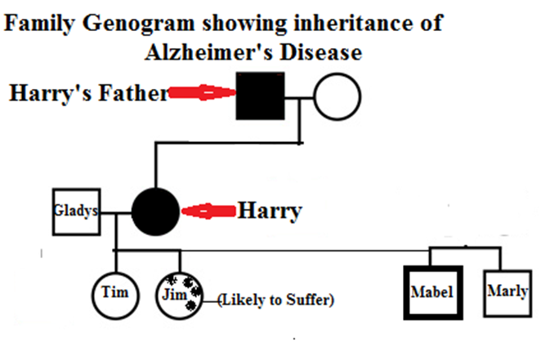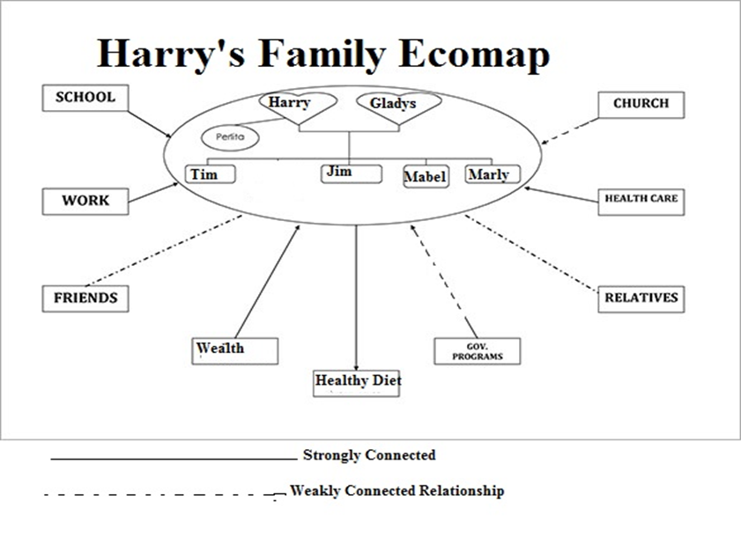

References
Kaakinen, J. R., Coehlo, D. P., Steele, R., & Robinson, M. (2018). Family health care nursing: Theory, practice, and research. FA Davis.
Stanhope, M., & Lancaster, J., (2015). Public health nursing-e-book: Population-centered health care in the community. Elsevier Health Sciences.
Svavarsdottir, E. K., Sigurdardottir, A. O., Konradsdottir, E., Stefansdottir, A., Sveinbjarnardottir, E. K., Ketilsdottir, A., ... & Guðmundsdottir, H. (2015). The process of translating family nursing knowledge into clinical practice. Journal of Nursing Scholarship, 47(1), 5-15.
Tao, B. A. N. (2016). Framework About Family Power Structure New Change——Young Couple's "Two Sides to Walk." Journal of Northwest A&F University (Social Science Edition), (2), 15.

