The Apology

This is the abbreviated text and is used for the term paper. The full text is available online at Project Gutenberg for free. This text is also in the book, Voices of Wisdom 6th and 7th edition in chapter 2.)
- This is Socrates’ Speech about the nature of death
Let us reflect in another way, and we shall see that there is great reason to hope that death is a good, for one of two things: - either death is a state of nothingness and utter unconsciousness, or, as men say, there is a change and migration of the soul from this world to another. Now if you suppose that there is no consciousness, but a sleep like the sleep of him who is undisturbed even by the sight of dreams, death will be an unspeakable gain. For if a person were to select the night in which his sleep was undisturbed even by dreams, and were to compare with this the other days and nights of his life, and then were to tell us how many days and nights he had passed in the course of his life better and more pleasantly than this one, I think that any man, I will not say a private man, but even the great king, will not find many such days or nights, when compared with the others. Now if death is like this, I say that to die is gain; for eternity is then only a single night. But if death is the journey toanother place, and there, as men say, all the dead are, what good, O my friends and judges, can be greater than this? If indeed when the pilgrim arrives in the world below, he is delivered from the professors of justice in this world, and finds the true judges who are said to give judgment there, Minos and Rhadamanthus and Aeacus and Triptolemus, and other sons of God who were righteous in their own life, that pilgrimage will be worth making. What would not a man give if he might converse with Orpheus and Musaeus and Hesiod and Homer? Nay, if this be true, let me die again and again. I, too, shall have a wonderful interest in a place where I can converse with Palamedes, and Ajax the son of Telamon, and other heroes of old, whohave suffered death through an unjust judgment; and there will be no small pleasure, as I think, in comparing my own sufferings with theirs. Above all, I shall be able to continue my search into true and false knowledge; as in this world, so also in that; I shall find out who is wise, and who pretends to be wise, and is not. What would not a man give, O judges, to be able to examine the leader of the great Trojan expedition; or Odysseus or Sisyphus, or numberless others, men and women too! What infinite delight would there be in conversing with them and asking them questions! For in that world they do not put a man to death for this; certainly not. For besides being happier in that world than in this, they will be immortal, if what is said is true.

In Standard Form:
Socrates’ Argument
Premise 1) Either death is a state of nothingness and utter unconsciousness or there is a change and migration of the soul from this world to another
Premise 2) If death is a state of nothingness and utter unconsciousness, then death will be a more relaxing process and give a sense of freedom within the mind
Premise 3) If death leads to change and migration of the soul from this world to another, the death will be a joyful experience as one will be united with the Gods, and individuals of the other world.
————————
Conclusion) Therefore, either death will be a relaxing process as one is given freedom within the mind, or death will lead to joy as one will be reunited with Gods and other individuals of the other world.

General Guidelines
- Type your paper on a computer and print it out on standard, white 8.5 x 11-inch paper.
- Double-space the text of your paper, and use a legible font (e.g. Times New Roman). Whatever font you choose, MLA recommends that the regular and italics type styles contrast enough that they are recognizable one from another. The font size should be 12 pt.
- Leave only one space after periods or other punctuation marks (unless otherwise instructed by your instructor).
- Set the margins of your document to 1 inch on all sides.
- Indent the first line of paragraphs one half-inch from the left margin. MLA recommends that you use the Tab key as opposed to pushing the Space Bar five times.
- Create a header that numbers all pages consecutively in the upper right-hand corner, one-half inch from the top and flush with the right margin. (Note: Your instructor may ask that you omit the number on your first page. Always follow your instructor’s guidelines.)
- Use italics throughout your essay for the titles of longer works and, only when absolutely necessary, providing emphasis.
- If you have any endnotes, include them on a separate page before your Works Cited page. Entitle the section Notes (centered, unformatted).

Formatting the First Page of Your Paper

- Do not make a title page for your paper unless specifically requested.
- In the upper left-hand corner of the first page, list your name, your instructor’s name, the course, and the date. Again, be sure to use double-spaced text.
- Double space again and center the title. Do not underline, italicize, or place your title in quotation marks; write the title in Title Case (standard capitalization), not in all capital letters.
- Use quotation marks and/or italics when referring to other works in your title, just as you would in your text: Fear and Loathing in Las Vegas as Morality Play; Human Weariness in “After Apple Picking”
- Double space between the title and the first line of the text.
- Create a header in the upper right-hand corner that includes your last name, followed by a space with a page number; number all pages consecutively with Arabic numerals (1, 2, 3, 4, etc.), one-half inch from the top and flush with the right margin. (Note: Your instructor or other readers may ask that you omit last name/page number header on your first page. Always follow instructor guidelines.)

Here is a sample of the first page of a paper in MLA style:
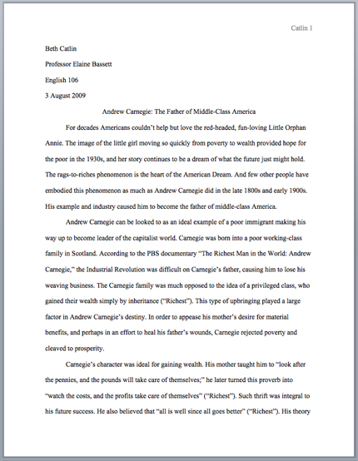
Image Caption: The First Page of an MLA Paper

http://classics.mit.edu/Plato/apology.html This was copied from The Internet Classics website. It was found by using a Google search for 'Plato's Apology Text.'

