Marketing Proposal- Santa Fe Grill
Amanda McCausland
Rod Ballard
BUS530
July 28, 2019

Change Matrix
Instructor’s feedback (specific listing of the error) | How the error was addressed by the student. | Page numbers where change appears
Inserting tables along with graphs | Placed graphs with their respective tables | P. 4
Change proximity of the restaurant | Changed proximity to cover restaurants in a 20 mile radius instead of just the mall. | P. 8

Table of Contents
Segmentation 3
Common characteristics 3
Perceptual map 6
Research methodology 7
Exploratory research 7
Qualitative research 7
The pros and cons of the methodology 7
In-depth interview as the data collection method 8
Descriptive variables 9
Hypothesis Design 10
Questionnaire 10
Qualitative questions 10
Quantitative questions, (Rucker 2015) 11
References 12

Introduction
Santa Fe Grill was founded by two roommates about a year and a half ago. The need for self-employment inspired the restaurant idea. The founders first came up with the plan based on what they had learned in an entrepreneurial class. The plan demographics had to be implemented in Dallas. However, the restaurant did not achieve an optimal outcome causing the owners to opt for marketing research. This research aims to survey to help the owners identify the liabilities in their plan. The main aim is to determine the factors that improve customer satisfaction and loyalty. They will, therefore, be able to adjust their strategy. The market research will use market segmentation. This study will generally involve a survey evaluating the traits, attitudes, and demography of the market. The study aims to come up with better marketing techniques in terms of effectiveness and efficiency to increase the customer base. The selected population should have provided expected to perform well in giving customers for the restaurant. More than half of the population lied within a suitable age range. The community could also afford to dine at the restaurant. The survey was comparative. It involved another dinner Jose's southwestern café. The study involved a sample of 400 customers. Two hundred fifty from the restaurant and 150 from Jose's. The customers have interviewed ant the Cumberland mall, which has a prominent brand after they had eaten. For the employee survey questionnaires to determine their performance was issued. The research is to be conducted by a market research company in the mall. The company has the advantage of being able to intercept the customers as they come in. For the founders, this survey will be an eye-opener to the restaurant's strengths as well as weaknesses. The study is not on the restaurant alone, and it will, therefore, provide insight into the market competition.In the longing, the restaurant will be able to come up with more strategies to improve the performance of the restaurant.

Segmentation

Common characteristics
The main advantage of market segmentation is that it informs on the aspects of the customers. This method provides an upper hand when it comes to marketing in that; the owner can personalize marketing. When you identify the needs of your targeted customer’s it leads to satisfaction, and theycan refer your business to their friend and relatives. The survey was done on a sample of 405 customers. One hundred fifty-two were from Jose's and 253 from the restaurant.
The founders settled for Dallas instead of Lincoln Nebraska because the market segmentation they had done showed that Dallas had a higher potential. The significant characteristics of the population in Dallas were: 50% of the 5.5 million people were between 15-60 years old. This was a favorable number the restaurant required an area with families of singles. Another characteristic of their target population is that they had a stable income. The range of the salary was $35000 to $ 75000 annually. This voltage was for 55% of the population. This meant that a similar percentage could afford the restaurant. This socioeconomic statistic assured the owners a regular customer base. Another favorable characteristic was that 59% of the population has a family setting. The table below is a summary of these socioeconomic and demographic characteristics
Table 1.0 Demographic characteristic the community
characteristic
Age | target(18 - 50) | 859968 | 72%
 | not targeted | 328032 | 28%
household type | Family | 267000 | 59%
 | singles | 148850 | 33%
 | total of target | 415850 | 92%
household income | $35000 - $75000 | 653400 | 55%
Average population target | All characteristics | 643072.67 | 73%

Figure 1.0 Graphical representation of the target population

From the graphabove, it is clear that the household characteristic gives the highest population target, which is 92 percent, followed by the age which constitutes 72%, and then income standing at 52%. From this data, the best case scenario the market could have 92% of the population as the target. The worst and most possible scenario means the industry would have 55% of the people who can afford the meals as the target. On average the targeted population would constitute 73% of the targeted population

Perceptual map
The perceptual map as made based on the food quality and the value in terms price of food. These values were obtained from the values of customer reviews on the TripAdvisor website. The Jose’s southwestern café had 1412 reviews and was ranked 17th out of 113 while the Santa Fe Grill was ranked 112th out of the 378 restaurants in its market. From the reviews, Jose's southwestern café had a rating of 4.5 out of 5 in terms of quality of food and a score of 4.5 out of 5 in termsof the value paid for the food (TripAdvisor 2019). On the other hand, Santa Fe Grill had a rating of 4 out of 5interms of food quality and a score of 4 out of five in terms of the price of the food.

Perceptual map

High Price
Jose's Southwestern Cafe
Santa Fe Grill
Low quality

High quality
Low Price

Research methodology

Exploratory research
For Santa Fe Grill, an exploratory form of research is to be used. This method is appropriate to determine why the customers visiting the restaurant are not as much as the expected number. To conduct the research, a sample of customers who dine at the mall will be interviewed. This will be compared with their competition’s reviews, Jose's southwestern café, to determine why the restaurant is not performing as expected and determine the difference, what Jose's is doing better, to improve on the quality of food and services they provide.
To effectively assess the market the respondent’s home will also have to be known to determine if they are from far and why they would take the distance instead of dinning at their local restaurants. The research will have a concentric radius of about 20miles. This would include visiting restaurants in the proximity to gain insights on their customers. covering this radius will help determine why customers would consider going there, also to determine if there are customers near Santa Fe Grill who still dine there. This part of the research is to help the marketing team determine the unique elements of other popular restaurants that make their customers loyal.

Qualitative research
To get more information on the matter, qualitative research would be the most appropriate. The company had initially used quantitative data during the start of the company. Though the research method was more reliable, it did not help in the marketing of the company. Qualitative research will, however, lead to personalizing the marketing strategy. Qualitative research implies the company will be able to capture thoughts, suggestion, and general rapport from customers. This information will, in the long run, help identify the obstacle preventing the restaurant from reaching its desired potential. The research will exploratory, and interviews will be conducted for a short period of around two weeks. The interview will be open-ended, providing capacity for more information. A small sample of about 400 will be used.

The pros and cons of the methodology
Compared to quantities research which was done earlier, qualitative research does not support box participants into specific categories? Qualitative research allows the researcher to have a deeper comprehension of the customers. In qualitative research, a quantitative analysis might be used to make the results more reliable. In qualitative research, the researchers will be in close contact with the participants. This will enable to collect more detailed data from the open-ended questions, and the nonverbal cues read from the participant. The researcher has to be equipped with interpersonal communication skills to do this. The data from this form of research is rich and can support other types of primary data. In this case, the restaurant might discover the cultural preference of their potential customers. The analysis might reveal what Jose's is doing in food quality and customer service that Santa Fe Grill is not doing. This method is better because it is quick. There is time efficiency, and data can also be collected from online conversations. The data will provide insights into the potential customer based on their behavior. The information is sufficient when coming up with proposals and models for marketing. The downside is that the data is less reliable and does not bring out the magnitude of the situation. Then the research company will perform a survey on the current staff in the restaurant. This will provide information on the quality of customer service offered, which can be compared to the preferred service by the customers.

In-depth interview as the data collection method
The collection method for this research will be an in-depth interview. The plan will use a trained interviewer having a one on one interview with a participant while using structured questions. The necessary steps of the process are; first is the researcher discusses with the management of the situation and the issue to be addressed. The interviewer has to have a good understanding of the restaurant's system to pinpoint the problem.
Secondly is developing the semi-structured questions to be used in the interview. The question should be logical. The structure of the conversation should be general at first then becomes more contextual towards the end. The contextual parts should address specific elements of the problem.
The third is the environment. This will be at the mall where the two restaurants are located. It will be an exit interview just after the customers have had their experience with the restaurants, and this will make the information more accurate. For the sample, since the mall is a great place, the respondents will have to be adults and should be coming from either of the two restaurants.
Forth is the interview. The interviewer should set a relaxed environment; this would entail the customer is aware of how the interview will be done, and the data collection techniques, for instance, video cameras. Secondly, the interviewer must provide an introduction of themselves and define the purpose of the interview.
The fifth is the actual interview. Here the interviewer responds to all the questions. On completion of the interview, the interviewer will thank and debrief the respondent.
Sixth is the analysis of the information collected. This includes classifying the data and identifying new and outlying information. Lastly, the interviewer will provide a summary of the research process.

Descriptive variables
In the research, the standard explanatory variables include; the size of the individual, the quantity of food they consumed, and people in his household, area of residence, and area of occupation.

Hypothesis Design
Null hypothesis- Changing the restaurant's customer service to match the Texas culture and Norms will have no impact on marketing.
The alternative hypothesis- Changing the restaurant's customer service to match the Texas culture and Norms will have an impact on marketing.

Questionnaire
During research one of the most significant process is the survey. The research will use questionnaires as a source of data. The main objective of the survey is to learn more about the target population in order to come up with better marketing models that would guarantee success. The research will have both qualitative and quantitative methods. The quantitative questions will provide descriptive data. For instance the most preferred restaurant, the often taken meals and other statistical information, (Epstein, 2019). These questions will provide data which when analyzed will help the management determine their cut in the market and the overall target population.
Qualitative questions in the research will provide more insights. The questions are open ended and will represent the reason behind the quantitative data. This part of the research will give the management information on where the competition is beating them and the current trend in the business, (Epstein 2019). This part will also have recommendations that the management could improve on. The data from this part will not be analyzed for efficiency and will only serve to answer the ‘why’. The following are the questions to be included in the questionnaire.

Qualitative questions
How would feel if Santa Fe Grill start making your favorite dishes?
How would you describe the service provided at your preferred restaurant?
What recommendations would you give to improve on the service provided?
What are the main reasons for your preferred restaurant?
Why have not been dinning at the other restaurant as frequent as the other?
What do you feel about the staff at Santa Fe Grill?
Describe the best experience at Santa FE Grill?
How would you feel if Santa Fe Grill adapted a similar environment setting to Jose’s café? (Fieldboom 2019)

Quantitative questions, (Rucker 2015)
Which restaurant between Santa Fe Grill and Jose’s dinner do you prefer?
How many times have you recommended the restaurant?
What is your alternative for this restaurant?
What are your top favorite dishes at these restaurants?
Which meals do you commonly take at the restaurant?
What is the comparison between the price of the service and the quality delivered, is the service worth it?
How many times have you dinned at the other restaurant?
Do you find the environment at Santa Fe Grill comfortable?
What changes would you make to the menu if you were the manager at Santa Fe Grill?
Would you dine at Santa Fe Grill if the prices were discounted?

Data Analysis and Findings
The findings of this project are displayed below

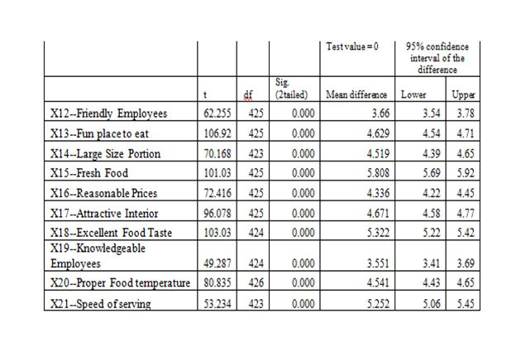
The t test above analyzes variables which describe the restaurant. The values are greater than .05 therefore becoming significant. A higher Mean difference in the restaurants for x21 ‘Speed of Service’x18 ‘Excellent Food Taste’ andx15 ‘Fresh Food’. The aspects highlighted enable the customers to come back again therefore, Jose needs to improve on these services and enhance employee productivity.

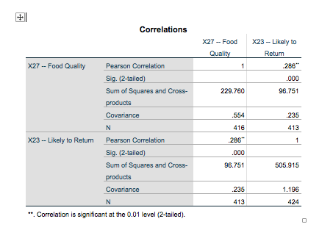
The biggest factor to make customers return was the quality of food. In the case above, correlation significance is 0.01 while significance between the two is 000 therefore the likeness of the customers to return is high. The quality of food must be improved further to make the customers return daily.

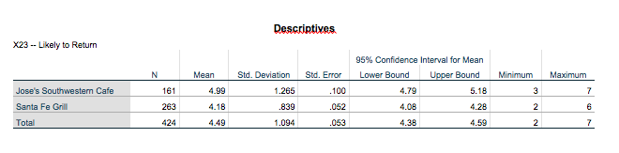
The comparisons between competitors as shown above indicate that the likeness of customers returning is high at the Southwestern Café compared to Santa Fe Grill. The southern café has a mean of 5.18 depicting the high likeness of the customers coming back compared to 4.28 mean by Santa Fe Grill customers. Santa Fe Grill management should work out more on customer satisfaction. Despite having high number of customers, the return rate is low because of the services the customers received.

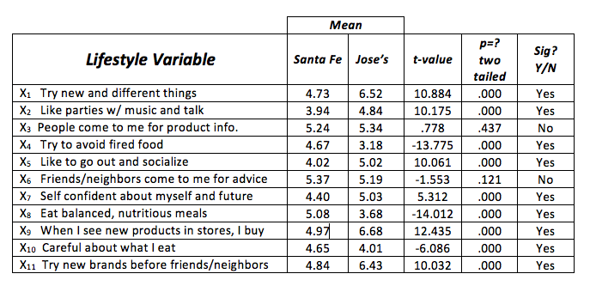
The table above displays the lifestyle attributes of customers between the two cafes. The report clearly indicates the customers who dine at Jose are flexible with introduction of new foods in the café. The customers seem to like visiting Jose’s because of this attribute. Therefore, the report reveals that Jose changes food products regularly which are a key factor in attracting more customers.

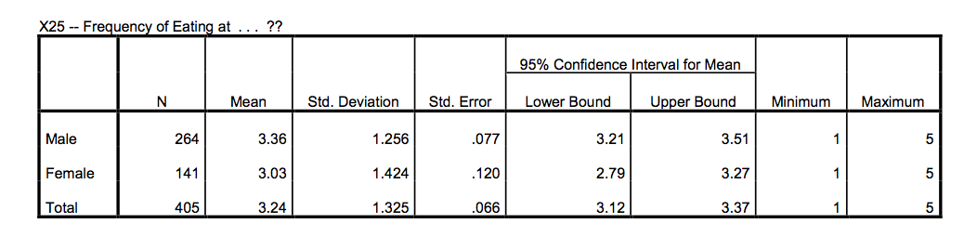
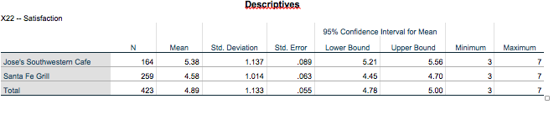
Southwestern Café has the highest customer satisfaction and this indicates the services provided are quality and the food served is satisfying. Despite this research results, Santa Fe Grill has loyal customers who visit daily. To attract more customers, Santa Fe Grill will have to introduce new products in their menu, and also compare the foods and services provided by Jose’s Southern Café to instill competitiveness.

References
Epstein, L. (July 2019). Get better and simplify analysis: qualitative vs quantitative questions. Retrieved from https://www.surveymonkey.com/curiosity/qualitative-vs-quantitative/
Fieldboom (June 2019). 50 survey questions to better learn about your customers. Retrieved from https://www.fieldboom.com/survey-questions/
Rucker, M. (October 2015). Qualitative and quantitative research questions. Retrieved from https://unstick.me/qualitative-vs-quantitative-research-questions/
TripAvisor. (July 2019). Santa Fe Grill Dallas. Retrieved from https://www.tripadvisor.com/Restaurant_Review-g60958-d647377-Reviews-Santa_Fe_Bar_Grill-Santa_Fe_New_Mexico.html
Trip Advisor. (July 2019). Jose’s southwestern Café. Retrieved from https://www.tripadvisor.com/Restaurant_Review-g31352-d1673744-Reviews-Cafe_Jose_Restaurant-Sedona_Arizona.html

