Course Name and Number:IT 425
Project Name: Supply Chain Management (SCM) System
Name: Hollie Gates
Date: 25 July 2019

Table of Contents

Week 1: System or Application Overview 3
Week 1: Requirements Specification 4
Week 2: System or Application Design 5
Week 3: Test and Quality Assurance Plan 6
Week 4: Development Strategy 7
Week 5: Integration and Deployment Plan 8

Week 1: System or Application Overview

A car manufacturing company, General Motors Company, intends to replace its old, outdated system with a supply chain management system. The supply chain management will ensure improved service delivery as a result of its effective and efficient ordering system that and this will make the company competitive and improve the profits realized by the company. Currently, General Motors make use of old legacy systems for making orders and managing their distribution and inventory, and the company management has realized that the existing system did not integrate properly with the current trend of the input data redundancy and its processing too. Instances of processes redundancy also forced their current system to have multiple data entry points which raised instances of having erroneous and irreconcilable data feeds.
The fulfillment of the system order for the supply requirements of the company took longer than they could have wished for due to the longer time is taken for the information to flow from one point to the other of the existing system(Singhal, 2016). This has left many customers dissatisfied of the company services because of the time taken for them to have their item or services from the company. The existing General Motors company system has an exorbitant carrying cost as a result of the numerous processes done for a complete order which can be minimized if not eliminated after a full realization of the proposed supply chain management system.
The General Motor supply chain management system will mainly affect the procurement department of the company. Primarily because, the proposed system aims at changing the way company inputs are ordered, and upon supply, the way these items will be managed and entered in the inventory. Instead of the existing way where good that the company needs will be procured by writing a letter from the procurement department and waiting for other processes to be done such as budget approval and quotation requesting in an old-fashioned way, it will take a long time before the goods are supplied. With supply chain management system, efficiency, and rate of data flow from one point to the other will be enhanced, reducing the delays experienced when there is a normal manual procurement process(Agrawal, 2016).
The departments that actively participate in the procurement process will benefit significantly with the proposed system as it will make use of a single data entry point resulting in data uniformity and improved cooperation level. If anything needs to be changed in the procurement process, then it will take effect on all points in the departments involved in the procurement process(Singhal, 2016). The uniformity ensures that there will be a high level of consistency in the entire process. The stakeholders of the proposed system will be the General Motors finance, procurement, and the top management departments in the company.
The General Motors strategic level is the initial proprietors of the supply chain management system. Since their main task is to design and oversee the implementation of functions that will enhance the customer experience of the firm. The strategic levels proposed to implement the system into the company to cut short the expenditures incurred in the existing system that includes the moving cost and the overall operation cost. They also targeted to use the system to make the process of procuring items to be done more quickly to reduce the anger that customers get when their items or services from the company are delayed. During the system development, the funding and sponsorship will be fetched from within the company and facilitate the development of the proposed system.

Week 1: Requirements Specification

Week 2: System or Application Design

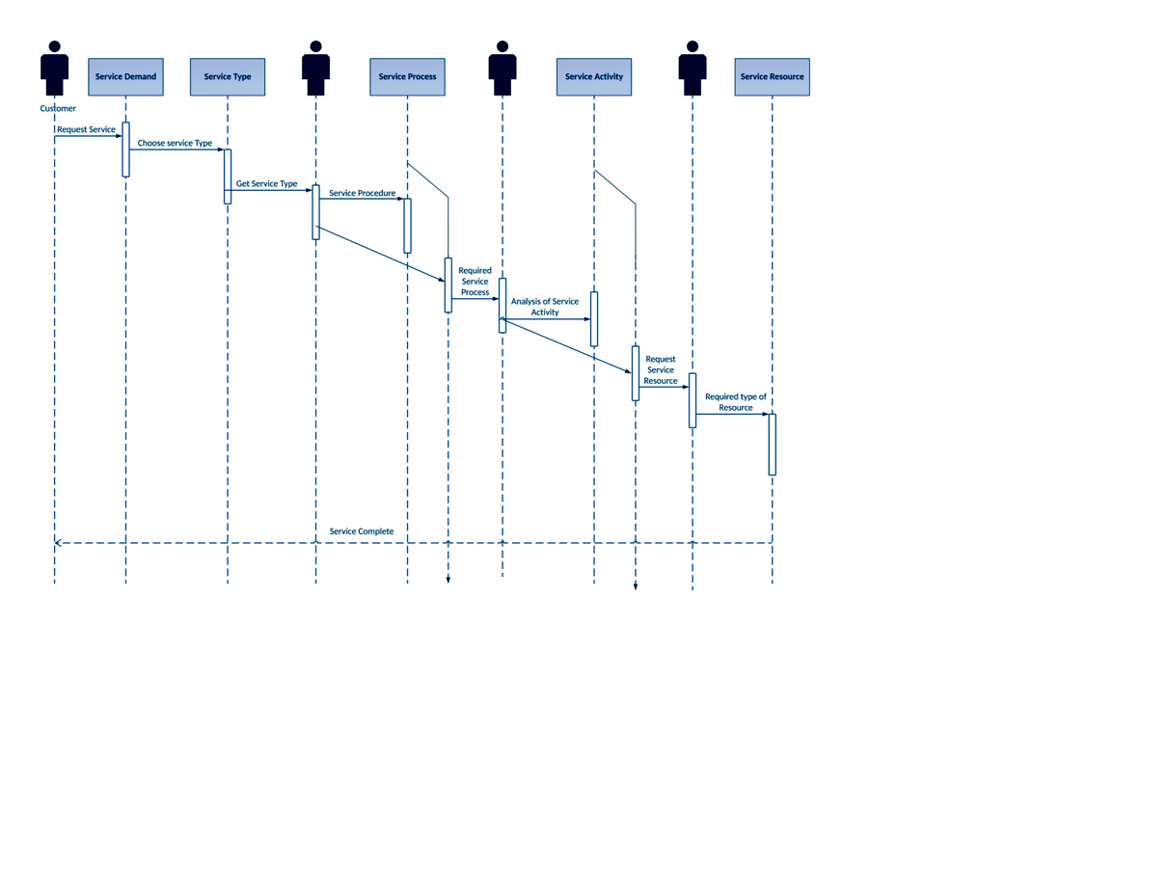
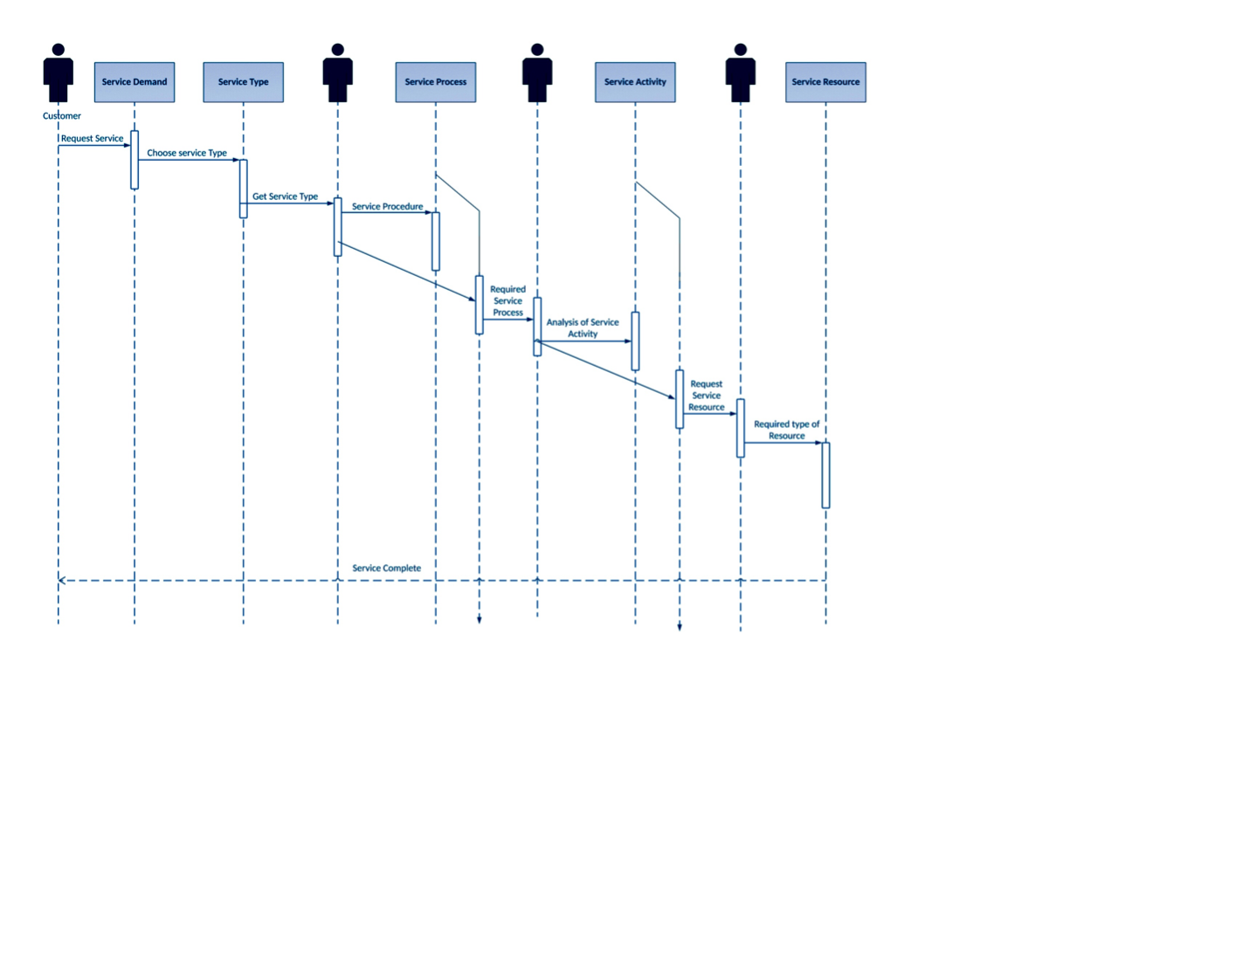
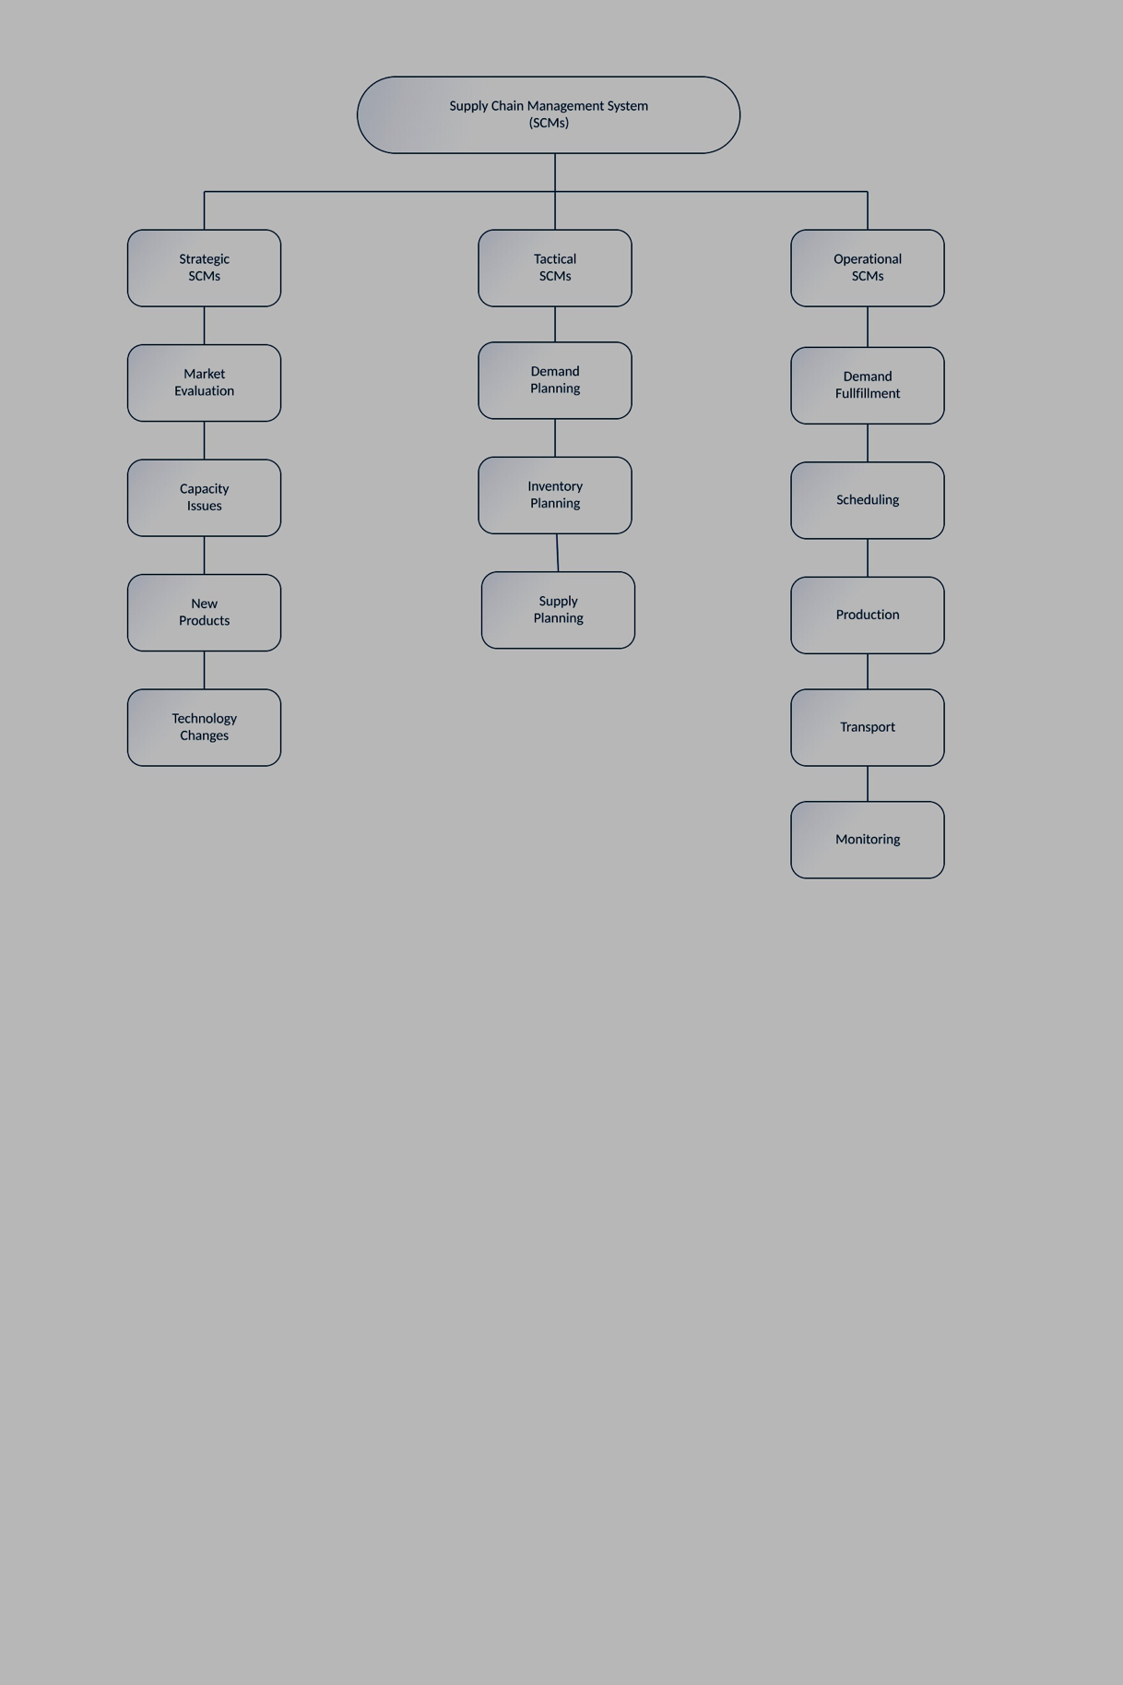
-
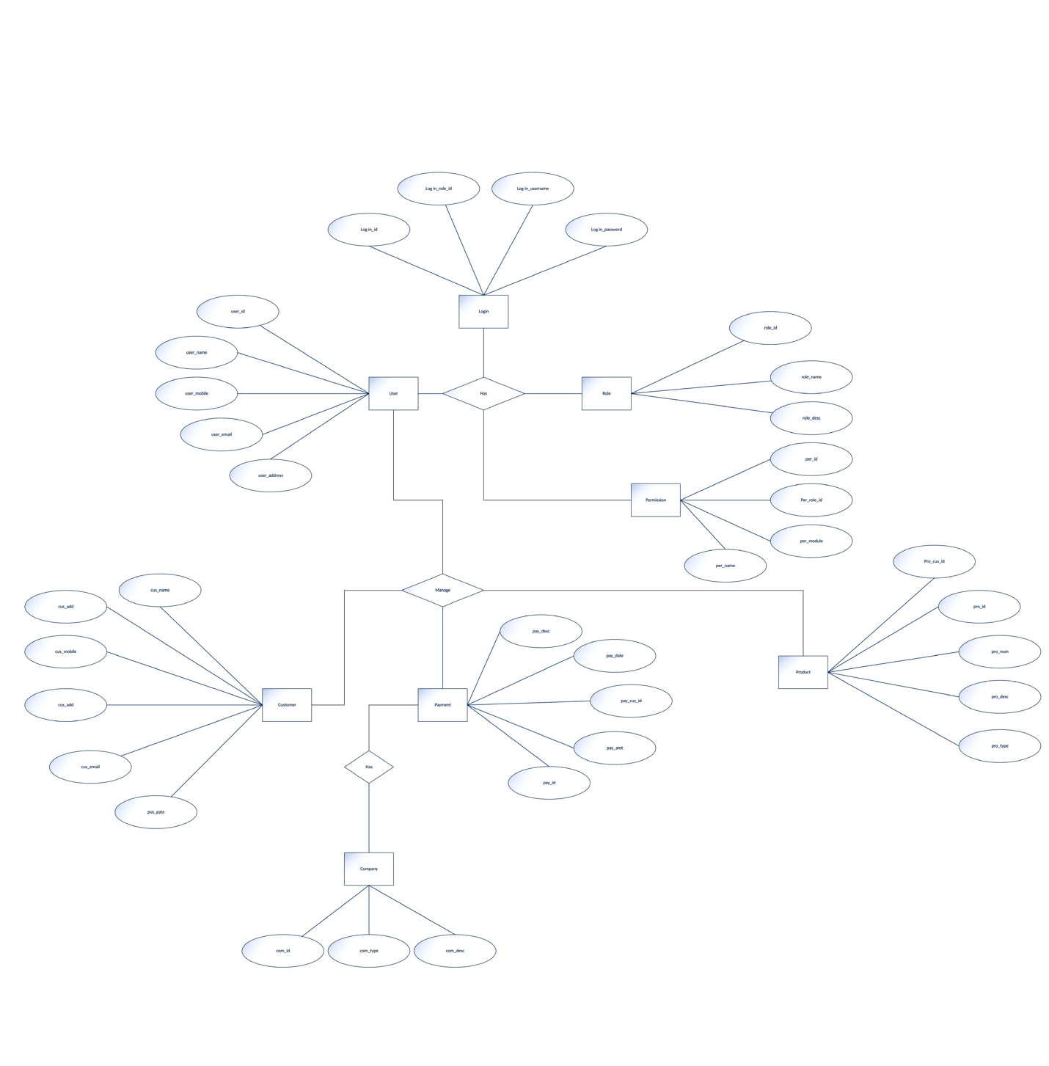

Week 3: Test and Quality Assurance Plan

Test and Quality Assurance Plan
Testing is a most crucial step in the SDLC life cycle. Testing is done to identify the presence of bugs that may compromise a system’s functionality. Testing is also a quality assurance technique. Quality assurance is a comprehensive process of ensuring that a system meets laid down standards for process and procedures used in building the system. High quality processes and procedures ultimately mean high quality software. As a system developer for the Supply Chain Management System, adherence or failure to adhere to quality has some ethical implications. For instance, suppose the SCM system breaks down amidst operations leading to losses in profit or even products, then such liability lies upon the shoulders of the developer. For this system, three testing techniques will be used alongside multiple quality assurance controls to guarantee the quality of the SCM software. The system will be tested using unit, system and acceptance testing. These techniques provide both horizontal and vertical testing approaches cutting across both application modules and functionalities from top to bottom.
Plan for Unit Testing
Unit testing modularizes the application code into various code segments that can be tested independently to verify their correctness. Alternatively, unit testing could be performed at the end of every module to determine its correctness. Either way, unit testing ensures the correctness of individual modules which contributes to the quality of the whole system. The step by step unit testing for the SCM system is described below.
STEP 1: Identifying Scope
The SCM system will be broken down into;
- Planning module
- Sourcing module
- Production module
- Delivery module
- Returns module
- Order fulfillment module
STEP 2: Forming Unit Test Cases
The following form will be used to test each module
TEST CASE  (e.g. Delivery Module) | AREAS TO BE TESTED | STATUS | COMMENTS
Delivery Module | Code design and Execution.
 | API suitability
 | Login Success
 | Black-box testing
 | White box testing
 | UI testing

STEP 3: Documenting Results
Upon completion of unit testing, the testing team will document results as part of final documentation for the whole system.
Plan for System Testing
System testing tests for the appropriateness and quality of whole system components. For the SCM software the system testing process will involve the following;
STEP 1: Identifying Test cases
The following tests cases will apply to the SCM software;
- Load testing
- Security testing
- User and operator interaction
- System performance
- Recovery and Back-up
- User interfaces
STEP 2: Conducting the Test
The tests will be conducted using the following processes.
- Planning- the testing team will identify key system metrics that apply to each and every module identifies above.
- Creating tests cases- the test cases above will then be disintegrated into smaller test cases to enable preciseness in the testing processes.
- Choosing test data- the testing team will select and apply different types of test data including data from the previous system.
- Executing tests cases- the testing is then performed using the various sets of test data chosen by the testing team.
- Verify test results- The test results are then assessed for bugs, in case of any, the testing process is started again.
STEP 3: Documentation
The test results are documented as part of meeting quality assurance requirements.
Plan for Acceptance testing
Acceptance testing goes beyond the functional scope of the system and tests for non-functional requirements that are indicative of the successful deployment of the system.
STEP 1: Establish acceptance testing framework
In this step, the goal is to identify a logical process that will be used for acceptance testing.
STEP 2: Plan test activities
Using the system’s documentation, the acceptance testing team identifies critical testing points while setting milestones to be accomplished during the procedure.
STEP 3: Developing test cases
Test cases are developed based on previously identified functional and non-functional requirements. The non-functional requirements for the SCM system would include, security, maintainability, performance, reliability, scalability and robustness.
STEP 4: Setting up the test environment
A test environment is then set up, simulating the real environment.
STEP 5: Executing the tests
The tests are then carried out and the results documented.
Software Quality Assurance Plan
The SQA of the SCM software will be based on the following guidelines and controls.
- Software Quality Standards
The quality standards of the SCM software will measured along the following lines;
- Coding standards; this will be determined by the application’s adherence to coding rules, styles and conventions as prescribed by respective programming languages. This has legal constraints as most programming languages restrict the modification of their rules.
- Documentation standards; the quality of documentation will be determined by the documentation’s format and following of laid out principles for that format. Additionally, the documentation consistency in terms of data presentation will also count as a metric for documentation standards.
- Design standards; the application must be modeled after universally identified architectures like the OSI and the TCP/IP models.
- Software Quality Factors
The following factors will serve as the basis of measurement of quality for the SCM software.
- Correctness- The correctness of the software will be based on the output of the software. The output should be accurate, complete, up- to date and readily available.
- Reliability- this will be measured using the software’s failure rate.
- Efficiency- this metric defines the how fast the software operates and will be a relative measure between the old and the new system.
- Integrity- this metric will measure the system’s ability to secure data through control of access rights and overall data protection mechanisms.
- Usability- this will record a measure of the user’s ability to learn and use the system in the shortest time possible.
- Software Quality Assurance Methodologies
The following methodologies will be used to assess the systems quality while taking into consideration the quality standards and factors mentioned above.
- Process and Product Quality Assurance – For the Supply Chain Management system I am developing, this quality assurance method would be essential in determining the effectiveness of processes and procedure within the system.
- Conformance testing- This quality assurance tests if the system meets business standards set out for Supply Chain Management systems.
- Data Comparison- since the SCM am developing is replacing an old system; data comparison will help determine the effectiveness of inputs and outputs of the new system in comparison to the old system. This would help determine the software’s correctness.
- Peer Reviews- Peer reviews are discussions held to discuss different aspects of the project works and their adherence to software standards.

Week 4: Development Strategy
TBD

Week 5: Integration and Deployment Plan
TBD

References
An, H. (n.d.). The Construction of Green Supply Chain Management System. Innovations in Supply Chain Management for Information Systems, 239-247. doi:10.4018/978-1-60566-974-8.ch010
Singhal, P., Agrawal, R., & Sharma, V. (2016). Significance of Supply Chain Management in Public Distribution System. Journal of Supply Chain Management Systems, 5(1). doi:10.21863/jscms/2016.5.1.024
Supply Chain Performance Management (SCPM) alsinterorganisationaleSteuerungskonzeptionfür das Supply Chain Management. (n.d.). Supply chain Performance Management, 211-263. doi:10.1007/978-3-8350-9026-2_4

