Instructions Journal V
Jigsaw puzzles use strategies that develop problem-solving skills and boost logical reasoning. People complete jigsaw puzzles individually and in groups. In groups, cooperative learning is used to help each other solve the puzzle and build comprehension. Individually, it helps build critical thinking. Online, it is difficult to solve the puzzle and build comprehension or even critical thinking; however, take one piece of the jigsaw puzzle, and discuss the one piece as to what it is; when it activates; where it is used; as well as how and why it is used. Have you ever seen a sprinkler head activated? Where? Did it control or extinguish the fire?
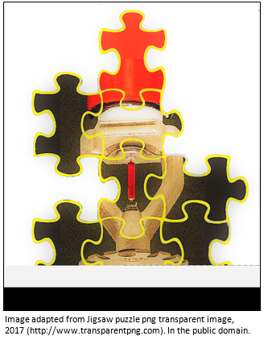
Your journal entry must be at least 200 words. No references or citations are necessary.

Unit VI Journal
Instructions
The textbook suggests that there is some disagreement over the value of standpipe and hose systems as they may give false security to building occupants. Some believe having a standpipe hose may create the impression that occupants should fight fire even though a safer course would be to escape. What are your thoughts? Have you ever lived in an apartment, worked in a building, or attended a school that had a standpipe hose system? Do you believe occupants should fight fire? Do you believe they should escape? Why, or why not?
Your journal entry must be at least 200 words. No references or citations are necessary.
Unit VII Journal
Instructions
Have you ever had a surge protector short out or even catch fire? Is it critical that fire protection systems have surge protection on all electrical fire protection equipment and appliances? Is surge protection real or just an illusion? Why do you think that?
Your journal entry must be at least 200 words. No references or citations are necessary.

Unit VIII Journal
Instructions
How will this course enhance your professional success?

Optional: Have you ever been in a situation where smoke was present, or do you know someone who has experience this? Recall the discussion about the hazards associated with smoke and the products of combustion as they spread throughout structures. What are your thoughts on the need for smoke management? Should smoke be controlled? Do you think the strategies of controlling smoke have any implication on occupants or even firefighters responding to a fire? Why, or why not?

Your journal entry must be at least 200 words. No references or citations are necessary.

