U.S. Health Care Systems for Small Populations, Part 1
MHA/599 Capstone: Leading the Organization Through Change
Lolita Clark
October 29, 2019
Dr. Debra S. Sandberg
U.S. Health Care Systems for Small Populations, Part 1
The US does not have a universal healthcare program that offers medical cover to all its citizens but instead has multiple healthcare programs that provide medical protection to specific groups in the country. Some of these medical healthcare programs include Medicare, Medicaid, veterans’ health administration, department of defense Tricare, state children health insurance, and Indian health services, among others. On the other hand, various cities in the US have a different population that influences the most prevalent healthcare programs in such a city. Yonkers, NY, is one of the cities in New York that has a population of fewer than 200,000 people. The discussion below is an analysis to identify the common healthcare system in Yonkers city in New York.
Yonkers City, NY Map
Yonkers is one of the cities in Westchester County in New York. It is located behind Rochester and Buffalo, NY. It is one of the inner suburbs of NY, 2miles north of the Northernmost part of Manhattan, as well as directly to the North of Bronx.
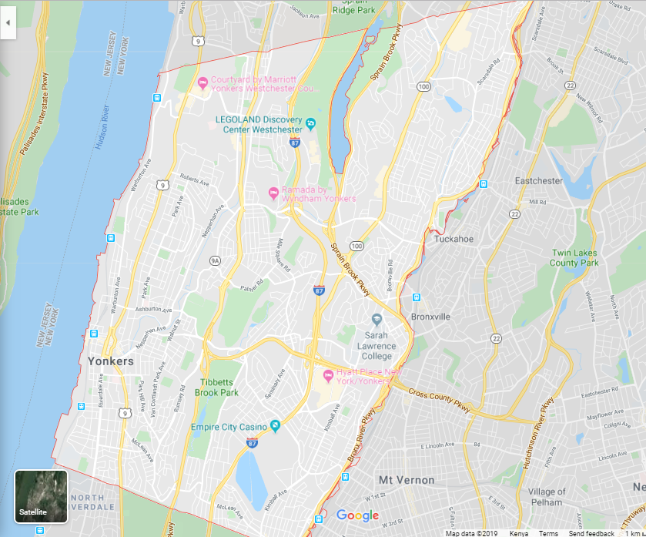
Types and location of medical services
Three major healthcare facilities exist in Yonkers City. These include Saint John’s Medical center, Saint John’s Riverside Hospital- Park Care Pavilion, and Saint John’s Riverside Hospital-Andrus Pavilion. The three major healthcare facilities offer health promotion, diagnosis, and treatment as well as disease prevention healthcare services in the City (Inkelas & McPherson, 2015). Saint John’s Riverside Hospital- Andrus Pavilion is located in 967 North Broadway. Saint John’s Riverside Hospital- Park Care Pavilion is located at 2 Park Avenue, while Saint Joseph’s medical center is located at 127 South Broadway. The strategic location of these significant healthcare facilities makes it possible to offer healthcare services to the residents of Yonkers.
Demographics of Yonkers
The population in Yonkers has continued to increase in the past as the lowest recorded population was 8,218 people in 1860. The recent census in 2010 showed that there are 195,679 people, and it’s estimated that in 2018, the community was 199,673 resulting in a population density of 11,215.72 people per mile squared.
For Yonkers, the median age is 38.8 years, while the average age for females is 40.1, and that of males is 37.3 years. The adult population is according to the 2018 census estimates indicate that there are at least 157,470 adults in the City (Inkelas & McPherson, 2015). The population of males in the City stands at 94,900, which is 47.2% of the total population in the City. The population of females, according to 2018 census estimates, is 106,070, which represents 52.78% of the entire population.
Whites are the dominant race in the Yonkers population, whereby they represented 56.3% of the estimated census population in 2018. Blacks or African Americans are the second most prevalent race in Yonkers, and they represent 17.8% of the estimated 2018 census population. Asians represent 7.2% of the population, while other races represent 14.5% of the population of Yonkers.
Income and employment in Yonkers
The employment participation of the population in Yonkers is 63.1%. The employment rate stands at 58.1% while the percentage of the population that is unemployed in 8. The median income for every household in Yonkers stands at $84,764. The mean salary for families in the City is $75,110, while that if married families is $98,843. The overall rate of poverty in the City stands at 16.42%, whereby in males, it stands at 15.25% while in females, it stands at 17.44%. Consideration of the economic status of the residents of Yonkers, the most prevalent healthcare program is Medicare, which helps to cover the majority of the people living in poverty (Wager et al, 2017).
Residential details of Yonkers population
According to the recent census population estimate of Yonkers, 58.76% of the population were born in New York. 69% of the 2018 population estimate is native-born, while 30.6% of the estimated population are foreigners, while 13.02% are non-citizens.
The rationale for selecting Yonkers city
One of the factors leading to the selection of Yonkers as the City under analysis is its ability to have a consistent population, as can be evidenced with the recent population censuses. The fact that the City is among the largest City in NY is an additional factor that contributed to the selection of the City (Morrissey et al, 2015). Lastly, it is widely believed that Yonkers is among the rich cities in NY, which increased my desire to examine the demographic characteristics of the population in the City.

References
Inkelas, M., & McPherson, M. E. (2015, December). Quality improvement in population health systems. In Healthcare (Vol. 3, No. 4, pp. 231-234). Elsevier.
Morrissey, M. B., Herr, K., & Levine, C. (2015). Public health imperative of the 21st century: Innovations in palliative care systems, services, and supports to improve health and well-being of older Americans. The Gerontologist, 55(2), 245-251.
Wager, K. A., Lee, F. W., & Glaser, J. P. (2017). Health care information systems: a practical approach for health care management. John Wiley & Sons.

