# 

**Views on Child Development**

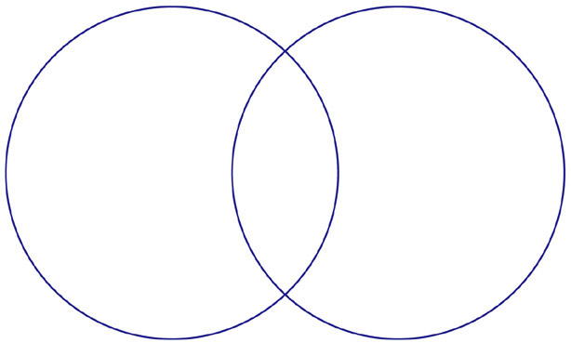

**Vygotsky**

**Piaget**

**Reflection:**