Section I: Survey and statistics of linguistic diversity in the USA (10 points)
The immigrant character of the United States makes it tolerant of all cultures. The USA is a multilingual nation under the conflict and fusion of different cultural backgrounds. Based on the survey and statistics by US census of 2010, published in 2011, 79% of the population in the US is monolingual. The number of individual languages spoken in the US is 230. The chart[1] below shows the top fifteen numbers of native spoken language in the US. Other languages show a more even decline from third place, unlike the big quantitative difference between English, Spanish, and Chinese.
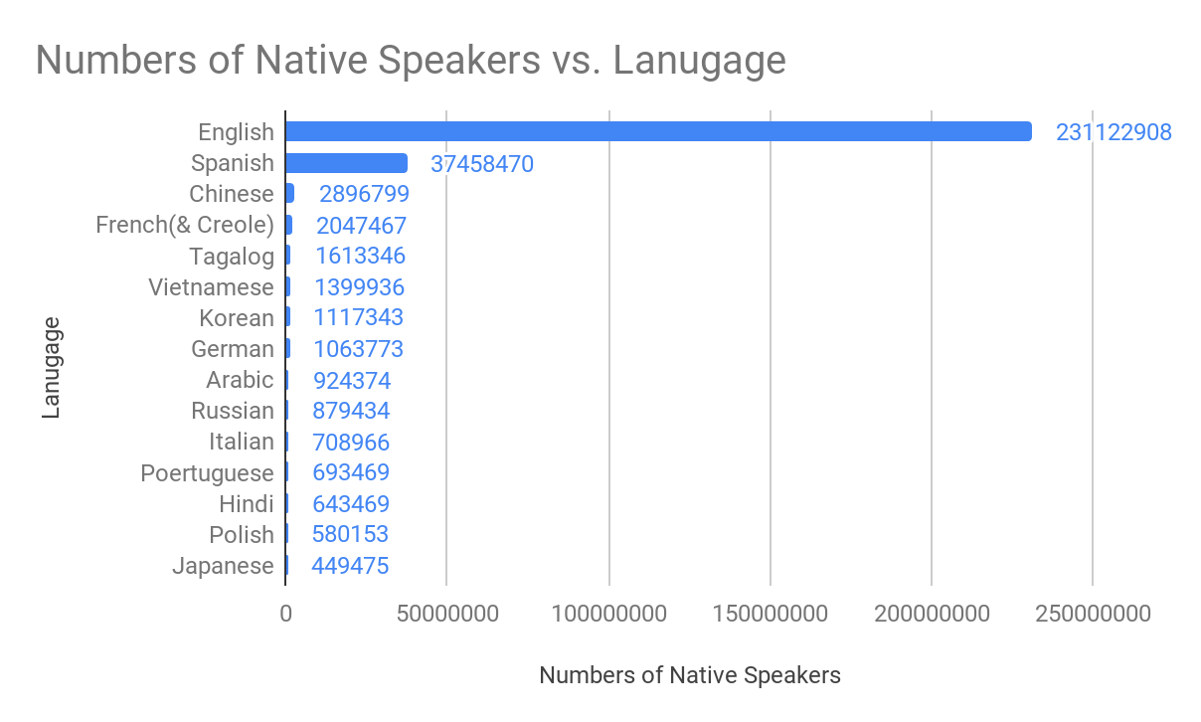
Bilingualism in the United States has increased from 11% to 21% over the past four decades.
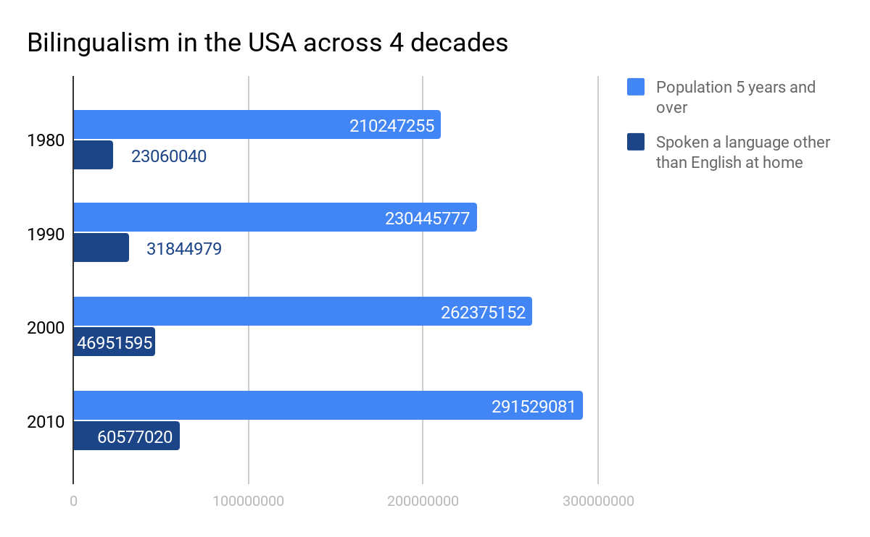
Section II: Survey and statistics of the target language (15 points)
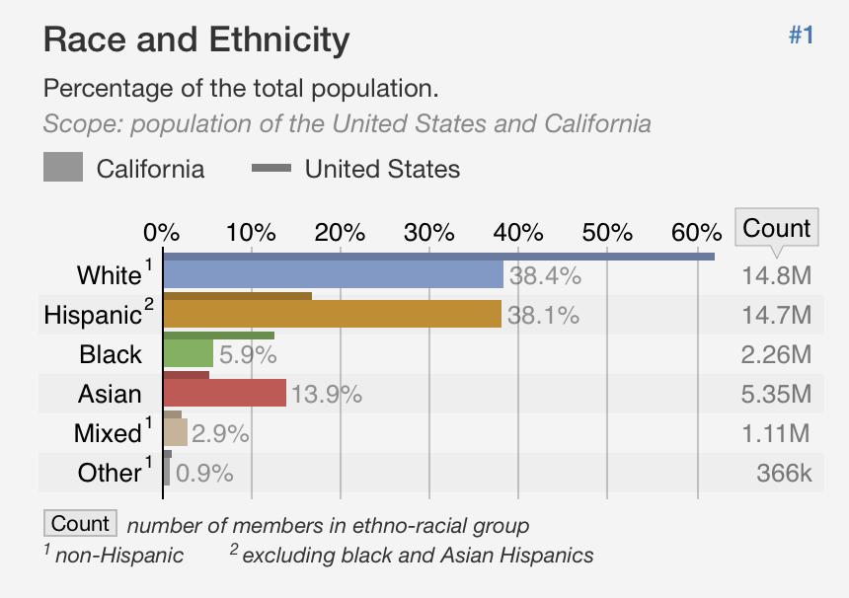
This final project is going to focus on the spanish-speaking community in California. Besides English, Spanish-speaking community has the greatest population in the US, 12 times more than the third most spoken language, Chinese. This shows that the spanish-speaking community has a greater influence on American culture compared with other non-English communities. The section of Race and Ethnicity in California from Statistical Atlas provides the overall information about ethnicity composition of California. Hispanics living in California are roughly equal to white Americans, who are slightly higher by a few tenths of a percentage point.
Based on the data provided by Statistical Atlas[2], about 28.8% of the total population living in California speak Spanish, which is 10.4 million of Spanish speakers. Compared with the United States as a whole, the proportion of Spanish speakers living in households in California is greater than the average 13.5%. There is an estimated population of 4.38 million people who speak Spanish and consider that do not speak English “very well”; A number of 6.03 million Spanish speakers in California consider their English “very well”.

Section III: History of immigration of the target linguistic community (10 points)
Based on the distribution map of Spanish speakers in the U.S by DayTranslations, thirty-eight percent of the population in California is hispanic, followed by New Mexico with 47 percent.[4] The term “hispanic” widely used began in the late 1970s. The U.S. Census Bureau defined “hispanic” as the group of population in the U.S who are descendant of Spain or from Spanish speaking countries(Garcia 1996, 197).
Although there are a lot of Spanish speakers in California, they were residents of California before California became part of the United States

Section IV: Language use and Language Maintenance (50 points)

Section V: Transcripts of interviews (10 points)
Interview
To younger Generations:
- Which languages do you speak in highest frequency? Is your Spanish still proficient?
- Yes, I can understand, speak, read, but can’t write.
- Are you still using Spanish within your community or family?
- Yes
- How to maintain your Spanish ability (from family or school)?
- Elementary school
- Speaking with friends and family
- Do you think that people who can speak both languages like you can get higher job opportunities in Southern California? What kind of job?
- Yes, California, Interpreter language teacher
- Yes, Medical field, human resources tours
- Do you feel better when you speak Spanish or stay with Spanish speakers?
- Yes
- No, English is better
- Have you seen any modern-day pop culture of Southern California in your language
(Spanish)? (Example: Despacito – Justin Bieber)
- Despacito, or big pop stars like Selena Gomez do Spanish renditions of their songs
- Drake’s songs MIA and Cardi B
- Do you have the code-switching habit in your daily conversations? How?
- Mix words or Clause by clause
- Used for Emphasis or Closer to people who can speak Spanish.
- Is the number of Spanish speakers increasing or decreasing in your community? How do you think of this trend?
- Decreasing in college but Increase overall
- Have you ever experienced any negative or positive bias from other communities for using Spanish?
- Only positive, some people admire people who can speak both languages

For older Generation:
- Which languages do you speak in highest frequency? Is your Spanish still proficient?
- Spanish. I can understand, speak, read and write.
- Are you still using Spanish within your community or family?
- Yes
- How to maintain your Spanish ability (from family or school)?
- Community, family bond
- Learn English from conversation
- Do you think that people who can speak both languages like you can get higher job opportunities in Southern California? What kind of job?
- Yes
- Do you feel better when you speak Spanish or stay with Spanish speakers?
- Yes
- No
- Do you have the code-switching habit in your daily conversations? How?
- problem or Emphasis- do your assignment!
- Is the number of Spanish speakers increasing or decreasing in your community? How do you think of this trend?
- If it is decreasing, what are the primary reasons for the decline in the language use?
- If not, what factors are playing a key role in the maintenance of the language, how to maintain the language?
- Can’t understand why speakers are less-negative.
- Negative-sad
- Have you ever experienced any negative or positive bias from other communities for using Spanish?
- Racism
- Yes, among Spanish community, if you can’t speak Spanish very well and in a weird accent, they will laugh at you. EX: Cheeseburger
- Among American community, some people have biases about Spanish people, they will call you to leave in the restaurant or public place-really mad but can’t do anything.

Citation:
[1]https://factfinder.census.gov/faces/tableservices/jsf/pages/productview.xhtml?pid=ACS_17_1YR_S1601&prodType=table
[2]https://statisticalatlas.com/state/California/Race-and-Ethnicity
[3]https://statisticalatlas.com/state/California/Languages
[4]https://upload.wikimedia.org/wikipedia/commons/c/c2/Distribution_of_Spanish_Language_Speakers_in_the_United_States.jpg
[5]https://www.tandfonline.com/doi/pdf/10.1080/00221349708978775

