How to Create a Powerful Argumentative Essay Outline

Since you have to write an argumentative essay, you might as well learn how to write it well, right?
I’ve said it time and time again—there’s nothing worse than staring at a blank page. Putting together an argumentative essay outline is the perfect way to turn your blank document into a ready-to-use template. All you have to do is fill in the blanks!
In this blog post, I’m going to share with you how to create an argumentative essay outline. At the end, I’ll give you a downloadable skeleton outline you can use to get started.

Structure of the Argumentative Essay Outline

If you distill your argumentative essay outline down to its basics, you’ll find that it’s made of four main sections:
- Intro
- Developing Your Argument
- Refuting Opponents’ Arguments
- Conclusion
That’s not so bad! There’s really nothing to be afraid of.
Here’s how your argumentative essay outline would look if you turned it into a pretty picture:
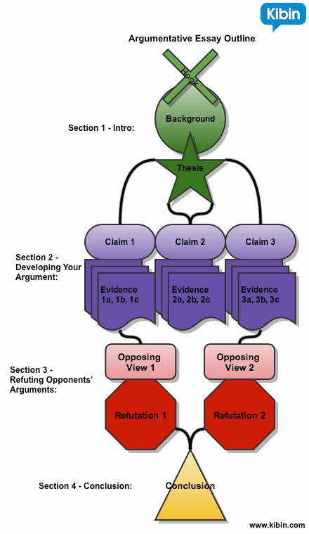

Each of these four sections requires some important elements. Let’s break those down now.

Argumentative Essay Outline Section 1: Your Intro
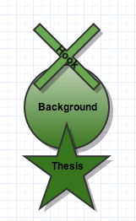 Your introduction is where you lay the foundation for your impenetrable argument. It’s made up of a hook, background information, and a thesis statement.
1. Hook. Your first sentence is comprised of a “hook.” Don’t know what a hook is? A hook is a sentence that grabs your reader’s attention just like a good Jackie Chan movie grabs the attention of a martial arts fan.
Let’s say I’m writing an argumentative essay about why American people should start eating insects.
My hook could be, “For those interested in improving their diets and the environment, say ‘goodbye’ to eating chicken, fish, and beef and ‘hello’ to eating silk worms, crickets, and caterpillars.”
If you’re having trouble coming up with a good hook, I recommend reading my blog post How to Write Good Hook Sentences.
2. Background information. The next part of your intro is dedicated to offering some detailed background information on your topic.
Try answering the following questions:
What is the issue at hand? Who cares? Where is this issue prevalent? Why is it important?
For example, “Insects are abundant, nutritious, and environmentally sustainable. Currently, people in the United States shun the idea of eating insects as part of their diets, favoring instead less nutritious and environmentally destructive food options, such as beef and pork. The UN recently issued a statement calling for more world citizens to embrace the many benefits of eating insects.”
3. Thesis. Your thesis typically makes up the last sentence of your intro paragraph. This is where you clearly state your position on the topic and give a reason for your stance.
For example, “A diet of insects can help fix problems related to starvation, obesity, and climate change, and therefore, United States citizens should learn to rely on a variety of insects over chicken, beef, and fish as their main source of protein and nutrition.”
Notice the word “should” in my thesis statement? Using this word makes it clear I’m taking a stance on the argument.
You’ll also notice that my thesis statement sets up the three claims I’m going to expand on later: a diet of insects can help fix problems related to starvation, obesity, and climate change.
Here are even more example argumentative thesis statements.
Let’s talk about adding those claims to our argumentative essay outline now.

Argumentative Essay Outline Section 2: Developing Your Argument
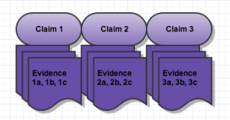Now that you have filled in the general points of your topic and outlined your stance in the introduction, it’s time to develop your argument.
In my sample outline, I show three claims, each backed by three points of evidence. Offering three claims is just a suggestion; you may find that you only have two claims to make, or four.
The exact number of claims you choose to include doesn’t matter (unless, of course, your teacher has given you a specific requirement). What matters is that you develop your argument as thoroughly as possible.
1. What is a claim? A claim is a statement you make to support your argument.
For example, “Bugs are highly nutritious and eating them can fix the problem of hunger and malnutrition in the United States.”
Great! So I’ve made my claim. But who’s going to believe me? This is where evidence comes into play.
2. What is evidence? For each claim you make, you need to provide supporting evidence. Evidence is factual information from reliable sources.
It is not personal knowledge or anecdotal.
For example, “Researchers at the Food and Agricultural Organization of the United States state that ‘Termites are rich in protein, fatty acids, and other micronutrients. Fried or dried termites contain 32–38 percent proteins.’“
My outline shows three pieces of evidence to support each claim, but you may find that each claim doesn’t necessarily have three pieces of evidence to back it. Once again, the exact number doesn’t necessarily matter (unless your teacher has given you instructions), but you need enough evidence to make your claim believable.
Once you have gathered your evidence to support your claims, it’s time to add the next important element of your argumentative essay outline: refuting your opponents’ arguments.
Let’s talk about that now.

Argumentative Essay Outline Section 3: Refuting Opponents’ Arguments
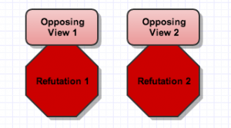In this section, you state your opponents’ views and then offer a rebuttal.
For example, “Opponents of insect eating from the Beef Council of America say that it is too difficult and time consuming to catch crickets, so it is not easy to gather enough food for a meal, whereas a cow is large and contains a lot of meat for many meals.”
Oh diss! We know the Beef Council just wants us to keep eating McD’s hamburgers and skip the cricket soup. (By the way—I just made that up. The Beef Council did not say that. In your essay, make sure to use real facts.)
Now it’s time to set the opponents straight with a refutation that is full of hard evidence and that will bring them to their knees.
For example, “According to researchers Cerritos and Cano-Santana, the best time to harvest crickets is to catch them in the hour just before sunrise when they are least active. What’s more, it is easy to develop the infrastructure to farm crickets in a way that is more sustainable than cattle farming.”
Booyah! The Beef Council has been served (crickets).
Once you have refuted your opponents’ viewpoints, it’s time to sail to the finish line with your conclusion.

Argumentative Essay Outline Section 4: Conclusion
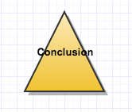In your conclusion, you are going to accomplish two important tasks.
1. Restate the importance of your issue. Similar to what you did in your introduction, you want to restate why this topic is critical.
For example, “Simply by incorporating insects into their diets, U.S. citizens can improve the sustainability and nutrition of the American diet.”
2. Paint a picture of the world if your argument is (or is not) implemented. In the final part of your conclusion, make your audience think about the ramifications of your argument. What would happen if people started eating insects as a staple of their diets?
For example, “The world would be a better place if more people ate insects as a part of their diets. Fewer people would go hungry, more people would get the vitamins, minerals, and micronutrients they need to live healthy lifestyles, and our planet would be relieved of the burden of an unsustainable food system.
Closing with a clear picture of the world as you would like it to be can leave your reader convinced that your argument is valid.

Download the Argumentative Essay Outline Template

Once you break it down, writing an argumentative essay outline isn’t that daunting.
Download this skeleton Argumentative Essay Outline to get started.
Before you go off into the sunset and use my outline template, make sure that you are following the guidelines specific to your course. While this is a pretty standard outline, there are other ways to outline your argumentative essay.
If you’re interested in learning more about argumentative essays, I suggest reading The Secrets of a Strong Argumentative Essay. Want even more knowledge? Check out this argumentative essay infographic!
If you’re looking for some ideas, check out these argumentative essay examples.
When you have your argumentative essay and outline ready to go, you can always have one of our awesome editors give it a second look.
Good luck!

Psst... 98% of Kibin users report better grades! Get inspiration from over 500,000 example essays.
About the Author
Naomi Tepper is the Kibin blog content manager, the Kibin operations manager, a former Kibin editor, and a self-proclaimed word nerd.
Meet the Editors
Essay Writing Blog

Google Plus

