Cultural Considerations
Brittany Crowe
Phase 4 Individual Project
December 11, 2019

Cultural Considerations
Based on the analysis of the company’s four perspectives, developing a balanced scorecard which requires the firm to assess some of its capabilities as it tries to expand into China. Once these capabilities have been developed, they will have to be studied in the new market with the aim of ensuring that strategic performance management is achieved in the long-term. The balanced scorecard is also critical since it will allow the management of the organization to easily keep track of the execution of various activities in the new market. Keeping track of its activities ensures that there is proper control of these activities, thereby providing management with tools for success. A balanced scorecard developed for the organization is shown below. This assesses what needs to be done for success to be observed.
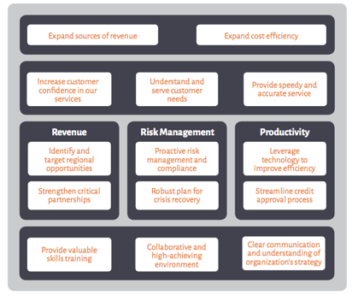

The company expanding into the Chinese market needs to be aware of several considerations to remain competitive. One of the considerations is to ensure that promotional messages and campaigns for the company are in line with the cultural aspects of the market. Failure to assess the impact that cultural aspects and differences have on the company and its products could easily push the company out of the market (John, & Roberts, 2017). The second consideration is to ensure that the company's products always reflect the culture of the people in the new market. Achieving this goal will require the company to always assess the needs and preferences of the customers in the market. Such aspects should be used in the design and production of the goods and services being provided in the market.
Based on the analysis and research that I have conducted throughout this project, the company possesses the ability to compete in the new market. I came to a conclusion based on the resources that the company has at its disposal. When venturing in a new market, it is imperative that a firm has resources that would allow it to cater for labor and other costs that could be incurred. The company also possesses technical expertise, which would allow it to create liaisons and collaborations with other firms that provide supportive roles in the new market. The second factor is brand recognition of the company’s products and services. Recognition or an impeccable brand image of a product or company is critical if it wants to access the global marketplace (Littrell, & Dickson, 2016). The brand has been a success in the local market, and this means that there is a possibility that the company could replicate the success in the new market that has been identified.
The third factor that could contribute to success in the new market is cultural understanding. Throughout the project, I conducted an analysis of the cultural considerations that need to be made by the company before it enters the Chinese market. The exercise provided the company with ways in which it can develop and implement aspects that showcase great cultural competence in the marketplace. Such an ability will improve the acceptance of the company’s products and services in the market. Any form that does not understand the needs of the marketplace in regards to cultural differences is bound to be pushed out of the market.
If I came across someone who was trying to dispute my position on the expansion into the foreign market, I would offer examples of companies whose operations have been successful in the Chinese market. The success of these companies in the market did not just come about. Each of the companies had to develop cultural competence in their operations before the expansion into the market. Cultural considerations dictate whether a firm is a success or a failure in the Chinese market. I would also explain the research and analysis that has been conducted before the decision was made. Doing this may help shed light on the success factors that the company possesses.
I plan to evaluate the global marketplace in the future by assessing what steps the company is taking in the new market to ensure cultural competence. Such an analysis can be conducted by comparing the product or service offering of the company with that of local companies in the new market. Such an assessment may reveal whether the company is in line with being successful in the industry. I would also assess the notions and perceptions that customers in the global marketplace have towards the company. Such an analysis may reveal changes that could be adopted by the company to ensure cultural competence.

References
John, M. T., & Roberts, D. G. (2017). Cultural Adaptation in the Workplace. Milton: Taylor and
Francis.
Littrell, M. A., & Dickson, M. A. (2016). Cultural considerations in the global market: Fair
trade of cultural products. Thousand Oaks, CA: Sage Publications.

