Case:
AS CHIEF EXECUTIVE officer of PepsiCo, Indra Nooyi is one of the world’s most powerful business leaders. A native of Chennai, India, Nooyi holds multiple degrees: a bachelor’s degree in physics, chemistry, and mathematics from Madras Christian College; an MBA from the Indian Institute of Management; and a master’s degree in public and private management from Yale University. Before joining PepsiCo in 1994, Nooyi worked for Johnson & Johnson, Boston Consulting Group, Motorola, and ABB. Indra Nooyi has been a regular in Forbes’ Top 20 most powerful women for the past several years. However, she is not your typical Fortune 500 CEO: She is known for walking around the office barefoot and singing—a remnant from her days in an all-girls rock band in high school.
It should come as no surprise, therefore, that Nooyi has been shaking things up at PepsiCo, a company with roughly $63 billion in annual revenues, $165 billion in stock market valuation, some 264,000 employees worldwide, and business interests in more than 100 countries. She took the lead role in spinning off Taco Bell, Pizza Hut, and KFC in 1997. Later, she masterminded the acquisitions of Tropicana in 1998 and Quaker Oats, including Gatorade, in 2001. When becoming CEO in 2006, Nooyi declared PepsiCo’s vision to be Performance with Purpose:
Performance with Purpose means delivering sustainable growth by investing in a healthier future for people and our planet…. We will continue to build a portfolio of enjoyable and healthier foods and beverages, find innovative ways to reduce the use of energy, water and packaging, and provide a great workplace for our associates…. Because a healthier future for all people and our planet means a more successful future for PepsiCo. This is our promise.²
In particular, Performance with Purpose has three dimensions:
- Human sustainability. PepsiCo’s strategic intent is to make its product portfolio healthier to combat obesity by reducing sugar, sodium, and saturated fat content in certain key brands. It wants to reduce the salt and fat in its “fun foods” such as Frito-Lay and Doritos brands, and to include healthy choices such as Quaker Oats products and Tropicana fruit juices in its lineup. Nooyi is convinced that if food and beverage companies do not make their products healthier, they will face stricter regulation and lawsuits, as tobacco companies did. Nooyi’s goal is to increase PepsiCo’s revenues from nutritious foods, substantially as detailed in her 2025 Performance with Purpose agenda.³
- Environmental sustainability. PepsiCo has instituted various initiatives to ensure that its operations don’t harm the natural environment. The page 451company has programs in place to reduce water and energy use, increase recycling, and promote sustainable agriculture. The goal is to transform PepsiCo into a company with a net-zero impact on the environment. Nooyi believes that young people today will not patronize or want to work for a company that does not have a strategy that also addresses ecological sustainability.
- The whole person at work. PepsiCo wants to create a corporate culture in which employees do not “just make a living, but also have a life.” Nooyi argues that this type of culture allows employees to unleash both their mental and emotional energies.
PepsiCo’s vision of Performance with Purpose acknowledges more than the importance of the corporate social responsibility and stakeholder strategy. Nooyi is convinced that companies have a duty to society to “do better by doing better.” She subscribes to a triple-bottom-line approach to competitive advantage, which considers not only economic but also social and environmental performance. Nooyi declares that the true profits of an enterprise are not just “revenues minus costs” but “revenues minus costs minus costs to society.” Problems such as pollution or the increased cost of health care to combat obesity impose costs on society that companies typically do not bear (externalities). As Nooyi sees it, the time when corporations can just pass on their externalities to society is nearing an end.
The external environment in the soft drink industry, however, has become much more challenging. Since their peak in the late 1990s, sales of carbonated soft drinks dropped some 25 percent. Consumption of bottled water, in contrast, surpassed the consumption of carbonated soft drinks in 2016. Energy drinks such as Monster or Red Bull are continuing to grow by double digits in the United States and overseas, making such products one of the hottest categories in the soft drink industry. Moreover, a wide range of governments, from municipalities such as Berkeley or Philadelphia in the United States to entire nation states such as France and Norway, now levy sugar taxes on soda drinks, making them much more expensive for consumers.
PepsiCo’s archrival Coca-Cola Co. continues to concentrate on its core business in soda and other nonalcoholic beverages. The full-calorie Coke remains America’s most popular soda, as more and more people abandon artificially sweetened sodas (number two is PepsiCo’s full-calorie cola and number three is Diet Coke). To enhance PepsiCo’s strategic focus, critics of Nooyi propose splitting PepsiCo into two standalone companies. One would focus on beverages (Pepsi, Gatorade, Tropicana); the other would focus on snack foods, several of which such as Lay’s and Doritos have become multibillion-dollar brands. This move would unlock additional profit potential, the argument goes, because the well-performing snack food business would no longer need to subsidize underperforming beverages. For the time being, Nooyi has decided that PepsiCo creates more value when the beverage and snack foods divisions are together in one corporation, rather than split into two companies.
Although PepsiCo’s revenues have remained more or less flat over the past few years, investors see significant growth potential. Over a five-year period between 2012 and 2017, PepsiCo has outperformed Coca-Cola by a relatively wide margin. During this period, PepsiCo’s normalized stock appreciation was almost 50 percentage points higher than that of Coca-Cola (see Exhibit MC2.1). Albeit down from 90 percent in 2000, soda drinks still accounted for 70 percent of Coca-Cola’s total revenues, while PepsiCo has been much more diversified. With better than expected financial results, Nooyi stands vindicated after years of criticism. Despite opposition, she stuck by her strategic mantra for PepsiCo—Performance with Purpose—and appears to be reaping the rewards.
2012 to June 2017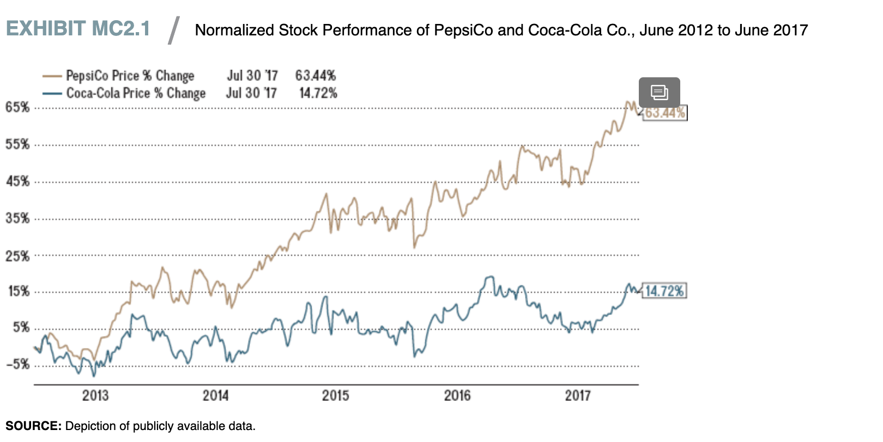
Additional Information:

HOW DO YOU BECOME A STRATEGIC LEADER?
LO 2-2
Outline how you can become a strategic leader.
Is becoming an ethical and effective strategic leader innate? Can it be learned? According to the upper-echelons theory, organizational outcomes including strategic choices and performance levels reflect the values of the top management team.¹¹ These are the individuals at the upper levels of an organization. The theory states that strategic leaders interpretsituations through the lens of their unique perspectives, shaped by personal circumstances, values, and experiences. Their leadership actions reflect characteristics of age, education, and career experiences, filtered through personal interpretations of the situations they face. The upper-echelons theory favors the idea that effective strategic leadership is the result of both innate abilities and learning.

upper-echelons theory A conceptual framework that views organizational outcomes—strategic choices and performance levels—as reflections of the values of the members of the top management team.

In the bestseller Good to Great, Jim Collins explored over 1,000 good companies to find 11 great ones. He identified great companies as those that transitioned from average performance to sustained competitive advantage. He measured that transition as “cumulative stock returns of almost seven times the general market in the 15 years following their transition points.”¹² A lot has happened since the book was published over a decade ago. Today only a few of the original 11 stayed all that great, including Kimberly-Clark and Walgreens. Some fell back to mediocrity; a few no longer exist in their earlier form or at all. Anyone remember Circuit City or Fannie Mae? Let’s agree that competitive advantage is hard to achieve and even harder to sustain. But his study remains valuable for its thought-provoking observations. Studying these large corporations, Collins found consistent patterns of leadership among the top companies, as pictured in the Level-5 leadership pyramid in Exhibit 2.2.¹³ The pyramid is a conceptual framework that shows leadership progression through five distinct, sequential levels. Collins found that all the companies he identified as great were led by Level-5 executives. So if you are interested in becoming an ethical and effective strategic leader, the leadership pyramid suggests the areas of growth required.
Level-5 leadership pyramid A conceptual framework of leadership progression with five distinct, sequential levels.
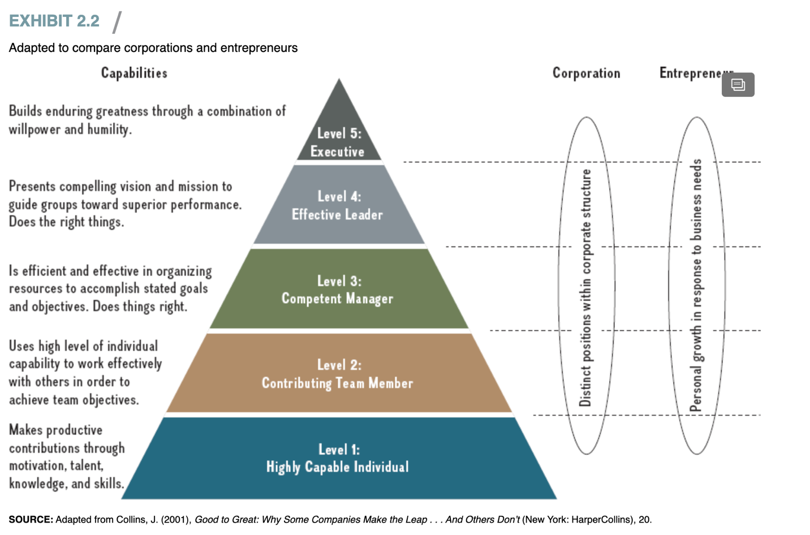

According to the Level-5 leadership pyramid, effective strategic leaders go through a natural progression of five levels. Each level builds upon the previous one; the individual can move on to the next level of leadership only when the current level has been mastered. On the left (in Exhibit 2.2) are the capabilities associated with each level. But not all companies are Fortune 500 behemoths. On the right we suggest that the model is valuable as well to the individual looking to develop the capacity for greater professional success.
page 35At Level 1, we find the highly capable individual who makes productive contributions through her motivation, talent, knowledge, and skills. These traits are a necessary but not sufficient condition to move on to Level 2, where the individual attains the next level of strategic leadership by becoming an effective team player. As a contributing team member, she works effectively with others to achieve common objectives. In Level 3, the team player with a high individual skill set turns into an effective manager who is able to organize the resources necessary to accomplish the organization’s goals. Once these three levels are mastered, in Level 4, the effective professional has learned to do the right things, meaning she does not only command a high individual skill set and is an effective team player and manager, but she also knows what actions are the right ones in any given situation to pursue an organization’s strategy. Combining all four prior levels, at Level 5, the strategic leader builds enduring greatness by combining willpower and humility. This implies that a Level-5 executive works to help the organization succeed and others to reach their full potential.
As detailed in the ChapterCase, Facebook CEO Mark Zuckerberg highly values Sheryl Sandberg, the COO. Here he says why: “She could go be the CEO of any company that she wanted, but I think the fact that she really wants to get her hands dirty and work, and doesn’t need to be the front person all the time, is the amazing thing about her. It’s that low-ego element, where you can help the people around you and not need to be the face of all the stuff.”¹⁴ Clearly, Sandberg is a Level-5 executive: She builds enduring greatness at Facebook through a combination of skill, willpower, and humility.

THE STRATEGY PROCESS ACROSS LEVELS: CORPORATE, BUSINESS, AND FUNCTIONAL MANAGERS
LO 2-3
Describe the roles of corporate, business, and functional managers in strategy formulation and implementation.
According to the upper-echelons theory, strategic leaders primarily determine a firm’s ability to gain and sustain a competitive advantage through the strategies they pursue. Given the importance of such strategies, we need to gain a deeper understanding of how they are created. The strategy process consists of two parts: strategy formulation (which results from strategy analysis) and strategy implementation.
Strategy formulation concerns the choice of strategy in terms of where and how to compete. In contrast, strategy implementation concerns the organization, coordination, and integration of how work gets done. In short, it concerns the execution of strategy. It is helpful to break down strategy formulation and implementation into three distinct areas—corporate, business, and functional.
strategy formulation The part of the strategic management process that concerns the choice of strategy in terms of where and how to compete.
strategy implementation The part of the strategic management process that concerns the organization, coordination, and integration of how work gets done, or strategy execution.
- Corporate strategy concerns questions relating to where to compete as to industry, markets, and geography.
- Business strategy concerns the question of how to compete. Three generic business strategies are available: cost leadership, differentiation, or value innovation.
- Functional strategy concerns the question of how to implement a chosen business strategy. Different corporate and business strategies will require different activities across the various functions.
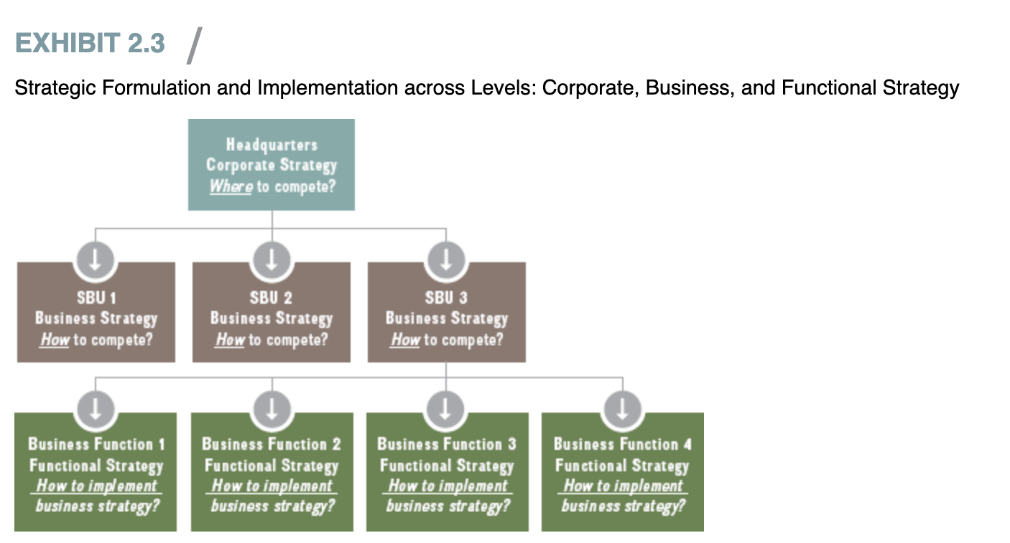

Although we generally speak of the firm in an abstract form, individual employees make strategic decisions—whether at the corporate, business, or functional level. Corporate executives at headquarters formulate corporate strategy. Think of corporate executives including Sheryl Sandberg (Facebook), John Flannery (GE), Virginia Rometty (IBM), Mukesh Ambani (Reliance Industries), Mary Barra (GM), or Marillyn Hewson (Lockheed Martin). Corporate executives need to decide in which industries, markets, and geographies their companies should compete. They need to formulate a strategy page 37that can create synergies across business units that may be quite different, and determine the boundaries of the firm by deciding whether to enter certain industries and markets and whether to sell certain divisions. They are responsible for setting overarching strategic objectives and allocating scarce resources among different business divisions, monitoring performance, and making adjustments to the overall portfolio of businesses as needed. The objective of corporate-level strategy is to increase overall corporate value so that it is higher than the sum of the individual business units.
Business strategy occurs within strategic business units (SBUs), the standalone divisions of a larger conglomerate, each with its own profit-and-loss responsibility. General managers in SBUs must answer business strategy questions relating to how to compete in order to achieve superior performance. Within the guidelines received from corporate headquarters, they formulate an appropriate generic business strategy, including cost leadership, differentiation, or value innovation, in their quest for competitive advantage.

DISCUSSION QUESTIONS
- What grade would you give PepsiCo CEO Indra Nooyi for her job performance as a strategic leader? What are her strengths and weaknesses? Where would you place Nooyi on the Level-5 pyramid of strategic leadership (see Exhibit 2.2), and why? Support your answers.
- The first few years after Indra Nooyi took over as PepsiCo’s CEO and implemented Performance with Purpose, the company underperformed archrival Coca-Cola Co. by a wide margin. What should a strategic leader do if his or her vision does not seem to lead to an immediate (financial) competitive advantage? What would be your top three recommendations? Support your arguments.
- Do you agree with Indra Nooyi’s philosophy that “performance and purpose are intimately linked and you can’t do one without the other”? Support your arguments. Apply the people, planet and profits model of sustainable strategy (see Exhibit 5.9).
- PepsiCo’s investors require the company to grow about 5 percent or $3.5 billion a year. PepsiCo’s top line, however, remained flat for the past few years. Where would future growth for PepsiCo come from?
- Some activist investors are putting pressure on Indra Nooyi to split PepsiCo into two standalone companies, with one focusing on beverages (Pepsi, Gatorade, Tropicana); the other would focus on snack foods (such as the Frito-Lay brand). What is the idea behind this corporate strategy? Do you think this move would add value for shareholders? For consumers? Other stakeholders? Why or why not?

Endnote
1. As quoted in Safian, K. (2014, Oct. 14), “It’s got to be a passion, it’s gotta be your calling: Indra Nooyi,” Fast Company.
2. www.pepsico.com/Purpose/Overview.html.
3. “Performance with Purpose: 2025 Agenda,” https://www.pepsico.com/docs/album/sustainability-reporting/pepsico_sustainability_report_2015_and_-2025_agenda.pdf, accessed July 1, 2017.

Here

Please use this strategy when you analyze a case:
- Identify and write the main issues found discussed in the case (who, what, how, where and when (the critical facts in a case).
- List all indicators (including stated "problems") that something is not as expected or as desired.
- Briefly analyze the issue with theories found in your textbook or other academic materials. Decide which ideas, models, and theories seem useful. Apply these conceptual tools to the situation. As new information is revealed, cycle back to sub-steps a and b.
- Identify the areas that need improvement (use theories from your textbook)
  - Specify and prioritize the criteria used to choose action alternatives.
  - Discover or invent feasible action alternatives.
  - Examine the probable consequences of action alternatives.
  - Select a course of action.
  - Design and implementation plan/schedule.
  - Create a plan for assessing the action to be implemented.
- Conclusion (every paper should end with a strong conclusion or summary)
Additional resources:
History of iPod prices:
• Article: http://brianford.newsvine.com/_news/2007/09/05/943723-putting-200-in-perspective-a-history-of-ipod-prices

Apple Watch adoption:
• Video: http://www.cnbc.com/2015/04/13/expect-slow-build-on-apple-watch-adoption-analyst.html
• Article: http://venturebeat.com/2015/07/08/the-apple-watchs-unsexy-but-powerful-path-to-enterprise-adoption/

Apple Project Titan
• Article: http://appleinsider.com/articles/15/03/13/project-titan-sixtyeight-sg5-inside-apples-top-secret-electric-car-project
• Article: http://www.ibtimes.co.uk/project-titan-apple-car-story-so-far-1515835
Sure Dividend: PepsiCo’s 22 Billion Dollar Brands & Future Growth: http://www.suredividend.com/pepsicos-22-billion-dollar-brands-future-growth/
PepsiCo. 2012. PepsiCo Announces Strategic Investments to Drive Growth: http://www.pepsico.com/live/pressrelease/PepsiCo-Announces-Strategic-Investments-to-Drive-Growth02092012
Writing Requirements
- 3–5 pages in length (excluding the cover page, abstract, and reference list)
- APA format, Use the APA template located in the Student Resource Center to complete the assignment.
- Please use the Case Study Guide as a reference point for writing your case study.

