Case:

Apple: The iPhone Turns 10, so What’s Next?
IN 2017, THE 10TH ANNIVERSARY of the iconic iPhone, Apple became the first company whose stock market valuation crossed the $800 billion threshold, making it the most valuable company of all time.¹ Many expect Apple to be also the first company that reaches a stock market valuation of $1 trillion! Some 20 years earlier, Apple would likely have gone bankrupt if archrival Microsoft (which enjoyed the same position with a valuation of $615 billion in December 1999) had not invested $150 million in Apple.
Apple got to where it is today by implementing a potent competitive strategy. That strategy, conceptualized by co-founder Steve Jobs, combines innovation in products, services, and business models. From near-bankruptcy in 1997, Apple’s revitalization really took off in 2001 (see Exhibit MC5.1) when it introduced the iPod, a portable digital music player, the same year it opened its first retail stores. Apple’s stores earn the highest sales per square foot of any retail outlets, including luxury stores such as jeweler Tiffany & Co. and LVMH, purveyor of fine handbags and other luxury goods.

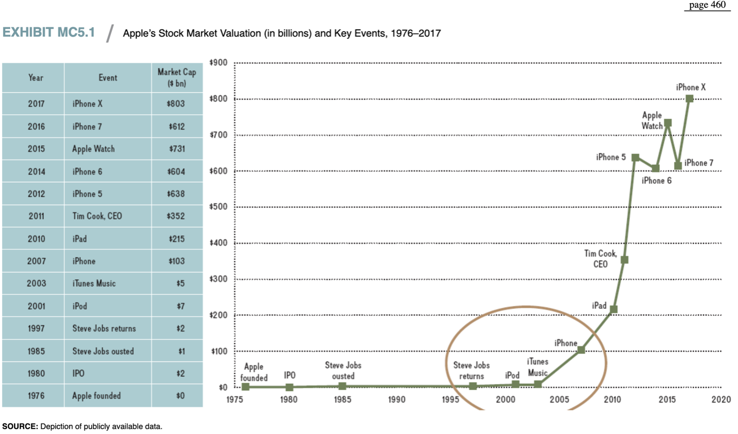
In 2003, Apple soared even higher when it opened the online store iTunes. Apple didn’t stop there. In 2007, the company revolutionized the smartphone market with the introduction of the iPhone. Just three years later, Apple created the tablet computer industry by introducing the iPad, thus beginning to reshape the publishing and media industries. Further, for each of its iPod, iPhone, and iPad lines of businesses, Apple followed up with incremental product innovations that extended each product category, culminating in the 10th anniversary edition of the iPhone launched in 2017. By combining tremendous brainpower, intellectual property, and iconic brand value, Apple has enjoyed dramatic increases in revenues, profits, and stock market valuation.

A Good Strategy
Why was Apple so successful? Why did Microsoft’s once superior market valuation evaporate? Why did Apple’s competitors, such as Sony, Dell, Hewlett-Packard (HP), Nokia, and BlackBerry, struggle or go out of business? The short answer is: Apple had a better strategy. But this raises the question: What is a good strategy? A good strategy is more than a mere goal or a company slogan. A good strategy defines the competitive challenges facing an organization through a critical and honest assessment of the status quo. A good strategy also provides an overarching approach (policy) on how to deal with the competitive challenges identified. Last, a good strategy requires effective implementation through a coherent set of actions. A good strategy, therefore, consists of three elements:²

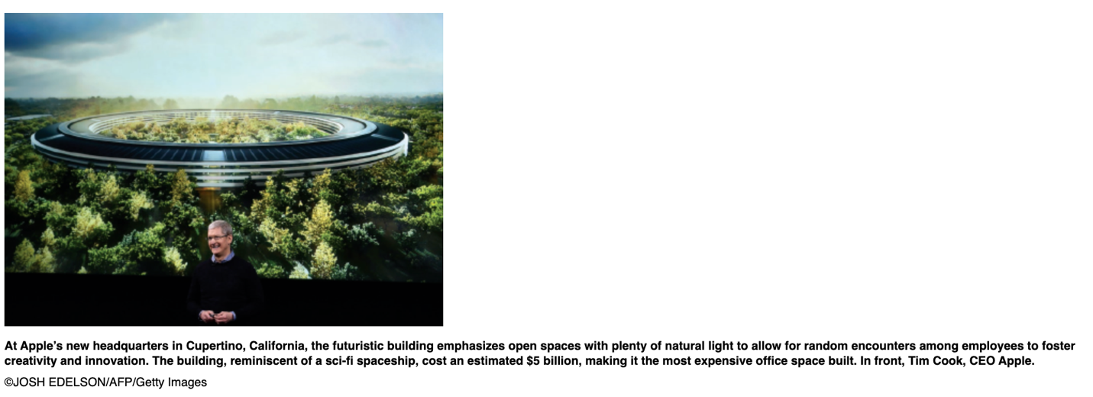

- A diagnosis of the competitive challenge.
- A guiding policy to address the competitive challenge.
- A set of coherent actions to implement the firm’s guiding policy.
page 461THE COMPETITIVE CHALLENGE. First, consider the diagnosis of the competitive challenge. Above, we briefly traced Apple’s renewal from the year 2001, when it hit upon the product and business-model innovations of the iPod/iTunes combination. Before that, Apple was merely a niche player in the desktop-computing industry and struggling financially. Steve Jobs turned the sinking company around by focusing on only two computer models (one laptop and one desktop) in each of two market segments (the professional market and the consumer market) as opposed to dozens of non-differentiated products within each segment. This streamlining of its product lineup enhanced Apple’s strategic focus. Even so, the outlook for Apple was grim. Jobs believed that Apple, with less than 5 percent market share, could not win in the personal computer industry where desktops and laptops had become commoditized gray boxes. In that world, Microsoft, Intel, and Dell were the star performers. Jobs knew that he needed to create the “next big thing.”³
A GUIDING POLICY. Second, Apple shifted its competitive focus away from personal computers to mobile devices. In doing so, Apple disrupted several industries through its product and business-model innovations. Combining hardware (i.e., the iPod) with a complementary service product (i.e., the iTunes Store) enabled Apple to devise a new business model. Users could now download individual songs legally (at 99 cents) rather than buying an entire CD or downloading the songs illegally using Napster and other file-sharing services. The availability of the iTunes Store drove sales of iPods. Along with rising sales for the new iPod and iTunes products, demand rose for iMacs. The new products helped disrupt the existing personal computer market, because people wanted to manage their music and photos on a computer that worked seamlessly with their mobile devices. Apple then leveraged the success of the iPod/iTunes business-model innovation, following up with product-category-defining innovations when launching the iPhone (in 2007) and the iPad (in 2010).
COHERENT ACTIONS. Third, Apple implemented its guiding policy with a set of coherent actions. Apple’s coherent actions took a two-pronged approach: It drastically streamlined its product lineup through a simple rule—“we will make only one laptop and one desktop model for each of the two markets we serve, professional and consumer.” It also disrupted the industry status quo through a potent combination of product and business-model innovations, executed at planned intervals. These actions allowed Apple to create a string of temporary competitive advantages (see Exhibit MC5.1). Taken together, this allowed Apple to sustain its superior performance for over a decade, making it the most valuable company on the planet in the process.
Past performance, however, is no guarantee of future performance. Microsoft was once the most valuable company in the world but has since struggled to keep up with Apple. At the same time, Microsoft, as well as Google, Samsung, Amazon, and others, are working hard to neutralize Apple’s competitive advantage.
The trillion-dollar question is whether Apple can continue to maintain a competitive advantage in the face of increasingly strong competition and rapidly changing industry environments. In both mobile payment systems (Apple Pay launched in 2014) and music streaming (Apple Music launched in 2015), Apple was a late mover. The Apple Watch, introduced in 2015, is the first new product category Apple launched since the iPad in 2010. Although Apple continues to capture over 90 percent of profits in the smartphone industry, more than 60 percent of Apple’s $220 billion revenue comes from the iPhone. Moreover, China accounts for more than 20 percent of Apple’s total revenues, a market that is becoming more and more volatile for the Cupertino, California, tech company. These are pressing issues that Apple CEO Tim Cook needs to address in order to sustain Apple’s competitive advantage.

DISCUSSION QUESTIONS
- Explain Apple’s success over the past decade relative to its main competitors. Think about which industries it has disrupted and how.
- Is Apple’s success attributable to industry effects, firm effects, or a combination of both? Explain.
- What are the greatest challenges Apple is facing? Detail them by internal weaknesses and external threats. How can Apple transform internal weaknesses into strengths, and external threats into opportunities?
- Apply the three-step process for developing a good strategy outlined above (diagnose the competitive challenge, derive a guiding policy, and implement a set of coherent actions) to Apple’s situation today. Which recommendations would you have for Apple to outperform its competitors in the future? Be specific.
page 462

Endnote
1. Apple’s valuation is in absolute dollars, not in real (inflation-adjusted) dollars. When adjusted for inflation since 1999, Microsoft’s record market valuation would be roughly $850 billion in 2017.
2. This discussion is based on Rumelt, R. (2011), Good Strategy, Bad Strategy (New York: Crown Business).
3. Rumelt, R. (2011), Good Strategy, Bad Strategy (New York: Crown Business), 14.

Here

Please use this strategy when you analyze a case:
- Identify and write the main issues found discussed in the case (who, what, how, where and when (the critical facts in a case).
- List all indicators (including stated "problems") that something is not as expected or as desired.
- Briefly analyze the issue with theories found in your textbook or other academic materials. Decide which ideas, models, and theories seem useful. Apply these conceptual tools to the situation. As new information is revealed, cycle back to sub-steps a and b.
- Identify the areas that need improvement (use theories from your textbook)
  - Specify and prioritize the criteria used to choose action alternatives.
  - Discover or invent feasible action alternatives.
  - Examine the probable consequences of action alternatives.
  - Select a course of action.
  - Design and implementation plan/schedule.
  - Create a plan for assessing the action to be implemented.
- Conclusion (every paper should end with a strong conclusion or summary)
Additional resources:
History of iPod prices:
• Article: http://brianford.newsvine.com/_news/2007/09/05/943723-putting-200-in-perspective-a-history-of-ipod-prices
Apple Watch adoption:
• Video: http://www.cnbc.com/2015/04/13/expect-slow-build-on-apple-watch-adoption-analyst.html
• Article: http://venturebeat.com/2015/07/08/the-apple-watchs-unsexy-but-powerful-path-to-enterprise-adoption/
Apple Project Titan
• Article: http://appleinsider.com/articles/15/03/13/project-titan-sixtyeight-sg5-inside-apples-top-secret-electric-car-project
• Article: http://www.ibtimes.co.uk/project-titan-apple-car-story-so-far-1515835
Writing Requirements
- 3–5 pages in length (excluding the cover page, abstract, and reference list)
- APA format, Use the APA template located in the Student Resource Center to complete the assignment.
- Please use the Case Study Guide as a reference point for writing your case study.
Grading Criteria:
- This assignment will be graded using the UOTP Writing Rubric displayed below

Assignment Submission Instructions:
- Prepare you assignment offline in a word processing software such as Microsoft Office
- To submit your document, scroll to the bottom of the page, below any rubric if applicable and click the Add Submission button
- Drag and drop your paper to the File Submissions area, or browse for your file by clicking the Add.. icon
- Check the box next to the original work acknowledgment statement
- Click the Save changes button to submit
Note: You may edit your submission up until the assignment is graded by your instructor or if requested by your instructor. To edit your submission, scroll to the bottom of the page, below any rubric if applicable and click the Edit Submissions button, and follow steps 3-5 above.​

