Label the Motherboard
- Make sure you cite your work, any work is not cited will earn a 0
- No copy and paste, use your own words

- Look up the Motherboard and label the letter inside the table below the figure:
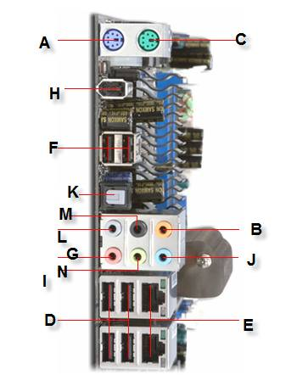

______ IEEE 1394a Port  ______ PS/2 Keyboard  ______ PS/2 Mouse  ______ S/PDIF out  ______ USB 2.0 Ports | ______ Center/Subwoofer (surround)  ______ Firewire port  ______ Microphone  ______ RJ-45 LAN ports | ______ Line in (sound)  ______ Line out (sound)  ______ Rear speakers  ______ Side speakers

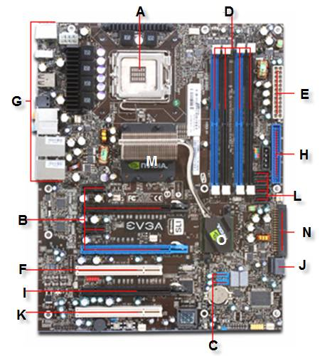

EVGA nForce 680i SE SLI (TR Version) Motherboard
______ Back panel connectors  ______ Socket 775  ______ PCI Express slots  ______ PCI Slot  ______ Another PCI Express Slot  ______ ATX Power Connector  ______ DDR2 DIMM Memory Slots  ______ IDE Header  ______ SATA Headers  ______ More SATA Headers  ______ FDD Header  ______ USB 2.0 Headers  ______ North Bridge  ______ South Bridge | List three processors this motherboard would support  How many IDE drives would this motherboard support?  How many SATA drives would this motherboard support? | What kind of cooling would this motherboard need?  How much RAM does this mobo support?  Explain dual channel RAM.  List two compatible memory sticks you could use with this mobo.

- What is each of the following? Label what it is, and describe its features.(do not use copy & paste, use your own words)

