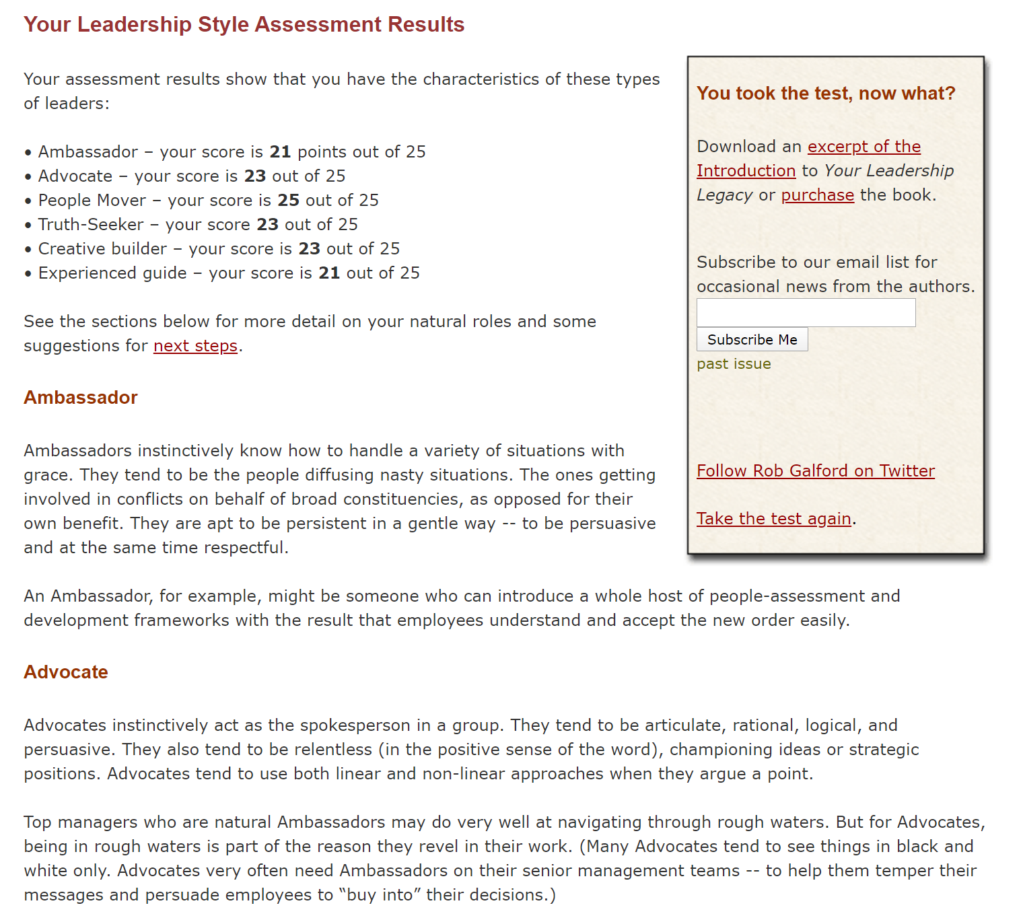

People Mover
Think: Talent-spotter, career-builder, motivator, someone with parental, nurturing qualities. People Movers instinctively take the lead in building teams. They’re also instinctive mentors. They generally have large contact lists; they are always introducing new people to new ideas and new paths. They’re also generally mindful of their employees’ lives outside of work; they view performance through the larger lens of potential.
There is a certain “holiday card joy” that comes with being a People Mover; when people continue to update you on their progress because they know you’ll care, even if you have nothing in common with them and are effectively out of touch with them, you know you’re a People Mover.

Truth-Seeker
Think: fairness, good judgment, equalizer, level-headed, process-oriented, scrupulous neutrality, objectivity is the high standard. This is the only role for which there is a “prerequisite;” Truth-Seekers are unfailingly competent in their field; their competence is unquestioned.
Truth-Seekers instinctively level the playing field for those in need. They also help people understand new rules and policies. They act to preserve the integrity of processes. They try to identify the root-cause issues, or pivotal issues. They also step in to ensure the just and fair outcome if the process has failed to yield the same.
Successful individuals in the Human Resources function are generally natural Truth-Seekers. Truth-Seekers also tend to gravitate towards line-manager positions.

Creative Builder
These individuals are visionaries and entrepreneurs – they are happiest and most driven at the start of things. They instinctively: see new opportunities for new products, new companies; spot niche markets; take ideas and make them real. They’re also often “serial entrepreneurs” over time, even if they remain in one leadership post.
Creative Builders instinctively understand that building is not necessarily about invention, but about process of making an invention real. Builders are constantly energized by new ideas, yet they have the staying power to see them through to fruition.
The issue is rarely simply the idea; builders aren’t “Hey Dave, what’s your latest scheme?” people. Builders are fascinated with implementation. Real estate developers are often “builders” in this way (beyond the obvious connection); they feel most rewarded when a project gets underway, or is newly completed.
Builders sometimes get into trouble if they remain in one place for too long. There are case studies, too numerous to mention, of entrepreneurs whose legacies are negative because they became enmeshed in the day-to-day operations of the companies they created, and didn’t know when it was time to leave. Builders can successfully remain in a single leadership position only if they figure out how to feed their own need for new projects.
Here’s an equation to try on yourself if you identify with the role of builder:
Strength of belief in end result + Ability to tolerate the process = Creative Builder

Experienced Guide
The term “Experienced Guide” conjures up an image of someone very old and wrinkled, with the experience that comes with age. That’s not incorrect, but Experienced Guides don’t have to be old, or necessarily experienced. What they do have to have is an ability to listen, and to put themselves in others’ shoes. They have a way of helping people think through their own problems; they are natural therapists. Often, they are seemingly bottomless wells of information on a diverse range of topics. These are the people who can always be counted on to supply the right quotation or the right historical connection.
They are not necessarily mediators, yet the experienced guide is often the person who finds him or herself “in the middle,” with people on both sides of a conflict seeking advice. When a corporate meeting has been particularly stressful or fraught with conflict, the “post-meeting, closed-door meeting” often takes place in the Wise One’s office.
Remember the “family lawyer” of old? The person, outside of the family, who knew (and kept) all the family secrets, and was often sought for advice? The experienced guide role naturally lends itself today to the position of minister, counselor, trusted advisor.
Renato Tagiuri, emeritus professor at the Harvard Business School, noted that natural “experienced guides” are often found one level down from the top in organizations. They get their greatest satisfaction helping others get through the day and helping others see the bigger picture. They empathize.

