Incident Briefing (ICS 201)
1. Incident Name:  Anywhere hospital | 2. Incident Number:  202 | 3. Date/Time Initiated: Date: 2/26 Time: 1300
4. Map/Sketch (include sketch, showing the total area of operations, the incident site/area, impacted and threatened areas, overflight results, trajectories, impacted shorelines, or other graphics depicting situational status and resource assignment):
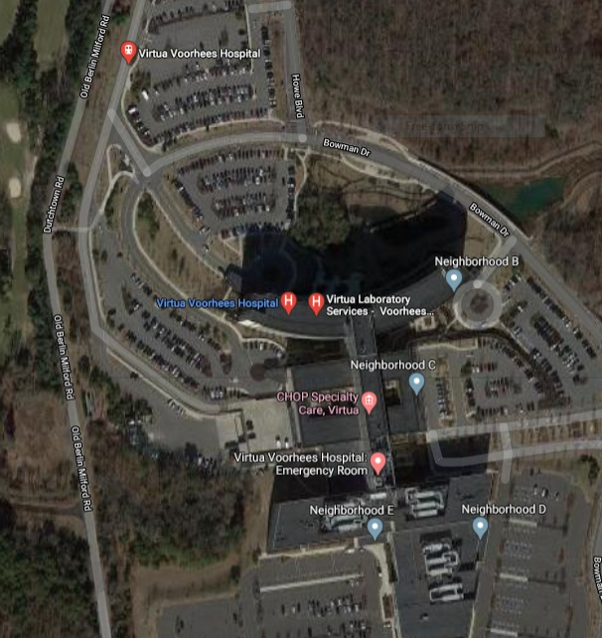
5. Situation Summary and Health and Safety Briefing (for briefings or transfer of command): Recognize potential incident Health and Safety Hazards and develop necessary measures (remove hazard, provide personal protective equipment, warn people of the hazard) to protect responders from those hazards.
Anywhere the hospital has had a power failuredo to a fire. The hospital has 129 beds, and 7 are ICU beds. The hospital has 3-4 days of fuel. However, this is not enough to run the hospital at full capacity. AGH has an MOU with University City Hospital and is 19 miles away. It has power and has 700 tertiary hospitals. It has said that it will accept patients.
6. Prepared by: | Name: Dan Wrinn | Position/Title:operations section chief | Signature: __________________
 | ICS 201, Page 1 | Date/Time: 2/26/2020 12:00 AM
Incident Briefing (ICS 201)
1. Incident Name: Anywhere hospital | 2. Incident Number:  201 | 3. Date/Time Initiated: Date:2/27 Time: 1300
7. Current and Planned Objectives:

- Order the incident commander to activate the EOP within ten minutes.
- Staff the EOC within 10 min.
- Have the liaison officer notify county EM of the situation within 15 min.
- Inform all departments of the situation within 15 mins.
- Coordinate with the facilities department to assess the situation and see when the power can be restoredwithin 1 hr.
- Activate MOU with UCH and alert EMS services within 20 mins.
- Have security assess to all patients, families, and staff to make sure they are safewithin 90 min.
- Assign security to help staff control the situation 20 min
- Evacuate the ICU patients and the most critically ill to University City within 4 hours.
- Using the planning Section Chief to help keep track of the patients in beds within 30 mins and task Logistics Section Chief to contact fuel company for a resupply within 2 hr.
8. Current and Planned Actions, Strategies, and Tactics:
Time: | Actions:
1300 | Power Failure
1302 | The engineering dept alerts the office of emergency management of the situation.
1303 | IC activates the EOP and EOC. Divert all ambulances to University City Hos.
1315 | Informs local EMS services of the situation and request their support.
1315 | Calls University Hospital and request there status.
1320 | Order public safety to secure the situation and access the safety of all individuals in the hospitals.
1323 | Cancel all nonemergency surgeries.
1330 | Make sure the OR, ER, and ICU have enough power to operate.
1350 | Have the building department asses the reliability of the generator and figure out how long it will l sustain the hospital
1405 | Order evacuation of ICU and critically ill.
1415 | Start working on a longterm plan with all departments
1430 | Inform the media of the situation and release a press release
1431 | Generate status of all patients and staff
1440 | Analyze IAP and make corrections
1600 | Brief the next shift on the situation
HHMM
HHMM
HHMM
HHMM
HHMM
HHMM
HHMM
6. Prepared by: | Name: Dan Wrinn | Position/Title: Operations Scetion Cheif | Signature:
ICS 201, Page 2 | Date/Time: Date
Incident Briefing (ICS 201)
1. Incident Name: Anywhere Hospital | 2. Incident Number:202 | 3. Date/Time Initiated: Date: Date Time: HHMM
9. Current Organization (fill in additional organization as appropriate):

 | Incident Commander  Dr. Dabney |  | Liaison Officer  Dr. Waxman
Safety Officer
Bob Swarth.
Public Information Officer
Annie Peters

OperationsSection Chief  Dan Wrinn |  | Planning Section Chief  Zoey Bloomfield |  | Logistics Section Chief  Joe Roberts |  | Finance/Admin Section Chief  Rob Stew

6. Prepared by: | Name:Dan Wrinn | Position/Title: operations Chief | Signature:
ICS 201, Page 3 |  | Date/Time: Date
Incident Briefing (ICS 201)
1. Incident Name: Anywhere Hospital |  | 2. Incident Number: 202 |  |  | 3. Date/Time Initiated: Date:2/27/2020DateTime:  1422
10. Resource Summary:
Resource | Resource Identifier | Date/Time Ordered | ETA | Arrived | Notes (location/assignment/status)
Building Dept | local | 2/27/2020  1300 |  | X
Incident commander | Local | 1302 |  | x
General and Command Staff | Local | 1305 |  | X | Information officer, liaison officer, safety officer, operations chief, and planning chief
Public Safety | Local | 1315 |  | X
EMS | Local | 1305 |  | x | Lead the transport of ICU patients to UCH
Media | Local | 1430 |  | X | Hospital press release
 |  |  |  | ☐
 |  |  |  | ☐
 |  |  |  | ☐
 |  |  |  | ☐
 |  |  |  | ☐
 |  |  |  | ☐
 |  |  |  | ☐
 |  |  |  | ☐
6. Prepared by: | Name: | Position/Title: |  |  | Signature: _________________
ICS 201, Page 4 |  | Date/Time: Date

ICS 201
Incident Briefing

Purpose. The Incident Briefing (ICS 201) provides the Incident Commander (and the Command and General Staffs) with basic information regarding the incident situation and the resources allocated to the incident. In addition to a briefing document, the ICS 201 also serves as an initial action worksheet. It serves as a permanent record of the initial response to the incident.

Preparation. The briefing form is prepared by the Incident Commander for presentation to the incoming Incident Commander along with a more detailed oral briefing.

Distribution. Ideally, the ICS 201 is duplicated and distributed before the initial briefing of the Command and General Staffs or other responders as appropriate. The “Map/Sketch” and “Current and Planned Actions, Strategies, and Tactics” sections (pages 1–2) of the briefing form are given to the Situation Unit, while the “Current Organization” and “Resource Summary” sections (pages 3–4) are given to the Resources Unit.

Notes:
- The ICS 201 can serve as part of the initial Incident Action Plan (IAP).
- If additional pages are needed for any form page, use a blank ICS 201 and repaginate as needed.

Block Number | Block Title | Instructions
1 | Incident Name | Enter the name assigned to the incident.
2 | Incident Number | Enter the number assigned to the incident.
3 | Date/Time Initiated  - Date, Time | Enter date initiated (month/day/year) and time initiated (using the 24-hour clock).
4 | Map/Sketch (include sketch, showing the total area of operations, the incident site/area, impacted and threatened areas, overflight results, trajectories, impacted shorelines, or other graphics depicting situational status and resource assignment) | Show perimeter and other graphics depicting situational status, resource assignments, incident facilities, and other special information on a map/sketch or with attached maps. Utilize commonly accepted ICS map symbology.  If specific geospatial reference points are needed about the incident’s location or area outside the ICS organization at the incident, that information should be submitted on the Incident Status Summary (ICS 209).  North should be at the top of page unless noted otherwise.
5 | Situation Summary and Health and Safety Briefing (for briefings or transfer of command): Recognize potential incident Health and Safety Hazards and develop necessary measures (remove hazard, provide personal protective equipment, warn people of the hazard) to protect responders from those hazards. | Self-explanatory.
6 | Prepared by  - Name  - Position/Title  - Signature  - Date/Time | Enter the name, ICS position/title, and signature of the person preparing the form. Enter date (month/day/year) and time prepared (24-hour clock).
7 | Current and Planned Objectives | Enter the objectives used on the incident and note any specific problem areas.
8 | Current and Planned Actions, Strategies, and Tactics  - Time  - Actions | Enter the current and planned actions, strategies, and tactics and time they may or did occur to attain the objectives. If additional pages are needed, use a blank sheet or another ICS 201 (Page 2), and adjust page numbers accordingly.
9 | Current Organization (fill in additional organization as appropriate)  - Incident Commander(s)  - Liaison Officer  - Safety Officer  - Public Information Officer  - Planning Section Chief  - Operations Section Chief  - Finance/Administration Section Chief  - Logistics Section Chief | - Enter on the organization chart the names of the individuals assigned to each position.  - Modify the chart as necessary, and add any lines/spaces needed for Command Staff Assistants, Agency Representatives, and the organization of each of the General Staff Sections.  - If Unified Command is being used, split the Incident Commander box.  - Indicate agency for each of the Incident Commanders listed if Unified Command is being used.
10 | Resource Summary | Enter the following information about the resources allocated to the incident. If additional pages are needed, use a blank sheet or another ICS 201 (Page 4), and adjust page numbers accordingly.
 | - Resource | Enter the number and appropriate category, kind, or type of resource ordered.
 | - Resource Identifier | Enter the relevant agency designator and/or resource designator (if any).
 | - Date/Time Ordered | Enter the date (month/day/year) and time (24-hour clock) the resource was ordered.
 | - ETA | Enter the estimated time of arrival (ETA) to the incident (use 24-hour clock).
 | - Arrived | Enter an “X” or a checkmark upon arrival to the incident.
 | - Notes (location/ assignment/status) | Enter notes such as the assigned location of the resource and/or the actual assignment and status.

