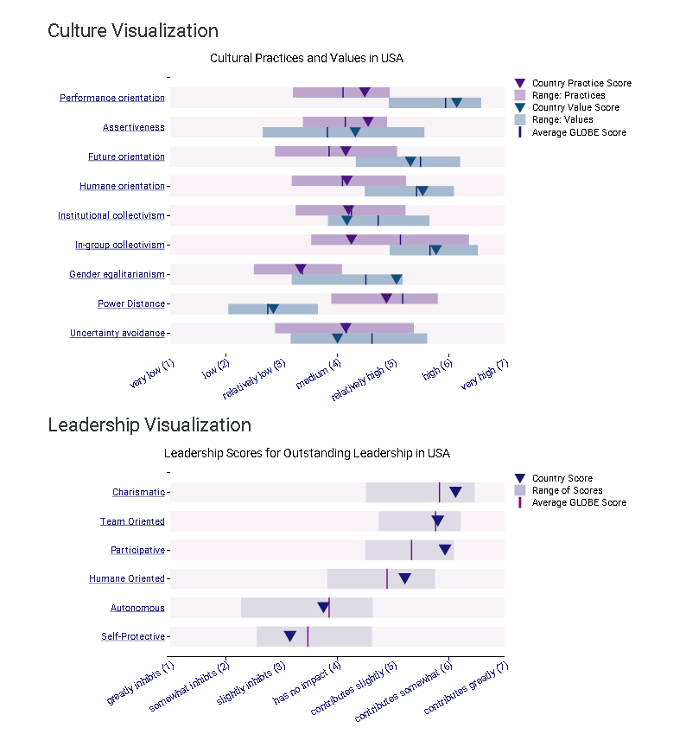

The above tables were taken from the website http://globeproject.com/results/countries/USA?menu=list and shows the results of the cultural practices and values in the USA as well as the results for outstanding leadership values in USA, as presented in the GLOBE study.
Key leader characteristics that mainstream U.S. society , implicitly and/or explicitly, look for and endorse in their leaders were condensed to 10 major characteristics:
1.Stand out through their individual achievements. They love to compete, win, and leave a personal legacy. They assert themselves through the force of their personality and/or convictions and lead by example.
2. Inspirethrough their optimism, can-do mentality, and energy. They appeal to the good in people and bring out the best in them. They are comfortable exerting their influence on others.
3. Stand up for their beliefs. They stay true to themselves and are authentic and straight forward. They can be trusted. They remain calm under pressure, can laugh at them-selves, and may show great humility.
4. Focus their efforts. They have an achievable vision, which they pursue against all odds and distractions. They communicate their vision frequently and are able to articulate it to a wide range of different audiences.
5. Strive for excellence in their and others’ performance. They love challenges and “go the extra mile.” They set measurable outcomes, improve on them, and execute efficiently.
6. Seek change. They are comfortable with taking risks and making mistakes. They learn from failures and are innovative and flexible. They define challenges as opportunities.
7. Act quickly. They exude a sense of urgency and are driven to act. They are decisive and forceful. They prefer swift and approximate over slow and deliberate decisions.
8. Promote team spirit. They stress the need to work and succeed together. They communicate team goals and clarify everyone’s roles and contributions. They instill pride in the team
9.Encourage participation. They seek input from others and are open to suggestions. They stress informality and create a supportive work environment. They build on people’s intrinsic motivations and delegate.
10. Care about people. They respect the inherent humanity and dignity of each person. They feel compassion for others and assist them when needed. They encourage and support others to realize their unique potential and strive to serve the greater good.
House, R. J., Brodbeck, F. C., Chhokar, J. S., & Global Leadership and Organizational Behavior Effectiveness Research, P. (2007). Culture and Leadership Across the World : The GLOBE Book of In-Depth Studies of 25 Societies. Mahwah, N.J.: Routledge.

Instructions:
- Review the PowerPoint on “cross-cultural ledership” before attempting to go any further.
- Look at the 10 characteristic that people in U.S.feel their outstanding leaders should possess, and for each characteristic write one or two paragraph about how that particular characteristic is exemplified in an American leader. Your narrative should be followed by a link to the source from where you are getting the information. You must choose at least 5 leaders, and one leader can possess more than one of those characteristics.
Here is a sample of how to organize your document :

Characteristics of outstanding American Leaders
- Stand out through their individual achievements. They love to compete, win, and leave a personal legacy. They assert themselves through the force of their personality and/or convictions and lead by example.
An example is Michael Smith. As a young ………. Later in his life as the CEO of ……………… he ……………… Mr Smith not only …………………, but also ……………………. He was also …………………………. In 2007 …………. named him ……………. for his dedication to………….. .
Mr Smith enjoyed …………….. And well ahead of his time he ………………..
Source: http://ftw.usatoday.com/2018/02/jemele-hill-michael-smith-sportscenter-sc6-hoespn.
- Inspire through their optimism, can-do mentality, and energy. They appeal to the good in people and bring out the best in them. They are comfortable exerting their influence on others.
These attributes are well reflected in Peter Paul. Mr Paul ………………..
Suggested American Leaders: Steve Jobs, Elon Musk, Jeff Bezos, Bill Gates, Warren Buffet, Lee Iacocca, John Welch, Thomas Watson, Abraham Lincoln, J.F. Kennedy, Martin Luther King, Harry Truman, James Bryant, Vince Lombardi, Tom Landry, Phil Jackson, Ted Turner, Steven Spielberg, Michael Eisner, etc. Feel free to use one not on this list.

