Please Reply to at least three classmates’ posts.

Please response to at least three classmates' posts related to HealthCare Emergency Management Field with providing APA citation. You can do this by many ways like showing an interest point and expandmore or addressing a personal experience as EMS or discuss an issue in depth with providing real live examples and such n such but please don't be boring! be respectful and excited to contribute in the class discussion and remember it's a dialogue so probably another classmates will comment on your reply and so on so forth! hit me up if you have any questions!

1 day ago
Anne Graf
DB 11
COLLAPSE

When developing my own hospital emergency management committee, I would adopt the Hospital Incident Command Structure. I would adopt the HICS structure because it is a best-practice approach for its clearly defined roles and order of authority already implemented. The hospital emergency management committee will perform risk assessments, adopt best practices for emergency planning. The emergency management committee will also develop exercise strategies to test policies, procedures and resources to ensure effective response methods and implement improvements upon lessons learned.

Incident Commander – Sets the incident objectives. Is the leadership position and responsibility of the incident. I would have the CEO of Hospital because they are already in a leadership position in the hospital.

Public Information Officer – Delivers information to the media and local communities about the incident. I would have the Public Relations Director because this position requires training and the ability/comfortability to speak to the media and public. This is an important aspect to have because the person must be able to give information that the public needs to know, but not cause a panic.

Liaison Officer- Coordinates with external partners for incident response. In the event of a disaster, there will be a need to coordinate with other hospitals, law enforcement, humanitarian organizations such as Red Cross. For this role, possibly a healthcare coalition representative would fulfill this position.

Safety Officer – Coordinates risk assessment of the hospital and proper steps to continue safety measures for facility, staff and patients. Many hospitals have a designated Safety Director. However, in the event that there isn’t one, I would use the Human Resources Representative. I would recruit this staff member because they are already knowledgeable and responsible about legal requirements to provide a safe working environment.

Medical/Technical Specialist – Advise the Incident Commander regarding the specific incident with their expertise. I will keep this position flexible to be open to other departments if the incident requires expertise to be in the leadership positions. For example, the IT director if the incident were an IT issue. An infectious disease expert for an outbreak.

Operations Chief -Establishes operational strategies and actions to accomplish the goals established by the incident commander. I would have this split separately between facility operations and clinical operations. Facility operations could be fulfilled by an operations manager/Director fulfill this position because they oversee activities outside the scope of the clinical service, such as oversee policy, implement strategies to achieve goals that would have positive impact on organizational performance. Clinical operations would be fulfilled by a nursing director, who would oversee quality of care given to patients and nurse operations.

Logistics Chief – Maintains and supports the operational actions by ensuring appropriate resources, equipment and personnel are available. I would have the Supply Chain Coordinator fill this position because their responsibility and expertise is already in the buying, managing and processing of medical supplies.

Planning Chief - Prepares and documents Incident Action Plan, collects and evaluations information and documentation. This position would be fulfilled by the Emergency Preparedness Coordinator because their role in the hospital is to oversee emergency planning and mitigation. This includes the continuous meetings and engagements of the Emergency Management Committee.

Finance Chief - Tracks and processes all licensure issues, financial expenditures and labor expenditures (over time). I would recruit the Chief Financial Officer to lead this role because their position already requires management of the hospital’s finances and records.

References:

Chetwynd, E. (2017). Developing a Hospital Emergency Incident Command System (HEICS). Everbridge.Retrieved from: https://www.everbridge.com/blog/developing-hospital-emergency-incident-command-system-heics/

Disaster Medicine. (n.d.). Hospital Incident Command. Retrieved from: https://disastermedicine.wordpress.com/ii-hospital-incident-command/

California Emergency Medical Services Authority. (n.d.). Hospital Incident Command System. Retrieved from: https://emsa.ca.gov/hospital-incident-command-system-job-action-sheets-2014-planning/

Lessons Learned Information Sharing. (n.d.). Emergency management programs for healthcare facilities: Program organization. Retrieved from: https://www.hsdl.org/?view&did=765426

3 days ago
Molly Basilio
Week 11
COLLAPSE
Top of Form
My emergency management committee (EMC) would be modeled after the HICS structure. While a typical HICS activation would include one person serving in the section chief and command positions, the committee would be subdivided into smaller groups with similar roles and responsibilities. Ideally, each committee would have one person from each shift pool on it so that there is a cohort that is familiar with the intricacies of HICS at the hospital at all times. Additionally, the copycat structure might help reduce role confusion and streamline operations in the event the EOP has to be activated. The committee might be structured like this:

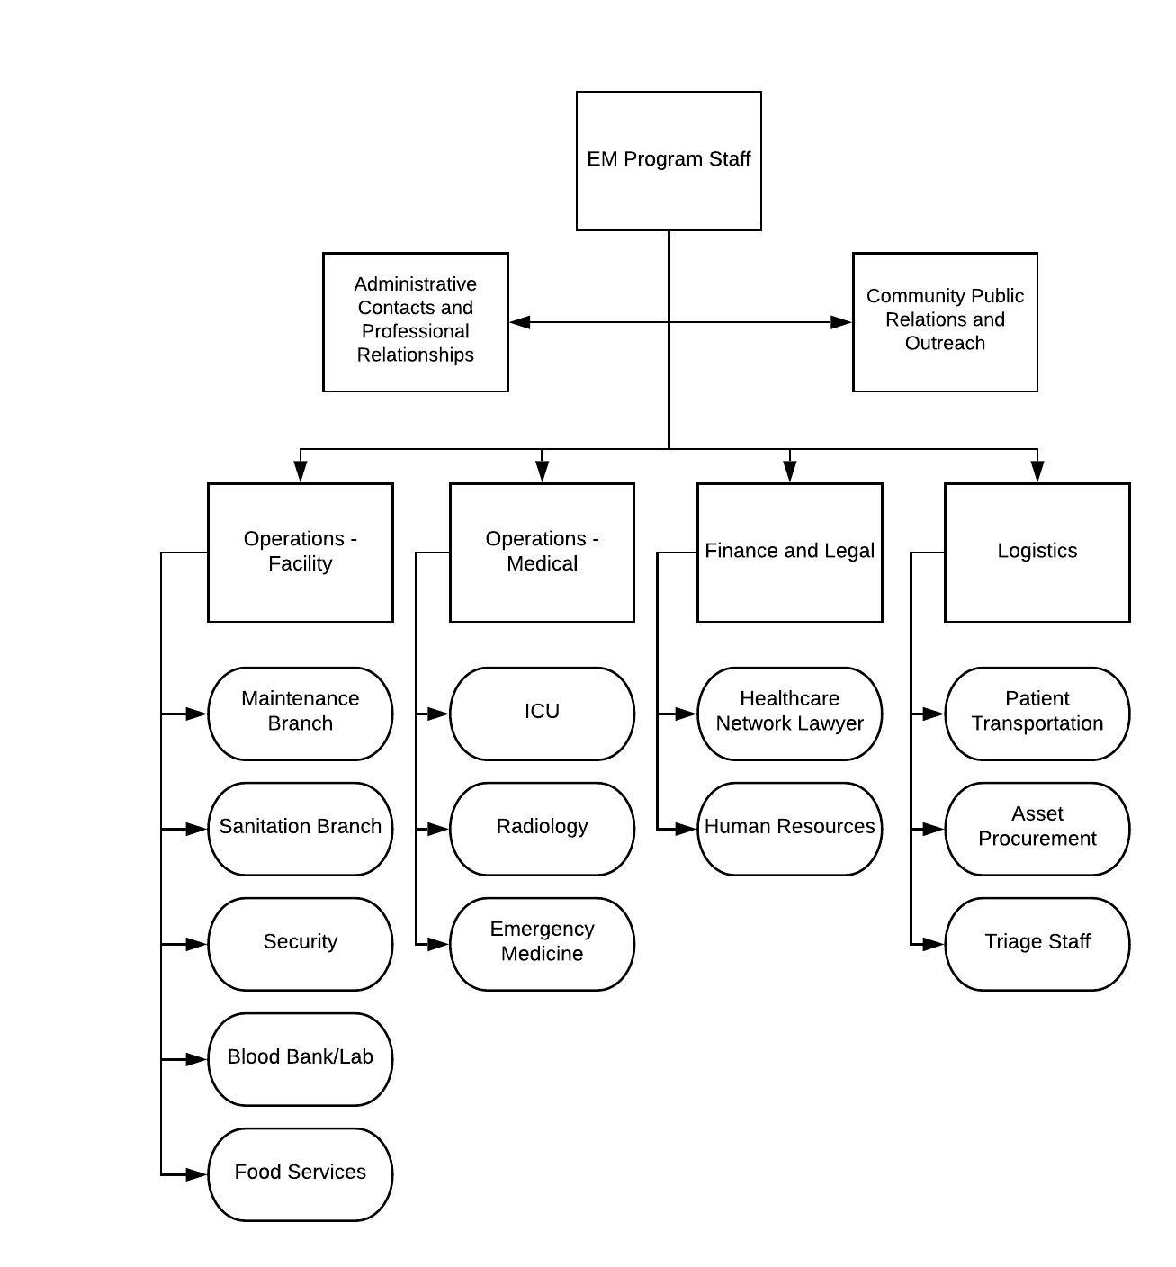
The overarching purpose of the EM committee is to explore the EOP and evaluate it for accuracy and assumptions and make changes as needed. Having everyone in a room together will help facilitate needed communication between departments. Although the figure above is how I would design my EMC with minimum staff, I would want to involve people from every department if I could, but I recognize that it’s not always feasible to do so. Other departments that I would like to include are mortuary services, the pharmacy, surgical staff, respiratory therapists, EMS personnel, and local fire departments if applicable. Disasters have the potential to produce a ripple effect and impact the whole hospital, so representation is essential.
During EOP activation, The EM program staff would transition to the planning section role, with someone who is experienced in the particular event takes the role of incident command. Similarly, somebody with experience with that type of emergency should be placed in the Safety Officer role. The purpose of placing the EM program staff in the command role during the planning process is to have them gain knowledge of each operational area so that they can be better planners during activation. They would have additional responsibilities of reaching out to other emergency management departments/agencies in the area. The Administrative Contacts and Professional Relationships group mimics the role of the Liaison Officer. The Community Public Relations and Outreach group mimics the part of the Public Information Officer. The groups in the ovals are some types of people who should be represented in each subcommittee. The groups included might change depending on the type of facility. The structure for a singular nursing home will look different from that of a network of outpatient clinics.
Additionally, the groups might look different depending on the capabilities and hazards of the healthcare institution. For example, a hospital might not have an ICU or blood bank, in which case they obviously would not be included. I read an article that came out of Israel, which recommended other HICS structures. It listed security as one of the section chief roles, which is just one example of how leadership roles in crisis can change based on priorities and specific hazards (Djalali et al., 2015). Ideally, the biannual drills required by TJC would be a good test of the efficacy of the EOP and appropriateness of the EMC makeup. If there are deficiencies in the after-action reports then the players and planners might need to be reexamined in an iterative improvement process.

- Molly

Djalali, A., Hosseinijenab, V., Peyravi, M., Nekoei-Moghadam, M., Hosseini, B., Schoenthal, L., & Koenig, K. L. (2015). The Hospital Incident Command System: Modified Model for Hospitals in Iran. PLoS Currents. doi: 10.1371/currents.dis.45d66b5258f79c1678c6728dd920451a
Bottom of Form

6 days ago
Tracy Lam
DB 11
COLLAPSE

A hospital emergency management committee is utilized to provide direction and feedback for the Emergency Management Program (EMP). While the Program Manager is responsible for the overall management of the EMP, the committee can add to its structure and provide support.
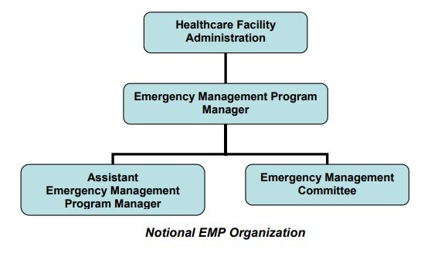
Under the "Best Practice" document created by the Department of Homeland Security (n.d.), it is recommended that the Program Committee consists of members from four principal groups: clinical personnel, non-clinical personnel, the sections of the facility's Incident Management System (IMS), and the local response community. Having a variety of these members within the EMC provides differing viewpoints in the determination of what is needed and necessary for an emergency management plan. This ensures that the plan is comprehensive and that certain specialties are not overlooked. This also incorporates all sections of the facility as well as the local response community, ensuring that everyone is on the same page. While it is critical for the facility's personnel to know what is going on and what plans have been enacted, it is also crucial for the local response community to know so that they can efficiently cooperate with the facility to ensure that patients receive the timely care that they may need.
Clinical Personnel | Non-clinical Personnel | Facility IMS | Local Response Community
- Burn Services  - Clinical Pharmacology/ Toxicology  - Critical Care Services  - Dietary  - Emergency medicine and nursing  - Internal Medicine  - Infection control/Infectious Disease  - Lab/blood band/ pathology (& Morgue)  - Medical Director  - Nursing Supervisor  - Pediatrics  - Pharmacy  - Post-anesthesia care unit (PACU)  - Psychiatry  - Radiology (& Radiation safety)  - Residents and students  - Surgery  - Trauma Services | - Administration (& media/public information, liaisons to outside agencies)  - Chaplain services  - Communications  - Finance  - Patient Registration  - Information Services  - Plant Operations  - Safety  - Security  - Volunteer Coordinator | - Management (IC, PI, Liaison, Safety and Security)  - Finance/Administration  - Operations  - Logistics  - Planning | - Emergency Management  - Emergency Medical Services (EMS)  - Fire Service  - Law Enforcement  - Public Health  - Others as appropriate

Department of Homeland Security (n.d.). Best practice - Emergency management programs for healthcare facilities: Program organization. www.LLIS.gov

6 days ago
Saleh Alyami
Developing a hospital EMC - Saleh
COLLAPSE

The name of the committee is the KNH Hospital Emergency Management Committee. An EMC is a multidisciplinary group that is tasked with the duty for compliance with joint Commission Emergency Management standards. The committee consisted of several representatives from administration, patient safety, risk management, emergency medicine, planning, emergency management, nursing, as well as other executives from departments across the hospital together with the community partners (Laberge, & Spence, 2019). The committee's mission is to collaborate on emergency management techniques, strategies, and initiatives designed to promote as well as enhance preparedness and improve the hospital's ability to respond to any threat.
The committee serves a wide variety of responsibilities and purposes in health other than managing the potential risks that can be encountered at the centers. According to Acevedo (2017), technology is one of the essential aspects of modern health care facilities because it enhances the delivery of quality medical care. This committee will analyze the most efficient tools and techniques to be used to strengthen the ability of the hospital to avoid or minimize the impacts of risks. Also, the committee is tasked with the duty of assessing the emergency management initiatives as well as evaluating its effectiveness to be ready for emergencies, response, recovery, and even mitigation in the institution.
Technological advancement affects many sectors of the medical center, including the nurses, the stakeholders, physician, IT team, patient safety, emergency response team, doctors, patients, as well as the surrounding community. Therefore having a leader to represent each of these categories should be present in my committee to allow each group to expresses their concerns and obligations. Moreover, these groups play a vital role in ensuring the levels of emergencies are maintained as low as possible, thus lowering the rate of mortality. Having each category elaborate on the pros and cons of the incorporation of the gadgets is a critical step in establishing an effective strategy to mitigate risk in each department. As explained by Borron, (2015), a committee in health care is also responsible for overseeing the development of emergency preparedness and response plans in the organization as well as developing an internal disaster drill each financial year. And one of the best ways of developing an exercise is including the participation of external emergency agencies.
The success of any project depends on the competence of the management team because most of the decisions they pass, impact the progress of the institution and its chances to survive any threat and emergencies. The chairs of the committee are occupied by the head of each department because they are well informed about each sector and its operations (Acevedo, 2017). Some of these departments that should be present at the emergency Management Committee include safety, facilities services, information technology service, human resources, patient care center, hospital security, hospital safety, emergency services, financial services, and risk management.
The primary goal of the committee is establishing systems and strategies that will assist the hospital in anticipating, mitigate, and recover from the possible risks and emergencies. Therefore, the underlying qualification of the committee has adequate knowledge about health care services, emergency management, as well as technology and its application to their daily operations (Laberge, & Spence, 2019). This is because the committee is expected to deliver the most appropriate methods and techniques collaborating with technology to increase the hospital's ability to overcome potential threats and emergencies.
References:
Acevedo Jr, F. (2017). The challenges of managing the emergence of emergency management within healthcare (Doctoral dissertation, Capella University).
Borron, S. W. (2015). Checklists for hazardous materials emergency preparedness. Emergency Medicine Clinics, 33(1), 213-232.
Laberge, M., & Spence, N. (2019). The evacuation of two rural hospitals following a tsunami warning: What happened next. Journal of business continuity & emergency planning, 12(4), 316-330.

