Business Plan

Jessica Clark
Phone: 2316490606
Email: jclark93@email.davenport.edu

Table of Contents

Table of Contents 2
Executive Summary 3
Company Description 4 - 5
Industry & Market Analysis 6
Products and Service Development Plan
Organization and Management Team
Operations Plan
Marketing Plan
Financial Plan
Growth Plan
Appendices

Executive Summary

When driving from Traverse City, Michigan to Lake Ann, Michigan on US-31, there is exactly one car wash. In fact, this one car wash is the only car wash within a seven-mile radius in every direction. The next available car wash closer to Lake Ann is over eighteen miles away. US-31 is most used route to get from Traverse City to Interlochen, Grawn, Honor, Beulah and Frankfort. Driving this route daily with no availability to clean the inside or outside of their car is what lead Jessica Clark and Kevin Konechne to the idea of US-31 Wash.
Besides the inability to get a common service done close to home, Jessica and Kevin also care a tremendous amount about the environment. Combining their love for cars and the environment lead them to create the newest, most sustainable car wash within twenty miles in any direction. Taking care of expensive and valuable things such as cars should not come at the cost of the environment.
US-31 Wash will include several in-bay automatic washes, a self-wash station and a couple interior vacuums. Having the ability to reuse and cleanly filter water and use environmentally friendly soaps will be just a couple ways that US-31 Wash will be superior to other car washes. The brand new facility will offer other types of washes such as salt washes to be specifically targeted to rinsing salt and dirt from vehicles in the wintertime. Having the ability to clean your car and do it socially responsibly will be a deal no one can refuse!

Company Description
US-31 Wash will provide brand new, state of the art and sustainable in-bay automatic and self-serve car wash options including interior vacuum stations. US-31 Wash will be located between Grawn, Michigan and Honor, Michigan off Highway US-31.
Mission Statement:
The mission of US-31 Wash is to provide an excellent car wash experience by providing environmentally friendly and reliable car washes for a reasonable price in our community. The core values of US-31 Wash would be sustainability, honestly, integrity and professionalism. Our business strategy will be to continually improve our car wash by increasing community growth and efforts to make US-31 Wash the most sustainable car wash available.
Business Structure:
US-31 Wash will be a Partnership. In a General agreement will be Jessica Clark and Kevin Konechne.
Target Customers:
The targeted consumers will be those of a legal driving age who like to take care of their vehicles. Knowing that US-31 Wash is actively finding new and innovative ways to help make the wash as sustainable as possible can also target those who would rather not use automatic car wash facilities for environmental purposes.

Business Model:

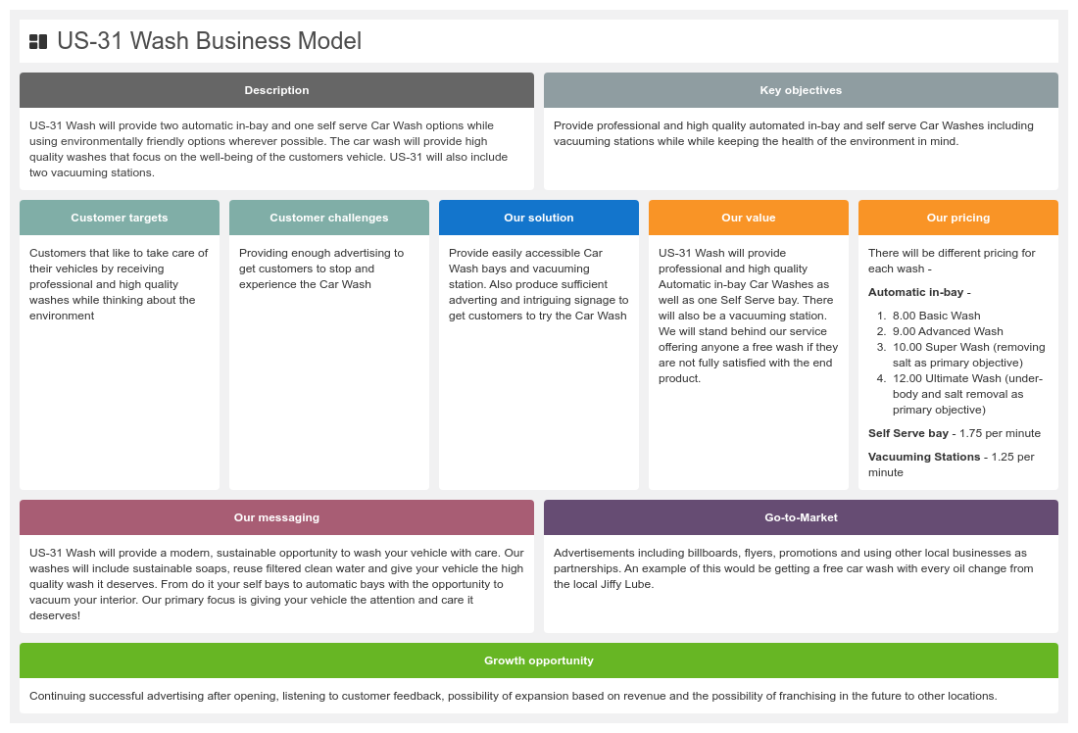

Core Competencies:
- Client Service – Puts client services first by responding and anticipating needs
- Excellent Communication – Communicates effectively to community and consumers
- Initiative – Constantly improving quality of services
- Results Driven – Acheives goals in a timely manner while providing excellent customer service
- Socially Responsible – Committed to making sustainable choices whenever possible

Industry and Market Analysis

- be four to five pages
- be based on secondary and primary research
- include industry research that identifies
  - the NAICS code for the business
  - Size of industry (sales volume, value and growth rate)
  - Typical financial margins
  - Major trends influencing the industry (Political, Economic, Socio-cultural, Technological)
  - identify any potential legal, regulatory and environmental constraints on the business
- include market research that identifies
  - the size and potential value of the customer segment(s) in the geographic area(s) the business will serve
  - the demographic profile of customers in the identified segment(s)
    - Consumer profiles should consider age, gender, location, income level, occupation, education level
    - Business profiles should include industry, location, firm size, quality/price/service preferences.
  - trends in the target market segments (growth, customer preferences, product development)
  - competitor analysis of both direct and indirect customers
  - the potential market share the business could capture
  - distribution channels
  - the best market entry strategy for the business

Management Team and Organization Plan
The Management Team and Organization Plan summarizes information about the organizational structure of the business, management roles, responsibilities, expertise and qualifications. This section of the plan should
- be two to three pages
- identify the legal form of the business.
- include a brief statement of management philosophy and desired organizational culture
- provide both an ethics and social responsibility statement including any principles and standards on which they are based.
- summarize the qualifications, experience and core competencies of each of the founding members of the business (detailed resumes may be included in Appendices).
- explain how key tasks will be accomplished on a daily basis
- identify any gaps in the management team and explain how these will be filled
- include an organizational chart with key positions identified and number of employees required (job descriptions and salary and payroll information can be included in the appendices)
- detail professional, governance and advisory support for the business
  - Board of directors (governance)
  - Management advisory board (including any mentors or consultants)
  - Attorneys (professional)
  - Accountant Banker (professional)
  - Insurance Agents (professional)
  - Web and Social Media Services (professional)

Product and Services Plan
The Product and Services Plan outlines the benefits the products and services of the business will provide, the needs the products and or services will fulfill and the problem they solve for the customer. This section of the business plan should
- be approximately two pages
- describe in detail each of the products and/or services the business will offer
- the differentiating features and benefits to customers of each of the products and/or services including level of quality
- technical specifications and intellectual property if applicable (patents, trade or service marks
- explain plans for prototyping or testing with customers
- identify the pricing strategy for each of the products or services
- any after sales warranties or service

Operations Plan
The Operations Plan identifies in some detail what needs to happen within the business to ensure it runs effectively and efficiently. This section of the business plan should
- be three to four pages
- identify how and where products or services are produced and the hours of operation
- identify any legal requirements
  - licensing, bonding, permits, zoning requirements, insurance coverage, trademarks, copyrights or patents
- the control processes and systems the business will use
  - quality
  - customer service – how you will acquire and train and deploy employees
  - inventory – type and quantity, typical value of stock, turnover rate, ordering lead time, seasonal fluctuations
  - product development
- detail the location characteristics necessary for the business
  - size, building type, zoning, necessary utilities
  - whether premises will be purchased or leased
  - accessibility such as parking, foot traffic etc
  - proximity to transportation networks (rail, road, air, shipping, suppliers)
- include researched cost estimates for rent, maintenance, utilities, insurance, any initial remodeling and the equipment necessary for the business to operate
- outline the business credit policies and the policy for slow paying customers
- outline the business policy for managing accounts receivable and payable
- identify key suppliers and what they will supply
- include a time line of key task milestones to start up

Marketing Plan
The marketing plan identifies how the business will reach and communicate with its identified target market segments to deliver a cohesive and consistent integrated marketing mix (product, price, promotion, place ) to reinforce the competitive position the in the mind of the consumer. This section of the business plan should
- be three to four pages
- briefly summarize the segment(s) and profile of customers the business will serve
- describe the overall positioning and branding strategy for each of the segments
- explain the marketing strategy for each of the segments
  - the strategy for entering the market
  - the business development strategy
  - the distribution strategy
  - the communications strategy
  - the pricing strategy
  - the sales strategy
    - size and type (internal or independent) of sales force
    - recruitment and training of the sales force
    - compensation package for sales force
  - outline the sales activities plan
    - identify and prioritize highest value contacts
    - sales targets (e.g # of sales calls per day, sales value per month)
  - include the marketing budget
Financial Plan
The financial plan is a forward-looking section of the business plan in which projections are based on anticipated revenues and costs. Each section of the business plan feeds into the development of these projections. The financial plan helps investors to determine if they wish to invest in the business and when they may see a return on any investment they make. It also guides the business owner to understand when they may need additional funding and, once the business is up and running, to determine if the business is meeting the anticipated financial targets. This section of the business plan should
- be three to four pages
- summarize key financial metrics
- identify capital requirements and anticipated sources of funding
- include a sales forecast for first year and expected percentage growth for following two years
- discuss the break even point
- state any assumptions made related to the development of financial statements and funding requirements
Note three years of financial projects should be included in the Appendix of the plan.

International Expansion Plan
Frequently, there comes a time when the business needs or wants to push into new overseas markets. Possible reasons include cost cutting to sustain or improve domestic profits , or market expansion to increase revenue. Planning for international business entails much of the same research as for a domestic business but has increased complexity and risk due to different political, economic, legal, social and cultural considerations. This section of the plan should
- be two to three pages
- clearly identify the country (countries) into which the business might expand and the reasons for international expansion
- outline the current political, economic, socio-cultural, technological and stage of country development
- consider the infrastructure of the country
- detail population income and literacy levels
- identify any potential risks arising from doing business in the selected country, including language, cultural, trade barriers and fluctuating exchange rates
- describe the skills and strategies to necessary to overcome or minimize the risks
- identify the market entry strategy the business will use to access the overseas market

Business Plan Appendices
Page #
Appendix 1: PESTLE Analysis
Appendix 2: Porters 5 Forces Analysis
Appendix 3: SWOT Analysis
Appendix 4 Break Even Analysis Calculation
Appendix 5 Three Year Income Statements
Appendix 6 Three Year Cash Flow Statements
Appendix 7 Opening Day Balance Sheet

References
(n.d.). Retrieved from https://my-ibisworld-com.proxy.davenport.edu/us/en/industry/81119a/about

(n.d.). Retrieved from https://www.nulook.com/car-wash-business-profit-expect/

Everything You Need to Know About Starting A Car Wash From Your Chemical Experts. (2019, October 16). Retrieved from https://www.jbsindustries.com/blog/starting-car-wash/

Ricardo, A. (2019, October 8). How to Open a Car Wash Business. Retrieved from https://www.wikihow.com/Open-a-Car-Wash-Business

Team, W., & Team, W. (2019, March 5). 12 Shocking Statistics About the Car Wash Industry That You Need to Know. Retrieved from https://www.washos.com/blog/statistics-car-wash-industry/

