First-name Surname^{1*}, Second-name Surname² and Third-name Surname³

¹Affiliation 1, Email address, University, City, Country
²Affiliation 1, Email address, University, City, Country
³Affiliation 1, Email address, University, City, Country

*Corresponding Author

ABSTRACT

An Abstract is required for every article; it should succinctly summarize the reason for the work, the main findings, and the conclusions of the study. The abstract should be no longer than 250 words. Do not include artwork, tables, elaborate equations or references to other parts of the article or to the reference listing at the end. The reason is that the Abstract should be understandable in itself to be suitable for storage in textual information retrieval systems.

Keywords: ; ; ; ;

- Introduction

We believe a template should help you, not hinder you, in authoring your article. It should follow you in how you want to write your article, not force you to fill in bits and pieces of text. It should allow you to type any text, copy from previous versions, or load an already existing plain text to be formatted. You will therefore find no fill-in screens; you will not need to remember shortcut keys, to use lists of styles, bother about alignment, indents, fonts and point sizes. Just a mouse-click at one of the menu options will give you the style that you want.
The objective of this template is to enable you in an easy way to style your article attractively. It should be emphasized, however, that the final appearance of your article in print and in electronic media will very likely vary to greater or lesser extent from the presentation achieved in this Word® document.

- The first page

Naturally, your article should start with a concise and informative title. Do not use abbreviations in title. Next, list all authors with their first names or initials and surnames (in that order). Indicate the author for correspondence. After having listed all authors’ names, you should list their respective affiliations. Link authors and affiliations using superscript lower-case letters from the ‘Author Footnote Symbols’ menu in the toolbar.

  - Article Size

The Manuscript should be prepared in English language by using MS Word. Article can be up to 12 pages inclusive references and abstract.
Supply some 3–5 keywords, separated with semicolons, e.g., Azomethine ylide; Claisen rearrangement; Diels-Alder cycloaddition; Enantioselective catalysis; Ionic liquid; Metathesis; Microwave-assisted synthesis.

- The main text

You will usually want to divide your article into (numbered) sections. Headings should reflect the relative importance of the sections. Your article can go beyond 4th order heading.
Ensure that all tables, figures and schemes are cited in the text in numerical order. Trade names should have an initial capital letter, and trademark protection should be acknowledged in the standard fashion, using the superscripted characters for trademarks and registered trademarks respectively. All measurements and data should be given in SI (System International) units where possible, or other internationally accepted units. Abbreviations should be used consistently throughout the text, and all nonstandard abbreviations should be defined on first usage. The experimental information should be as concise as possible, while containing all the information necessary to guarantee reproducibility.
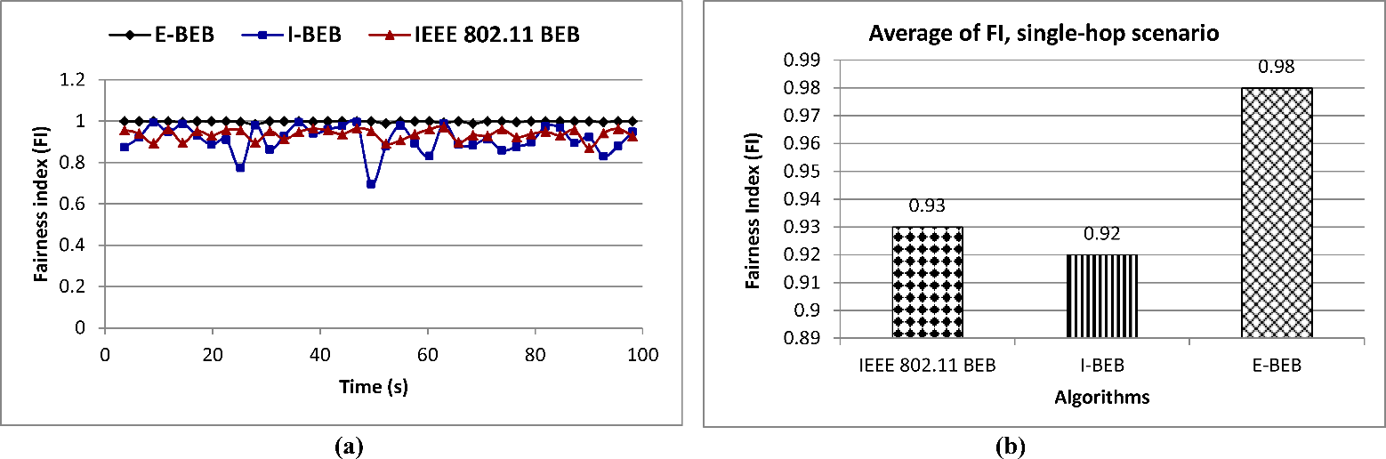
Figure 1. (a) Fairness index, (b) Average Fairness Index

Table 1. Table, version 1

Parameter | Value | Parameter | Value
Slot time | 20 μs | Slot time | 20 μs
ACK size | 20 bytes | ACK size | 20 bytes
RTS size | 25 bytes | RTS size | 25 bytes
CTS size | 20 bytes | CTS size | 20 bytes
Data packet size | 1000 bytes | Data packet size | 1000 bytes
DIFS interval | 40 μs | DIFS interval | 40 μs
SIFS interval | 10 μs | SIFS interval | 10 μs
CWmin | 31 | CWmin | 31
CWmax | 1023 | CWmax | 1023
Bandwidth | 2 Mbps | Bandwidth | 2 Mbps
Transport protocol | UDP | Transport protocol | UDP

  - Tables, figures and schemes

All citations of figure and tables in text must be in numerical order. Citations to figures in text always carry the word “Figure.”, “Table.” followed by the figure/table number.
You can choose to display figure/table through one column (see Table 1, Figure 1) or across the page (see Table 2, Figure 2). Remember that we will always also need high-resolution versions of your figures for printing in (i.e. TIFF) format.

Table 2. Table, version 2

Parameter | Value
Slot time | 20 μs
ACK size | 20 bytes
RTS size | 25 bytes
CTS size | 20 bytes
Data packet size | 1000 bytes
DIFS interval | 40 μs
Bandwidth | 2 Mbps
Transport protocol | UDP

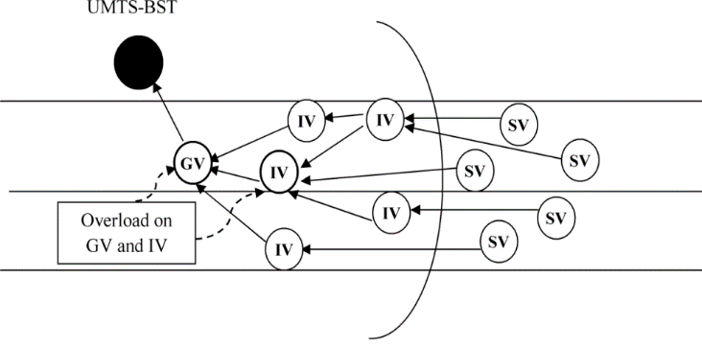
Figure 2. Overload on GV and IV vehicles

  - Lists

For tabular summations that do not deserve to be presented as a table, lists are often used. Lists may be either numbered or bulleted. Below you see examples of both.
- The first entry in the list
- The second entry
- A subentry
- The last entry

- A bulleted list item
- Another one

You can use the Bullets and Numbering options in the ‘Formatting’ toolbar of Word® to create lists. Note that you should first block the whole list. A sublisting is coded using the ‘Increase Indent’ (go to a sublevel of numbering) and ‘Decrease Indent’ (go to a higher level of numbering) buttons.

  - Equations

Equations within an article are numbered consecutively from the beginning of the article to the end. All variables are italic. (e.g., x, y, n). Function names and abbreviations are Roman (sin, cos, sinc, sinh), as are units or unit abbreviations (e.g., deg, Hz,) complete words (e.g., in, out), and abbreviations of words (e.g., max, min), or acronyms (e.g., SNR).
You can type your equations and use the symbols in the Word® equation editor or in MathType™. Using the ‘Insert Equation’ option, you can create equations in the Word® equation editor, or if the MathType™ equation editor is installed on your computer.
(1)

Acknowledgments

Acknowledgments should be inserted at the end of the article, before the references. When citing names within the Acknowledgment, do not use Mr., Mrs., Ms., or Miss. List first initial and last name only. Use the Dr. or Prof. title with each name separately; do not use plural Drs. or Profs. with lists of names.

References

The journal uses the IEEE Template for references formatting. References in the text should be indicated by Arabic numerals that run consecutively through the article and appear inside punctuation.
Authors should ensure that all references are cited in the text and vice versa. Authors are expected to check the original source reference for accuracy. See examples shown in the References section. In text, refer simply to the reference number. Do not use “Ref.”, “reference” or “Reference [3] shows ....” use as demonstrated in [3], according to [4] and [6-9]. Please do not use automatic endnotes in Word, rather, type the reference list at the end of the article using the “References” style. The authors encourage using the “EndNote” software to format and insert the references into the article (http://endnote.com/). IEEE EndNote template can be downloaded from (http://endnote.com/downloads/template/ieee). Below is the references formatting:

Basic format for books:
- J. K. Author, “Title of chapter in the book,” in Title of His Published Book, xth ed. City of Publisher, Country if not
- USA: Abbrev. of Publisher, year, ch. x, sec. x, pp. xxx–xxx.
Examples:
- G. O. Young, “Synthetic structure of industrial plastics,” in Plastics, 2nd ed., vol. 3, J. Peters, Ed. New York: McGraw-Hill, 1964, pp. 15–64.
- W.-K. Chen, Linear Networks and Systems. Belmont, CA: Wadsworth, 1993, pp. 123–135.

Basic format for journals:
- J. K. Author, “Name of article,” Abbrev. Title of Periodical, vol. x, no. x, pp. xxx-xxx, Abbrev. Month, year.
Examples:
- J. U. Duncombe, “Infrared navigation—Part I: An assessment
of feasibility,” IEEE Trans. Electron Devices, vol. ED-11, no. 1, pp. 34–39, Jan. 1959.
- E. P. Wigner, “Theory of traveling-wave optical laser,” Phys. Rev.,
vol. 134, pp. A635–A646, Dec. 1965.
- E. H. Miller, “A note on reflector arrays,” IEEE Trans. Antennas Propagat., to be published.

Basic format for reports:
- J. K. Author, “Title of report,” Abbrev. Name of Co., City of Co., Abbrev. State, Rep. xxx, year.
Examples:
- E. E. Reber, R. L. Michell, and C. J. Carter, “Oxygen absorption in the earth’s atmosphere,” Aerospace Corp., Los Angeles, CA, Tech. Rep. TR-0200 (4230-46)-3, Nov. 1988.
- J. H. Davis and J. R. Cogdell, “Calibration program for the 16-foot antenna,” Elect. Eng. Res. Lab., Univ. Texas, Austin, Tech. Memo. NGL-006-69-3, Nov. 15, 1987.

Basic format for handbooks:
- Name of Manual/Handbook, x ed., Abbrev. Name of Co., City of Co., Abbrev. State, year, pp. xxx-xxx.
Examples:
- Transmission Systems for Communications, 3rd ed., Western Electric Co., Winston-Salem, NC, 1985, pp. 44–60.
- Motorola Semiconductor Data Manual, Motorola Semiconductor Products Inc., Phoenix, AZ, 1989.

Basic format for books (when available online):
- Author. (year, month day). Title. (edition) [Type of medium]. volume (issue). Available: site/path/file
Example:
- J. Jones. (1991, May 10). Networks. (2nd ed.) [Online]. Available: http://www.atm.com

Basic format for journals (when available online):
- Author. (year, month). Title. Journal. [Type of medium]. volume (issue), pages. Available: site/path/file
Example:
- R. J. Vidmar. (1992, Aug.). On the use of atmospheric plasmas as electromagnetic reflectors. IEEE Trans. Plasma Sci. [Online]. 21(3), pp. 876–880. Available: http://www.halcyon.com/pub/journals/21ps03-vidmar

Basic format for articles presented at conferences (when available online):
- Author. (year, month). Title. Presented at Conference title. [Type of Medium]. Available: site/path/file
Example:
- PROCESS Corp., MA. Intranets: Internet technologies deployed behind the firewall for corporate productivity. Presented at
INET96 Annual Meeting. [Online]. Available: http://home.process.com/Intranets/wp2.htp

Basic format for reports and handbooks (when available online):
- Author. (year, month). Title. Comp an y . C ity, State or Country. [Type of Medium]. Available: site/path/file
Example:
- S. L. Tall een. (1996 , Apr . ). The In t r an et Archi -tecture: M a nagi ng i n f o rm at i on i n t h e ne w paradigm. Amdahl Corp., CA. [Online]. Available: http://www.amdahl.com/doc/products/bsg/intra/infra/html

Basic format for computer programs and electronic documents (when available online).
Example:
- A. Harriman. (1993, June). Compendium of genealogical software. Humanist. [Online]. Available e-mail: HUMANIST@NYVM.ORG Message: get GENEALOGY REPORT

Basic format for patents (when available online):
- Name of the invention, by inventor’s name. (year, month day). Patent Number [Type of medium]. Available: site/path/file
Example:
- Musical toothbrush with adjustable neck and mirror, by L.M.R. Brooks. (1992, May 19). Patent D 326 189
[Online]. Available: NEXIS Library: LEXPAT File: DESIGN

Basic format for conference proceedings (published):
- J. K. Author, “Title of article,” in Abbreviated Name of Conf., City of Conf., Abbrev. State (if given), year, pp. xxxxxx.
Example:
- D. B. Payne and J. R. Stern, “Wavelength-switched pas- sively coupled single-mode optical network,” in Proc. IOOC-ECOC, 1985,
pp. 585–590.
Example for articles presented at conferences (unpublished):
- D. Ebehard and E. Voges, “Digital single sideband detection for interferometric sensors,” presented at the 2nd Int. Conf. Optical Fiber Sensors, Stuttgart, Germany, Jan. 2-5, 1984.

Basic format for patents:
- J. K. Author, “Title of patent,” U.S. Patent x xxx xxx, Abbrev. Month, day, year.
Example:
- G. Brandli and M. Dick, “Alternating current fed power supply,”
U.S. Patent 4 084 217, Nov. 4, 1978.
Basic format for theses (M.S.) and dissertations (Ph.D.):
- J. K. Author, “Title of thesis,” M.S. thesis, Abbrev. Dept., Abbrev. Univ., City of Univ., Abbrev. State, year.
- J. K. Author, “Title of dissertation,” Ph.D. dissertation, Abbrev. Dept., Abbrev. Univ., City of Univ., Abbrev. State, year.
Examples:
- J. O. Williams, “Narrow-band analyzer,” Ph.D. dissertation, Dept. Elect. Eng., Harvard Univ., Cambridge, MA, 1993.
- N. Kawasaki, “Parametric study of thermal and chemical nonequilibrium nozzle flow,” M.S. thesis, Dept. Electron. Eng., Osaka Univ., Osaka, Japan, 1993.
Basic format for the most common types of unpublished references:
- J. K. Author, private communication, Abbrev. Month, year.
- J. K. Author, “Title of article,” unpublished.
- J. K. Author, “Title of article,” to be published.
Examples:
- A. Harrison, private communication, May 1995.
- B. Smith, “An approach to graphs of linear forms,” unpublished.
- A. Brahms, “Representation error for real numbers in binary computer arithmetic,” IEEE Computer Group Repository, Article R-67-85.

Basic format for standards:
- Title of Standard, Standard number, date.
Examples:
- IEEE Criteria for Class IE Electric Systems, IEEE Standard 308, 1969.
- Letter Symbols for Quantities, ANSI Standard Y10.5-1968.

