Unit 3: Wealth and Racial Inequalities
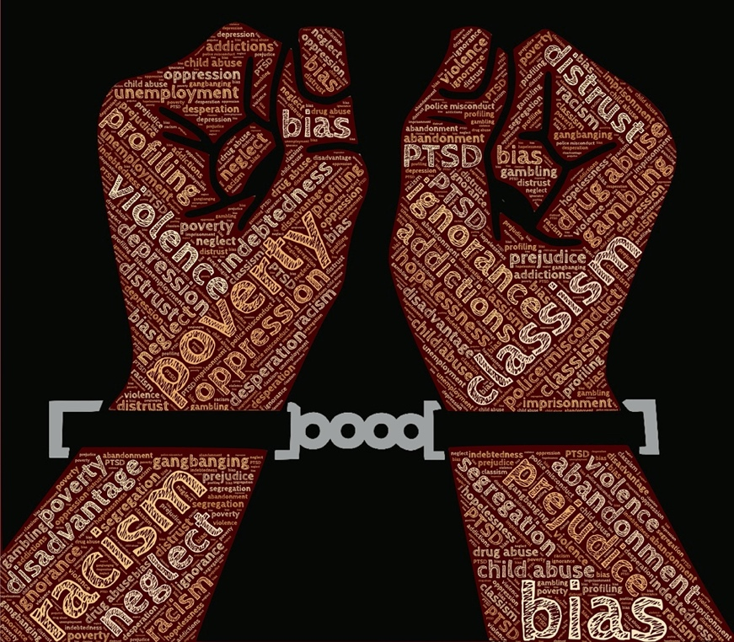

Introduction
This unit examines two important systems of inequality which impact many social problems in US society. The first chapter provides insights into understanding the persistence of poverty and wealth inequality. This social problem is grounded in the history of the development of the US capitalist economy which results in an increase in unequal wealth distribution. While the image of the US economy is one of wealth and strength, the poverty rate is one of the highest compared to other industrialized nations. Racial inequality is the other system of inequality addressed in this unit. Like class based inequality, racial inequality also is rooted in the US’s history of colonialism and slavery and these histories have a lasting impact on racial inequality today.

Unit Learning Outcomes
At the conclusion of the unit, the learner will be able to:
- Understand how the official poverty line in the United States is measured and the impact and limitations of this measurement.
- Explain the difference between the individualist and structural explanations of poverty.
- Identify social problems caused by poverty and wealth inequality.
- Describe the social construction of race and the critique of a biological basis of racial categories.
- Define the concepts of prejudice, racism, and stereotypes.
- Identify social problems caused by racial inequality.

Readings and Materials

Readings
- Chapters 2 & 3 in Social Problems: Continuity and Change

2 The Measurement and Extent of Poverty
When US officials became concerned about poverty during the 1960s, they quickly realized they needed to find out how much poverty we had. To do so, a measure of official poverty, or a poverty line, was needed. A government economist, Mollie Orshanky, first calculated this line in 1963 by multiplying the cost of a very minimal diet by three, as a 1955 government study had determined that the typical American family spent one-third of its income on food. Thus a family whose cash income is lower than three times the cost of a very minimal diet is considered officially poor.
This way of calculating the official poverty line has not changed since 1963. It is thus out of date for many reasons. For example, many expenses, such as heat and electricity, child care, transportation, and health care, now occupy a greater percentage of the typical family’s budget than was true in 1963. In addition, this official measure ignores a family’s noncash income from benefits such as food stamps and tax credits. As a national measure, the poverty line also fails to take into account regional differences in the cost of living. All these problems make the official measurement of poverty highly suspect. As one poverty expert observes, “The official measure no longer corresponds to reality. It doesn’t get either side of the equation right—how much the poor have or how much they need. No one really trusts the data” (DeParle, et. al., 2011). We’ll return to this issue shortly.

The measure of official poverty began in 1963 and stipulates that a family whose income is lower than three times the cost of a minimal diet is considered officially poor. This measure has not changed since 1963 even though family expenses have risen greatly in many areas.
Wikimedia Commons – public domain.
The poverty line is adjusted annually for inflation and takes into account the number of people in a family: The larger the family size, the higher the poverty line. In 2010, the poverty line for a nonfarm family of four (two adults, two children) was $22,213. A four-person family earning even one more dollar than $22,213 in 2010 was not officially poor, even though its “extra” income hardly lifted it out of dire economic straits. Poverty experts have calculated a no-frills budget that enables a family to meet its basic needs in food, clothing, shelter, and so forth; this budget is about twice the poverty line. Families with incomes between the poverty line and twice the poverty line (or twice poverty) are barely making ends meet, but they are not considered officially poor. When we talk here about the poverty level, then, keep in mind that we are talking only about official poverty and that there are many families and individuals living in near poverty who have trouble meeting their basic needs, especially when they face unusually high medical expenses, motor vehicle expenses, or the like. For this reason, many analysts think families need incomes twice as high as the federal poverty level just to get by (Wright, et. al., 2011). They thus use twice-poverty data (i.e., family incomes below twice the poverty line) to provide a more accurate understanding of how many Americans face serious financial difficulties, even if they are not living in official poverty.

The Extent of Poverty
With this caveat in mind, how many Americans are poor? The US Census Bureau gives us some answers that use the traditional, official measure of poverty developed in 1963. In 2010, 15.1 percent of the US population, or 46.2 million Americans, lived in official poverty (DeNavas-Walt, et. al., 2011). This percentage represented a decline from the early 1990s but was higher than 2000 and even higher than the rate in the late 1960s (see Figure 2.1 “US Poverty, 1959–2010”). If we were winning the war on poverty in the 1960s (notice the sharp drop in the 1960s in Figure 2.1 “US Poverty, 1959–2010”), since then poverty has fought us to a standstill.
Figure 2.1 US Poverty, 1959–2010
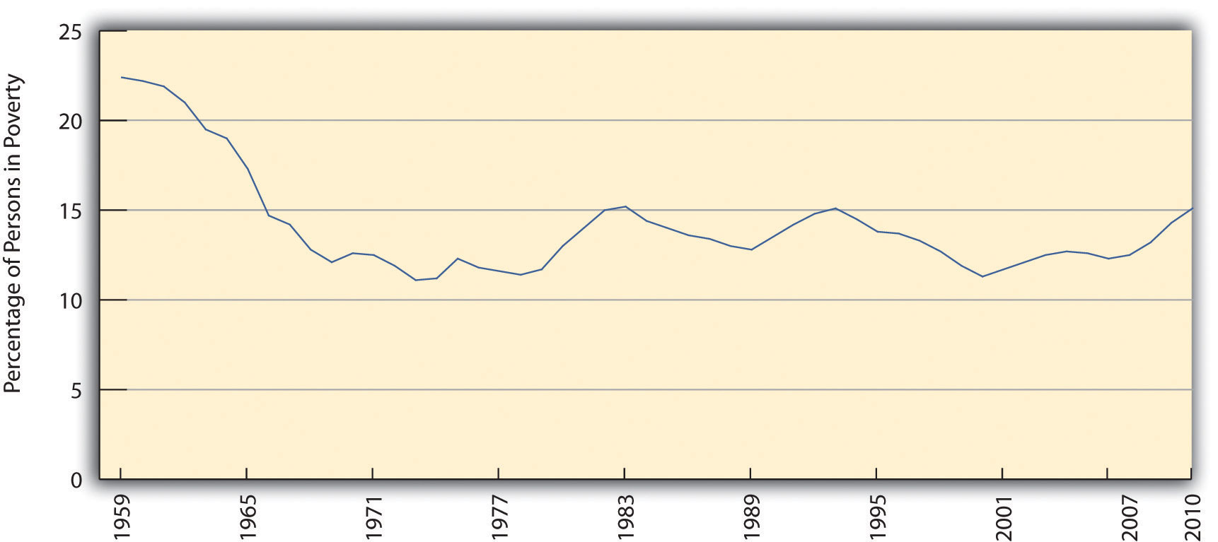
Source: Data from US Census Bureau. (2011). Historical poverty tables: People. Retrieved from http://www.census.gov/hhes/www/poverty/data/historical/people.html.
Another way of understanding the extent of poverty is to consider episodic poverty, defined by the Census Bureau as being poor for at least two consecutive months in some time period. From 2004 to 2007, the last years for which data are available, almost one-third of the US public, equal to about 95 million people, were poor for at least two consecutive months, although only 2.2 percent were poor for all three years (DeNavas-Walt, et al., 2010). As these figures indicate, people go into and out of poverty, but even those who go out of it do not usually move very far from it. And as we have seen, the majority of Americans can expect to experience poverty or near poverty at some point in their lives.
The problems in the official poverty measure that were noted earlier have led the Census Bureau to develop a Supplemental Poverty Measure. This measure takes into account the many family expenses in addition to food; it also takes into account geographic differences in the cost of living, taxes paid and tax credits received, and the provision of food stamps, Medicaid, and certain other kinds of government aid. This new measure yields an estimate of poverty that is higher than the rather simplistic official poverty measure that, as noted earlier, is based solely on the size of a family and the cost of food and the amount of a family’s cash income. According to this new measure, the 2010 poverty rate was 16.0 percent, equal to 49.1 million Americans (Short, 2011). Because the official poverty measure identified 46.2 million people as poor, the new, more accurate measure increased the number of poor people in the United States by almost 3 million. Without the help of Social Security, food stamps, and other federal programs, at least 25 million additional people would be classified as poor (Sherman, 2011). These programs thus are essential in keeping many people above the poverty level, even if they still have trouble making ends meet and even though the poverty rate remains unacceptably high.
A final figure is worth noting. Recall that many poverty experts think that twice-poverty data—the percentage and number of people living in families with incomes below twice the official poverty level—are a better gauge than the official poverty level of the actual extent of poverty, broadly defined, in the United States. Using the twice-poverty threshold, about one-third of the US population, or more than 100 million Americans, live in poverty or near poverty (Pereyra, 2011). Those in near poverty are just one crisis—losing a job or sustaining a serious illness or injury—away from poverty. Twice-poverty data paint a very discouraging picture.

Key Takeaways
- The official poverty rate is based on the size of a family and a minimal food budget; this measure underestimates the true extent of poverty.
- The official poverty rate in 2010 was 15.1 percent, equal to more than 46 million Americans.
- About one-third of the US population, or more than 100 million Americans, have incomes no higher than twice the poverty line.

2.2 Who the Poor Are: Social Patterns of Poverty
Who are the poor? Although the official poverty rate in 2010 was 15.1 percent, this rate differs by the important sociodemographic characteristics of race/ethnicity, gender, and age, and it also differs by region of the nation and by family structure. The poverty rate differences based on these variables are critical to understanding the nature and social patterning of poverty in the United States. We look at each of these variables in turn with 2010 census data (DeNavas-Walt, et, al., 2011).

Race/Ethnicity
Here is a quick quiz; please circle the correct answer.
- Most poor people in the United States are
  - Black/African American
  - Latino
  - Native American
  - Asian
  - White
What did you circle? If you are like the majority of people who answer a similar question in public opinion surveys, you would have circled a. Black/African American. When Americans think about poor people, they tend to picture African Americans (White, 2007). This popular image is thought to reduce the public’s sympathy for poor people and to lead them to oppose increased government aid for the poor. The public’s views on these matters are, in turn, thought to play a key role in government poverty policy. It is thus essential for the public to have an accurate understanding of the racial/ethnic patterning of poverty.

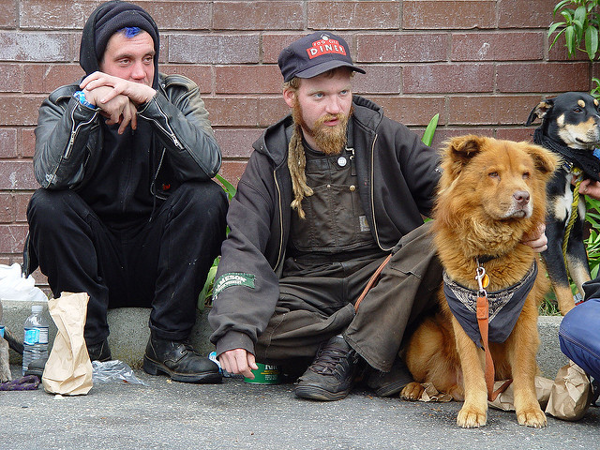
The most typical poor people in the United States are non-Latino whites. These individuals comprise 42.4 percent of all poor Americans.
Franco Folini – Homeless guys with dogs – CC BY-SA 2.0.

Unfortunately, the public’s racial image of poor people is mistaken, as census data reveal that the most typical poor person is white (non-Latino). To be more precise, 42.4 percent of poor people are white (non-Latino), 28.7 percent are Latino, 23.1 percent are black, and 3.7 percent are Asian (see Figure 2.2 “Racial and Ethnic Composition of the Poor, 2010 (Percentage of Poor Persons Who Belong to Each Group)”). As these figures show, non-Latino whites certainly comprise the greatest number of the American poor. Turning these percentages into numbers, they account for 19.6 million of the 46.2 million poor Americans.
It is also true, though, that race and ethnicity affect the chances of being poor. While only 9.9 percent of non-Latino whites are poor, 27.4 percent of African Americans, 12.1 percent of Asians, and 26.6 percent of Latinos (who may be of any race) are poor (see Figure 2.3 “Race, Ethnicity, and Poverty, 2010 (Percentage of Each Group That Is Poor)”). Thus African Americans and Latinos are almost three times as likely as non-Latino whites to be poor. (Because there are so many non-Latino whites in the United States, the greatest number of poor people are non-Latino white, even if the percentage of whites who are poor is relatively low.) The higher poverty rates of people of color are so striking and important that they have been termed the “colors of poverty” (Lin & Harris, 2008).

Figure 2.2 Racial and Ethnic Composition of the Poor, 2010 (Percentage of Poor Persons Who Belong to Each Group)
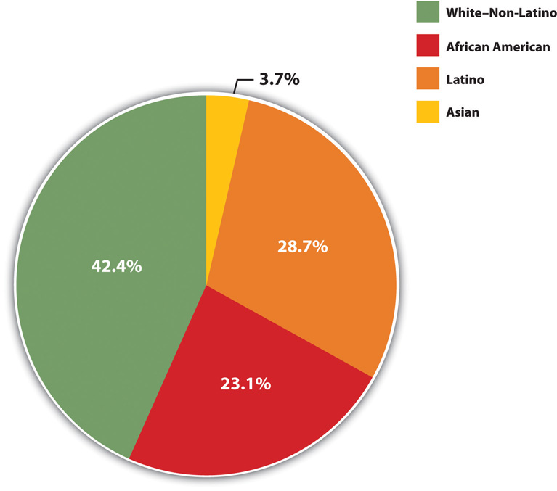
Source: Data from DeNavas-Walt, C., Proctor, B. D., & Smith, J. C. (2011). Income, poverty, and health insurance coverage in the United States: 2010 (Current Population Report P60-239). Washington, DC: US Census Bureau.

Figure 2.3 Race, Ethnicity, and Poverty, 2010 (Percentage of Each Group That Is Poor)
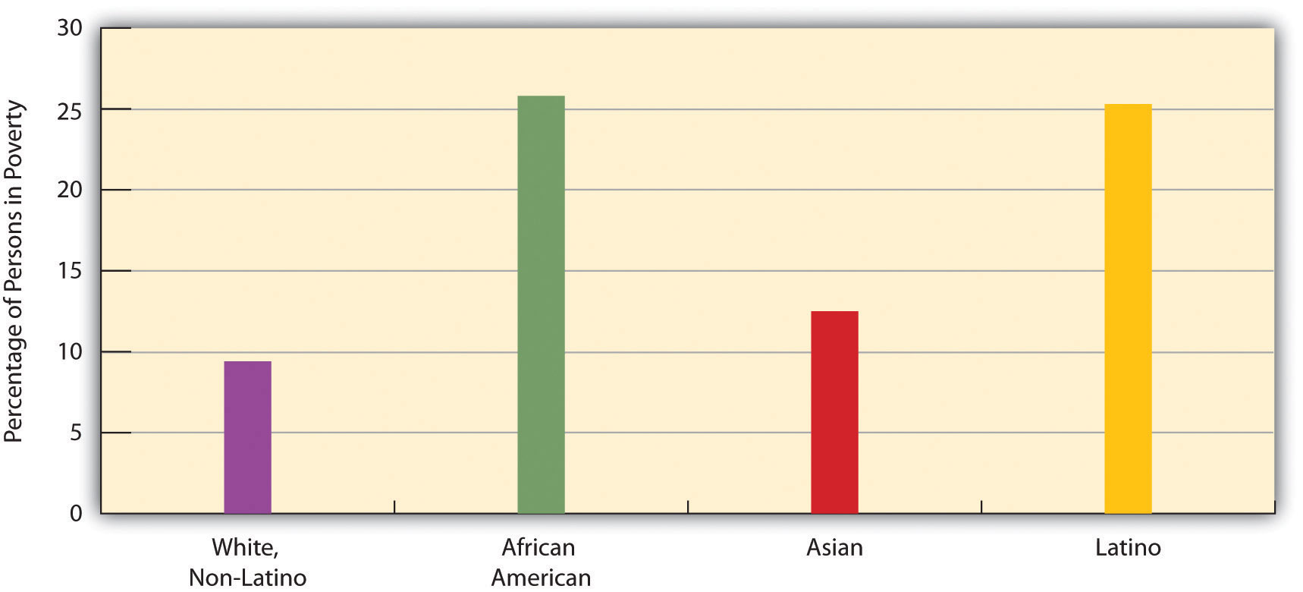
Source: Data from DeNavas-Walt, C., Proctor, B. D., & Smith, J. C. (2011). Income, poverty, and health insurance coverage in the United States: 2010 (Current Population Report P60-239). Washington, DC: US Census Bureau.

Gender
One thing that many women know all too well is that women are more likely than men to be poor. According to the census, 16.2 percent of all females live in poverty, compared to only 14.0 percent of all males. These figures translate to a large gender gap in the actual number of poor people, as 25.2 million women and girls live in poverty, compared to only 21.0 million men and boys, for a difference of 4.2 million people. The high rate of female poverty is called the feminization of poverty (Iceland, 2006). We will see additional evidence of this pattern when we look at the section on family structure that follows.

Age
Turning to age, at any one time 22 percent of children under age 18 are poor (amounting to 16.4 million children), a figure that rises to about 39 percent of African American children and 35 percent of Latino children. About 37 percent of all children live in poverty for at least one year before turning 18 (Ratcliffe & McKernan, 2010). The poverty rate for US children is the highest of all wealthy democracies and in fact is 1.5 to 9 times greater than the corresponding rates in Canada and Western Europe (Mishel, et. al., 2009). As high as the US childhood poverty rate is, twice-poverty data again paint an even more discouraging picture. Children living in families with incomes below twice the official poverty level are called low-income children, and their families are called low-income families. Almost 44 percent of American children, or some 32.5 million kids, live in such families (Addy & Wright, 2012). Almost two-thirds of African American children and Latino children live in low-income families.
At the other end of the age distribution, 9 percent of people aged 65 or older are poor (amounting to about 3.5 million seniors). Turning around these age figures, almost 36 percent of all poor people in the United States are children, and almost 8 percent of the poor are 65 or older. Thus more than 43.4 percent of Americans living in poverty are children or the elderly.

Region
Poverty rates differ around the country. Some states have higher poverty rates than other states, and some counties within a state are poorer than other counties within that state. A basic way of understanding geographical differences in poverty is to examine the poverty rates of the four major regions of the nation. When we do this, the South is the poorest region, with a poverty rate of 16.9 percent. The West is next (15.3 percent), followed by the Midwest (13.9 percent) and then the Northeast (12.8 percent). The South’s high poverty rate is thought to be an important reason for the high rate of illnesses and other health problems it experiences compared to the other regions (Ramshaw, 2011).

Family Structure
There are many types of family structures, including a married couple living with their children; an unmarried couple living with one or more children; a household with children headed by only one parent, usually a woman; a household with two adults and no children; and a household with only one adult living alone. Across the nation, poverty rates differ from one type of family structure to another.
Not surprisingly, poverty rates are higher in families with one adult than in those with two adults (because they often are bringing in two incomes), and, in one-adult families, they are higher in families headed by a woman than in those headed by a man (because women generally have lower incomes than men). Of all families headed by just a woman, 31.6 percent live in poverty, compared to only 15.8 percent of families headed by just a man. In contrast, only 6.2 percent of families headed by a married couple live in poverty (see Figure 2.4 “Family Structure and Poverty Rate (Percentage of Each Type of Structure That Lives in Poverty)”). The figure for female-headed families provides additional evidence for the feminization of poverty concept introduced earlier.

Figure 2.4 Family Structure and Poverty Rate (Percentage of Each Type of Structure That Lives in Poverty)
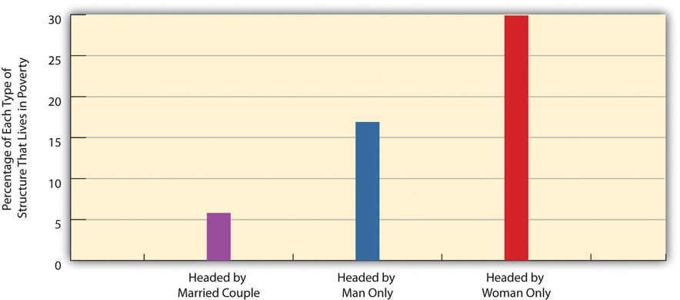
Source: Data from DeNavas-Walt, C., Proctor, B. D., & Smith, J. C. (2011). Income, poverty, and health insurance coverage in the United States: 2010 (Current Population Report P60-239). Washington, DC: US Census Bureau.

We saw earlier that 22 percent of American children are poor. This figure varies according to the type of family structure in which the children live. Whereas only 11.6 percent of children residing with married parents live in poverty, 46.9 percent of those living with only their mother live in poverty. This latter figure rises to 53.3 percent for African American children and 57.0 percent for Latino children (US Census Bureau, 2012). Yet regardless of their race or ethnicity, children living just with their mothers are at particularly great risk of living in poverty.

Labor Force Status
As this chapter discusses later, many Americans think the poor are lazy and lack the motivation to work and, as is often said, “really could work if they wanted to.” However, government data on the poor show that most poor people are, in fact, either working, unemployed but looking for work, or unable to work because of their age or health. Table 2.1 “Poverty and Labor Force Participation, 2010” shows the relevant data. We discuss these numbers in some detail because of their importance, so please follow along carefully.

Table 2.1 Poverty and Labor Force Participation, 2010
Total number of poor people | 46,180,000
Number of poor people under age 18 | 16,401,000
Number of poor people ages 65 and older | 3,521,000
Number of poor people ages 18–64 | 26,258,000
Number of poor people ages 18–64 who were:
Working full- or part-time | 9,053,000
Unemployed but looking for work | 3,616,000
Disabled | 4,247,000
In the armed forces | 77,000
Able-bodied but not in the labor force | 9,254,000
Source: Data from US Census Bureau. (2010). Current population survey (CPS) table creator. Retrieved from http://www.census.gov/cps/data/cpstablecreator.html.
Let’s examine this table to see the story it tells. Of the roughly 46.2 million poor people, almost 20 million were either under age 18 or at least 65. Because of their ages, we would not expect them to be working. Of the remaining 26.3 million poor adults ages 18–64, almost 17 million, or about two-thirds, fell into one of these categories: (a) they worked full-time or part-time, (b) they were unemployed but looking for work during a year of very high unemployment due to the nation’s faltering economy, (c) they did not work because of a disability, or (d) they were in the armed forces. Subtracting all these adults leaves about 9.3 million able-bodied people ages 18–64.
Doing some arithmetic, we thus see that almost 37 million of the 46.2 million poor people we started with, or 80 percent, with were either working or unemployed but looking for work, too young or too old to work, disabled, or in the armed forces. It would thus be inaccurate to describe the vast majority of the poor as lazy and lacking the motivation to work.
What about the 9.3 million able-bodied poor people who are ages 18–64 but not in the labor force, who compose only 20 percent of the poor to begin with? Most of them were either taking care of small children or elderly parents or other relatives, retired for health reasons, or in school (US Census Bureau, 2012); some also left the labor force out of frustration and did not look for work (and thus were not counted officially as unemployed). Taking all these numbers and categories into account, it turns out that the percentage of poor people who “really could work if they wanted to” is rather miniscule, and the common belief that they “really could work if they wanted to” is nothing more than a myth.

People Making a Difference
Feeding “Motel Kids” Near Disneyland
Just blocks from Disneyland in Anaheim, California, more than 1,000 families live in cheap motels frequently used by drug dealers and prostitutes. Because they cannot afford the deposit for an apartment, the motels are their only alternative to homelessness. As Bruno Serato, a local Italian restaurant owner, observed, “Some people are stuck, they have no money. They need to live in that room. They’ve lost everything they have. They have no other choice. No choice.”
Serato learned about these families back in 2005, when he saw a boy at the local Boys & Girls Club eating a bag of potato chips as his only food for dinner. He was told that the boy lived with his family in a motel and that the Boys & Girls Club had a “motel kids” program that drove children in vans after school to their motels. Although the children got free breakfast and lunch at school, they often went hungry at night. Serato soon began serving pasta dinners to some seventy children at the club every evening, a number that had grown by spring 2011 to almost three hundred children nightly. Serato also pays to have the children transported to the club for their dinners, and he estimates that the food and transportation cost him about $2,000 monthly. His program had served more than 300,000 pasta dinners to motel kids by 2011.
Two of the children who eat Serato’s pasta are Carlos and Anthony Gomez, 12, who live in a motel room with the other members of their family. Their father was grateful for the pasta: “I no longer worry as much, about them [coming home] and there being no food. I know that they eat over there at [the] Boys & Girls Club.”
Bruno Serato is merely happy to be helping out. “They’re customers,” he explains. “My favorite customers” (Toner, 2011).

3.1 Racial and Ethnic Inequality: A Historical Prelude
Race and ethnicity have torn at the fabric of American society ever since the time of Christopher Columbus, when an estimated 1 million Native Americans populated the eventual United States. By 1900, their numbers had dwindled to about 240,000, as tens of thousands were killed by white settlers and US troops and countless others died from disease contracted from people with European backgrounds. Scholars say this mass killing of Native Americans amounted to genocide (Brown, 2009).
African Americans also have a history of maltreatment that began during the colonial period, when Africans were forcibly transported from their homelands to be sold as slaves in the Americas. Slavery, of course, continued in the United States until the North’s victory in the Civil War ended it. African Americans outside the South were not slaves but were still victims of racial prejudice. During the 1830s, white mobs attacked free African Americans in cities throughout the nation, including Philadelphia, Cincinnati, Buffalo, and Pittsburgh. The mob violence stemmed from a “deep-seated racial prejudice…in which whites saw blacks as ‘something less than human’” (Brown, 1975) and continued well into the twentieth century, when white mobs attacked African Americans in several cities, with at least seven antiblack riots occurring in 1919 that left dozens dead. Meanwhile, an era of Jim Crow racism in the South led to the lynching of thousands of African Americans, segregation in all facets of life, and other kinds of abuses (Litwack, 2009).
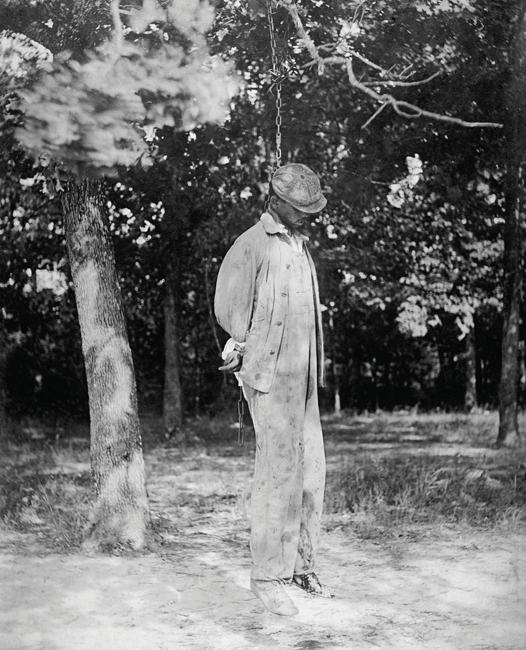
During the era of Jim Crow racism in the South, several thousand African Americans were lynched.
US Library of Congress – public domain.
African Americans were not the only targets of native-born white mobs back then (Dinnerstein & Reimers, 2009). As immigrants from Ireland, Italy, Eastern Europe, Mexico, and Asia flooded into the United States during the nineteenth and early twentieth centuries, they, too, were beaten, denied jobs, and otherwise mistreated. During the 1850s, mobs beat and sometimes killed Catholics in cities such as Baltimore and New Orleans. During the 1870s, whites rioted against Chinese immigrants in cities in California and other states. Hundreds of Mexicans were attacked and/or lynched in California and Texas during this period.
Nazi racism in the 1930s and 1940s helped awaken Americans to the evils of prejudice in their own country. Against this backdrop, a monumental two-volume work by Swedish social scientist Gunnar Myrdal (Myrdal, 1944) attracted much attention when it was published. The book, An American Dilemma: The Negro Problem and Modern Democracy, documented the various forms of discrimination facing blacks back then. The “dilemma” referred to by the book’s title was the conflict between the American democratic ideals of egalitarianism and liberty and justice for all and the harsh reality of prejudice, discrimination, and lack of equal opportunity.
The Kerner Commission’s 1968 report reminded the nation that little, if anything, had been done since Myrdal’s book to address this conflict. Sociologists and other social scientists have warned since then that the status of people of color has actually been worsening in many ways since this report was issued (Massey, 2007; Wilson, 2009). Evidence of this status appears in the remainder of this chapter.

Key Takeaways
- US history is filled with violence and other maltreatment against Native Americans, blacks, and immigrants.
- Social scientists warn that the status of people of color has been worsening.

3.2 The Meaning of Race and Ethnicity

Learning Objectives
- Critique the biological concept of race.
- Discuss why race is a social construction.
- Explain why ethnic heritages have both good and bad consequences.
To begin our understanding of racial and ethnic inequality, we first need to understand what race and ethnicity mean. These terms may seem easy to define but are much more complex than their definitions suggest.

Race
Let’s start first with race, which refers to a category of people who share certain inherited physical characteristics, such as skin color, facial features, and stature. A key question about race is whether it is more of a biological category or a social category. Most people think of race in biological terms, and for more than three hundred years, or ever since white Europeans began colonizing nations filled with people of color, people have been identified as belonging to one race or another based on certain biological features.
It is certainly easy to see that people in the United States and around the world differ physically in some obvious ways. The most noticeable difference is skin tone: Some groups of people have very dark skin, while others have very light skin. Other differences also exist. Some people have very curly hair, while others have very straight hair. Some have thin lips, while others have thick lips. Some groups of people tend to be relatively tall, while others tend to be relatively short. Using such physical differences as their criteria, scientists at one point identified as many as nine races: African, American Indian or Native American, Asian, Australian Aborigine, European (more commonly called “white”), Indian, Melanesian, Micronesian, and Polynesian (Smedley, 2007).
Although people certainly do differ in these kinds of physical features, anthropologists, sociologists, and many biologists question the value of these categories and thus the value of the biological concept of race (Smedley, 2007). For one thing, we often see more physical differences within a race than between races. For example, some people we call “white” (or European), such as those with Scandinavian backgrounds, have very light skins, while others, such as those from some Eastern European backgrounds, have much darker skins. In fact, some “whites” have darker skin than some “blacks,” or African Americans. Some whites have very straight hair, while others have very curly hair; some have blonde hair and blue eyes, while others have dark hair and brown eyes. Because of interracial reproduction going back to the days of slavery, African Americans also differ in the darkness of their skin and in other physical characteristics. In fact, it is estimated that at least 30 percent of African Americans have some white (i.e., European) ancestry and that at least 20 percent of whites have African or Native American ancestry. If clear racial differences ever existed hundreds or thousands of years ago (and many scientists doubt such differences ever existed), in today’s world these differences have become increasingly blurred.
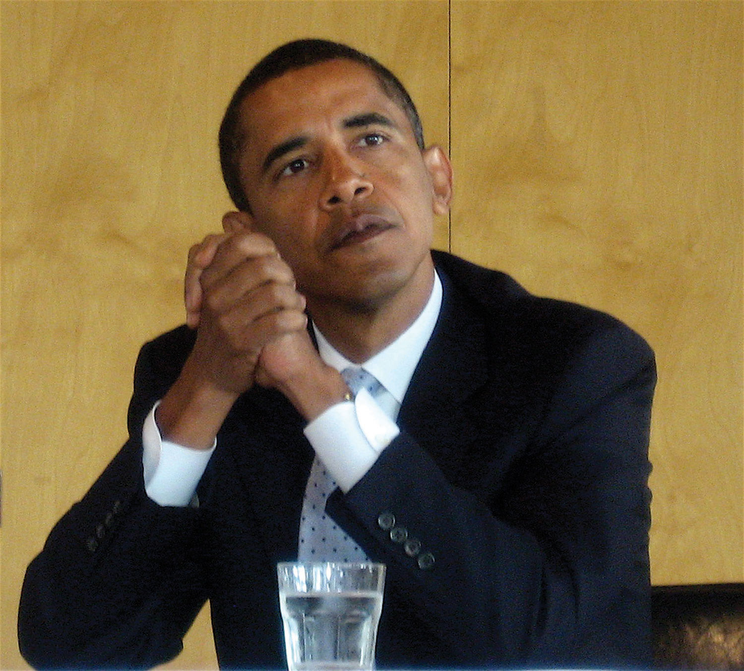
President Barack Obama had an African father and a white mother. Although his ancestry is equally black and white, Obama considers himself an African American, as do most Americans. In several Latin American nations, however, Obama would be considered white because of his white ancestry.
Steve Jurvetson – Barak Obama on the Primary – CC BY 2.0.
Another reason to question the biological concept of race is that an individual or a group of individuals is often assigned to a race arbitrarily. A century ago, for example, Irish, Italians, and Eastern European Jews who left their homelands were not regarded as white once they reached the United States but rather as a different, inferior (if unnamed) race (Painter, 2010). The belief in their inferiority helped justify the harsh treatment they suffered in their new country. Today, of course, we call people from all three backgrounds white or European.
In this context, consider someone in the United States who has a white parent and a black parent. What race is this person? American society usually calls this person black or African American, and the person may adopt this identity (as does President Barack Obama, who had a white mother and African father). But where is the logic for doing so? This person, as well as President Obama, is as much white as black in terms of parental ancestry.
Or consider someone with one white parent and another parent who is the child of one black parent and one white parent. This person thus has three white grandparents and one black grandparent. Even though this person’s ancestry is thus 75 percent white and 25 percent black, she or he is likely to be considered black in the United States and may well adopt this racial identity. This practice reflects the traditional one-drop rule in the United States that defines someone as black if she or he has at least one drop of black blood, and that was used in the antebellum South to keep the slave population as large as possible (Staples, 2005). Yet in many Latin American nations, this person would be considered white (see Note 3.7 “Lessons from Other Societies”). With such arbitrary designations, race is more of a social category than a biological one.

Lessons from Other Societies
The Concept of Race in Brazil
As the text discusses, race was long considered a fixed, biological category, but today it is now regarded as a social construction. The experience of Brazil provides very interesting comparative evidence for this more accurate way of thinking about race.
When slaves were first brought to the Americas almost four hundred years ago, many more were taken to Brazil, where slavery was not abolished until 1888, than to the land that eventually became the United States. Brazil was then a colony of Portugal, and the Portuguese used Africans as slave labor. Just as in the United States, a good deal of interracial reproduction has occurred since those early days, much of it initially the result of rape of women slaves by their owners, and Brazil over the centuries has had many more racial intermarriages than the United States. Also like the United States, then, much of Brazil’s population has multiracial ancestry. But in a significant departure from the United States, Brazil uses different criteria to consider the race to which a person belongs.
Brazil uses the term preto, or black, for people whose ancestry is solely African. It also uses the term branco, or white, to refer to people whose ancestry is both African and European. In contrast, as the text discusses, the United States commonly uses the term black or African American to refer to someone with even a small amount of African ancestry and white for someone who is thought to have solely European ancestry or at least “looks” white. If the United States were to follow Brazil’s practice of reserving the term black for someone whose ancestry is solely African and the term white for someone whose ancestry is both African and European, many of the Americans commonly called “black” would no longer be considered black and instead would be considered white.
As sociologist Edward E. Telles (2006, p. 79) summarizes these differences, “[Blackness is differently understood in Brazil than in the United States. A person considered black in the United States is often not so in Brazil. Indeed, some U.S. blacks may be considered white in Brazil. Although the value given to blackness is similarly low [in both nations], who gets classified as black is not uniform.” The fact that someone can count on being considered “black” in one society and not “black” in another society underscores the idea that race is best considered a social construction rather than a biological category.
Sources: Barrionuevo & Calmes, 2011; Klein & Luno, 2009; Telles, 2006
A third reason to question the biological concept of race comes from the field of biology itself and more specifically from the studies of genetics and human evolution. Starting with genetics, people from different races are more than 99.9 percent the same in their DNA (Begley, 2008). To turn that around, less than 0.1 percent of all DNA in our bodies accounts for the physical differences among people that we associate with racial differences. In terms of DNA, then, people with different racial backgrounds are much, much more similar than dissimilar.
Even if we acknowledge that people differ in the physical characteristics we associate with race, modern evolutionary evidence reminds us that we are all, really, of one human race. According to evolutionary theory, the human race began thousands and thousands of years ago in sub-Saharan Africa. As people migrated around the world over the millennia, natural selection took over. It favored dark skin for people living in hot, sunny climates (i.e., near the equator), because the heavy amounts of melanin that produce dark skin protect against severe sunburn, cancer, and other problems. By the same token, natural selection favored light skin for people who migrated farther from the equator to cooler, less sunny climates, because dark skins there would have interfered with the production of vitamin D (Stone & Lurquin, 2007). Evolutionary evidence thus reinforces the common humanity of people who differ in the rather superficial ways associated with their appearances: We are one human species composed of people who happen to look different.

Race as a Social Construction
The reasons for doubting the biological basis for racial categories suggest that race is more of a social category than a biological one. Another way to say this is that race is a social construction, a concept that has no objective reality but rather is what people decide it is (Berger & Luckmann, 1963). In this view, race has no real existence other than what and how people think of it.
This understanding of race is reflected in the problems, outlined earlier, in placing people with multiracial backgrounds into any one racial category. We have already mentioned the example of President Obama. As another example, golfer Tiger Woods was typically called an African American by the news media when he burst onto the golfing scene in the late 1990s, but in fact his ancestry is one-half Asian (divided evenly between Chinese and Thai), one-quarter white, one-eighth Native American, and only one-eighth African American (Leland & Beals, 1997).
Historical examples of attempts to place people in racial categories further underscore the social constructionism of race. In the South during the time of slavery, the skin tone of slaves lightened over the years as babies were born from the union, often in the form of rape, of slave owners and other whites with slaves. As it became difficult to tell who was “black” and who was not, many court battles over people’s racial identity occurred. People who were accused of having black ancestry would go to court to prove they were white in order to avoid enslavement or other problems (Staples, 1998).
Although race is a social construction, it is also true that race has real consequences because people do perceive race as something real. Even though so little of DNA accounts for the physical differences we associate with racial differences, that low amount leads us not only to classify people into different races but also to treat them differently—and, more to the point, unequally—based on their classification. Yet modern evidence shows there is little, if any, scientific basis for the racial classification that is the source of so much inequality.

Ethnicity
Because of the problems in the meaning of race, many social scientists prefer the term ethnicity in speaking of people of color and others with distinctive cultural heritages. In this context, ethnicity refers to the shared social, cultural, and historical experiences, stemming from common national or regional backgrounds, that make subgroups of a population different from one another. Similarly, an ethnic group is a subgroup of a population with a set of shared social, cultural, and historical experiences; with relatively distinctive beliefs, values, and behaviors; and with some sense of identity of belonging to the subgroup. So conceived, the terms ethnicity and ethnic group avoid the biological connotations of the terms race and racial group.
At the same time, the importance we attach to ethnicity illustrates that it, too, is in many ways a social construction, and our ethnic membership thus has important consequences for how we are treated. In particular, history and current practice indicate that it is easy to become prejudiced against people with different ethnicities from our own. Much of the rest of this chapter looks at the prejudice and discrimination operating today in the United States against people whose ethnicity is not white and European. Around the world today, ethnic conflict continues to rear its ugly head. The 1990s and 2000s were filled with ethnic cleansing and pitched battles among ethnic groups in Eastern Europe, Africa, and elsewhere. Our ethnic heritages shape us in many ways and fill many of us with pride, but they also are the source of much conflict, prejudice, and even hatred, as the hate crime story that began this chapter so sadly reminds us.

Key Takeaways
- Sociologists think race is best considered a social construction rather than a biological category.
- “Ethnicity” and “ethnic” avoid the biological connotations of “race” and “racial.”

