Industrial &Organizational Psychology
PSY 338
Saint Leo University
LeChard K. Jones

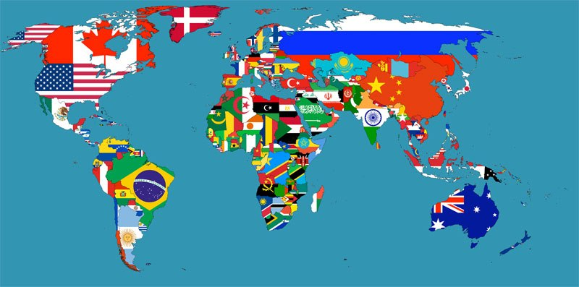

Dream Company: Travel organization

Produce: Travel game plans

Name of organization: World Wide Travels

Number of Employees: 15

• Human Resource Manager

o HR. Right hand

• Accountant

o Accounting Assistant

• Financial Manager

• Travel Agent (5)

• Corporate Travel Consultant

• Office Manager

o Office Assistant

• Marketing Manager

• IT Manager

• CEO

Authority Structure: Decentralized Business Model

Geographic Location: United States (East Coast)

Quality: solid initiative

Shortcoming: substantial rivalry

Organization catchphrase: Get lost without getting lost

Industry: Travel game plans and reservation administrations

• Industry Classification: 2012 NAICS: 5615 - Travel course of action and reservation administrations

• Definition: This industry bunch involves foundations principally occupied with (1) travel office administrations; (2) organizing and gathering visits; (3) offering show and guests department administrations; and (4) offering all other travel course of action and reservation administrations.
Org Chart

Key Industry Statistics: United States

 | 1997 | 2002 | 2007 | 2012 | 07-12  % Chg
Number of establishments | 36,578 | 28,470 | 22,595 | 20,078 | -11.1%
Receipts ($ Millions) | 21,484 | 25,535 | 37,112 | 34,346 | -7.5%
Annual payroll ($ Millions) | 7,699 | 8,051 | 12,409 | 10,473 | -15.6%
Total employment | 300,504 | 264,614 | 258,329 | 229,383 | -11.2%
Receipts per establishment ($1,000) | 587 | 897 | 1,642 | 1,711 | 4.2%
Receipts per employee ($1,000) | 71 | 97 | 144 | 150 | 4.2%
Receipts per $ of payroll ($) | 2.79 | 3.17 | 2.99 | 3.28 | 9.7%
Payroll per employee ($) | 25,622 | 30,425 | 48,035 | 45,657 | -5.0%
Employees per establishment | 8.22 | 9.29 | 11.43 | 11.42 | -.1%
Receipts per capita ($) | 79 | 89 | 123 | 109 | -11.2%
Population per establishment | 7,454 | 10,103 | 13,332 | 15,635 | 17.3%

Nonemployee establishments (establishments without paid employees)
Number of establishments | 38,069 | 32,993 | 43,076 | 40,581 | -5.8%
Receipts ($1,000) | 1,382,219 | 1,433,042 | 1,728,636 | 1,618,978 | -6.3%
Receipts per establishment ($) | 36,308 | 43,435 | 40,130 | 39,895 | -.6%
Receipts per capita ($) | 5.07 | 4.98 | 5.74 | 5.16 | -10.1%
Population
Total Population | 272,646,925 | 287,625,193 | 301,231,207 | 313,914,040 | 4.2%

Resources:

United States Census Bureau. 2012 NAICS: 5615 - Travel arrangement and reservation services. Industry Statistics Portal.
https://www.census.gov/econ/isp/sampler.php?naicscode=5615&naicslevel=4
https://datausa.io/profile/naics/5615/
https://siccode.com/en/naicscodes/561510/travel-agencies-2
http://www.aaa.com/travelinfo/

