Land and Oil
In March 1867, Tsar Alexander II of Russia agreed to sell "Russian America" (quickly renamed the "Department of Alaska") to the United States. Under the Treaty of Cession, the U.S. government paid the Tsar $7.2 million for a territory that comprised 586,412 square miles—roughly two cents an acre. (To see the text of the treaty, click here.)
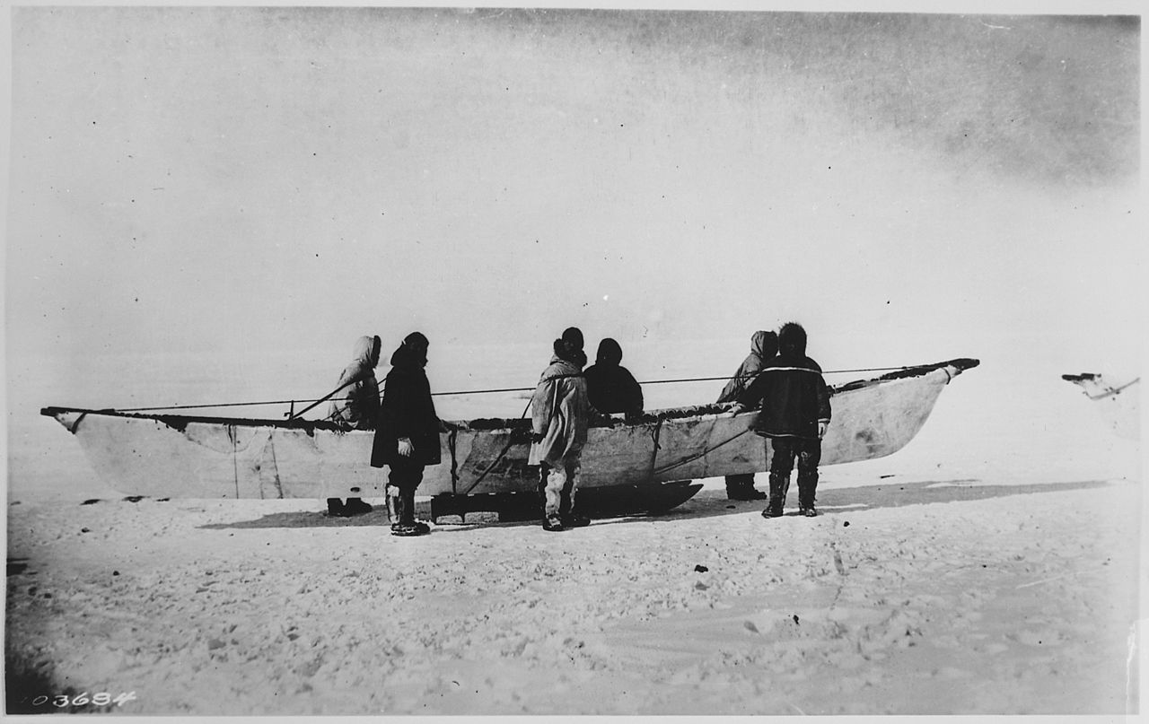
Iñupiat with a Native skinboat, or umiak, 1935. (Click button for citation)
But who really owned all that land? At the time of the Alaska Purchase, Secretary of State William H. Seward estimated that the Native population of Alaska was slightly less than 60,000. (Seward, 1891) These Alaska Natives—including the Inuit, Tlingit, Yupik, Haida, Aleut, and Iñupiat, among many others—claimed that the land had always been their home. Their aboriginal land claims dated back well before American or even Russian ownership of the land.
Those land claims went unresolved for more than a century; the United States government claimed ownership of the vast majority of Alaskan land until the 1960s. In 1971, only about 1 million of the state's 375 million acres were in private hands. (Turner, 1982). But, with Alaska so sparsely populated (especially in the vast Interior), and with little agriculture or commercial use for most Alaskan land, there were few conflicts over the Natives' continued use of it. Most of Alaska was not suitable for settlement, in the same way that land in the Lower 48 was; for that reason, relatively few non-Natives were interested in the land. Congress in 1884 passed the Alaska Organic Act, which protected the Natives' right to the "use and occupancy" of ancestral land, without addressing the question of whether the Natives actually owned it. (Jones, 1981)
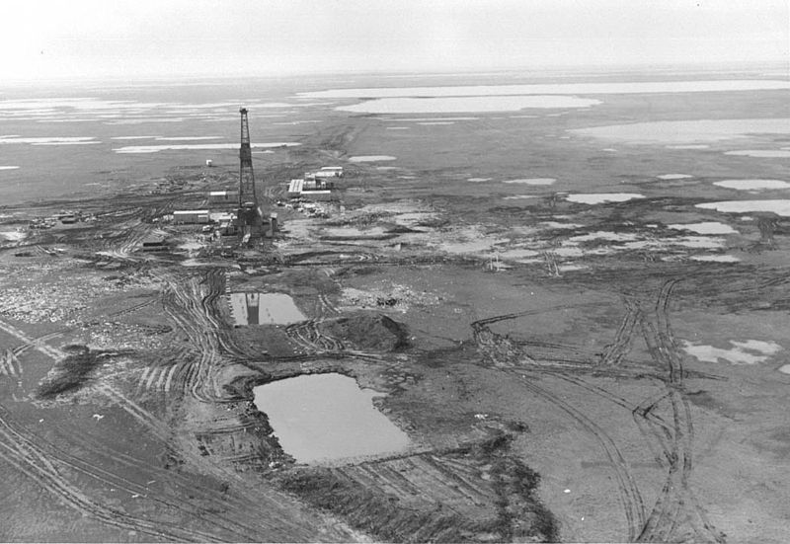
Prudhoe Bay in 1968, the year oil was discovered there. (Click button for citation)
All that changed in 1968, when the Atlantic-Richfield Company discovered oil at Prudhoe Bay on Alaska's Arctic Coast. It quickly became apparent that the most effective way to get crude oil from Prudhoe Bay to markets in the Lower 48 would be to build a pipeline to carry the oil to the port of Valdez in southern Alaska. (Banet 1991) But to build the pipeline, the oil companies would need clear title to the land—land that was still subject to Native land claims.
It was a scenario that had played out so many times before in American history: land that for centuries had been used by Natives was, suddenly, extremely valuable to non-Natives. So many times before, that scenario had ended up with Natives being forced or cheated out of their land. But the outcome this time would be very different.
This learning block uses the history of the Alaska land claim issue as another way to use historical evidence to draw conclusions about historical events—as well as to reinforce your understanding of historical contingency and complexity.

ANCSA and Native Corporations
Alaska was admitted to the Union as the 49th state on January 3, 1959. Under the terms of the Alaska Statehood Act, the federal government would transfer ownership of up to 104.5 million acres of land to the new state, but none of this would be land that was subject to Native claims. (Alaska Statehood Act, 1958. To read the law, click here. )
Former Alaska Governor Walter Hickel. (Click button for citation)
The law gave the state 25 years to select which tracts of land it wanted. In the 1960s, the state began to make its selections—but much of the land it wanted was subject to Native claims. Several Native groups filed lawsuits to stop the land selections, and the Alaska Federation of Natives (AFN) was founded to advocate for a fair and comprehensive settlement to the land-claim issue. In response, the federal government shut down the selection process and told the state to negotiate an agreement with the Natives. (Jones, 1981)
The discovery of oil at Prudhoe Bay in 1968 added urgency to those negotiations. Without a resolution of the Native claims, it would not be possible to build the massive Trans-Alaska Pipeline that the oil industry said was needed to carry Alaskan oil to markets in the Lower 48. (Naske, 1994)
The pressure to come to a quick settlement in the interest of economic development was in fact reminiscent of the pressure to seize Native lands following the Georgia Gold Rush in the 1830s. In each case, the opportunity to extract a highly valuable natural resource suddenly made Native land even more valuable than before. But several factors helped to produce a very different outcome for the Alaska Natives:
- The Natives had effective political representation, through the AFN and other organizations;
- U.S. courts were more sympathetic to the Alaska Natives' claims, ruling in their favor in several instances;
- The state government was willing to seek a negotiated settlement with the Natives;
- The federal government—including Secretary of the Interior Walter Hickel, a former governor of Alaska—also favored a negotiated settlement; and
- Greater public awareness of the injustices done to Natives in the past increased the social and political pressure to find an equitable settlement. (Jones, 1981)
After protracted negotiations, Alaskan officials and the AFN reached an agreement in principle: Natives would receive land that they had historically used and drop their claims to any other land in the state in return for a cash settlement. The exact terms of that agreement would be for the federal government to decide and—after initially offering the Natives far less than they wanted, in terms of land and cash—Congress and President Richard Nixon eventually agreed to a historic deal.

A map of the original 12 Alaska Native regional corporations. A 13th regional corporation was established later. (click map to enlarge) (Click button for citation)
On December 18, 1971, President Nixon signed into law the Alaska Native Claims Settlement Act (ANCSA), which at the time was the largest land claim settlement in American history.
In return for letting the federal government "extinguish" their claims to most Alaskan land, Natives received 44 million acres and a cash payment of $962.5 million. The 44 million acres was one-ninth of the total area of the state of Alaska; the monetary settlement represented a direct payment of $462.5 million from the federal government and another $500 million to be paid over time from state oil revenues. (ANCSA, 1971)
Even more historic than the size of the ANCSA settlement was the way it was structured—a radical departure from the traditional model of Native reservations in the Lower 48, in which the federal government holds Native lands in trust. Instead of establishing reservations ANCSA set up a system of Native corporations to administer the land and invest the monetary settlement for the benefit of Natives. (Thomas, 1986)
The law set up 12 regional corporations, each associated with a particular part of the state and the Natives who traditionally lived there. All Natives who were alive in 1971 could enroll in one of the corporations, and each received 100 shares of stock in the corporation in which they enrolled. (A 13th corporation was established later, for Natives who were not living in Alaska in 1971). The law also established more than 200 local or "village" corporations, in which Natives could also enroll and receive shares of stock. The corporations were given free rein to use the land and any mineral or other natural resources it might hold to develop for-profit businesses and to pay Native shareholders a yearly dividend based on those profits.
The corporation structure was the brainchild of the AFN, which saw this proposal as an opportunity to extend "the transformational power of capitalism...to Alaska Natives," while also preserving the land and cash settlement so that it could benefit future generations. (Linxwiler, 2007)
A Tlingit totem pole in Sitka, Alaska. Click on the image to go to the Smithsonian's Alaska Native Collections. (Click button for citation)
ANCSA was generally well-received in Alaska by both Natives and non-Natives. After years of legal wrangling over exactly who was entitled to Native corporation shares, many of those corporations have grown into successful businesses that generate substantial dividends and provide thousands of jobs for Native shareholders. And, by removing one critical barrier to construction of the Trans-Alaska Pipeline, ANCSA paved the way for the emergence of the state's "oil economy," which has generated substantial economic benefits for both Natives and non-Natives. (Alaska Humanities Forum, 2016)
One unique aspect of Alaska's "oil economy" is the Alaska Permanent Fund, a state fund that collects 25 percent of all oil-land royalties and invests those funds for the benefit of all Alaskans. The Fund, which in 2015 amounted to more than $51 billion, pays a yearly dividend to every qualified Alaskan; in 2015, that meant a dividend check of $2,072 for virtually every man, woman, and child in the state. (Klint and Doogan, 2015) By enabling construction of the Trans-Alaska Pipeline, ANCSA in a very real sense made the Permanent Fund, and its yearly dividend checks, possible.
Still, the law remains controversial, especially among Natives who believe it weakens ties to Native heritage. (Thomas, 1985) Almost a half-century after its passage, the jury is still out on whether ANCSA was a "good deal" or a "raw deal" for Natives. But it is, in almost every respect, a very different sort of deal than that received by any other group of Natives in American history.

Native Corporations : Further Readings
So, what's the bottom line—has ANCSA been a success or a failure? Have the Native corporations benefited the Native community, or not?
If you look only at the bottom line—that is, just at the economic performance of the Native corporations themselves—it's fair to say that, after a rocky start, many of the regional corporations have done fairly well. In 2004, seven of the top ten Alaska-owned business were Native regional corporations, which distributed $117.5 million in shareholder dividends, employed 3,116 Native shareholders, and paid $5.4 million in scholarships for Native students, (Linxwiler, 2007)
Like much of the oil-dependent Alaska economy, the regional corporations are highly sensitive to fluctuations in the price of oil, and their performance in any given year will reflect whether the oil business is doing well or poorly. Nonetheless, many of these corporations have matured as businesses and are providing significant economic benefits for their Native shareholders.
The economic performance of the village corporations has been spottier. Many of the village corporations were located in remote rural areas with extremely limited opportunities for economic development. While some village corporations—particularly those in more densely populated areas with easy access to outside markets—have fared well, others have been forced to merge or have gone out of business. (Thomas, 1985)
But is economic performance all that really matters? While ANCSA was designed only to provide Alaska Natives with opportunities for economic development, many Natives saw the corporation system as a substitute for—or a rival to—the traditional structures of tribal government. Among Alaska Natives, tribes are generally associated with individual villages (American Indian Resource Directory, 2016); many of the successful village corporations have established nonprofit agencies to provide health care and other social services to Native shareholders. At the same time, the pressure to turn a profit led many corporations, both regional and village, to bring in outside executives to run the businesses—bypassing tribal leaders and Elders, who have traditionally had a revered place in Alaska Native society.
In recent years, many Natives have questioned the extent to which the corporation system might be supplanting some tribal structures and weakening ties to Native heritage. In some areas, tribal government has seen a resurgence in importance.
The readings in this learning block look at two sides of the ANCSA question: the economic performance of the Native corporations and their relationship to the Native heritage and tribal structures. Both articles are taken from the same academic journal: Journal of Land, Resources, and Environmental Law, Vol. 25, No. 2 (Winter, 2005).
Select a list item tab, press enter, then search down for text. When you hear End of tab content, go back to the next list item to access the next list item tab.
- "Our Lives Are Not Measured in Dollars"
- Economic Performance of the Regional Corporations

ANCSA Unrealized: Our Lives Are Not Measured in Dollars
The following excerpt is from an article by James Allaway, a professor and expert on sustainable economic development, and Byron Mallett, former president of the Alaska Federation of Natives and former CEO of Sealaska, one of the larger Native regional corporations. You can read it at this link, which will take you to the Journal of Land, Resources, and Environmental Law; you can find this specific article in the Table of Contents on the left side of the page. Click on the title of the article to read, download, and print a copy of the text. These readings are provided by the Shapiro Library. This reading is required. You will have to log into Shapiro Library with your SNHU credentials.
One of the legacies of ANCSA's short history is the confusion it has caused, including confusion over governing structures. Certainly in Southeast Alaska we have known that clans, family, and family relationships were critical in the conduct of our affairs. I think this was the case all across the state.
Existing traditional governing groups, with their relationships and structures, did not go away with ANCSA. In fact, especially in the last decade, there has been a resurgence of those institutions. The resurgence has been felt and seen all across the state, particularly because there was a universal sense that ANCSA, and other efforts that deal with our circumstances, were not getting at the core of what we needed.
It is crucial that there is a place for traditional tribal governmental structures. I think the emergence of tribes in recent years is not so much about governmental structures, but is a reassertion that we will take hold of our own lives. We will be responsible for our destinies, which is a powerful ideal. It also places a profound obligation on Native people.
There is a vital place for Elders here. We cannot know the past and have a sense of values, we cannot have a sense of place or purpose, without Elders. Elders are an important part of the spiritual path. They carry the fire. We do not need to institutionalize the role of Elders, other than to sustain them materially. If we do, they will sustain us spiritually.
At the root of this course is a fundamental question: Why study history? As we've said before, the purpose of studying history is not to catalogue a long list of names and dates. Rather, the purpose of studying history is to learn more about the world around us, about human society and, in the end, about ourselves.
History is also a tool that can help us in whatever academic discipline or professional career we choose to pursue. As we saw in Theme: Approaches to History, historical thinking is a skill that can be applied to a wide range of problems and issues, both in the classroom and in everyday life.
The following passage is excerpted from an essay by the prominent historian Peter N. Stearns, which is featured on the website of the American Historical Association. It provides a clear summary of how studying history can benefit those who don't choose to make history their life's work—which is to say, the vast majority of today's history students:

Why Study History?
In the first place, history offers a storehouse of information about how people and societies behave. Understanding the operations of people and societies is difficult, though a number of disciplines make the attempt. An exclusive reliance on current data would needlessly handicap our efforts. How can we evaluate war if the nation is at peace—unless we use historical materials? How can we understand genius, the influence of technological innovation, or the role that beliefs play in shaping family life, if we don't use what we know about experiences in the past?...
The argument I make pivots on a tension that underlies every encounter with the past: the tension between the familiar and the strange, between feelings of proximity to and feelings of distance from the people we seek to understand. Neither of these poles does full justice to history's complexity, and veering to one side or the other only dulls history's jagged edges and leaves us with cliché and caricature. Furthermore, I claim that the essence of achieving mature historical thought rests precisely on our ability to navigate the jagged landscape of history, to traverse the terrain that lies between the poles of familiarity with and distance from the past.
A study of history is essential for good citizenship. This is the most common justification for the place of history in school curricula. Sometimes advocates of citizenship history hope merely to promote national identity and loyalty through a history spiced by vivid stories and lessons in individual success and morality. But the importance of history for citizenship goes beyond this narrow goal and can even challenge it at some points....
What does a well-trained student of history, schooled to work on past materials and on case studies in social change, learn how to do? The list is manageable, but it contains several overlapping categories.
The Ability to Assess Evidence. The study of history builds experience in dealing with and assessing various kinds of evidence—the sorts of evidence historians use in shaping the most accurate pictures of the past that they can. Learning how to interpret the statements of past political leaders—one kind of evidence—helps form the capacity to distinguish between the objective and the self-serving among statements made by present-day political leaders. Learning how to combine different kinds of evidence—public statements, private records, numerical data, visual materials—develops the ability to make coherent arguments based on a variety of data. This skill can also be applied to information encountered in everyday life.
The Ability to Assess Conflicting Interpretations. Learning history means gaining some skill in sorting through diverse, often conflicting interpretations. Understanding how societies work—the central goal of historical study—is inherently imprecise, and the same certainly holds true for understanding what is going on in the present day. Learning how to identify and evaluate conflicting interpretations is an essential citizenship skill for which history, as an often-contested laboratory of human experience, provides training. This is one area in which the full benefits of historical study sometimes clash with the narrower uses of the past to construct identity. Experience in examining past situations provides a constructively critical sense that can be applied to partisan claims about the glories of national or group identity. The study of history in no sense undermines loyalty or commitment, but it does teach the need for assessing arguments, and it provides opportunities to engage in debate and achieve perspective.
Experience in Assessing Past Examples of Change. Experience in assessing past examples of change is vital to understanding change in society today—it's an essential skill in what we are regularly told is our "ever-changing world." Analysis of change means developing some capacity for determining the magnitude and significance of change, for some changes are more fundamental than others. Comparing particular changes to relevant examples from the past helps students of history develop this capacity. The ability to identify the continuities that always accompany even the most dramatic changes also comes from studying history, as does the skill to determine probable causes of change. Learning history helps one figure out, for example, if one main factor—such as a technological innovation or some deliberate new policy—accounts for a change or whether, as is more commonly the case, a number of factors combine to generate the actual change that occurs.
Professor Stearns' full essay can be found at this link. This reading is required.
As a student of history, you have the opportunity to apply historical thinking to your own life. In a broad, philosophical sense, studying history will help you to understand how the decisions you make today can cause different options to open up tomorrow; to see the importance of judging events in context; and to be able to deal with the complexity of circumstances that confront you. And in a highly practical sense, the critical thinking skills you develop in this course can apply directly to your other academic work at SNHU.

"The Familiar and the Strange"
Sam Wineburg, a professor of education who has written extensively about historical thinking, offers a more lyrical—but no less compelling—description of the value of history in our daily lives. He describes historical thinking as the process of navigating "the tension between the familiar and the strange," both of which are essential to our understanding of the past. The passage below is excerpted from "Historical Thinking and Other Unnatural Acts". Click on the title of the article to read, download, and print a copy of the text. These readings are provided by the Shapiro Library. This reading is required. You will have to log into Shapiro Library with your SNHU credentials to access this article.

From "Historical Thinking and Other Unnatural Acts"
What is history good for? Why even teach it in schools? In a nutshell my claim is that history holds the potential, only partially realized, of humanizing us in ways offered by few other areas in the school curriculum. I make no claim of originality in arguing this point of view. But each generation, I believe, must answer for itself anew why the study of the past is important...
The argument I make pivots on a tension that underlies every encounter with the past: the tension between the familiar and the strange, between feelings of proximity to and feelings of distance from the people we seek to understand. Neither of these poles does full justice to history's complexity, and veering to one side or the other only dulls history's jagged edges and leaves us with cliché and caricature. Furthermore, I claim that the essence of achieving mature historical thought rests precisely on our ability to navigate the jagged landscape of history, to traverse the terrain that lies between the poles of familiarity with and distance from the past.
The pole of familiarity pulls most strongly. The familiar past entices us with the promise that we can locate our own place in the stream of time and solidify our identity in the present. By hitching our own stories to the stories of those who went before us, the past becomes a useful resource in our everyday lives, an endless storehouse of raw materials to be shaped for our present needs. Situating ourselves in time is a basic human need. Indeed, it is impossible to conceive of life on the planet without doing so. But in viewing the past as usable, as something that speaks to us without intermediary or translation, we end up turning it into yet another commodity for our instant consumption. We discard or just ignore vast regions of the past that either contradict our current needs or fail to align easily with them....
The other pole in this tension, the strangeness of the past, offers the possibility of surprise and amazement, of encountering people, places, and times that spur us to reconsider how we see ourselves as human beings. An encounter with this past can be mind-expanding in the best sense of the term. Yet, taken to extremes, this approach carries its own set of problems. Regarding the past "on its own terms"—detached from the circumstances, concerns, and needs of the present—too often results in a kind of esoteric exoticism, precisely the conclusion one comes to after a tour through the monographic literature that defines contemporary historical practice. Most of this specialized literature may engage the attention of a small coterie of professionals, but it fails to engage the interest of anyone else.
There is no easy way around the tension between the familiar past, which seems so relevant to our present needs, and the past whose applicability is not immediately manifest. The tension exists because both aspects of history are essential and irreducible.

Communicating Historical Ideas
There's another side to historical thinking as well: being able to develop and communicate your ideas about history. Framing the right research question, doing research to develop a thesis, using historical evidence to develop arguments that support your thesis—these are all skills that will serve you well in your other academic pursuits.
Think back about the essay you've been preparing for this course. Over the last several weeks you've had to research primary and secondary sources; assess the reliability of those sources; incorporate the evidence you've found into the body of your essay; and properly cite all the information you've gathered. When will you ever use those skills again? Most likely, it will be in the next course you take during your college career.

In Conclusion: Historical Perspective
The draft you've already submitted to your instructor for feedback contains almost all the essential elements of a thorough historical analysis: a clear and specific thesis statement; background information and context; analytical arguments to support your thesis; and historical evidence to buttress your arguments.
What's missing? Your own historical perspective.
As we've said before, thinking about history requires more than assembling and evaluating information. It also requires you to think about the impact that studying history can have on you personally—by changing the way you think about specific historical events, and broadening your understanding of how historians pursue historical truth.

Essay Progress Check 4
We'd like you to address those ideas in the concluding paragraphs of your historical event analysis essay. In one or two paragraphs, tell us why your historical event was important to you personally—that is, why you chose it in the first place—and how your historical research has changed the way you think about this event. Finally, describe how a historian might pursue this subject further, to provide an even fuller and more complex analysis of your historical event.

Revision Strategies
In every form, style, genre, and medium, no matter what your skill level, revision is essential to good writing. It's the difference between showing talent and getting the job done. By revising your work, you transform it from a record of your own understanding to writing that connects with readers and is able to shape their understanding.
Newspaper reporters have editors to review their work, but you'll have to handle the revisions yourself. (Click button for citation)
Writers often think that if they didn't see a problem the first time, they won't see it the second time either. But this isn't the case with many problems you can identify and fix in the first few stages of revision. Revision allows you to come back to your paper with fresh eyes and read it as a reader rather than as the writer who already knows what he or she is saying. If there is a gap in evidence or paragraphs inserted where they don't logically flow, you're most likely to notice these problems after you've set your paper aside for a while. If you're lacking topic sentences for your paragraphs, you are going to have just as difficult a time figuring out what you were saying as your reader would. So come back to your paper "as a reader" and see what you can find during these revision stages.
The other critical task in the revision process is implementing the feedback you have already received from your instructor. Make sure that you have re-read any and all instructor feedback you received during this course, and be certain that you have made all suggested changes.

